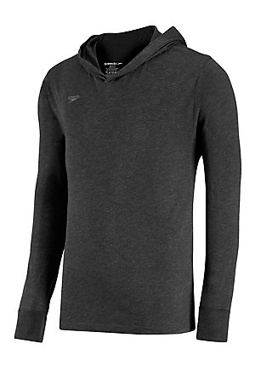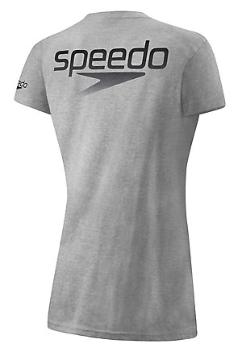
Sweatshirt Pull Over T-Shirt (women’s, back) T-Shirt (men’s, back)

ITEM | PRICE | SIZE | COLOR | GENDER | QUANTITY | TOTAL
Sweatshirt |  | S M L XL |  | Unisex
Pull Over |  | XS S M L XL | Black Heather/Royal Blue | Unisex
T-Shirt |  | XS S M L XL XXL |  | M F

Payment Information

Name________________________ Phone Number____________________________________

Please charge my card on file in the amount of

Today’s Date: Signature

Please note that prices are subject to New York sales tax, which will be added to the total prior to processing.

