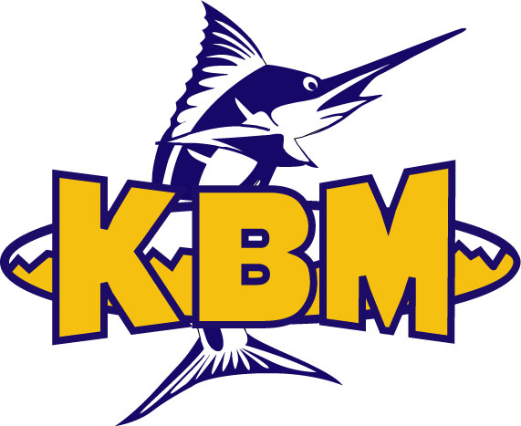

KBM/EBSC
MINI MEET
THURSDAY MAY 3rd, 2012

Hosted by the Kingston Blue Marlins Held at Artillery Park Aquatic Centre

Entry Deadline Thursday April 26th, 2012

Entry Procedures
All entries must submitted on an excel spreadsheet and must be sent to carlaswimming@gmail.com by Thursday April 26th, 2012

KBM /EBSC MINI MEET
Date: Thursday May 3rd, 2012
Hosted by: Kingston Blue Marlins
Location: Artillery Park Aquatic Centre
Facility: 6 lane, 25m pool with electronic start system.
Parking: available
Entry deadline: All entries must be received by April 26th, 2012.
Event Limit: 3 event limit
Scratches: Scratches must be sent to the Clerk of Course 15 minutes prior to the session start.
Awards: All participants will receive ribbons immediately following each event.
Meet Manager: Carla Ingimundson – carlaswimming@gmail.com

Thursday Afternooon

3:30PM Warm-up; 4:30PM Start
Event # | Event
1 | 25 free
2 | 50 fly
3 | 50 bk
4 | 100 free
5 | 50 breast
6 | 50 free
7 | 100 IM
8 | 25 fly

