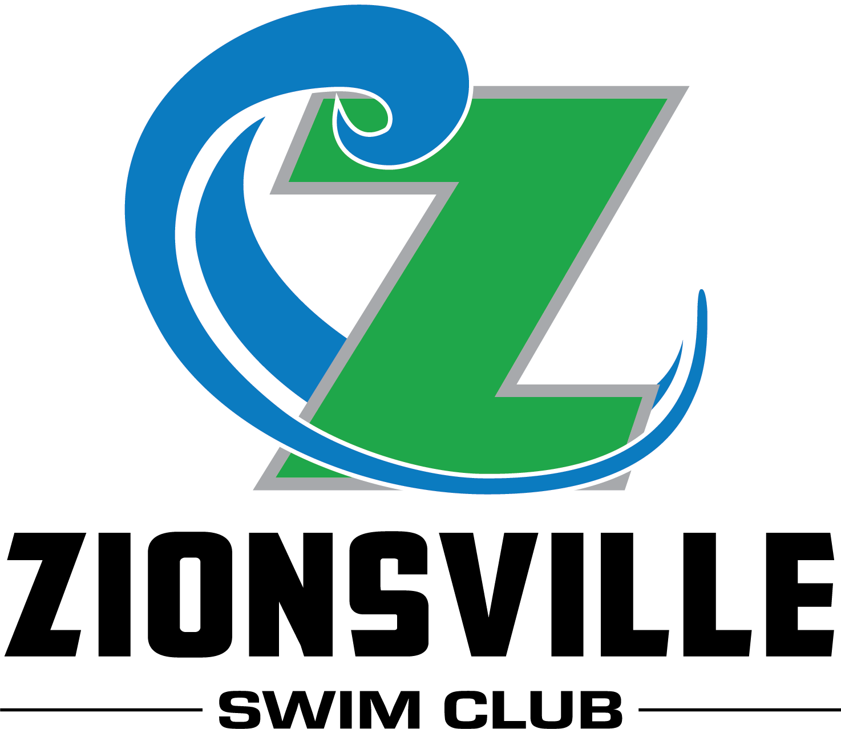

10 & Under
Candy Cane Classic

December 1, 2018

Zionsville Aquatic Center
Zionsville, IN

Official Event Information

Candy Cane Classic
December 1, 2018
Zionsville Aquatic Center

- This meet is sanctioned by USA Swimming and Indiana Swimming. Sanction number #
- This will be an open invite.
- Session #1 will be GIRLS ONLY, Session #2 will be BOYS ONLY
- This meet will be pre-seeded.
- A clerk of course will be provided for 8 and under swimmers.
- Entries will be accepted starting November 5, 2018.
- The entry deadline will be November 16, 2018, unless the meet fills before then.

Meet Administration
Facility Address  Zionsville Aquatic Center  Zionsville Community High School  1000 Mulberry Street, Zionsville, IN 46077 | Meet Directors  Jim Cox  email: jimcox@zionsvilleswimclub.org
Meet Referee  Mike Asam  email: masam@zionsvilleswimclub.org | Entry Chair  Brandi Bowlds  Evenings: 502-475-1787  email: brandi@zionsvilleswimclub.org  326 S 9th Street  Zionsville, IN 46077

al Information
Host: | Zionsville Swim Club, Inc. (ZSC)
Facility: | Zionsville Aquatic Center  Zionsville Community High School  1000 Mulberry Street, Zionsville, IN 46077  Eight-lane 25 yard pool with Daktronics timing systems and 8 lane scoreboard. Balcony seating for spectators overlooks pool. Concessions will be available. The diving well will be available to warm-up and cool-down.  The minimum water depth, measured in accordance with Article 103.2.3, is 5.0 feet at each end of the pool.  The competition course has not been certified in accordance with 104.2.2C(4).
Eligibility: | Swimmer(s) must be registered with USA Swimming prior to the competition (202.3.4B). Age as of December 1, 2018 shall determine the swimmer’s age for the entire meet (205.2.2).  ***Indiana Swimming does not process on-site athlete registration.
Rules: | Current USA Swimming and Indiana Swimming rules will govern this meet.  202.5.2- At a sanctioned competitive event, USA Swimming athlete members must be under the supervision of a USA Swimming member coach during warm-up, competition, and warm-down. The Meet Director or Meet Referee shall assist the athlete in making arrangements for such supervision.  202.4.9 D - Any swimmer entered in the meet, unaccompanied by a USA Swimming member coach, must be certified by a USA Swimming member coach as being proficient in performing a racing start or must start each race from within the water. It is the responsibility of the swimmer or the swimmer’s legal guardian to ensure compliance with this requirement.  ISI rule - Coaches MUST constantly display their current USA Swimming coach credential to gain deck access. The meet referee reserves the right to ask for coach credential display and/or deny deck access if coach does not comply or card is no longer valid/current.  ISI rule to include USA-S 102.8.1 B - In swimming competitions, the competitor must wear only one swimsuit in one or two pieces except as provided in USA Swimming rule 205.10.1. All swimsuits shall be made from textile materials. For men, the swimsuit shall not extend above the navel nor below the knees, and for women, shall not cover the neck, extend past the shoulder, nor extend below the knee.  202.4.9 H - Use of audio or visual recording devices, including a cell phone, is not permitted in changing areas, rest rooms or locker rooms  202.4.9 I - Changing into or out of swimsuits other than in locker rooms or other designated areas is prohibited.  202.4.9 J: Operation of a drone, or any other flying apparatus, is prohibited over the venue (pools, athlete/coach areas, spectator areas and open-ceiling locker rooms) any time athletes, coaches, officials and/or spectators are present. Exceptions may be granted with prior written approval by the Program Operations Vice Chair.​
Meet Format: | This is a timed finals meet and will be pre-seeded for each session. There will not be a positive sign-in for the athletes at the door.
Entry Limitations: | Each swimmer will be limited to 4 individual events and one relay. If an entry is submitted with a swimmer in more individual events than allowed, the swimmer will be entered into the order of events until the rule is satisfied. Both short course yard and long course meter times will be accepted. Long course meter times will be converted by HyTek Meet Manager to determine seeding. If submitting meter times, please make sure your cl2 file is correct.
Entry Format: | Hy-Tek Team Manager meet entry files must be sent by email. A confirmation entry list will be emailed back to the person who sent the email entry.  The following must be received prior to the start of warm-ups:  · Team summary report and executed release, and hold harmless agreement (included in this packet)  · Check for payment of all entry fees made out to Zionsville Swim Club.
Entry  Deadlines: | Entries will be accepted starting November 5, 2018. Entry deadline will be November 16, 2018.
Fees: | $5.00 per individual event and $6.00 per relay. Make checks payable to Zionsville Swim Club. Fees must accompany each team’s entry if sent by mail and must be received before warm-ups if a team sends an email entry. If deck entries are allowed, the fee will be $8.00 per individual event and $12 per relay. There will be no refunds issued for any missed or scratched events. In addition, per Indiana Swimming, all sanctioned meets must charge a $2.00 surcharge fee per athlete.  Refunds: In any meet sanctioned by Indiana Swimming other than Championship Meets, the host team shall limit the number of swimmers in any one or more events to maintain a reasonable length of the meet. In the event that entries are limited, the host team must return the entry fees to the club(s) whose swimmers are not allowed to compete in the specific event(s).
Officials: | All USA Swimming certified officials are welcomed and encouraged to officiate. Please provide the names of any officials interested in participating, along with day(s) and session(s) available, and a contact phone number.
Awards: | Ribbons will be given for 1st through 8th place in individual events and 1st through 8th place relay events. Individual events will be scored in the following single age categories, 6 & under, 7, 8, 9 ,10.  Individual high point awards we be given to the top 3 athletes in each age and gender category.
Extra Costs: | Admissions: $5.00 per day, Kids 10 & Under are free.  Heat Sheets: $2.99 on Meet Mobile, or $2 per session at admissions  Parking: Free!

Go to www.zionsvilleswimclub.org/ for directions and other meet information.

Schedule of Events
 | Session 1: Girls --Saturday Morning
 | Doors open at 7:45 a.m.
 | Warm-up at 8:00 a.m.
 | Meet starts at 9:00 a.m.
Girls | Event Description
1 | 9-10 100 IM
2 | 8 & Under 100 IM
3 | 9-10 50 Freestyle
4 | 8 & Under 25 Freestyle
5 | 9-10 50 Breaststroke
6 | 8 & Under 25 Breaststroke
7 | 9-10 50 Backstroke
8 | 8 & Under 25 Backstroke
9 | 9-10 50 Butterfly
10 | 8 & Under 25 Butterfly
11 | 9-10 100 Freestyle
12 | 8 & Under 50 Free
13 | 10 & Under 200 Free Relay
14 | 8 & Under 100 Free Relay
 | Session 2: Boys – Saturday Afternoon
 | Warm-up starts no earlier than 12:30 noon
 | Meet starts one hour later
Boys | Event Description
15 | 9-10 100 IM
16 | 8 & Under 100 IM
17 | 9-10 50 Freestyle
18 | 8 & Under 25 Freestyle
19 | 9-10 50 Breaststroke
20 | 8 & Under 25 Breaststroke
21 | 9-10 50 Backstroke
22 | 8 & Under 25 Backstroke
23 | 9-10 50 Butterfly
24 | 8 & Under 25 Butterfly
25 | 9-10 100 Freestyle
26 | 8 & Under 50 Free
27 | 10 & Under 200 Free Relay
28 | 8 & Under 100 Free Relay
2018 Candy Cane Classic
December 1, 2018 -- Zionsville Aquatic Center
Please supply the information requested below and mail with your Official Form and check to the Entry Chairperson. Make check payable to: Zionsville Swim Club.

Club Name: ____________________________________________ Club Code _____________
Entries and Fees:
Total Swimmers Entered: ______ @ $2.00 Indiana Swimming Athlete
Surcharge per swimmer = __________
Girls Individual Entries: ______ @ $ 5.00/event = __________
Boys Individual Entries: ______ @ $ 5.00/event = __________
Relay Entries: ______ @ $ 8.00/event = __________
TOTAL FEES DUE = __________
Club Official Submitting Entry: Coaches' Names

Name __________________________________ ________________________________

Address ________________________________ ________________________________

City ____________________________________ ________________________________

State/Zip ________________________________ ________________________________

Phone Number___________________________ ________________________________

E-mail __________________________________ ________________________________
Release and Hold Harmless Agreement

In consideration of being permitted to participate in this swim meet, and for other good and valuable consideration, the undersigned for himself, his successors and assigns, hereby releases and forever discharges the Zionsville Swim Club, Inc. and its Board of Directors, United States Swimming, Eagle Recreation Aquatics and each of their respective officers, agents, employees, members, successors and any other persons in any way connected with this meet, from any and all liabilities, claims, demands, actions, or causes of action of whatever kind of character arising out of or in connection with said event. Further the undersigned shall indemnify and hold harmless United States Swimming, Zionsville Swim Club, Eagle Recreation Aquatics and the officers, trustees, agents, employees and members of the foregoing and all other persons in any way and claims arising out of or in connection with any injury, including death, or alleged injury of damage to property sustained or alleged to have sustained in connection with or to have arisen out of said event.

Executed this _____ day of _________________, 20__.

Signature of Club Official or Coach: _________________________________________

**You may have one designated spokesperson for your team to talk to the referee or Clerk-of-Course. The coach would be the logical person. Please list the name of your spokesperson: _____________________________________________
Did you include?
_________________ Individual Entry Sheets ______________________ Check to ZSC
_________________ Relay Sheets ______________________ This form completed and signed

How do you want the results sent?
Hard Copy (.htm/.pdf file emailed) Email address to send to: ________________________________
Meet Manager Backup (Emailed)
Team Manager .cl2 file (Emailed)

