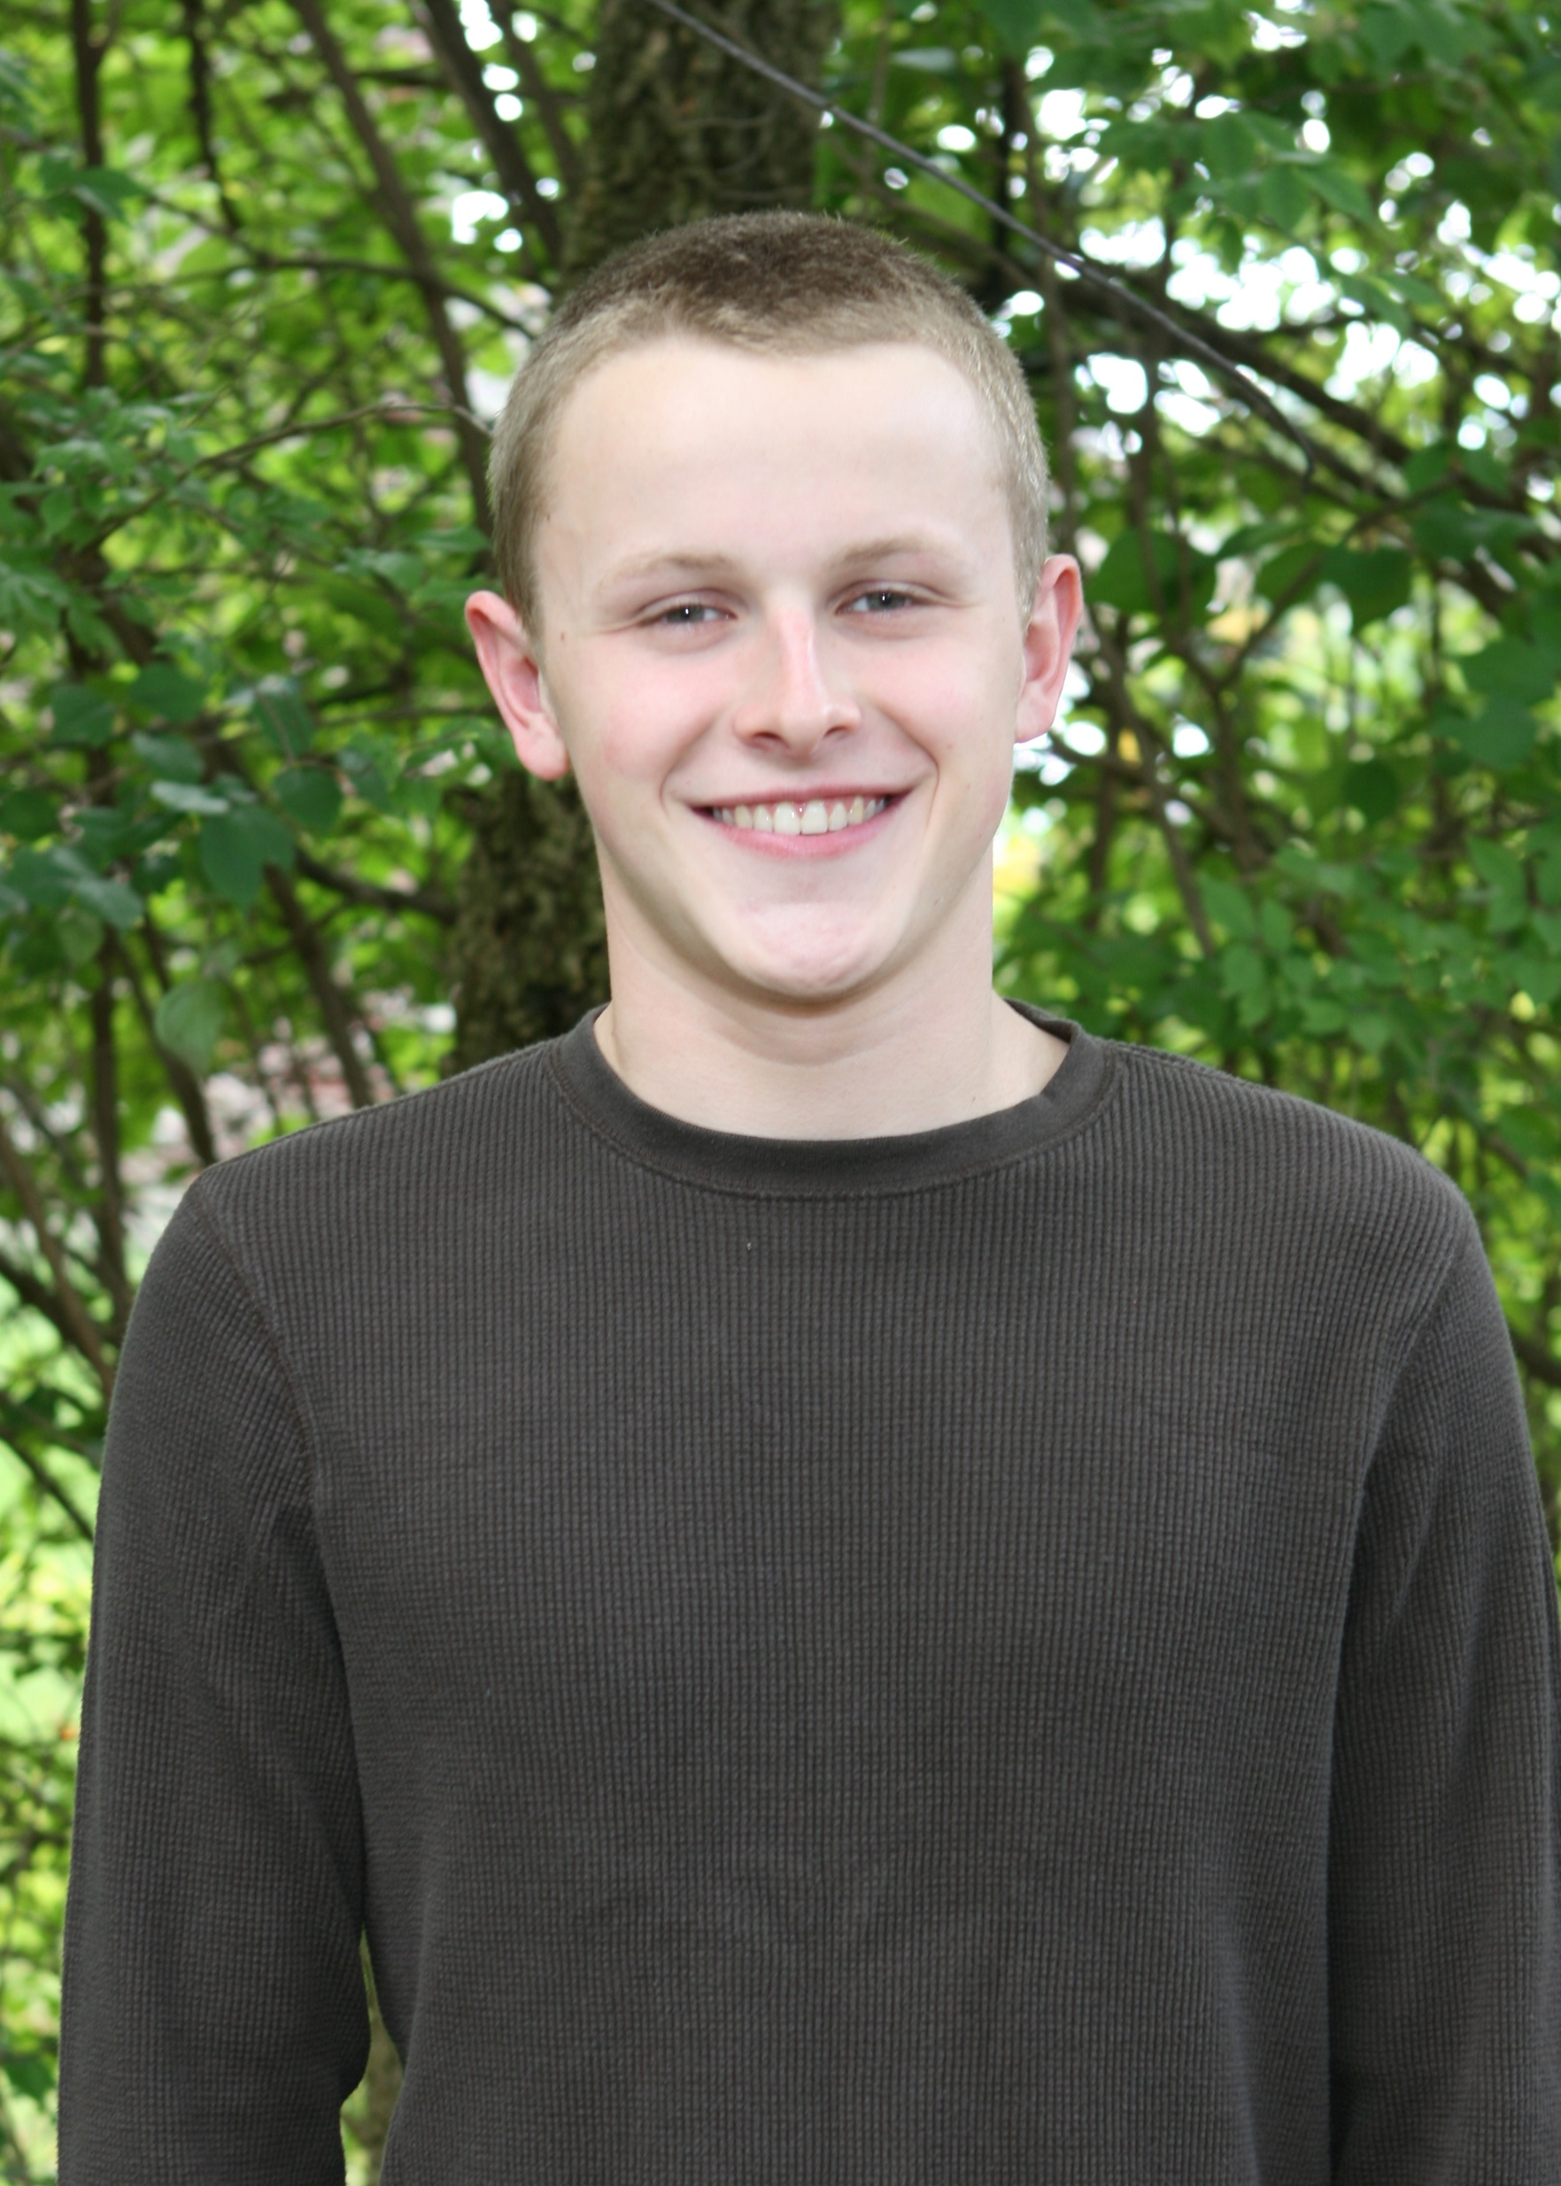
Devin Shanahan

Residence: Vandalia, OH

Year Joined Raiders: 2010
Swimming Competitively Since: 2008

High School: Butler High School
High School Highlights: District qualifier

College: undecided
College Major: Aeronautical Engineering

Favorite Events: 200 Free, 100 Free, 100 Fly
Best Yard Times: 200 Free: 1:48.2; 100 Free: 49.7
Best Meter Times: 200 Free: 2:04.1; 100 Free: 57.7
USA-Swimming Highlights:

Extracurricular Activities: guitar
When I'm not swimming, I like to: hang out with friends
Favorite Food: Chinese food
Favorite Movie: Blazing Saddles
Fondest memory as a member of the Raiders: Makos 2010
What advice I would give to another swimmer: Always give your best

