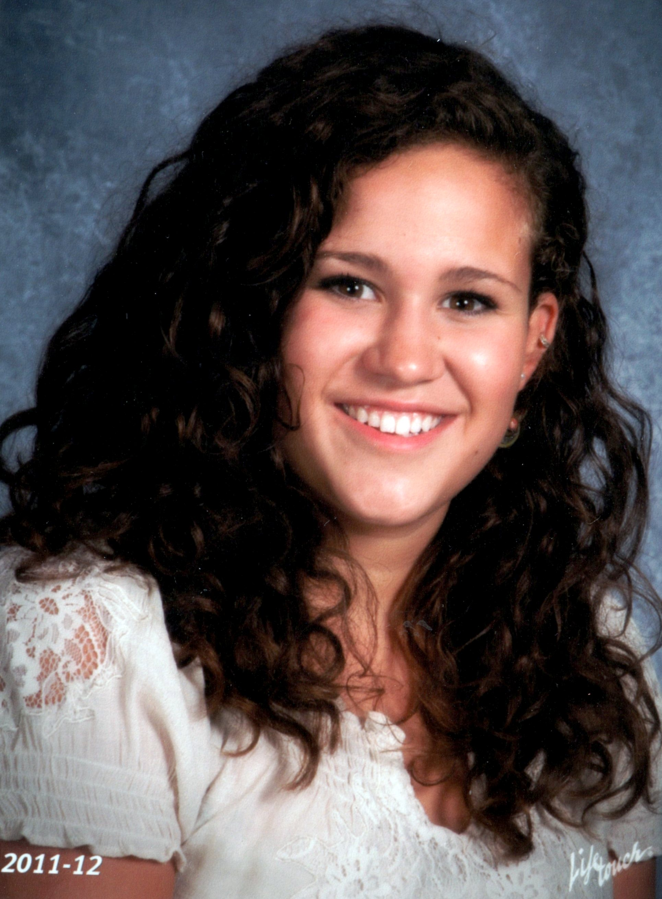
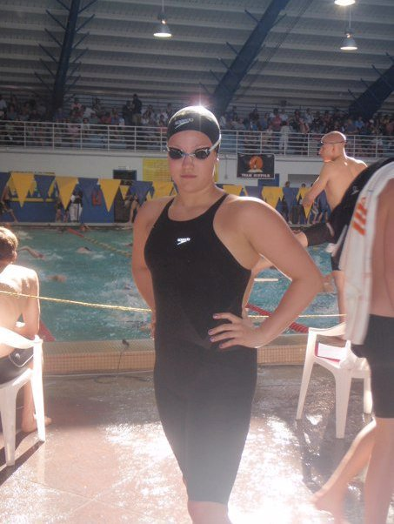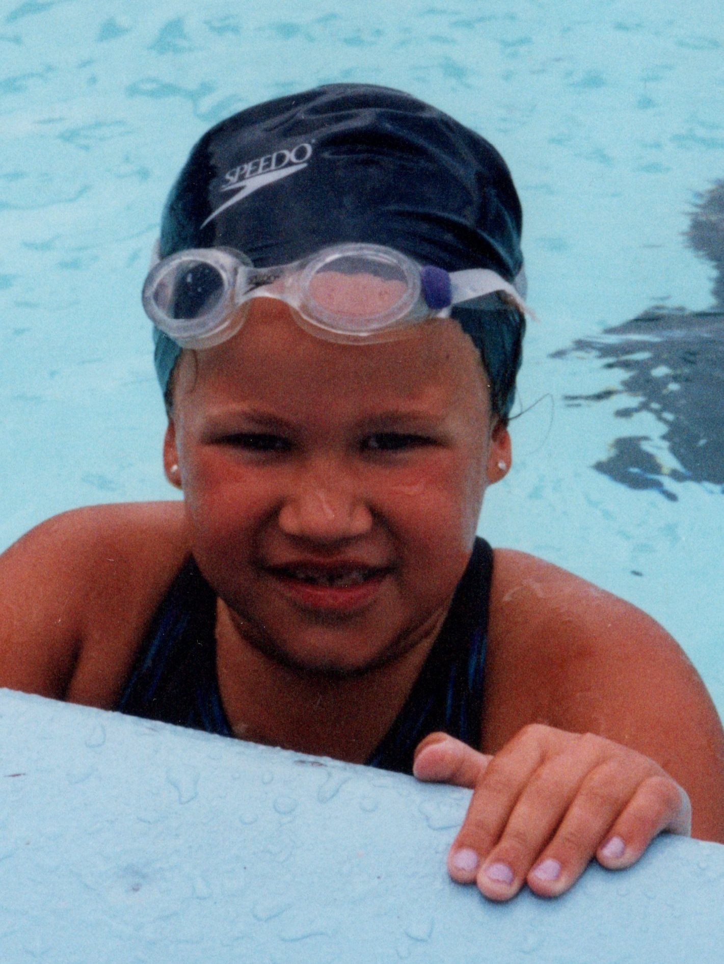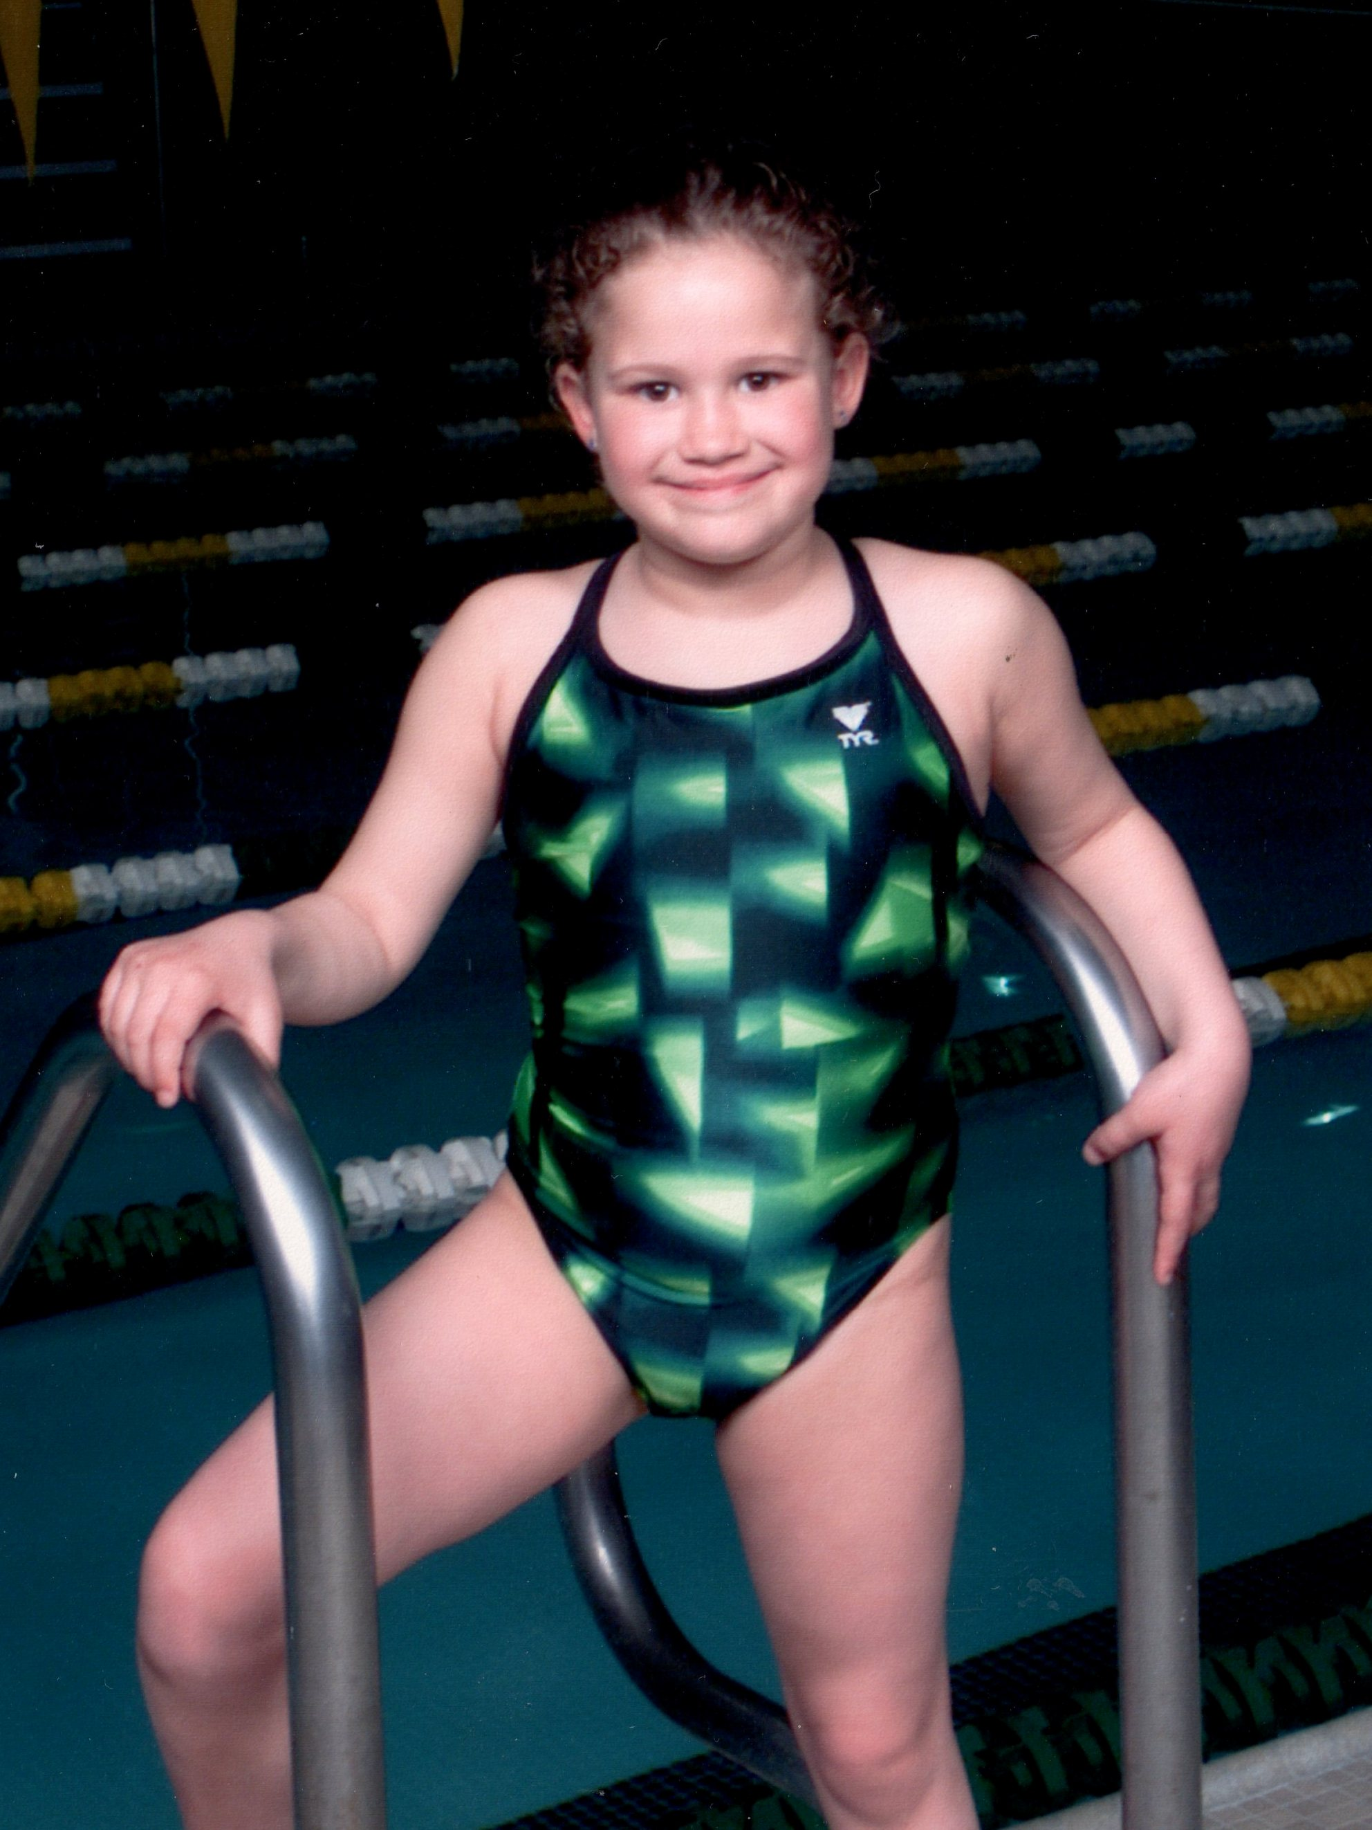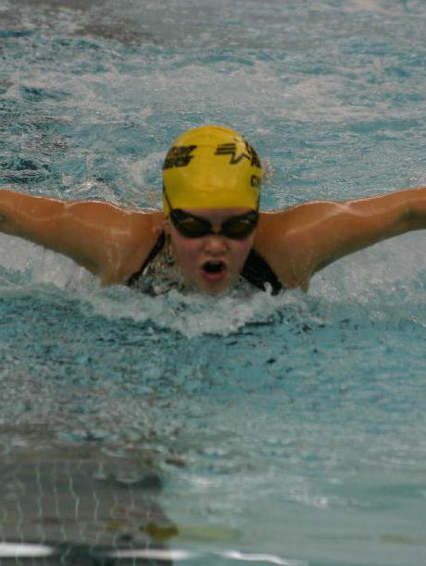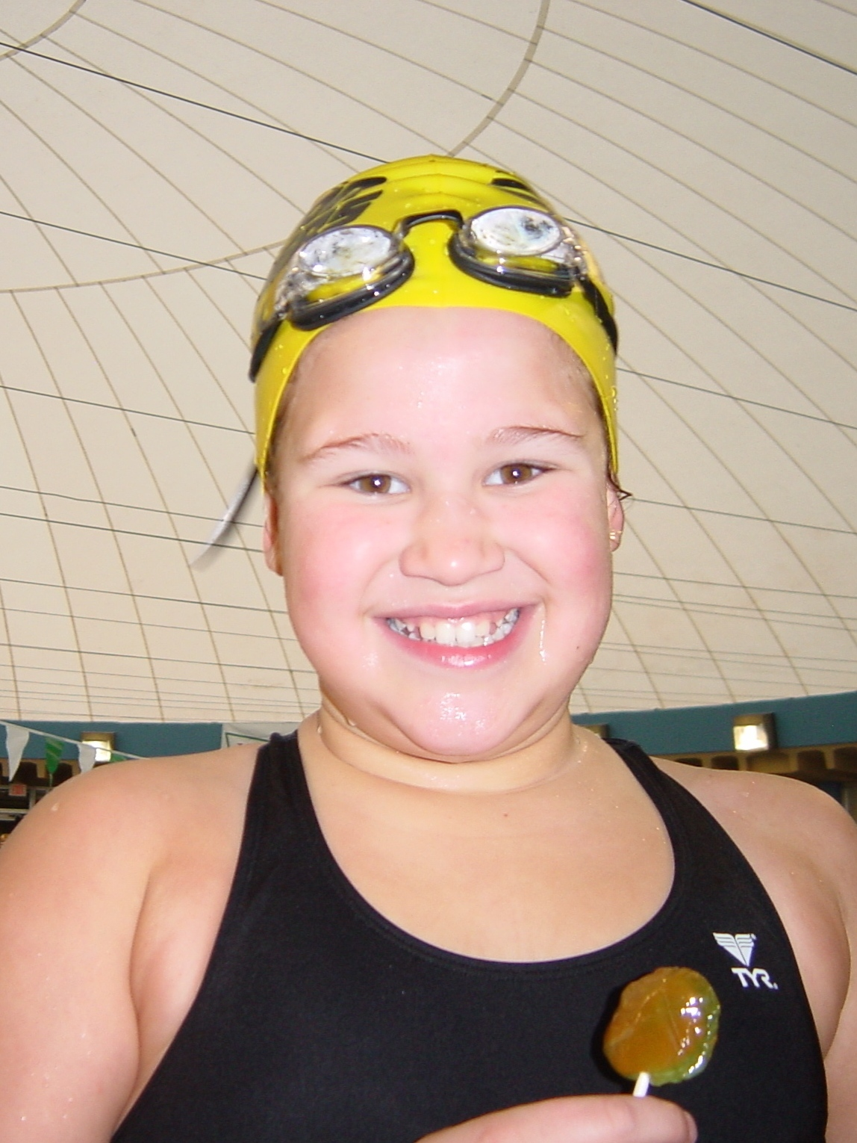
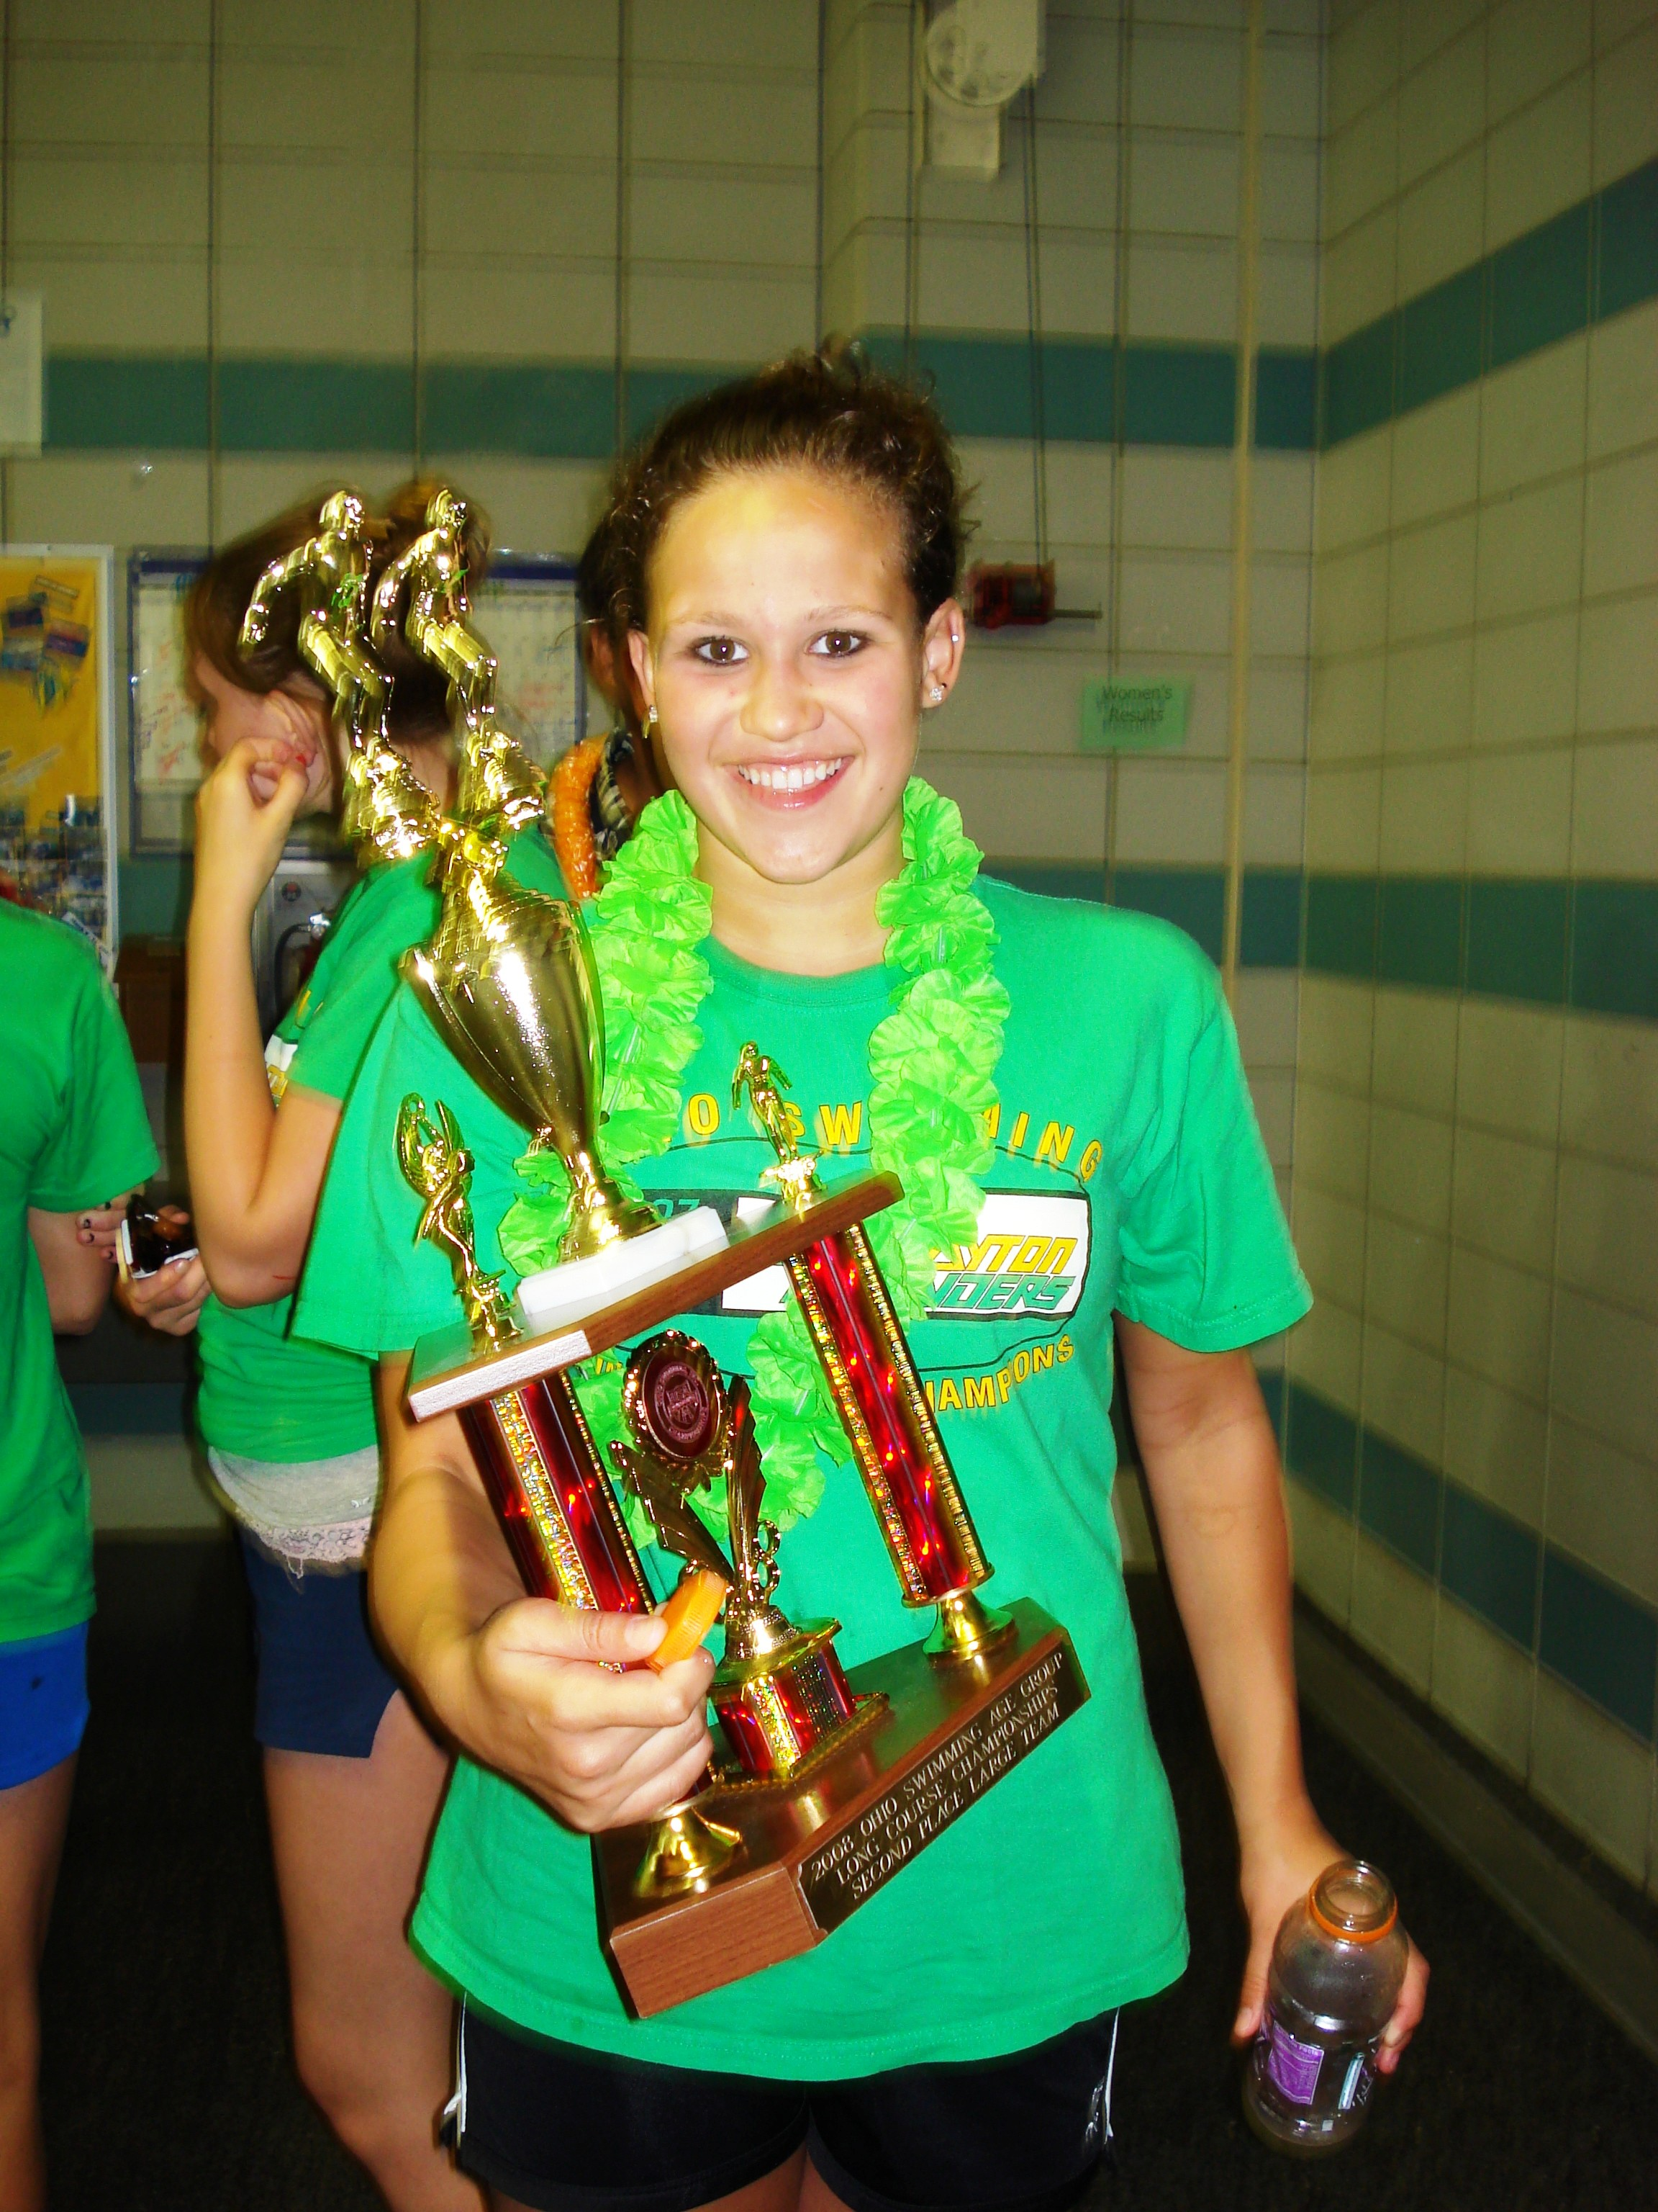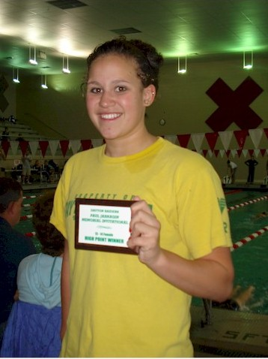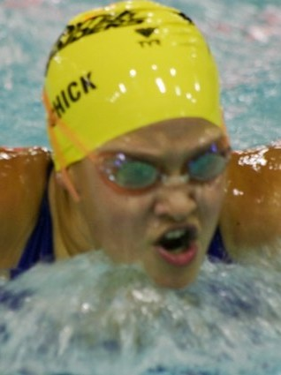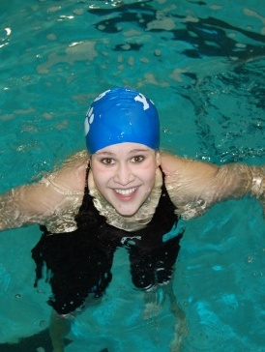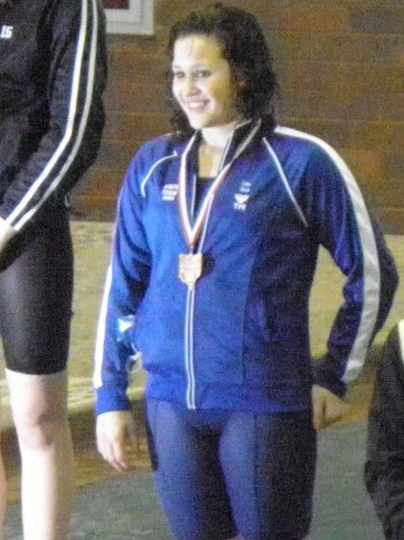

Erika Hunter Chick
Residence: Yellow Springs
Year Joined Raiders: 2000
Swimming Competitively Since: 5 years old (Yellow Springs Seadogs)
High School: Yellow Springs High School
College: Cornell University
College Major: Biology
Favorite Events: 200 Free, 500 Free, 200 Fly, 200 Back
Best Yard Times: 200 Free (1:51.61) 500 Free (4.59.40) 200 Fly (2:05.49) 200 Back (2:07.93), 100 Fly (58.90) 1650 (17:17.32) 100 free (53.90)
Best Meter Times: 200 Free (2:08.54), 400 Free (4:35.51) 200 Fly (2:26.81) 100 Free (1:00.53)
USA-Swimming Highlights: 2008 OHIO LC Age Group Champion 200 free and 100 free,
USA Scholastic All American 2010/2011 with GPA 4.0 recognition and 2010 High Altitude
Olympic Training Center Participant
High School Highlights: Ohio Buckeye Metro Female Swimmer of the Year 2010-2011 , 2010-2011 All Ohio Award, 200 free/500 free, Sectional Meet Record Holder, (2009, 2010, 2011) Sectional Champion 200/500 free, (2009, 2010, 2011) District Champion, 200/500 free, District Record holder, Top 8 finisher Ohio High School State Meet (2009, 2010, 2011)200free/500 free, Yellow Springs High School Record Holder: 200 Free, 500 Free, 100 Back, 200 Back, 200 Fly, Wittenberg University Pool Record-500 Free
Extracurricular Activities: National Honor Society, School Leadership Council, School Forest, NCCJ (National Conference for Community and Justice), ANYTOWN Participant, Chem-Buddies.
When I'm not swimming, I like to: Hang out with friends, listen to music, be involved in school and community activities, and School Forest.
Favorite Food: Indian
Favorite Movie: She’s the Man, Step Brothers
Fondest memory as a member of the Raiders: Summer of 2008, Silver Group, Zones 2008
What advice I would give to another swimmer: Have fun, and stick with it!

