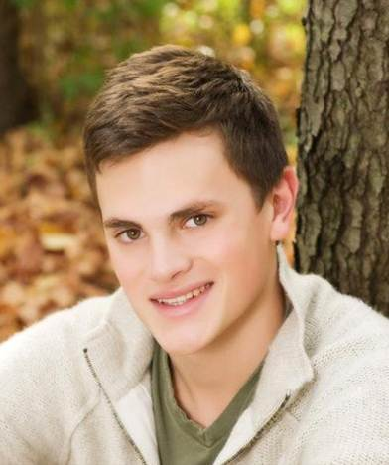
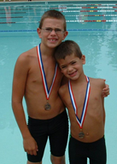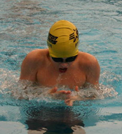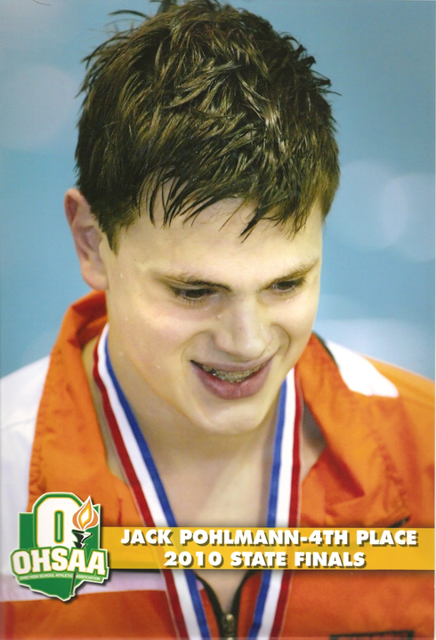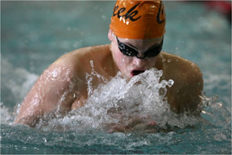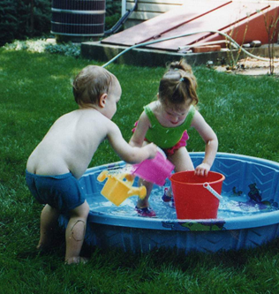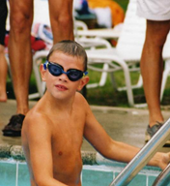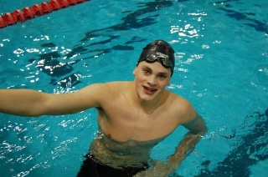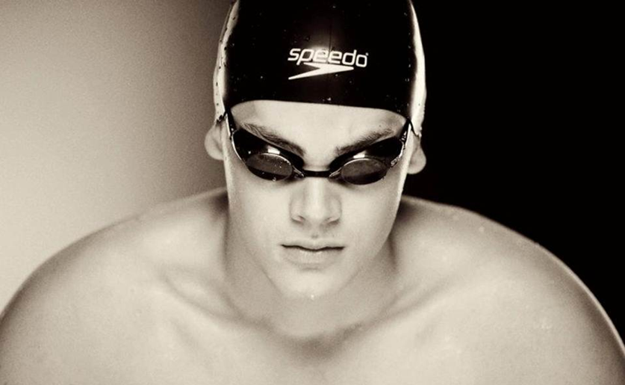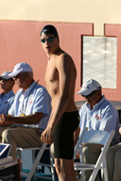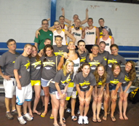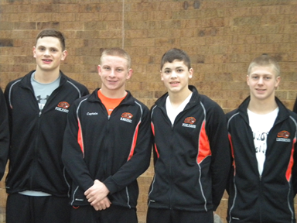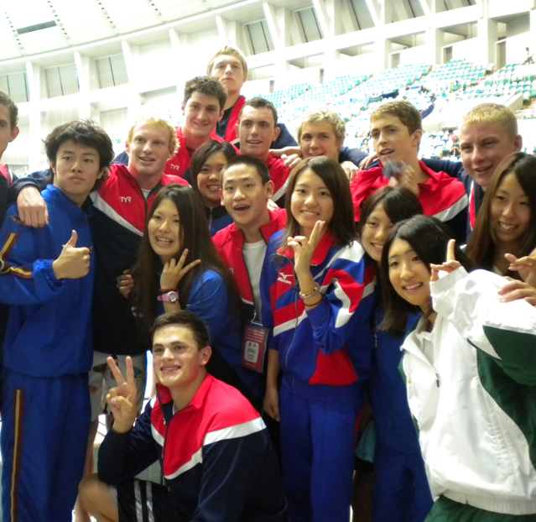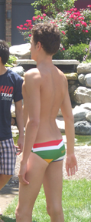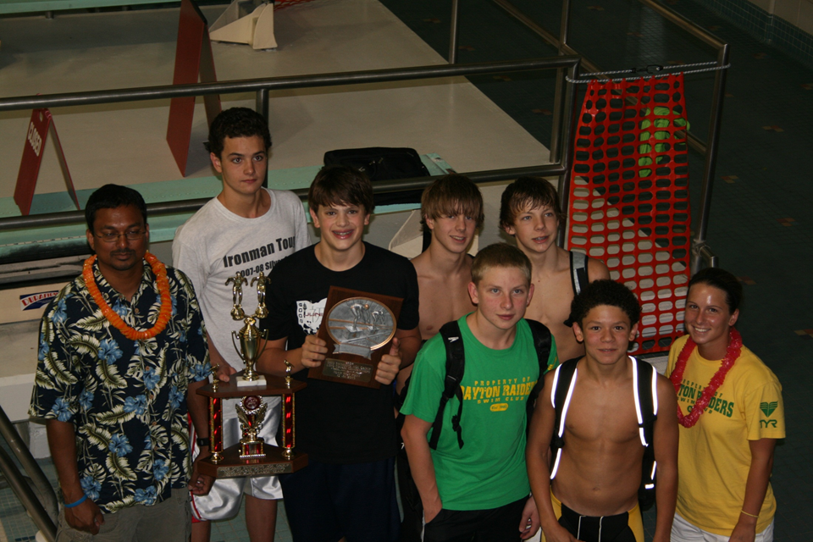
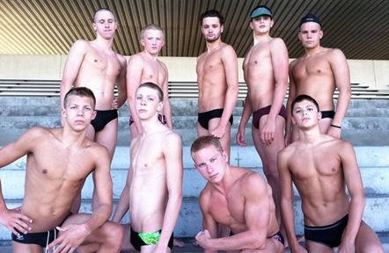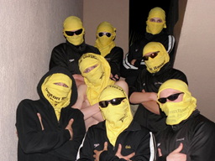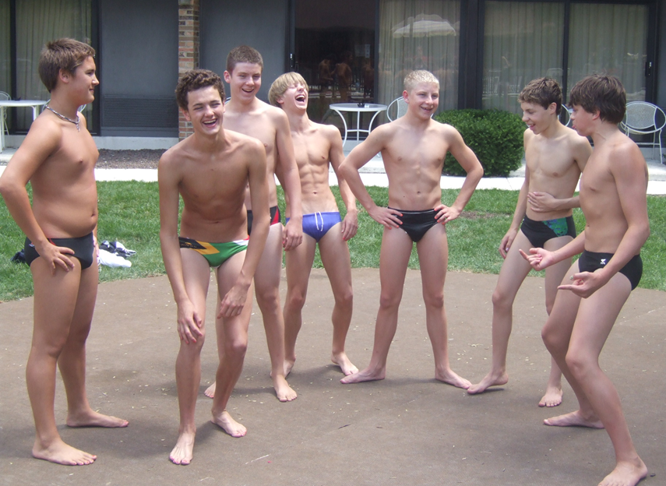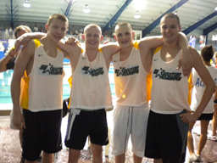
Swimmer: Jack Pohlmann
Residence: Beavercreek
Year Joined Raiders: 2004
Swimming Competitively Since: age of 8
High School: Beavercreek High School

College: Princeton University
College Major: Physics & Economics

Favorite Events: 100, 200 Breast, 100 Free
Best Yard Times: 100 Breast (56.11), 200 Breast (2:02.83), 100 Free (47.44)
Best Meter Times: 100 Breast (1:04.97), 200 Breast (2:24.71), 53.85 (100 Free)

USA-Swimming Highlights: Winning JO’s individually and as a team, qualifying for the NCSA All-American Japan Team, seeded 70th in 400 med relay at Juniors Nats in Palo Alto and finishing 7th overall, USA Scholastic All-American
High School Highlights: Making State as a Freshman
Extracurricular Activities: Swimming…? Science Bowl, NHS President, Pysics Bowl, Real World Design Team

When I'm not swimming, I like to: Eat. Sleep. Softly cry in corners where no one can hurt me.
Favorite Food: Chipotle, Sushi
Favorite Movie: Zoolander, Pulp Fiction
Favorite Line from a movie: “Bring out the Gimp…..the Gimps sleepin‘….well, I guess you’ll just have to wake him up now, won’t you.”
Fondest memory as a member of the Raiders: Megazones (Brett passing out while cheering), NCSA Junior Nationals, the mysterious faces Kevin makes

What advice I would give to another swimmer: Always remember where you started and how far you’ve come, it’s motivating.

