Convention Report
Angela Monty
September 11-14

“Mindset” Trevor Moawad USA Swimming Keynote:
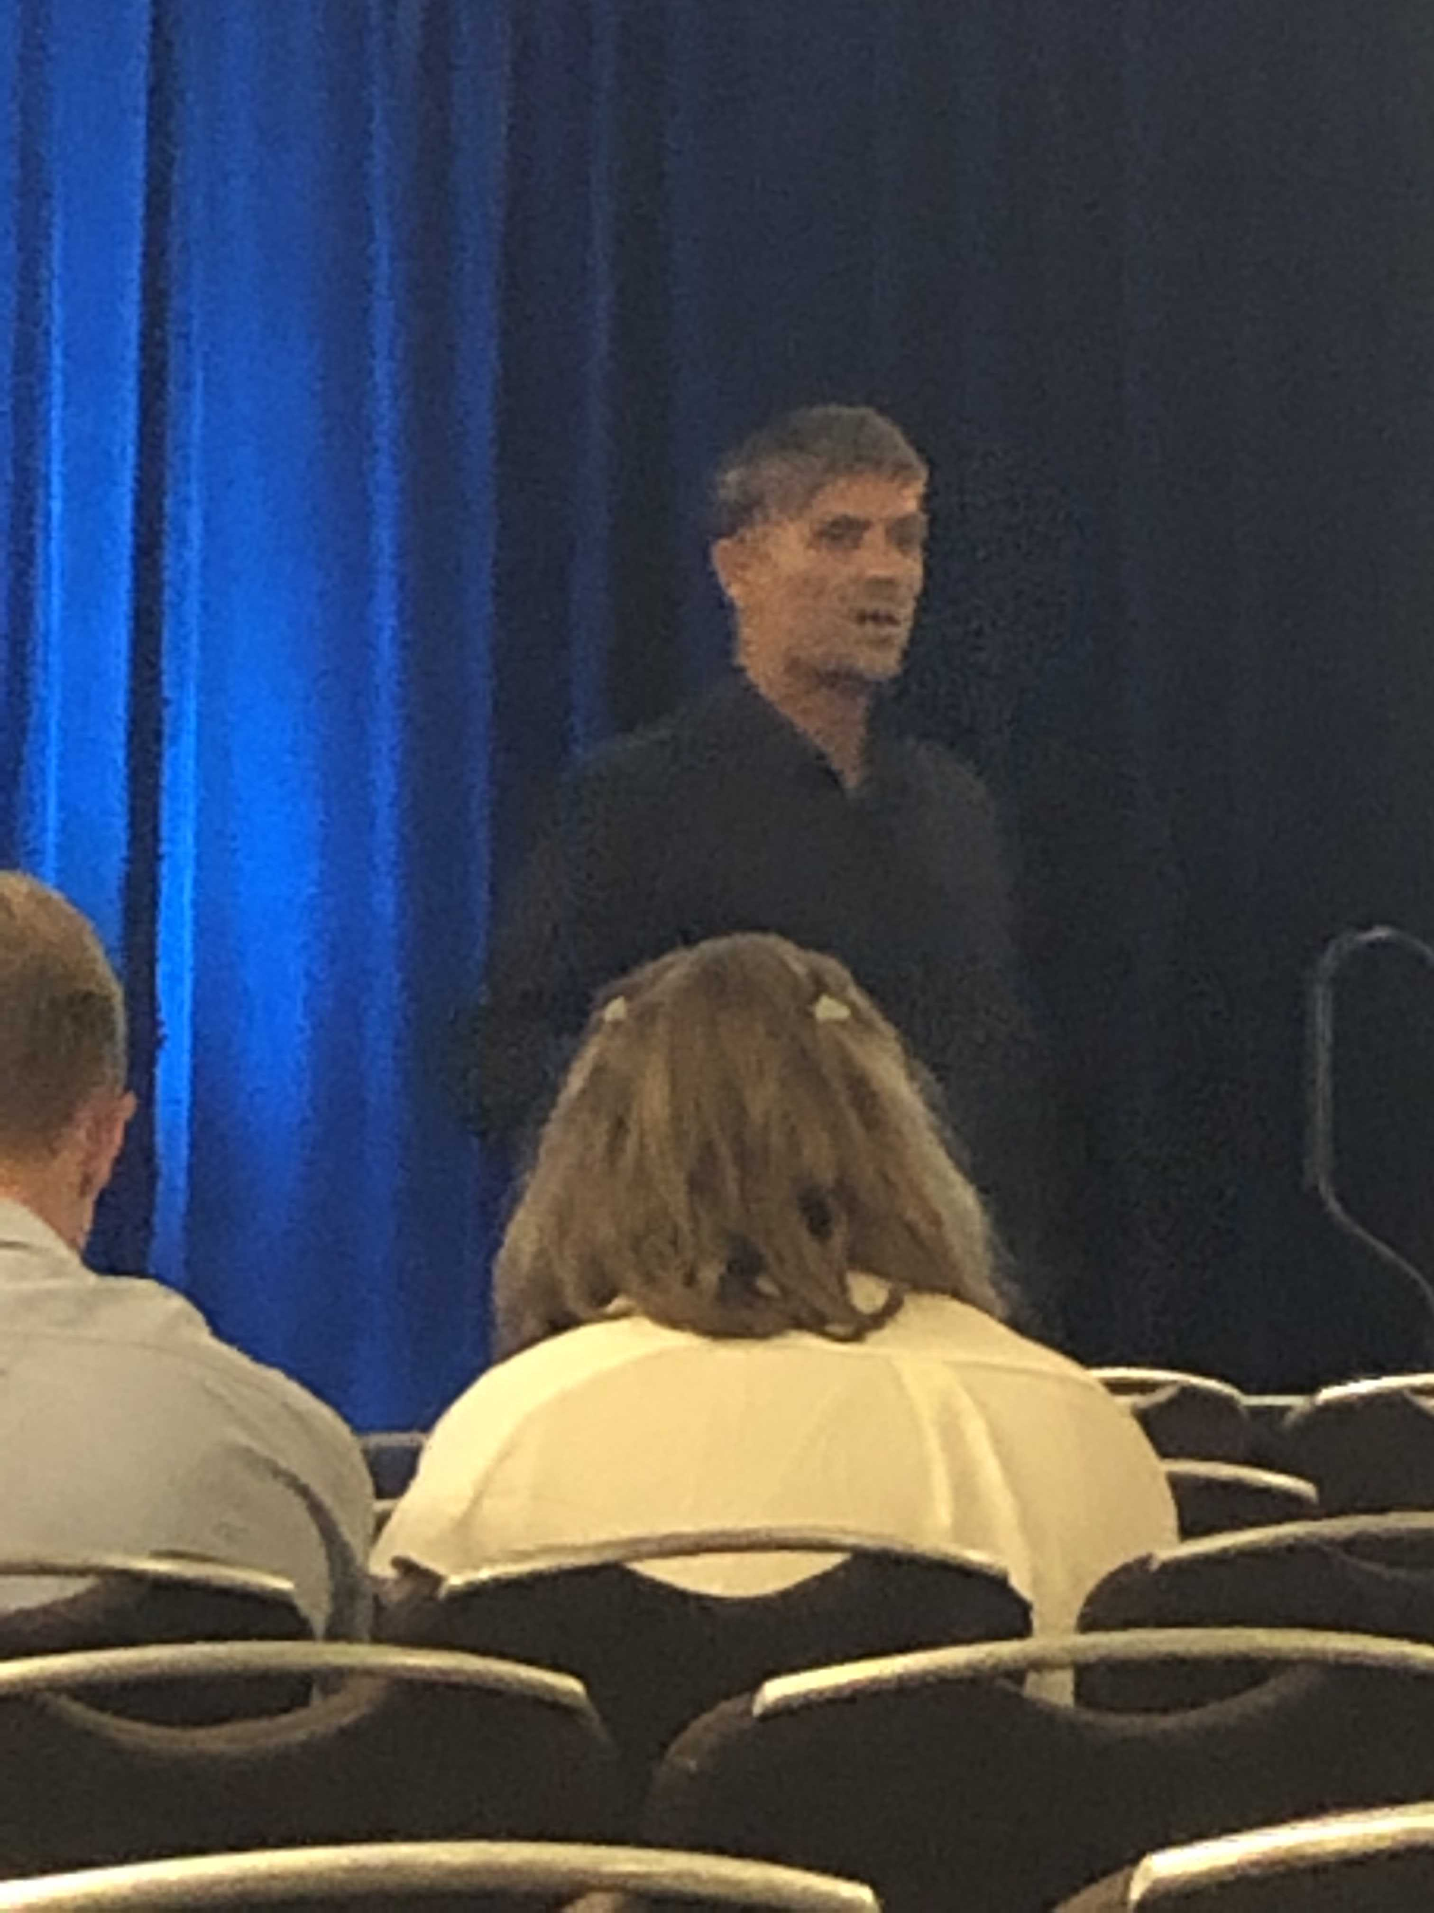

Mental Conditioning/ Sports Psychology that works with NFL players
Developing every aspect of the athlete.
How you think effect show you feel which effect how you behave

Successful people do what unsuccessful people do not like to do.

18 years old was diagnosed with cancer.
Father was a founder of Chicken soup from the soul series.

Doesn’t talk about positive thinking. But the ability of removing the negative without ever teaching any alternative.

Director of performance of IMG academy. Hogwarts for athletes.

When you are green you grow, when you are ripe you rot.

The world needs average people by average behavior. Great performers become great through great behaviors.

Learning how to do simple better.

Aggregate of marginal gains. How do we make micro improvements across the organization?
We all have access to the same insights, but am I open to give those insights access to me?

We measure ourselves by who we think we are not. What they know they can become based on what the world thinks they can do. If I am 5’9” but the world thinks I have to be 6’$” then I have to find a way to be 5’9” and aspire to do big things.

Matthew McConaughey- Pressure is a Privilege Speech. https://www.youtube.com/watch?v=zSGoJk-D1LQ

Give your obstacles credit.
Fear is a good thing because it increases the need to overcome the fear.
Declare your fear. Admit it and give them the credit they deserve. Don’t deny they are there so you can find the courage to overcome them or to see clearly that they are not worth prevailing over.
If you validate them and call them out- You get more respectful of yourself and that which you fear.

Behavior is more powerful than emotion. If you align yourself with incredible behaviors over time, you will become incredible (Steph Curry). If you align yourself with average behaviors over time you will become average (Tiger Woods).

Success is found in the minimal gains not the big gains.

Don’t focus on winning cause winning is deceptive. If you perform well over long periods of time you will win.

Life is a combination of decisions, free will and behavior.

If you want to be good- the formula exists. Nothing wrong with not following the formula but it is a waste of time if you don’t follow the formula.

You make time by making time.

Unconsciously incompetent- don’t know that you don’t know.
Consciously incompetent- know that you don’t know.
Unconsciously competent- don’t know that you know.
Consciously competent- know that you know.

Truths that are objective whether you like the person telling you or not.

- How we interact with other people.
- Two things employers look for: 1. Mental approach and 2 ability to interact with other people
- Fans point out what everyone can see.
- Coaches and educators have to be able to change things in real time to make an impact

- Ability to think about the right thing at the right time. Game changer.
Game plan is what you have to solve for yourself.

Why customers quit
3% move away/go out of business.
9% leave for competitive reasons.
14% don’t come back because of product dissatisfaction.
25% develop other friendships.
49% quit because of the attitude of indifference toward the customer by one or more of the employees.

Negative Thinking:
Mind is like gravity- don’t see it.
Gravity doesn’t wait for you to study it- it still impacts you.

A universal truth is always true.
In a game you can say over 100,000 things to yourself.
Words are three dimensional
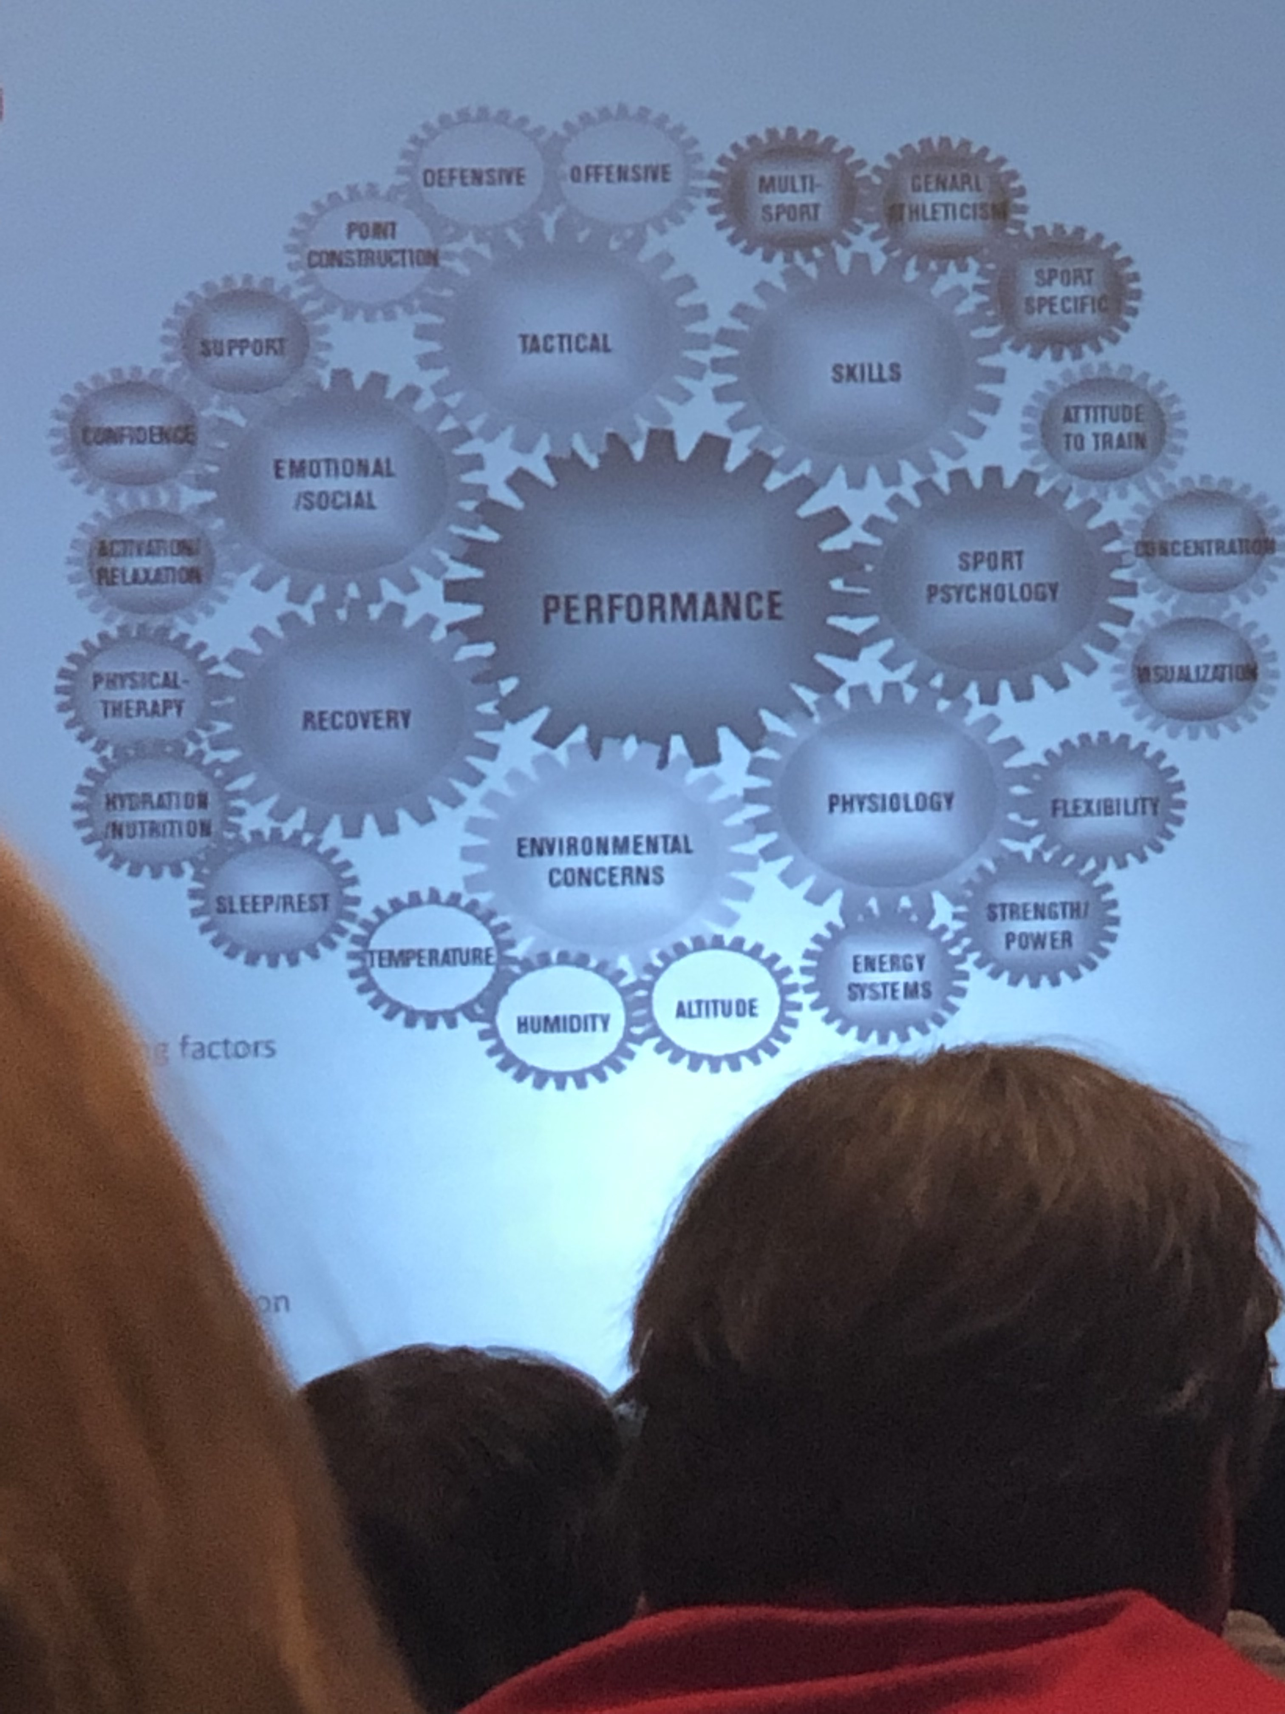

Law of substitution means at any give moment as soon as I focus my thought on one thing that is what I think about.
Mind is governed by thinking.

1988 Nike was a 1.2 million dollar company chasing Reebok. They cloned the phrase “Just Do It” and have stuck with it since.

My influence is 10X more powerful on the inside than anyone else on the outside. If you are not succeeding it is because of you.
Environment doesn’t make us, we make us.

10X more powerful if you say it out loud instead of just thinking it in your mind.
You are always in control of what you say outlaid. Negativity is 4-7X the multiple more powerful so 40-70X more powerful just by saying it outlaid.

Absence of negativity. Negative speaking does not help you perform better.
40-70 times of what you don’t want to happen with happen.

1/10 the influence on the people around you that can be contagious. What is your language? How do you speak? What is coming out of your mouth?
You are the ad campaign.
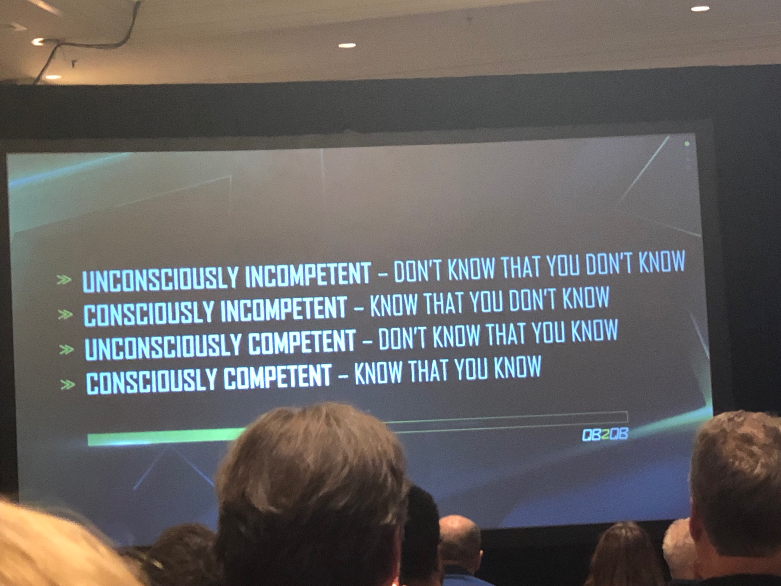
The Power of Language
A thought process where people tend to find the worst in everyone or reduce their expectations.
I Am Not a Safe Place.

Negativity articulated int he world of sports.
Your words matter!

What you are willing not to do: impacts your life.

Control what you can control. You can always control what you say. Don’t increase positivity just remove negativity. Set Simple and Achievable Goals:
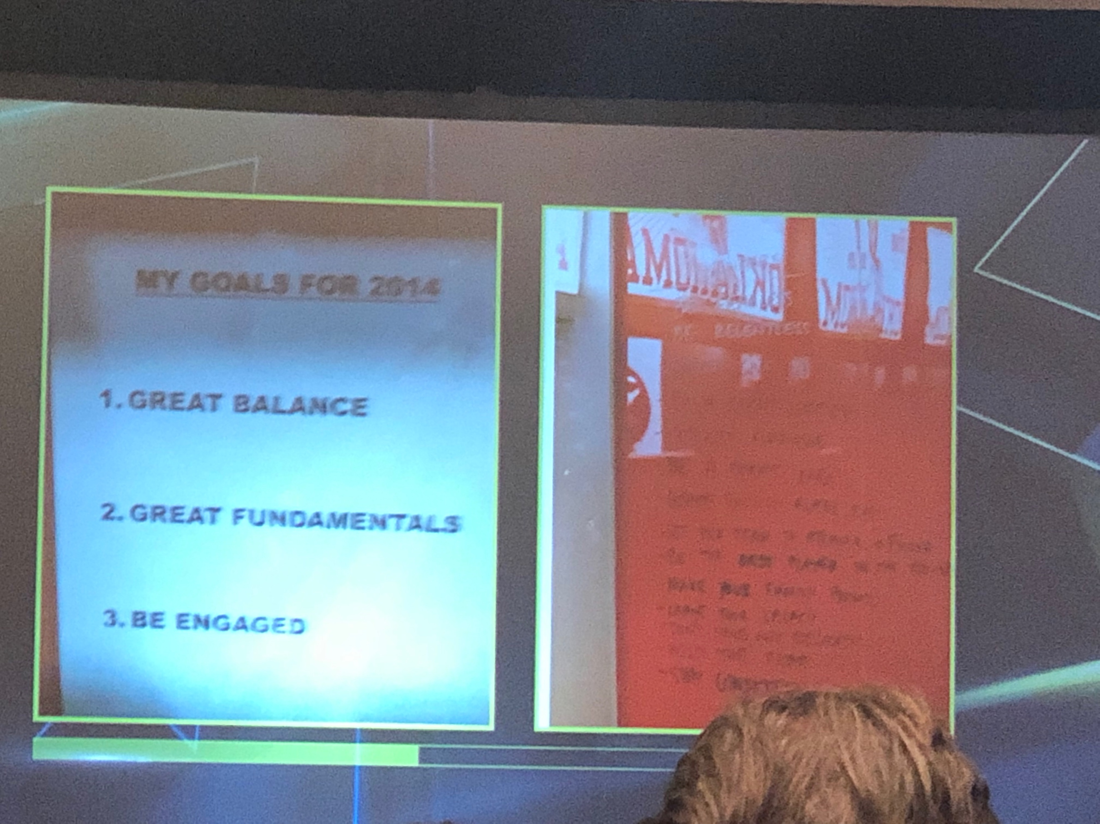
Pressure is a privilege
expectations should be embraced. How you manage that and getting effectiveness of players out is important.
Potential vs effectiveness

Champions take chances and pressure is a privilege.

Have to be thankful for the pressure. It is a blessing. Use it to motivate yourself instead of letting it weigh you down.

Pressure is a neutral term.
Be prepared. Don’t like to be caught off guard.
Pressure is a reflection of ambition!

There is a rhythm to all greats in everything

Be a doer
Seek responsibility
Leadership is wanting the responsibility to be on your shoulders
Leaders are heat seekers not heat deflectors.

If you are waiting for something on the outside to change something from the inside, you are taking control away from yourself

Your life changes when you start acting in alignment with the goals you want.
Behaviors give you the best chance to overcome everything.

Central Zone Meeting
* USA Swimming is going to propose an increase in the club fees from $70-$250.
* This will impact the WI LSC because we currently have a structure for club fees based on registration time and attendance at the annual meeting.
* Questions were posed regarding a structure for small teams versus large team fees and for hardships. Also for seasonal versus annual fees. Vote will take place on Saturday sat HOD.

John Bradley reflected on his time as the Coach Director for the Central Zone and took some time to talk about trust. The importance of trust as a BOD and representatives are acting on our own best interest.

We need to reestablish our swimming middle class for our club, our zone and our sport.

Zone meet-
- strengthening the communication between the zones.
- NT in distance will be seeded with a real time, if the athlete does not have a time he/she will swim at the slowest non-conforming time.

Mighty Mega Workshop
- Inspirational Leadership
- What skills do you coaches bring to LSC Leadership?
- Getting the right people on the steering wheel and finding new people/ fresh blood.

How do you involve coaches in developing successful LSC programming?
- Advertise on fb and Instagram
- Senior race series, once a month, Sunday dual meets and then a championship meet in Dec only 15 and above. Teams buy into it and they can be part of the series.
- Champ meet stipend in New Jersey

Coach driven initiatives in LSC’s

Decision making model:
- Elements of the model that direct decision-making strategies.
- Produce the tightest quality decision
- Achieve decision in shortest possible time
- Avoid damage to long-term morale
- Increase chances of effective and efficient implementation.

Coach driven initiative
- USA Swimming resources

Wouldn’t it be nice if USA Swimming provided __________ to help us achieve OUR coach-driven LSC initiatives?
- Job Description template
- Board Manuel
- Committee Mandate based on position
- Best practices for board members
- Sending consultants and employees or national teamer to the champ meets
- Air quality education and solutions and focus on the health issues to invest in the longevity of coaches.
- Easily accessible best practices and applicable contacts for each.
- Analytics- access to analytics
- Rural natures of LSC’s to assist those areas by working with those communities. “Swim Deserts”
- Communication in a timely fashion
- Reverent and easily accessible communications
- Updating website information
- More unified Marketing Options

AEC Leadership Committee workshop
- Develop a mindset regarding service on your LSC BOD
- Mission and vision, finances and representing all athletes in your LSC
- 1 tangible goal for your LSC
- Facilitate communication in LSC or non Athletes
- Facilitate communication between LSC’s

Local Swimming Committee
- What are the must haves?
- 1 senior athlete rep and 1 junior athlete rep
- Have to have 20% athlete representative
- No more than 12 members on your athlete committee
- 20% athletes on all other committees.

501c3 status
- Duties of Care, Loyalty and Obedience must be upheld by all LSC Board Members
- Have to uphold Bylaws

Making decisions for your LSC
- Mission and Vision Statements
- Remind mission and vision statement before making any BOD decisions

Why is it important for BOD to consider their Mission and vision statements
Think of a recent decision that your BOD made did they consider the mission or vision statements?
- LSC Training Trip for North Dakota and leading to the Olympic trials

Representing all athletes of your LSC
- Should be intentional about seeking opinions from many different athletes
- Face to face iterations
- Swim Meets
- LSC Non-competitive events
- Club practices
- School

Social media
- Direct messages
- Instagram
- Snapchat
- Facebook
- Twitter polls

Surveys
- Google forms
- Survey monkey

Link surveys to LSC and Club websites and social media sites for maximum responses.

- Barriers
- Athletes have to have 20% representation
- Athletes need to have a voice and speak up even thought adults can be intimidating
- Athletes getting cut out of conversations.

Solution:
- Clearly communicate to athletes that their voice matters
- Athlete to athlete rep communications is very important

How does your BOD/Gen chair help bring out your voice?
- The BOD is good about asking the athletes to speak up.

How can your BOD/ Gen Chair improve this?

What do you athletes do really well?

- In Wisconsin- do our Officials need include athletes on committee calls? (Confirm)

Fiduciary duties as LSC’s
- Duty of Care- you are a steward to your LSC’s funds!
- Budgeting process
- Remember your mission and vision statement
- Ask for help when you need it.
- Athletes need to be cognitive of budgetary needs in order to request $ for programs.

Making it Happen
- Determine what you want to accomplish its desired impact, and how you will measure success.
- Determine the amount of money needed for your initiative, and where the money will come from.
- Consider costs and benefits
- Present your request/proposal confidently to your LSC Board and Finance Committee
- If your initial request is not approved in full, negotiate! Work to compromise and consider avoidable costs.
- Carry out your plan! Make it happen!!

LSC Example:
- What is the purpose of this event?
- What will you do with the money?
- Where will you be hosting the event?
Beside to have an answer to these three questions prior to asking your board for funding

Biggest expenses in LSC and Biggest source of revenue
- Operations expenses
- Awards expenses

Putting everything together!
- Propose registration and potential projects for your Board and Committee
- Play leading role in carrying out projects
- Ask for support from others when needed
- Your are a full fledged board members - don’t expect to be told what to do!
- Critical thinking required!

Present your idea to appropriately and confidently and to the right people

Discuss with Board Members prior to the meeting

Be Prepared to and answer questions.

Goal Setting:
Write down 1 specific goal or action item to which your are going to commit to driving home in your LSC.

- Safe Sport Mondays on social media
- Camp or clinic idea
- Growing the Scholarships

Further resources
Not an exhaustive list of needs or tools for your LSC
- Older athlete reps
- LSC and Board members
- Your table discussion leader
- AEC Cluster leader
- USA Swimming website and many others.

Zone Diversity Select Camps Recommendations for Future Camps by USA Swimming
- Zone coordinator - Time standard of one 13-14 AA time standard or an IMX score of 2500.
- Age groups are 13-16.
- Times have to be used from the previous year to qualify because the championships for that year will fall after the camp date. No recommendations on a time window that they should be using.
- Athlete is going to document their best times. It will be up to the zone to make the decision.
- Outreach athletes with one of the above is automatically brought in for participation.
- The application process will open in February and close in March.

