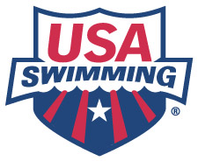Top 10 Sources of Fun for Age Group Swimmers

From: 1998 Study by Dr. Suzy Tuffey, USA Swimming
Kids Tell Us What Is Fun About Swimming

Coaches may assume that when age group swimmers talk of fun, they are talking about playing games and goofing around rather than productive, focused practices. However, in this study swimmers related a much different concept of fun.

- Being with friends*

- Compliments and encouragement from the coach

- Being known as a good swimmer

- Winning races

- Getting in shape

- Varied workouts

- Relays where the team comes together*

- Feelings of accomplishment

- Cheering for each other/Coming together as a team*

- Trying to improve my times/ Being on a team*

Note the importance of the Team/Social aspect of fun in swimming (*4 of the 10 factors tied into this). In fact, ‘being with friends’ was rated as the most important source of fun. While it may seem that these sources of fun will automatically be realized since the athletes are ‘on a team’, this is not necessarily the case. Coaches should consider purposely fostering a team environment since athletes indicate that being with friends and being part of a unified team are significant sources of fun.

