USA SWIMMING
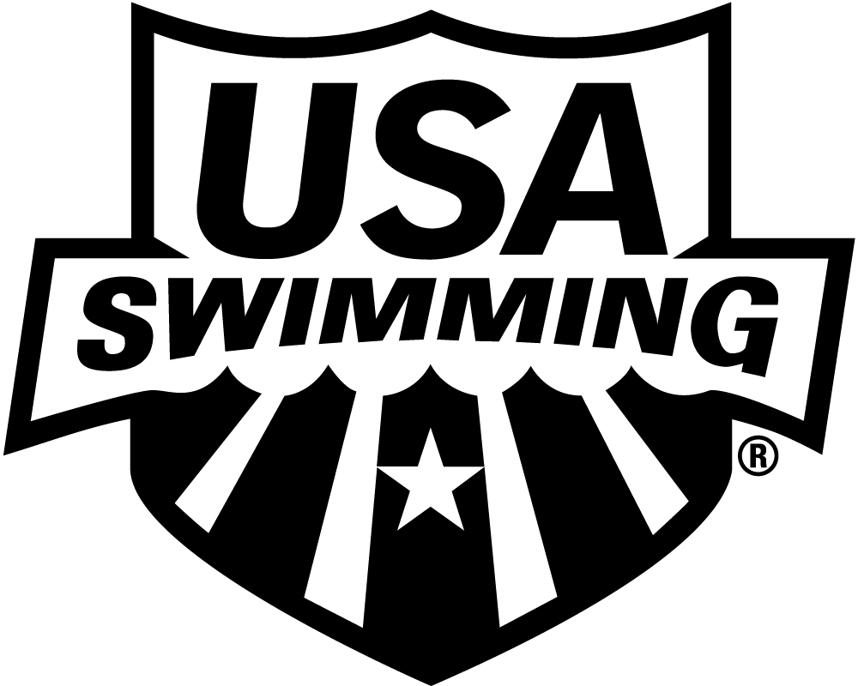

2022 APPRENTICE OFFICIAL APPLICATION INITIAL TRAINING

LSC: MIDWESTERN SWIMMING (MW) SESSION DATE:

PLEASE PRINT LEGIBLY COMPLETE ALL INFORMATION TO ENSURE THAT CONTACT INFORMATION IS CORRECT AND UP TO DATE:

LAST NAME LEGAL FIRST NAME MIDDLE NAME

Have you ever been a member of USA Swimming under a different last name? If yes, please provide that name:

Previously registered with USA Swimming. Yes No If registered in a different LSC, which LSC:

PREFERRED NAME DATE OF BIRTH (MO/DAY/YR) SEX (M/F) CLUB CODE CLUB NAME

(Bill, Beth, Scooter, Liz, Bobby) If not affiliated with a club, enter “Unattached”

MAILING ADDRESS

CITY STATE ZIP CODE

–

AREA CODE TELEPHONE NO. AREA CODE TELEPHONE NO. MEMBER’S E-MAIL ADDRESS

HOME MOBILE

THIS APPRENTICE OFFICIAL STATUS EXPIRES 60 DAYS FROM THE DATE OF THE INITIAL TRAINING SESSION. CONTACT YOUR LSC OFFICIALS CHAIR FOR FURTHER INSTRUCTIONS.

I acknowledge that I have reviewed and agree to abide by rules and regulations of the Minor Athlete Abuse Prevention Policy.

LSC OFFIICIALS CHAIR:
MAIL OR EMAIL APPLICATION TO:

LSC Registrar Contact Info: LSC Officials Chair Contact Info:
Scot Sorensen Debra Pearson
110 N 248th Cir dhpjrp@gmail.com
Waterloo NE 68069
scotsorensen@cox.net

