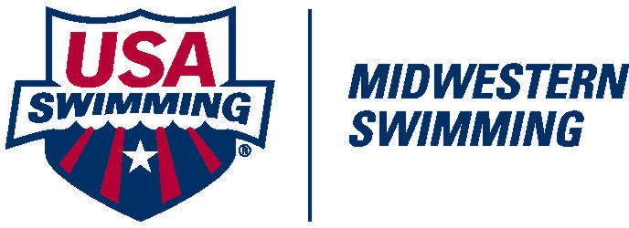
Safe Sport Guidelines

The following guidelines will be followed by all clubs requesting new or renewal registration with Midwestern Swimming and USA Swimming. These guidelines mirror Articles 304 and 305 in USA Swimming Rules and Regulations. Club applications will not be processed without a signed guideline document.
- Parents will be encouraged to appropriately support their children’s swimming experience.
- All swimming practices will be open to observation by parents.
- Two-deep Leadership: Every attempt will be made to have one coach member and at least one other adult who is not in the water present at all practices and other sanctioned club activities whenever at least one athlete is present. Clubs and coaches should evaluate their seasonal plans and map out how to best accomplish this extremely important guideline.
- Open and Observable Environment: An open and observable environment will be maintained for all interactions between adults and athletes. Private, or one-on-one situations, will be avoided unless they are open and observable. Common sense should be used to move a meeting to an open and observable location if the meeting inadvertently begins in private.
- Coaches will not invite or have an athlete(s) to their home without the permission of the athlete’s parents (or legal guardian).
- During team travel, when doing room checks, attending team meetings and/or other activities, two-deep leadership and open and observable environments will be maintained.
- Athletes will not ride in a coach’s vehicle without another adult present who is the same gender as the athlete, unless prior parental permission is obtained.
- During overnight team travel, if athletes are paired with other athletes they shall be of the same gender and should be a similar age. Where athletes are age 13 & Over, chaperones and/or team managers would ideally stay in nearby rooms. When athletes are age 12 & Under, chaperones and/or team managers may stay with athletes. Where chaperones/team managers are staying in a room with athletes, they will be the same gender as the athlete and written consent should be given by athlete’s parents (or legal guardian).
- When only one athlete and one coach travel to a competition, at the competition the coach and athlete will attempt to establish a “buddy” club to associate with during the competition and when away from the venue.
- Communications between non-athlete adult members and athletes will not include any topic or language that is sexual or inappropriate in nature.
- Non-athlete adult members shall respect the privacy of athletes in situations such as changing of clothes, showering, etc. Non-athlete adult members will protect their own privacy in similar situations.
- Relationships of a peer-to-peer nature with any athletes will be avoided. For example, coaches will avoid sharing their own personal problems with athletes.
- Coaches and other non-athlete adult members will avoid horseplay and roughhousing with athletes.
- When a coach touches an athlete as part of instruction, the coach should do so in direct view of others and inform the athlete of what he/she is doing prior to the initial contact. Touching athletes should be minimized outside the boundaries of what is considered normal instruction. Appropriate interaction would include high fives, fist bumps, side-to-side hugs and handshakes.
- Coaches will not initiate contact with or accept supervisory responsibility for athletes outside club programs and activities without the permission of the athlete’s parents (or legal guardian).
- Coaches will not engage in sexual intimacies with a former athlete for at least two years after the cessation or termination of professional services.
My signature below represents understanding and agreed compliance with these guideline policies as a condition of club registration.

_______________________________ ___________________ ___________________
Signature of Club President Club Code Date

