HACY WRITTEN PERMISSION FOR A MENTAL HEALTH CARE PROFESSIONAL OR HEALTH CARE PROVIDER TO HAVE ONE-ON-ONE INTERACTION WITH A MINOR ATHLETE

HAMILTON Y AQUATIC CLUB
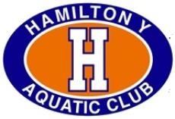

I, , legal guardian of , a minor athlete, give express written permission, and grant an exception to the Minor Athlete Abuse Prevention Policy for , a mental health care professional and/or health care provider, to have a one-on-one interaction with (minor athlete) in conjunction with participation in the sport of swimming on (date) from am/pm to am/pm.
I acknowledge that this one-on-one interaction may be a closed-door meeting, provided that the door remains unlocked; another adult is present at the facility; and the other adult at the facility is advised that a closed-door meeting is occurring. I further acknowledge that this written permission is valid only for the dates and location specified herein.

Legal Guardian Signature:
Date:

