Worthington

Swim Club



TEAM HANDBOOK

2007-2008



Worthington Swim Club Booster Board of Directors

2007-2008

Responsibility | Board Member | Phone | Email
 | OFFICERS
President | Bill Wachtel | 614-799-2629 | wwachtel@columbus.rr.com
Vice President | Charlie Oellerman | 614-885-9181 | coellermann@jonesday.com
Secretary | Christine Johnson | 614-885-2442 | kjohns11@columbus.rr.com
Treasurer | Ron Smith | 614-880-0822 | tcipcolbw@aol.com
 | COMMITTEES
Director of Meets | Tim McGhee | 614-430-3743 | t_mcghee@sbcglobal.net
Entry Fee Account | Beth Parks | 614-847-7424 | Beth-parks@fccourts.org
Hotline | Penny Boes | 614-846-1293 | worswimclub@aol.com
Home Meet Ent. | Phil Stanger | 614-431-6436 | ebd6000@sbcglobal.net
Away Meet Entry | Dalida Zdravkovic | 614-885-1204 | drzdravkovic@zaner-bloser.com
Equipment Mgt. | Steve Davis | 614-436-8893 | mjdavis@columbus.rr.com
 | Jeff Bell | 614-268-1345 | belld@ccri.net
Awards | Cheryl Mueller | 614-430-9733 | mueller2248@sbcglobal.net
Webmaster | Marc Goldenberg | 614-436-9473 | worswim@netwalk.com
USA Swim Reg | Marc Goldenberg | 614-436-9473 | worswim@netwalk.com
Registration | Lisa Valverde | 614-846-1672 | lval@wideopenwest.com
COSA Rep | Paul Reeder | 614-885-0611 | preeder@worthingtonpools.com
Publicity/Bull. Bds. | Lori Reeder | 614-885-0611 | cmsreeder@sbcglobal.net
Ways and Means | Mark Huber | 614-888-6358 | mhuber@columbus.rr.com
Concessions | Marilyn Norman | 614-430-9956 | marenorman@ameritech.net
 | Angie Witkiewicz | 614-430-9956 | Orangeang13@aol.com
Hospitality | Patty Doyle | 614-848-7701 | gdoylefamily@earthlink.net
Safety | Jean Davis | 614-436-8893 | mjdavis@columbus.rr.com
Travel Planner | Tracy Yazvac | 614-799-9613 | Jtl05tlj@earthlink.net

Other Important Numbers/Emails
 | Coach Bernard | 614-598-7064 | coachbernard@worthingtonpools.com
 | WOR Website |  | www.worthingtonswimclub.org,
 | Swiminc Office | 614-885-1619 | dickrabold@worthingtonpools.com
 | Kast-A-Way Swimwear | 614-403-5117 | aaron@kastawayswimwear.com
 |  | 800-543-2763 | www.kastawayswimwear.com
 | Club Address: |  | Worthington Swim Club  Swiminc, Inc.  400 W. Dublin-Granville Rd  Worthington, OH 43085
MEET SCRATCHES:
GO TO: http://www.worthingtonswimclub.org/
CLICK ON: Meet Schedule
CLICK ON: Scratch Request (for the meet in question)

Letter from the President

I would like to welcome our swimmers and their families to the 2007-2008 Worthington Swim Club. I am very excited about this upcoming season and I look forward to serving as your President for the up coming year.

The Boosters goal is “to promote and support team spirit and to seek excellence as a team and as individuals.” Similarly, it is the Worthington Swim Club Boosters’ mission to offer our volunteer services to the program in the pursuit of these club goals.

This Worthington Swim Club Handbook is your guide for competitive swim terminology, coaches’ profiles, swim equipment, uniforms and other questions you might have during the year. In addition, the club web site (also developed and maintained by the Boosters) is an invaluable resource for you (www.worthingtonswimclub.org). All the latest news will be available through the web site. Please visit it often!

Over the years, the Boosters have become integral to the program. In fact, we simply would not have a competitive Swim Club in Worthington without parents’ involvement. We have a small coaching staff that is committed to skill development and the motivational aspects of competitive swimming. Our team then relies on volunteers to fill leadership and service roles (see below), so our coaches can coach.

We need the Booster volunteers to:
* Provide numerous service roles for events at our pool--timers, announcers, scorekeepers, bullpen, etc.
* Take and fill orders for team and “spirit” apparel
* Account for swim meet fees and expenses
* Plan for travel and logistics for out of town events
* Manage the team website
* Maintain meet equipment
* Communicate by e-mail and phone among all team members
* Host or plan team parties and banquets
* Manage concession stands and hospitality stations for coaches and officials
* Officiate at swim meets
* Or just answer the call for help

Pick out a role that suits you best! Look for an opportunity and jump in. Each of us must “promote and support the team spirit and the pursuit of excellence” by filling a volunteer role. Each swim team family is required to fill positions at the four home swim meets this season as well as provide a food donation once during the season—so mark your calendars! You will find this time around the pool is a great way to meet new friends and learn about the sport. Thanks in advance for jumping in!!!

I have said in the past that our club produces many great athletes as well as great leaders. Remember, it is important for your child to learn the strokes correctly, perform in the meets, but it is even more important that your children have fun.

I look forward to working with all of you this year. See you at the pool!!!!

Sincerely,

Bill Wachtel

President Worthington Swim Club.
Table of Contents

Introduction
Booster Board and Phone Numbers/Email Addresses…............... | .................Inside Cover
Letter From the President…………………......……………………. | .................................1
The Team
Mission Statement………………………….....………………………. | ..................................4
Goals and Objectives....................................................................... | ..................................4
About Swiminc, Inc............................................................................ | ..................................5
About the Booster Board................................................................... | ..................................5
Governing Bodies………………………………………………......….. | ..................................6
USA Swimming, Inc………………………………...............……. | ..................................6
Ohio Swimming, Inc………………………………….................. | ..................................6
COSA........................................................................................ | ..................................6
Meet the Coaching Staff………………….....………………………… | ..................................7
The Training Program
Philosophy of Training………………………...........………………… | ..................................8
Total Immersion................................................................................. | ..................................8
Group Placement Considerations……………..............…………….… | ..................................9
Practice Groups................................................................................. | ..................................10
Stroke School and Stroke Clinics............................................ | ..................................10
Bronze…………………………………................………………… | ..................................10
Silver...................................................................................... | ..................................10
Gold......................................................................................... | ..................................10
Senior....................................................................................... | ..................................10
Worthington Racers................................................................. | ..................................10
Worthington Wave.................................................................... | ..................................10
Adult Program…………….......................................................... | .................................11
Group Comparison Chart.......................................................... | .................................11
Practice Expectations....................................................................... | .................................12
Practice Equipment........................................................................... | ..................................12

Meets
Philosophy of Competition............................................................ | ..........................................13
Classification and Types of Meets................................................ | ..........................................14
Short Course/Long Course........................................................... | ...........................................15
Meet Entry Procedure............................................................... | .........................................16
Relays........................................................................................... | ..........................................17
Swim Connection...................................................................... | ...........................................17
Out-of-Town Competition.......................................................... | ..........................................17
Preparing, Understanding, and Enjoying Meets....................... | ..........................................18
Worthington Swim Club Home Meets.......................................... | ..........................................21
Worthington Swim Club Away Meets......................................... | ...........................................21
Parents’ Role
Communication......................................................................... | ...........................................22
Chain of Command................................................................... | ...........................................22
Parent-Coach-Athlete Relationship........................................... | ...........................................23
Parent-Athlete Relationship......................................................... | ...........................................24
Costs of Swimming...................................................................... | ...........................................25
Coaching Fees/Swim Inc................................................. | ...........................................25
USA Swimming/COSA Membership............................... | ...........................................25
Escrow Account (Entry Fees)........................................... | ...........................................25
Outfitting Your Swimmer.......................................................... | ...........................................26
Working at Worthington Swim Club Home Meets..................... | ...........................................27
USA Swimming Meet Officials................................................. | ...........................................28
Meet Managers…………………………………………………… | …………………………..29
How to Become A USA Swimming Meet Official......................... | ......................................30
Appendices
Rules for USA Swimming Events............................................. | ...........................................31
Time Standards........................................................................ | ...........................................36
Worthington Swim Club Team Records.................................... | ...........................................38
Glossary of Swim Meet Terminology.......................................... | ....................................47
Maps to Pools........................................................................... | ...........................................49
Best Times Log Sheet………………........................................... | ....................................53
Family Commitments................................................................... | ...........................................54
Swim Meet Schedule………………………………………………. | …………….…Outside Cover

THE TEAM

Worthington Swim Club Mission Statement

The Worthington Swim Club provides a competitive swimming program for the Worthington community. We respect all levels of swimming abilities while striving for balance between individual achievement and team success. We provide opportunities for each individual to improve at their own rate and reach their personal best in a supportive, positive, and fun atmosphere. We promote and support team spirit and personal pride, and seek excellence as a club, as a team and as individuals.

Objectives of the Worthington Swim Club
The primary objective of the Worthington Swim Club is to provide an enjoyable environment of progression at all levels of achievement. Our main goal is to teach every child the values of hard work, dedication, sportsmanship, team camaraderie and success.
As a coaching staff, we teach current technique and efficiency in the four competitive strokes before we emphasize training. Great technique and striving to meet challenges are the two essential components to continued success.
Swimming is a team sport. Just try to practice daily by yourself! At the Worthington Swim Club we strive to instill a feeling of TEAM at all times. We share in each other’s success and failures. We cheer each other on to best times. We keep each other focused while having fun at practice and meets. We push each other towards team goals, i.e. Championships!
Self-improvement is a strong component of our program. Appropriate short and long term goals keep one focused on the every day task at hand. As a club we have team goals. The personal goals and team goals keep everyone excelling forward.
Our swimmers, parents, and coaches constantly strive for excellence. As a coaching staff, we help parents teach life lessons in the form of goal setting, dealing with success and failure, perseverance, and contributing to the success of the team!

“Swimming is a great life sport. It provides an excellent environment for physical and mental growth. It teaches how to win and lose, succeed and fail, and keep trying. The Worthington Swim Club will give many experiences from which to learn.”
-Eddie Reese, 2004 USA Olympic Coach

About Swiminc, Inc.
Swiminc, Inc was incorporated as an Ohio non-profit corporation in 1953, principally with the support of Cardinal Boosters (the predecessor of Worthington Youth Boosters), a local organization committed to providing recreational opportunities for residents of the community. The purpose of Swiminc is, and has been, to provide residents of the Worthington School District with swimming, diving and related facilities and programs for their recreational enjoyment. The Swiminc facilities include three outdoor swimming pools and a natatorium. Swiminc has a ten member volunteer Board of Trustees, two appointed by the City of Worthington; one appointed by the Worthington Swim Club Boosters and seven at large volunteers from the community. A member of the Board of Education serves as an ex-officio member of the Swiminc Board of Trustees.
The Worthington School District owns the swimming pools and natatorium as well as the approximate 3.7 acres of ground upon which those facilities are located. Under a lease agreement with the school district, Swiminc manages and operates both the indoor and outdoor pools. In this capacity, Swiminc employs an Aquatics Director and Aquatics Staff to operate and maintain the facilities; it also employs the coaches for the Age Group Swimming Program.
The lease between the Worthington School District and Swiminc provides that the use of the ground is limited to the construction and operation of swimming and related facilities only for the use and benefit of all of the residents of the School District and their guests. Swiminc is solely responsible for the construction, maintenance and repair of the facilities and for the operation of the pools. Swiminc is required to obtain the approval of the Board of Education before it undertakes any substantial improvements of the facilities. Swiminc has the authority, under the lease, to charge reasonable dues and fees for the use of the facilities.

About the Boosters
The Booster Board of Directors is separate from Swiminc. It’s sole purpose is to support the program with the coaches’ guidance as a PTA would help a school. All functions of the Booster Board are made possible by volunteer parents.
The Booster Board is responsible for conducting meets, banquets, and other social functions. The Boosters raise money for training equipment, travel meets and everything that helps make our program special.
Look for an opportunity and jump in. Each of us must “promote and support the team spirit and the pursuit of excellence” by filling a volunteer role. Each swim team family is required to fill a position at the four home swim meets this season as well as provide a food donation once during the season—so mark your calendars! You will find this time around the pool is a great way to meet new friends and learn about the sport. Thanks in advance for jumping in!!!

Governing Organizations

USA Swimming, Inc.

USA Swimming, Inc. is the national governing body (NGB) for swimming in the United States. USA Swimming was established in 1978 with the passage of the Amateur Sports Act which specified that all Olympic sports would be administered independently. Prior to this act, USA Swimming was the Competitive Swimming Committee of the Amateur Athletic Union (AAU). USA Swimming Headquarters office was established in Colorado Springs, Colorado, in 1981 and is located at the Olympic Training Center.
As the National Governing Body for the sport, USA Swimming is responsible for the conduct and administration of swimming in the United States. In this capacity, USA Swimming formulates the rules (as prescribed by FINA – Federation Internationale de Natation Amateur), implements the policies and procedures, conducts the national championships, disseminates safety and sports medicine information and selects athletes to represent the United States in international competition. The website is www.usaswimming.org

Ohio Swimming, Inc. (OSI)
USA Swimming is divided into 59 Local Swimming Committees (LSC) located in all 50 states. They are organized geographically and not according to state boundaries. Our LSC is Ohio Swimming, Inc. (OSI). It includes all of Ohio except the Cleveland are. Also included is the south side of Cincinatti just over the Kentucky border.
OSI administers the officials, setting the meet schedule, and developing and improving the sport of swimming in Ohio. Ohio Swimming believes that volunteers better serve our sport and its athletes and for that reason officials in Ohio Swimming are not paid to officiate. We welcome additions to our officials and have an extensive training program. The website is www.ohioswim.org

Central Ohio Swimming Association (COSA) is a not for profit group of USA Swimming clubs in central Ohio whose purpose is to promote swimming at all levels in the area. Membership costs $3.00 per swimmer per year. COSA saves central Ohio swim parents money by sponsoring swim meets in the area. Yes, we charge entry fees, but think of the hotel bills and travel costs if you had to go out of town for these meets! COSA returns all proceeds to swimming in the form of grants to local clubs for assistance at meets, payments for swim clinics, Ripples (the COSA newsletter), and the All-Star Banquet, as well as other activities. And finally, helps sponsor the Mike Peppe/John Bruce Memorial Summer Swim Meet--one of the few 100% charity meets in the nation. The website is www.cosaonline.net.

Meet the Coaches

Head Coach Bernard Vrancken comes from the other side of the Atlantic. Coach Bernard is a native of Waterloo, Belgium where he swam on the national team. He came over to the US as a high school exchange student and became a freestyle and IM specialist. He was an All-American swimmer in the mid-distance and distance events for The Ohio State University. He graduated in 1995 with a degree in Marketing and International Business. Coach Bernard has 10 years of experience coaching high school and age group swimmers, including 3 years as assistant to previous Worthington Head Coach Scott Colby.

Coach Angie Provo is a Worthington resident who worked with previous Worthington Head Coach Scott Colby at the Bengal Tiger Aquatic Club in Baton Rouge, Louisiana. She coached swimmers ages 7-12 at that time. Angie has also worked as an assistant for Dublin Scioto High School boys and girls swimming. A competitive swimmer from age 7 through high school, Angie brings an extensive background to our club. Angie holds a Masters Degree in MIS earned at LSU and works full-time for AEP. This is her fifth season at Worthington.

Coach Stephanie Asman has 15 years of competitive swimming experience under various coaches including previous Head Coach Scott Colby and current Head Coach Bernard Vrancken. She has coached for 6 years, most notably as Head Coach of the WAVE team last Summer. One sister, Valerie, swims in the Silver Group and another sister is a champion diver who will represent The Ohio State University starting this Fall. Coach Stephanie attends Columbus State and will transfer to OSU majoring in Education.

Coach Heather Loge has been swimming, and teaching swimming her entire life. She swam at Worthington High School for two years and went on to swim for The University of Akron. In the past, Heather has coached the Worthington Wave Swim Team, assisted with the 8 and unders for the Worthington Swim Club, and was a student assistant with The University of Akron's women's swim team. Heather graduated from the University of Akron with a BS in Mechanical Engineering, worked for a year and decided she wanted to pursue a career where she would help people and work with them face to face. She is back in school working toward a Doctorate in Physical Therapy at The Ohio State University.

Coach Amy San Filippo has been a competitive swimmer since she was 6 years old. She moved to Worthington in eighth grade and began swimming for WOR, and then swam all 4 years of high school under Jim Callahan for Thomas Worthington. She is a previous holder of the varsity record for 100 yd fly and she was a member of the State Championship Team 1989 for both swimming and water polo. She was also a member of the state record Medley Relay team in 1989. Amy has more than 5 years of coaching experience as an age group coach and high school coach. Over the past few years, Amy and her husband Dan have started a family and Amy finished graduate school at OSU. She is an Exercise Physiologist as well as a Physical Therapist.

Coach Jim Callahan has been the head coach of both TWHS and WKHS for the past 22 years. He graduated from Solon HS, where he was a state finalist, then went to OSU graduating in 1981 with a degree in PE. While at OSU, Coach Jim lettered 4 years and was captain his senior year. Jim earned his MA degree in Sports Administration at Northeast Missouri State. At NMSU his duties included asst. coaching, pool management, and teaching. Since 1983 Jim has been with Worthington as a USA Swimming coach, water polo coach, HS coach and he teaches Physical Education at Brookside Elementary School. He is also an avid Masters swimmer and has recently won several National Championships. Coach Jim is married to Dara and has 3 children.
THE TRAINING PROGRAM

Philosophy of Training

Each practice group is progressively challenged with more advanced skills and higher levels of proficiency that are age appropriate. Each group builds on what was learned in the previous group. Allowances are made for new members with less experience. Our program is based on the “big picture.” That is, children are taught skills they need to learn at their particular age to be successful competitive swimmers in high school and college. All training and technique are based on safe, sound scientific principles. Our staff stays on the cutting edge of coaching swimming by attending clinics, questioning other successful coaches, and over 100 years cumulative experience.
We teach great stroke mechanics. These skills will stay with the swimmer for life – like riding a bicycle. Endurance is still achieved while doing the drills. It makes no sense to train our athletes to be the best inefficient swimmers they can be by hammering out the most yardage possible, thrashing away at the water. This is not to say that limits aren’t tested and all we do is drills. Being able to perform the full stroke at a fast rate will lead to best times. First, the stroke, then the speed.
Secondly, we teach competition in practice with “class.” The word competition has Latin roots meaning “to strive together.” We race in practice to help each other go faster for the good of the team. Coaches praise two swimmers racing in practice with, “Way to race!” That way the whole team rises in ability level. Competition brings out the best in us.
Finally, how fast you swim in a particular practice or meet isn’t nearly as important as the life skills you learn. Life skills learned in practice and competition include: working together as a team, persistence, diligence, and a strong work ethic. Opportunities to teach how to deal with successes and set backs abound.

Total Immersion
Developed over a ten-year span by founder Coach Terry Laughlin, Total Immersion has become the fastest-growing method of teaching swimming in the world. While Red Cross, YMCA, etc. accomplish their mission of “waterproofing” students, Total Immersion’s focus is on smooth, efficient, fluid swimming for racing and/or enjoyment. Most top coaches in the USA teach these methods in one form or another and T.I. is taught to U.S. Navy Seals! A great deal of time is spent on drills for balance and sleekness. Due to T.I.’s emphasis on efficiency first, some coaches are under the misconception that T.I. does not believe in challenging training. T.I. just emphasizes technique first, instead of training with inefficient, sloppy technique. Check out the T.I. web site for more information www.totalimmersion.net

Group Placement Considerations
When placing a child on the team for the first time, or when considering whether a “move up” is warranted, the swimmer is placed in the group that best sets the swimmer up for success. When a swimmer falls between two practice groups, the swimmer will be placed in the “easier” of the two groups. If we made a mistake in judgment it will become obvious and the swimmer will be moved to the next challenging practice group. If we were wrong and put the swimmer in “over their head,” we all will become frustrated, especially the swimmer. They will become demoralized and either quit or have a perceived stigma of being demoted. Usually, they just quit the sport. Please do not ask to place your child in a group where they will be over-challenged for the convenience of car pools.
Stroke proficiency – We place a great deal of emphasis on technique. Even if a swimmer can out-train others in the group, they will not be advanced until they learn the technique prerequisites for the next group.
Ability to train – Keeping up is a big factor in a swimmer’s success. If they are last all the time in a group, they will be demoralized. The swimmer must demonstrate they will be able to handle the training load of the next group while maintaining great form before being placed there.
Attendance – Swimming technique and fitness are like mathematics. You need the basics and the foundations to build on for the next step. Swimmers should demonstrate the ability to come to practice at the next groups recommended attendance level, before they are moved ahead.
Social Age – Some swimmers may be able to swim as well as swimmers several years older than they are. Unfortunately they won’t have much in common with these people if they are moved to that level. It is frustrating for the athlete to be without their friends/peers in practice. Some athletes move to the next level together as a group to keep friends together, but they all must meet the other criteria too.
Age – We try to keep swimmers with their peer group. There are always exceptions and this is factored into the group parameters. We will consider putting athletes in a group with swimmers they will compete with at the end of the season. (i.e. If a 10 year old will become 11 in January, we will consider starting the season with other 11-12 year olds.).
Competition Level – Contrary to popular belief, this is probably the least important factor when placing swimmers in groups. After all, 99% of their swimming time is practicing.
Again, please do not ask us to move swimmers for carpool conveniences. This is unfair to the swimmer and the others in the group. Your cooperation is appreciated!

The Training Groups

Worthington Swim Club Training Groups
Bronze – This level of training is primarily designed for our 8 and younger. Some swimmers will be new to the team and some will be experienced. Some 9 year olds may train here until they are proficient in the strokes. All the focus is on technique taught through drills and games.
Silver – For swimmers aged 8-12 years who have gained all they can from the Bronze group. While more advanced stroke technique is emphasized, this is the first group that introduces. Swimmers with previous experience with the Worthington Swim Club Bronze and Silver groups train here. Swimmers range in age from 8-11.
Gold – Swimmers who have mastered the skills taught in Silver will be invited to the Gold group. This is the first group that spends some time actually doing aerobic training sets. Learning how to train while maintaining proper technique is the focus. Simple race strategies are taught. Swimmers range in age from 9-12.
Age Group- Older swimmers with the goals of being in shape, competing at the local level, and possibly swimming on their high school team are placed here. These swimmers prefer to swim a couple of times a week and do other activities. Ages 12-15.
Advanced Age Group –This group is for pre-high school swimmers who want to and have the ability to excel at the state and national level. Rigorous daily training is offered. Complex, cyclical aerobic and anaerobic training systems are emphasized. Dryland training is conducted. Swimmers should be able attend most practices and compete regionally.
High School Prep – for high school athletes looking to ‘brush up’ on their technique and get a leg up before the High School season starts in early November. Swimmers are encouraged to return for the Spring/Summer program to continue improvement before the next high school season!

Other Programs
Stroke School – provides a “bridge” between swim lessons and competitive swimming. All four strokes are taught and children are recommended to join the Worthington Swim Club when ready.
Stroke Clinics – New this year is a series of stroke clinics offered on selective Saturday afternoons. The Stroke Clinics are open to swimmers of all ages and abilities. They are meant to provide an extra umph to swimmers that need additional attention to a specific stroke. Late starters are strongly encouraged to sign up for September and/or October clinics. There is an extra fee for the clinics but every swimmers on the team gets one clinic free of charge.
Worthington Racers – This program is meant to be a place for those that would like to swim occasionally throughout the winter. On Sunday evenings, Worthington High Schools’ Coach Jim Callahan will conduct training sessions this winter. There are no meets. Three eight-week sessions are offered: Fall, Winter, and Spring. Sign up for one or all.
Adult Program – Practices are offered up to 4 times per week and are open to adult swimmers from fitness swimmers, to Masters and triathletes. The adult program is not meant for beginners.
Worthington Wave – The “Wave” is a summer league team that practices at the Worthington pools, and competes in the Suburban Summer Club League (SSCL). This is a great place to start out in competitive swimming and a great place for our newer swimmers to “shine.” The season is five weeks.
WORTHINGTON SWIM CLUB PRACTICE GROUPS
Short Course Season – September 2007-March 2008
Practice  Group | Bronze |  |  | Silver |  |  | Gold |  | Age Group |  |  | Advanced  Age Group |  | High School
Ages | 6-9 |  |  | 8-11 |  |  | 10-13 |  | 11-14 |  |  | 11-14 |  | 15-18
Overview | Fundamentals of all  Four strokes, Starts & turns  Fun! Fun !Fun! |  |  | Continues instruction,  Introduction to Race strategy |  |  | Increased focus on  Training the  Four strokes |  | Sophisticated  stroke Instruction and training |  |  | Sophisticated  Training with emphasis  on success at State |  | Pre-season stroke  Instruction and training
Prereq. | Demonstrate 25yds  Free and backstroke |  |  | Demonstrate 25yds  Of all 4 strokes |  |  | Assigned by coaches |  | Assigned by coaches |  |  | Assigned by coaches |  | Demonstrate 100yds  Of all 4 strokes
Training  Breakdown | 100% instruction |  |  | 75% instruction  25% training |  |  | 50% instruction  50% training |  | 25% instruction  75% training |  |  | 15% instruction  85% training |  | 15% instruction  85% training
Sept 10  To  Oct 28 | M/T/Th/F  6-6:45pm |  |  | M/T/Th/F  6:45-8pm  W 6-7:15pm |  |  | M/T/Th 6-7:30pm  Sat 9-10:30am |  | M/T/Th 7:30-9pm  W 6:30-8:30pm  Sat 9-11am  Sun 6-8pm |  |  | M/T/Th 7:30-9pm  W 6:30-8:30pm  Sat 9-11am  Sun 6-8pm |  | M/T/Th 7:30-9pm  W 6:30-8:30pm  Sat 9-11am  Sun 6-8pm
Oct 29  To  March 16 | M/Tu/Th/F  5:30-6:15pm |  |  | M/T/Th/F  6:15-7:30pm  W 5:30-6:45pm |  |  | M/T/Th 6:30-8pm  Sat 9-10:30am |  | Same as above |  |  | Same as above |  | Does not apply
Dryland | - |  |  | - |  |  | - |  | - |  |  | 1/2 hr prior to practice  12/under Sun, T, Th  13/older: M, W, Sat |  | 1/2 hr prior to practice  M, W, Sat
Recom.  Attendance | 2 or 3 times/wk |  |  | 2 to 3 times/wk |  |  | 3 to 4 times/wk |  | 3 times/wk |  |  | 4 to 5 times/wk |  | 3 times/wk
Place Code On Registration  Sheet | Options | Code | Fee | Options | Code | Fee | Code | Fee | Options | Code | Fee | Code | Fee | Options | Code | Fee
Place Code On Registration  Sheet | Any 2 | B2 | $335 | M,W,F | SM | $500 | G | $615 | Sun +  Pick 2 | AG | $520 | AAG | $790 | Sun +  Pick 2 | HS | $220
Place Code On Registration  Sheet | F+Any 2 | B3 | $440 | T,Th,F | ST | $500 |  |  |  |  |  |  |  |  | WOR Stud=$50

Notes:
- Bronze swimmers are to pick their practice days at registration.
- Each practice group is further subdivided during practices.
- Schedules vary during holidays.
- Above fees do not include $53 USA Swim registration or Booster fees

Payment:
- 5% discount if fees paid in full at registration (checks preferred), OR
- 3 payments: 40% at registration, 30% Oct 15, 30% Jan 15
- 10% discount for each additional swimmer of equal or lower group.
- 10% discount for late start, Sunday, Oct 14)
- 15% additional non-resident fee (outside Worthington School District)

Practice Expectations
Swimmers are expected to follow coaches’ directions at all times. Disrespect or inappropriate behavior will not be tolerated. Unacceptable behaviors include but are not limited to: abusive language, lying, stealing, vandalism, and endangering fellow athletes. These behaviors are in direct conflict with our Goals and Objectives and are detrimental to the group enough to warrant disciplinary action. Such action can range from “time out” to dismissal from the team.
Children like to please their parents. They would also like to please their coaches. If your child can see you on the pool deck, you become a distraction and your child, the coaches, and/or the group loses focus. Watch practice from the balcony. Only and communicate with the children/coaches before and after practice.
As a matter of safety, accountability, and courtesy, swimmers may only leave practice (bathroom or other reasons) with the coaches’ permission.
If a swimmer will be out of the water for one week or more, please inform the coach ahead of time at your earliest convenience.
As a safety precaution large earrings or other jewelry should not be worn at practice. Wristwatches are okay.
Also for safety, swimmers are not to be dropped off without a coach present. Coaches try to be at the pool 15 minutes before practice begins. Swimmers are not allowed in the water without a member of the coaching staff present.
Do not leave your children unattended during times when they are not practicing. Always have a “baby sitter” or designated parent that agrees to be responsible for their behavior.
If your child(ren) is not practicing, bring quiet games or books for them to use. PLEASE KEEP YOUR CHILDREN OFF TRAINING EQUIPMENT unless directly under a coach’s supervision. This will keep them safe and not disrupt the water practice.
Similarly, please come in the building to pick your child up. Take a moment to read the bulletin board and find out what is going on with your program!
Practice changes or cancellations will be made via the Hotline, www.worthingtonswimclub.org, In cases of inclement weather, practice may not be called off until 3:30pm.

Practice Equipment
Each swimmer in Gold, and Senior needs their own swim fins. There are some extra fins that the high school and club team have for emergencies, but we do not want the situation where a swimmer stuffs their size 9 foot into a pair of size 7-8 fins and develops blisters. As children outgrow fins they may trade/sell them at our seasonal “Fin Swap Week.”

Each swimmer in Silver, Gold, and Senior should also have a water bottle with them at poolside. They may fill it at the water fountain before practice.

Be sure to put your name on all equipment – especially shirts, goggles, and fins. It’s easy to return them to the rightful owner that way!

MEETS

Philosophy of Competition

THIS IS A COMPETITIVE SWIMMING TEAM. AS A PART OF THIS TEAM, ALL SWIMMERS ARE EXPECTED TO CNTRIBUTE TO THE TEAM EFFORT AT THE MEETS – ESPECIALLY CHAMPIONSHIP MEETS! You wouldn’t be accepted on a soccer team if you told the coach all you wanted was practice and you were unwilling to help the TEAM out at the games
Although our swimmers spend most of their time in practice, we measure success at meets. With this in mind, our program seeks challenging competitive situations for all swimmers.
We emphasize competition with oneself and the stopwatch. Winning ribbons, medals, high point trophies are not the main goal. Even if one finishes first, there may be gross errors to correct. Similarly, one may come in last and have a very successful race. Individual improvement is our main objective.
Sportsmanlike behavior is of equal importance. Respect for officials, congratulations to fellow competitors, encouragement of teammates, determined effort, and positive attitudes are examples of behavior praised and rewarded by the coaching staff.
We cannot control how fast others swim, nor can they block us as in some other sports. Setting goals to win are fine, but can be overdone. Comparing our children to others is very unnecessary. The swimmers will be ranked in the results. They get enough comparisons that way.
Our team prepares all swimmers to participate in all events for their age group. This promotes versatility, which is vital in high school and college competition. Secondly, new potential events are discovered this way. The team can benefit from more points scored by each swimmer. Finally, this provides a chance to learn to race without undue pressure.
All athletes are encouraged to set meaningful and challenging goals to motivate training and competition. However, help your child keep goals in perspective. A good goal has a 50% chance of being achieved. This means they will be missed 50% of the time. Before the race, the goal is important. After the race, the goal has served its purpose and should be reset.
We race for the opportunity to do our best and learn what we need to practice. Sometimes that “best” will be measured in proper pacing, execution of start/turn/finish, or stroke technique (measured in number of strokes taken per length).

Classification and Types of USA Swimming Meets

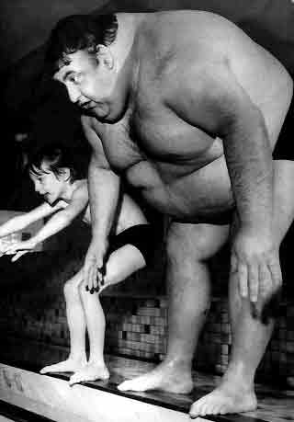

A. Age Grouping
- Swimmers commonly compete in age groups as follows: 8 and under, 9 – 10’s, (sometimes 10 and under), 11 – 12’s, 13 – 14’s, 15 – 16’s, 17 – 18’s (sometimes 15-18 or 15-up). An “open” or “senior” age category means that it is open to any age, including adults.
- The age group in which a swimmer competes in a meet will be determined by his age on the first day of the meet.
- Swimmers must swim in their respective age brackets. There is no “swimming up an age group” in USA Swimming.
- Sometimes single-age categories are contested. (7-year olds, 8-year old, 9-year old, etc.)

B. Grouping by Times
- Some meets restrict entries to specified qualifying times. This means that only swimmers who have achieved the specified qualifying time for an event may swim in the event at that meet. For example only swimmers with Ohio AA times may compete at the State Championship Meets in the events that they have achieved the time standard.
- Often, a swimmer will achieve a State Qualifier Time Standard in one event and not in another. Qualifying times for meets are usually good for about a year and a half.
- USA Swimming National Time Standards are “BB”, “A,” “AA,” “AAA,” and “AAAA”. These times change every four years.
- National Top 16 times may be applied for if the swimmer achieves a certain time. These times are very tough, and only 16 people in each event and each age are ranked each year.
- Junior National, Sectional, and Senior National times are set by USA Swimming every four years.

Short Course/Long Course
USA Swimming permits competition is three official pool lengths; 25 yards and 25 meters, known as short course; and 50 meters known as long course. Records and qualifying times are established for all three courses. International competition is only recognized in 25 meter and 50-meter pools.
The short course season runs from September to March. The long course season runs April to July or early August. Swimmers are encouraged to participate in BOTH seasons, as the key to a great short course season is a great long course season and vice versa.
Another difference between 25 yards and 50 meters is actual length of races. In the 100-yard freestyle an average 13 year old may actually swim 75 yards (when taking out 7 yards for the dive and 6 yards for each of the three turns. In the 100 meter long course race is equal to 110 yards. That same 13 year old will actually swim the equivalent of 97 yards (taking out 7 yards for the dive and 6 yards for the only turn). This is quite a difference!
The difference is even greater in the 200 distances. The 200-yard event will require a 151 yards of swimming (taking out 7 yards for the start and 6 yards for 7 turns). The 200 meter long course event is equal to 220 yards that requires 195 yards of swimming (taking out 7 yards for the dive and 6 yards for each of the 3 turns).
The short course season can last as long as 30 weeks, while the long course season lasts only 12-15 weeks. If you start training in the summer for the long course season, you have a 6-7 week season to swim events that are longer and tougher than the short course events. Hence, you can see the necessity for training in the spring to have a good long course season.

IMPORTANCE OF TRAINING LONG COURSE
When swimmers reach the age of 10-11 years old, continued success comes from swimming the summers with the USA club team. The short course season ends in March, and not swimming with your USA club will have a definite limiting factor in your progress.
This does not mean you give up swimming for your summer league team. We encourage you to participate with your summer league team. You are the best recruiting tool we’ve got! Wear your Worthington Swim Club team cap at practices (not in meets if your summer club has a team cap).
A summer league season lasting 5-6 weeks does not equate to 15 weeks of solid stroke instruction and training with the club. The summer club swimmers still get a 6-8 week break! Swimmers who have not kept up their club membership have lost most of the stroke work established throughout the winter season while their counterparts have leapt significantly ahead in technique and conditioning.
Meet Entry Procedure
Worthington Swim Club’s policy is to rely heavily on the expertise of the professional coaching staff with regard to competition. Although parental concerns will be taken into account, it is ultimately the Coaching Staff’s responsibility to determine what meets and events are best suited for each athlete’s needs and abilities.
Some meets are for certain ages only (i.e. 8-under), some meets have qualifying time standards that must be met in order to enter, and some meets are open for all our members. These stipulations are noted on our meet schedule. If you have a question about your child’s eligibility to compete in a certain meet, please ask your child’s coaches!
The coaching staff selects the meet schedule. The schedule has been selected with the expectation that swimmers will attend every meet available for their age and ability. We do not schedule meets that are unimportant to the athletes’ progress!

Timeline What Happens

3 wks before the meet Swimmers will receive a notice in their folder at the pool about one week before a meet entry deadline. This information will include the events they are entered in, meet times, location, etc. SHOULD YOU HAVE A CONCERN ABOUT THE ENTRY, NOW IS THE TIME TO ADDRESS YOUR CONCERNS WITH THE COACH VIA EMAIL!
MEET SCRATCHES:
GO TO: http://www.worthingtonswimclub.org/
CLICK ON: Meet Schedule
CLICK ON: Scratch Request (for the meet in question)

You may not be able to attend the meet both days, you may question what events your child is entered in, or you may question your child’s entry time. Our coaches welcome open communication about any of these points. (Note: The Coaching Staff has final say in which events a swimmer is entered in). We’d like to get the entries correct and agreed upon for the sake of the swimmers, parents, and coaches before entries are sent to the host club!! Changes can be made and corrections rectified at this time – including scratching from a day or the whole meet if unable to attend. Changes made BEFORE the posted Scratch Deadline will not result in any charges to your escrow account.

2 wks before the meet After the Scratch Deadline has passed, entries will again be posted on the bulletin board at the pool for final verification. Please be sure we got the corrections right!

21/2 wks before the meet Within three days the entries will be sent to the host club. The host club gives no refunds, therefore, your Meet Entry Fund will be charged if you have not scratched by the entry deadline.

At the meet Should you need to “late enter” at a meet, entry fees become expensive. It can be a very stressful time for swimmers, coaches, and parents. The team is warming up, your child is not on the heat sheet, and there may not be space in the published heats for your child to swim.

Relays
Most meets include relays that are worth double the points of an individual event. All swimmers must check with the coaching staff to find out if they are scheduled to compete for the team on a relay. Relays are fun and exciting. Consequently, usually a swimmer will perform better on a relay.

The building of a relay team is the sole responsibility of the staff. There are many variables to be considered: swimmer’s fastest time, how well they have performed at the particular meet in question, how much rest they have had since their previous event, ability to perform under pressure, hunch that a particular swimmer will excel, general attitude and practice attendance of a particular swimmer. Each factor is weighted differently depending on the meet in question. With all these variables, it is particularly difficult to predict which children (sometimes as young as 6 years old) will perform the best on that day at that moment! Your support is appreciated!
Occasionally a meet program will show names of relay swimmers. These names were probably selected by the team’s computer to establish the entry time. PLEASE DISREGARD THESE NAMES!

Swim Connection
Swim Connection is a service purchased by Ohio Swimming, Inc. It is “free” to you. All you need to do is go to www.swimconnection.com and register. A link is on the Worthington Swim Club web site.
After each meet you will be sent a complete statistical analysis of your athletes times at the meet. Improvements will be marked and amount of time improved shown. It is fun to look at these statistics, but not healthy to dwell on them and/or reward your swimmer based on these stats.

Preparing, Understanding, and Enjoying Meets
“Fun, self-improvement, and team spirit are ingredients of a great meet!”-coach

Meets bring us together as a team. It is here that we have time to visit with our friends we usually only see in passing. Relationships are strengthened and new ones made.
Meets are a way of checking how we are doing individually and as a team. Although meets are just a snapshot of a performance on that day at that time, under those conditions, they provide valuable feedback to coaches and swimmers.
WOR parents avoid the trap of becoming part of this feedback process. Instead, parents have a chance to cheer for their child and other team members. They can share in the happiness of improvement and comfort their child when laps go wrong. You can show support for the team by cheering, timing, officiating, or working in some other capacity.
BE PREPARED BEFORE A MEET
Much stress and anxiety stems from uncertainty of racing new people in front of an audience especially at a pool new to them. Being prepared will help calm some of their anxiety about the unknown.
Get your meet information and review warm-up times, which events you are in. Get your Team Handbook and be sure you look up the map for your destination.
Pack these items and bring them with you to a meet:
  - Entry and meet information (start times, directions, timing assignments, etc.)
  - Best Times Logbook (see inside back cover of this manual)
  - Team Suit
  - Team Cap
  - Team Shirt
  - Goggles (2)
  - Towels (2-3)
  - Quiet games (cards)
  - Nutritious snacks and loads of water
  - Warm-ups, sweat suit
  - Socks and shoes
  - Great, Positive, Attitude!!
On Wednesday most clubs publish a psyche sheet (all swimmers ranked in each event) on their website. Compare your entries from WOR to the heat sheet the host club has published. Occasionally there are mistakes that can be taken care of before the meet.
Figure out when you need to leave to arrive 15 minutes before warm up starts. Allow 15 extra minutes if you’ve never been there before and 15 minutes if rush hour traffic will be involved.
WHEN YOU ARRIVE
- Upon arrival, set up camp with the rest of the team. We bond better when we’re together. Also, in an emergency, it easy for coaches to find swimmer’s if they are in the team area.
- Purchase a heat sheet and check what heats and lanes your swimmer will compete. It is traditional for parents to write events, heats, and lanes in ink or marker on swimmers’ hands. This helps assure that he/she makes it to the blocks art the appropriate time. Very young swimmers will need their name on their shoulder to assist in the bullpen.
- Have your child report to our coach at our assigned warm-up lane five minutes before warm-up is to start. Team warm-ups are conducted following a specific pattern based on scientific data. Coming in during a warm-up in progress will definitely limit effectiveness of the warm-up and disrupt your teammates. We want our children prepared the best we can BE.
- Some events, Usually 200 yards/meters and longer require a positive check-in before warm-up is over. Please be aware of this procedure and be sure your swimmer is checked in or the host will assume they are not present and will not put them in the event. This procedure cuts down on empty lanes and therefore the number of heats in these events.
AT THE MEET
- Have your child report to the coach before they swim if at all possible! Last words of encouragement and review of “focus goals” are gone over at this time. Do not provide this information to your child yourself. Instead tell your child to “Swim fast, have fun, and I love you!”
- During the race yell and scream for your child and their teammates whatever way you like. It’s your right to get into it!
- After the race, the athlete is instructed to cool-down in the warm-up pool, if available. Next, it is extremely important to report again to the coach for a critique of the swim – whether the athlete feels it was a “good” swim or a “bad” swim. While the race is fresh in the coach’s and athlete’s mind, they can best analyze what just transpired. The coach will offer constructive criticism pointing out the value of the swim whether a goal time was achieved or not. It is possible to swim poorly and do a best time, or swim well and do a poor time. The time is not always what we’re after – improvement in swimming is! That might not show up in a faster time yet. It can mean the stroke was improved, strategy was well executed, conditioning improve start/turn/finish technique was improved.
When the athlete comes back to you after a “poor” swim, ask/say:
  - “What did the coach say?”
  - “Well, remember to work on that in practice with your coach.”
  - “I liked ____. (your effort, your start, turn, stroke – SOMETHING POSITIVE!)
  - “I am disappointed FOR YOU (not ‘in’ you or your performance).”
  - “That’s not like you. You will do better next time.”
  - “At least you learned something, so that makes it a successful swim.”
  - “I love watching you race. I love you!”
  - “Be sure to drink lots of water.”
Say these things and mean them!
When the athlete comes back to you after a “great” swim, ask/say:
- “What did the coach say?”
- “Well, remember to work on that in practice with your coach.”
- “I liked _____. (your effort, your start, turn, stroke – SOMETHING POSITIVE!)
- “I am excited FOR YOU (not ‘in’ you).”
- “That’s awesome.”
- “You learned something, so that makes it a successful swim.”
- “I love watching you race. I love you!”
- “Be sure to drink lots of water.”
Say these things and mean them!

- It is very important to check with the coach before you leave the meet. Check to be sure all your events are completed and you’re not entered in a subsequent relay. Often the coach will add a comment or two about a great meet and remind the swimmer of the next practice session they are to be at. It’s also okay to instruct the swimmer to thank the coach for their time at the meet. This little comment goes a long way!

AFTER THE MEET
- Record all your times in your Best Times Logbook (see inside cover of this handbook). If you have registered with Swim Connection, in the next day or two you should receive an email from Swim Connection detailing your results. Remember improvement is not only measured in a best time!
- Celebrate with picture of your son/daughter with the team. This is what they’ll remember! Go for ice cream or other small reward.

Out-of-Town Competition
Trips to meets in other cities provide a chance to race unfamiliar competition. Your child will likely not be up against “Johnny” who has beaten your child the last 5 times they’ve raced and therefore may swim better because there are no “supposed-to’s.” The following policies are adopted for the swimmers’ safety and the parents’ piece of mind.
Parents are responsible for arranging transportation and lodging at away meets, with the exception of Nationals and some “All-Star” competition. Do not ask your swimmer to arrange for their accommodations. If any fees are payable to WOR, payment is expected in full before the trip starts.
Each child needs a non-coach, adult chaperone. All swimmers 12 years old and younger are expected to have a chaperone stay in their room. All swimmers age 13 and older are expected to have an assigned chaperone throughout the trip.

Worthington Swim Club Home Meets
The Worthington Swim Club hosts three-five meets during the winter swim season, The John Bruce Memorial Worthington Open, The Kelly German Memorial Invitational, and the Barbara Kay Mini Meet. Ohio Swimming Inc. sanctions all meets and all USA Swimming rules are applicable.
The John Bruce Memorial Worthington Open is held in October and is open to all levels of swimmers. There is one session Friday evening and two sessions each on Saturday and Sunday.
In December, COSA holds the Katy Callard Meet At Worthington Pools. Worthington Swim Club Boosters are usually responsible for staffing approximately half of the meet. We do get part of the profits from said meet. Another local team co-hosts (staffs) the meet.
The Kelly German Memorial Invitational is named in honor of an outstanding Worthington swimmer who died in 1984. The meet is normally held in January and is open to all age groups with specified qualifying times. There are seven sessions for this meet. Friday evening events are timed finals. Saturday and Sunday mornings are preliminaries to consolation and final heats swum in the evening.
This year, we will once again host one of the Ohio Regional Championships on February 16-18. This meet is the last qualifying meet for the State Championships.
The Barbara Kay Mini Meet is a two-day meet held in late February or early March and is named after our former eight and under coach. The meet is for 8 and under swimmers only with separate events for age 6 and under, 7 year olds, and 8 year olds. There are two sessions each on Saturday and Sunday.
We also host the Judith Girardi Mini Champs during the summer swim season. This a one-day meet held in July to give the 9 and under group an opportunity to compete in a Championship.

Worthington Swim Club Away Meets
At meets hosted by other clubs, Worthington parents may be called upon to help time or officiate. Please volunteer to time for our club’s assignment. If each volunteer times for one hour, the task is manageable and pleasant. We would like our parents to be the ones who willingly assist the meet’s host as needed.
Some meets are hosted by COSA or Ohio Swimming. These meets are run by one, two, or more teams. Each team receives an assignment before the meet starts. One team may need to provide hospitality for coaches and officials, another may work the timing console, another the bullpen, etc. Please help Worthington fulfill it’s obligation at these special meets.
Parents’ Role

Worthington Swim Club Communication
With a large number of swimmers practicing at different times, communicating with families is both challenging and vital. The Worthington Swim Club Boosters provides the following ways to keep each swimmer, family and coach abreast of information:
Web Site: The Worthington Swim Club website, www.worthingtonswimclub.org, has the contents of the current Club Hotline along with information about events on the Club Calendar such as upcoming meets. Additionally, information concerning the coaching staff, practice schedules, meet schedules, meet warm-up times, meet results and room reservations for out-of-town meets are available. Check the Other Links page to find additional information on other Ohio swimming activities.
Email: A copy of the “HotlinE” message and updates is emailed to swim families automatically. If you would like this service, please go to the Worthington Swim Club website, www.worthingtonswimclub.org and click on the E-Mail Subscription button. Fill in your name and email address and submit the form to be added.
Each registered swim family has a File Folder within the Worthington Swim Club file box at the Natatorium. The folder serves several functions: 1) Meet information including personal entry information is distributed here, 2) After meets, awards are usually placed here. 3) Other notices about team parties, etc are also distributed here. Any family without email access can have paper copies of announcements delivered her upon request.
Bulletin boards at the pool have postings about upcoming meets; meet results, volunteer needs, etc. Please check the bulletin boards regularly.
Head Coach Bernard Vrancken can be reached at coachbernard@worthingtonpools.org or cell phone 614-598-7064.

Chain of Command
If concerns arise, please communicate directly with the child’s coach. If you are not clear or satisfied with your results there, then call the head coach Bernard Vrancken. If satisfaction is not attained there, call Dick Rabold, Worthington Pools Aquatic Director. Our Booster Board, coaching staff and Swiminc Board of Directors are committed to assist you in following the “chain of command”.
Although there are a few “bad apples” in the coaching business, we pride ourselves in solving your problems together with you. Any problems you may have with the staff will never be “taken out on a child.”

Parent-Coach-Athlete Relationship
To build a successful program there must be trust and understanding between coach, parent, and athlete. A swimmer’s success depends on this relationship being positive, truthful, open, and healthy.
Coaches are responsible for getting information to parents. Parents are responsible for reading, understanding, and acting on this information. All communiqués from the staff will not be perfect and simple to understand. ANY AND ALL questions should be asked to avoid miscommunication.
Every individual learns at different rates. Do not compare your child’s progress to others’. They get enough of that in the meets. Many “early bloomers” have difficulty when the “great equalizer” (puberty) kicks in. Their success came easy and they haven’t learned the work ethic that the late bloomers have developed. Explain to the “late bloomers” that “their time will come.”
When an athlete first starts practicing, their meet performance may suffer. Learning new skills, adapting to new training loads, and adjusting to a new environment will cause this. Don’t be alarmed if this happens.
Plateaus occur in every athlete’s progression. They simply signify that they have mastered a set of skills and continue to do them well. Swimmers and parents who learn to “love the plateau” will see the next improvement step occur much sooner than those who spend their time on the plateau worrying about what is wrong.
In terms of meet performance, younger swimmers are very inconsistent, frustrating coaches and parents alike! They may look awesome, then 20 minutes late you’ll wonder why you paid money to have them coached. The attitude of parents and coach has a huge impact on these young people. Enjoyment of the sport, learning new technique, and teamwork should be emphasized at these times.
If you have any questions about you child’s progress, or coaching techniques, please ask the coach. It is much better for you to understand and support the coach in front of your child and question the coach “in private.” Similarly, any information you could share about your child that will help the coach do a better job is appreciated (visual learner, ADDT, etc.). This information may be shared with staff members as needed and will be kept confidential.
Just as you would not attempt to fix your child’s broken arm, do attempt to give stroke hints or racing strategies. Often your information is outdated and confusing to the child. Use swimming as a teaching opportunity to help your child grow emotionally. It is an excellent chance to cement bonds necessary for their success later in life. Once you step over the line and start to coach, they start equating your love to their performance. (See the next section)

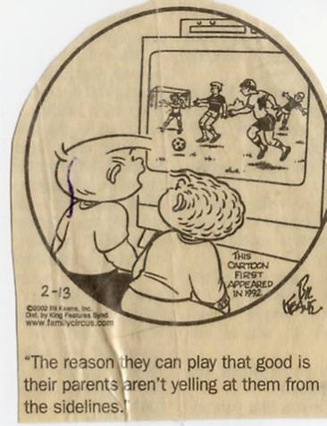
”The reason they can play that good is their parents aren’t yelling at them from the sideline!”
Parent-Athlete Relationship
YOU MAY NOT WANT TO HEAR THIS BUT...most kids have a lot to say about their parents ' involvement in their sports lives, especially what they don't like about it. Here is our Top 10 list of kids' advice for parents, gleaned from comments by S.I. FOR KIDS readers.

- During car rides to games or practice, kids don't want you to tell them how to do this or that. "I am not stupid," said one 12-year-old. "I know how to play the sport I play."
- Kids can get psyched for a game without your help. "I hate when parents say, 'Are you ready? We're going to win,' like they're playing," said one kid.
- It's your duty as a parent to sit quietly and watch your kids do wonderful things. Kids get bummed out when you miss games or yak it up too much with friends in the stands. "We're sweating and playing the game, and they're busy socializing," complained one girl.
- If you don't know what you're talking about, kids don't want you to talk. Typical comments: “Parents think they know the rules, but they don't." "My mom asks annoying questions." And "I hate when my mom tells me to do things even when she doesn't know the first thing about sports."
- Even if you do know what you're talking about, kids don't want you to talk (unless you're the coach). "I hate when parents tell us to do the exact opposite of what the coaches say," said one child. Added another: "If your parent isn't the coach, he or she shouldn't try to be one."
- Kids wish you would practice what you preach about sportsmanship. "My mom always wants me to be a 'good sport,' but a lot of the time she blames the loss on the ref," claimed one kid. "Arguing with the refs is not only embarrassing, but it takes up time," said another.
- Kids often can't hear you yelling when they're concentrating on the game. Sometimes, they can. Either way, they don't like it. " Parents yell advice you don't hear because you're so into playing the game. Afterward they say, 'Why didn't you listen to me?" complained one child. Said others: "I feel embarrassed when my parents yell so loud that the whole town can hear," and "They yell and scream and look like dorks."
- After they lose, kids don't want to be told it doesn't matter. Typical reactions: "I hate when we get knocked out of the playoffs and my parents say, 'You'll get them next time!' " and "When parents try to cheer you up after a loss, all they do is remind you of the score."
- After they lose, kids don't want to be told that it does matter. “Parents take losses harder than we do," wrote one boy. Advised one girl: "You win some; you lose some, no big deal! Get over it!"
- Kids just want to have fun. Parents just don't get this, kids say. Many kids say they would rather play on a losing team than sit on the bench on a winning one. Some would like to skip practice once in a while. "The thing that bugs me the most is that my parents take it too seriously," summed up one child. "They act like its school."

The Costs of Swimming

Swimming is a wonderful, lifelong sport, but it is not inexpensive. Unlike soccer or baseball, it requires a very costly piece of equipment – a swimming pool. And unlike most of the booster athletic programs, including some select teams, our coaches are not parent volunteers. They are paid professionals who must be compensated for their work with our children. When you examine our program closely, you will see that the hourly fee you are paying for your child to learn and grow in this sport is quite modest, especially when you compare it to select soccer, gymnastics, hockey and many travel team sports.
Swiminc, the non-profit corporation that maintains Worthington’s indoor and outdoor pools, oversees all the Worthington Swimming programs and pays the staff and coaches’ salaries and travel expenses. Swiminc’s long-time goal has always been to make swimming as affordable as possible for the children of the Worthington School District.
The following is an explanation of the various expenses involved in Worthington swimming:
- Training Fee: This fee goes to Swiminc and pays for the coaches’ salaries and meet travel expenses of the coaches. This fee also goes to heating and maintaining the pool and natatorium and to paying for the maintenance, guarding and office staff required to keep the pool open during the winter.

2007-2008 Short Course Fees – Competitive Swim Program
Group | Fee | Days/Week
Bronze 2 | $335 | 2
Bronze 3 | $440 | 3
Silver | $500 | 3
Gold | $615 | 4
Age Group | $520 | 3
Advanced Age Group | $790 | 6
High School Prep | $220 | 3
- USA Swimming Membership: As a USA Swimming club, we are required to have each swimmer pay a $54 membership each year. No swimmer can get in the water for practice or participate in a local USA Swimming meet without a USA Swimming number. Among other things, this membership provides secondary insurance for our swimmers in case of injury.
- Central Ohio Swimming Association (C.O.S.A.) Dues: This $3 fee per family enables us to be a part of C.O.S.A., which is our local swimming organization.
- Meet Entry Fees: All swim clubs (including ours) host meets in order to raise money for their club. They do this primarily by charging the swimmers a fee for entering each event. Fees vary from meet to meet, but typically are:
$4.00 – $5.00 per swimmer per individual event
$1.50 – $2.50 per swimmer per relay event
$1.00 per swimmer for the Ohio LSC travel fund (per meet)
$1.00 per swimmer for the Championship fund (per meet)
As a service to our swim families, the Swim Boosters maintains a Meet Entry Fund for each swimmer and pays his or her entry fees with the money in that account. We ask each member start your escrow at $100, and replenish it when the account sinks below $20. When leaving the team, remaining escrow funds will be refunded upon request.

- Travel Expenses: If your child qualifies for an Ohio State Championship meet or if you decide to enter him or her in an out-of-town meet, you will face hotel and meal expenses. The Club usually books a block of rooms at a moderate level hotel and most families use one of these rooms. Some parents share a room to cut costs and others bring food in coolers to avoid excessive restaurant expenses. These meets are optional. In the summer, there may be a few more out of town meets simply because there are so few long course pools in the Central Ohio area.
- Swim Gear: A team suit for meets is required. It our uniform we wear with pride. Worthington Boosters provides a team cap for meets and a tee shirt for each swimmer. Shirts are earned after a minimal number of practices are attended. Practice suits, fins (depending on the group) caps, towels, and a couple pairs of goggles are all necessary supplies.

Outfitting Your Swimmer
Required Apparel for meets:
- Team Suits – The Worthington Swim Club has a standard team suit that everyone is required to have. It is the responsibility of the swimmer to purchase their suit. They may be purchased from Kast-A-Way Swim Wear’s local representative can be reached at 614-403-5417 or by email at: aaron@kastawayswimwear.com. The 800 number for customer service is 800-543-2763. Kast-A-Way will come to the pool in September each year for your convenience. Their website is: www.kastawayswimwear.com
- Team swim caps are also required at meets. Each swimmer will be given a silicone Worthington swim cap at the beginning of the season. If, during the season, the cap rips, the swimmer may receive a new one by returning the ripped cap to his coach. If the cap is lost, the swimmer must purchase a replacement cap. Additional caps may be purchased for $10 at any time during the year. It is recommended that swimmers wear practice caps, not their team caps, during practice.
- Team T-shirts are distributed to each swimmer at the beginning of the season. Swimmers should wear them at meets for team pride and easy identification. The T-shirts and caps are supplied by the Swim Boosters.

Recommended Items:
- Goggles
- Warm-up suit, sweats or parka for warmth (available at Greenhouse Aquatics)
- A roomy waterproof swim bag is recommended for daily use. Team swim bags, parkas, towels, sweats, jackets, parent shirts, and numerous other items are available for purchase from Greenhouse Aquatics. Equipment such as swim fins may be required.

Working at Home Meets - WE NEED YOU!
“I work at the home meets to show my son that I’m 100% behind his participation in the sport. I also know that everybody has to do their part.” -swim mom
Every year, the Worthington Swim Club hosts several swim meets at the Worthington Natatorium. The home meets for the 2007-2008 swim season are as follows:

- John Bruce Memorial Worthington Open: October 26-28, 2007
- COSA Katy Callard: November 30-December 2, 2007
- Kelly German Memorial Invitational: January 18-20, 2008
- Ohio Regional Championships: February 16-18, 2008
- Barbara Kay Mini Meet (8 year old & under): March 1-2, 2008
- Judith Girardi Mini Champs Meet (9 year old & under): July 2008 (exact date tba)
All of these meets require an extraordinary amount of parent participation, as you will see from the sign-up boards that are posted a month or so prior to each of the meets. These home meets not only provide a forum for our swimmers to gain valuable meet experience and test their swimming skills, they also often provide an additional source of revenues for our club, either directly through meet entry fees and concession sales, or indirectly through money saved on out-of-town travel and the advertising space we sell for our meet programs. Volunteering to work at our home meets enables you to earn Family Participation Credits and gives you the opportunity to “pay yourself back” the money you deposited in your Family Participation account. In case you need additional incentives to volunteer, meet workers don’t have to scramble for limited seating in the very hot upstairs section of the Natatorium, and instead have a front row view right down on deck! Volunteering also keeps you closer to your swimmer and the excitement of the team.
In order to assist you in deciding how you would most like to help the club in volunteering your time, a brief description of each position is provided below, including, where appropriate, one or more names of swim club parents who are experienced in the position and can answer any questions you may have. In addition, each meet we host has one or more parents who have volunteered for the position of Meet Manager, and you may always contact any of the meet managers for a particular meet.
Timers: The timers use stopwatches to provide manual back up to the electronic timing system. There are two timers assigned to each lane. Timers get a close-up look at the action in the pool, and don’t need any prior experience. You might get a little wet, however, so don’t wear your best shoes! The head timer oversees all the lane timers, and is the only timer who needs prior experience.
Awards: The helpers in awards assist the head awards person (who will already have ordered the ribbons, etc. in advance) affix the race result labels on the appropriate awards, and sort the awards out to make sure they get to the right swimmer. No prior experience is necessary. There will always be one experienced awards person there to help out the other volunteers. The awards people work at a table on the swim deck, and can easily watch their children swim.
Bullpen: The “bullpen” is the area where the younger swimmers are organized in advance of their races, in order to keep the meet running smoothly. No prior experience is needed for this position. As with the awards positions, the meet managers will make sure that there is at least one experienced parent in this area at each meet session to help guide the other volunteers. These volunteers work right down on the deck, and so can easily see the races in progress.
Computer/Console: These people are absolutely essential to the operation of the meet. They operate the electronic timing equipment and the computer that generates the race and meet results. Prior experience and/or training are required for these jobs. Experienced parents in this area will be more than happy to train anyone who is interested in learning these jobs. We are always in need of more volunteers to learn Computer and Console. This year it is especially important that we train new parents, as we will be losing a large number of experienced parents next year as their swimmers move on to high school swimming. Computer and console operators know race results first, and if you enjoy working with technology, these jobs may interest you.
Hospitality: These volunteers help prepare and pass out snacks and drinks to the meet workers, officials and coaches while the meet are in progress. No prior experience in necessary. As with the other positions, the meet managers will make sure at least one experienced parent is available at each meet session. The hospitality workers work on the deck, and can easily see their swimmers swim.
Concessions: These volunteers help with the food and heat sheet sales upstairs at the Natatorium. No prior experience is necessary. There is always more than one parent working in this area, so you can always take a break to watch your swimmer when his or her turn comes (although you do need to keep an eye on the progress of the meet, which you can easily do by watching the scoreboard, clearly visible from upstairs). If you have any questions, please call Marilyn Norman (614-430-9956).
Announcer: We need one announcer per meet session. While no prior experience is necessary, it does help to be familiar with meet procedures. We are in need of more parents who are willing to announce! In addition to the volunteer positions described above, we always have need of volunteers for the following positions:
Meet Managers: For each home meet, we need at least two, and preferably three or four parents or sets of parents to act as the meet managers. The meet managers are in charge of running the meet, which includes preparing and mailing out the meet information letter, staffing the volunteer positions for the meet, being on hand during the meet to resolve any problems, and sending out meet results after the meet. While at least one volunteer need to be experienced, the rest of the meet managers need not have prior experience because the experienced volunteer(s) can help the inexperienced ones along. We have a real need for new blood in the ranks of our parents with meet manager experience! It’s a big job, but it can be fun and rewarding, and we need more volunteers so the burden doesn’t always fall on the same parents for each meet. Needless to say, as meet manager you get to be on deck all the time, and will have plenty of opportunity to watch your swimmer swim.
Meet Entry Chairs: We also have a pressing need for more people willing to be trained as meet entry chairs for the meets we host. This position does require experience and/or training. We currently have only a few parents who know how to do this job, and they have been carrying the burden of doing this job for years. This job requires entering into the computer all the entries for swimmers participating in the meet, and preparing a notebook and various reports for use during the meet. The primary time commitment occurs about a week or two prior to the meet, and the work can be done on your own time. This job does not require any work at the meet itself. So if you like working on the computer, and fulfilling your volunteer obligations at midnight or whenever appeals to you, this may be the job for you!!
Meet Officials: The meet officials (referees, starters, stroke and turn judges) run the meets in order to ensure that the races are conducted as fairly as possible. There are usually about six officials required for each session of the meet. This position requires prior training and certification. You are also required to become a USA Swimming non-athlete member, and the club will pay this fee. You will need to provide your own “uniform” (navy blue shorts or pants, not denim, and a white shirt). You are required to be on deck for both warm-ups and (usually) the entire meet session. In addition to working at the meets hosted by Worthington, you are also likely to be asked to officiate at other meets. This is a great opportunity to avoid sitting in crowded, uncomfortable bleachers at away meets! While it can be hard to have to disqualify a swimmer who wasn’t performing his or her stroke properly or for some other rule infraction, the position also has plenty of rewarding moments. It also helps you to gain a much greater appreciation of what is required of each swimmer, and what an accomplishment it is for each of our swimmers to successfully complete a race, regardless of where they place.
Swim Meet Managers and Chairmen
Non-Voting members of the Worthington Swim Club Boosters
These positions are required to run Home Swim Meets
(Not required, but may attend Board Meetings)

Swim Meet Director Tim McGhee
Meet Managers Bill Wachtel Ron Smith
Concessions Marilyn Norman, Co-chair
Angie Witkiewicz, Co-chair
Donations Marilyn Norman
Hospitality Patty Doyle
Scoreboard & Equipment Steve Davis
Safety Chair Jean Davis
Entry Chair Phil Stanger, Co-chair
Dalida Zdravkovic Co-chair
Bullpen

USA Swimming Meet Officials
The Worthington Swim Club attends USA Swimming sanctioned swim meets that are run by certified officials. A minimum of four officials must work at each session of a meet:
Referee: This is the head official at the meet. They make the final decisions over disqualifications, time discrepancies, etc.
Starter: This is the official who announces the event and starts it with an electronic start system.
Stroke and Turn Judge: This official walks the deck and makes sure each swimmer is performing the stroke according to USA Swimming rules.
Becoming a USA Swimming official is another way you can help the club and the sport. It is easy. You are trained by current officials, helped with a USA Swimming test, and then ‘apprentice’ alongside a certified official before you are permitted to officiate by yourself. You will be confident in your abilities before you need to make your first “DQ!”

Working as an official counts toward your family commitment for the Booster Club
and you get the best seat in the house!
How to Become A USA Swimming Meet Official

The central commission of Ohio Swimming Inc. will hold its semi-annual officiating clinic on October 7th at the Dublin Recreation Center. The time is set for 1:00 until 4:00pm, but typically runs closer to 90 minutes. If you have been considering joining the ranks of officials, this is your opportunity to get in and help us for the 2007-2008 short course season. Each session you officiate, whether at home or away meets, counts as one session toward your family participation requirement. Our club is just starting to rebuild a base of officials, and a minimum of 6 officials is required to successfully run each session at home meets. The clinic typically will review key points of emphasis, highlight rules changes in the past 6 months, and sho a video demonstrating legal and illegal stroke techniques for newer and prospective officials. When you are ready, you will then complete four multiple-choice exams at your own pace on the US Swimming web site to complete your certification and to obtain apprentice status to join us on deck.

Returning officials must attend one clinic every 12 months, so if you missed the April clinic, please attend this one. The clinic fee for returning WOR-affiliated officials is $6, and remember to bring your USA membership card and LSC officials card for verification of membership, certification and to show that you have worked the six required sessions in the past 12 months period. If you cannot attend this session, there are also fall clinics in Cincinnati (October 3), Toledo (October 10) and Dayton (yet to be scheduled).

If you have any questions about the meeting format, testing format, or what it will be like on deck as an official, please feel free to contact me. I will also be at the parent meeting on September 9 if you would like to discuss officiating with me in person.

Tim McGhee
614-430-3743
t_mcghee@sbcglobal.net

Rules for USA Swimming Events

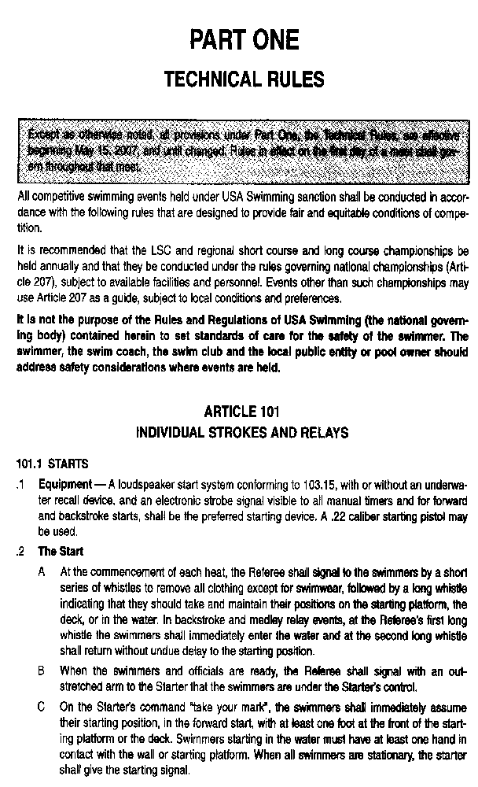
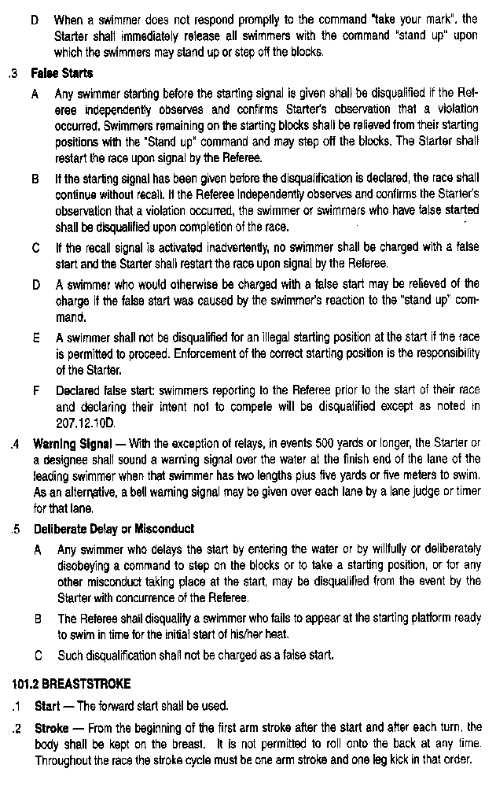

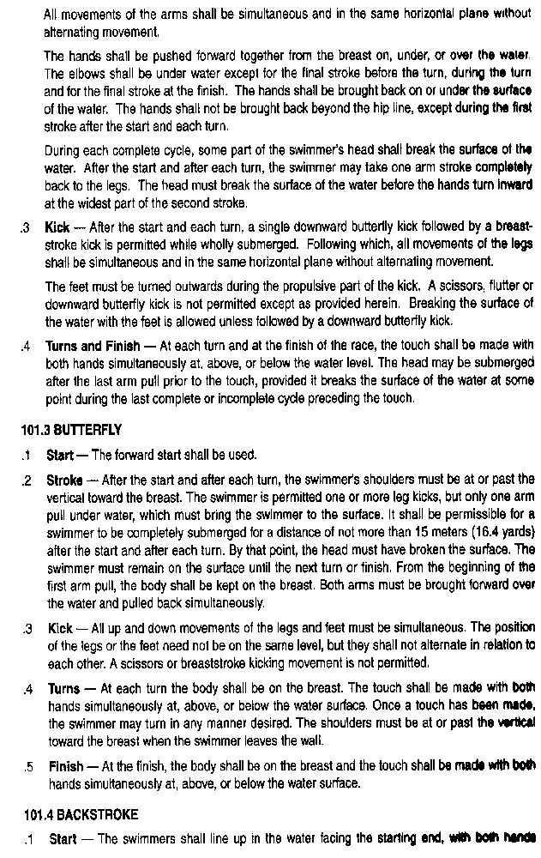

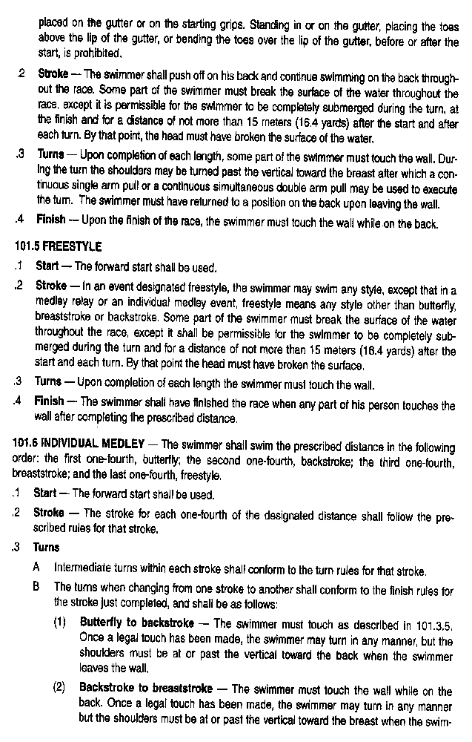

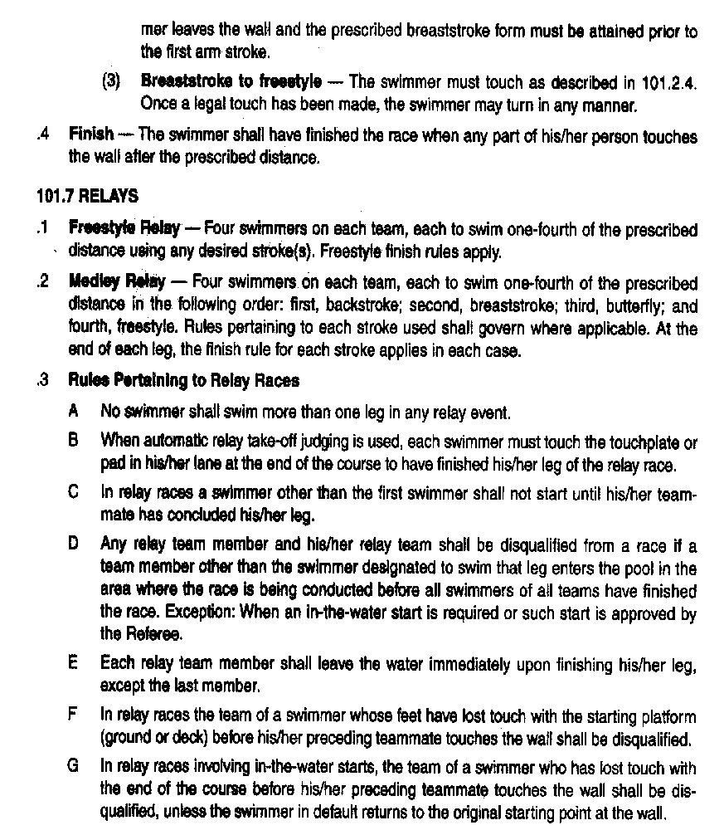
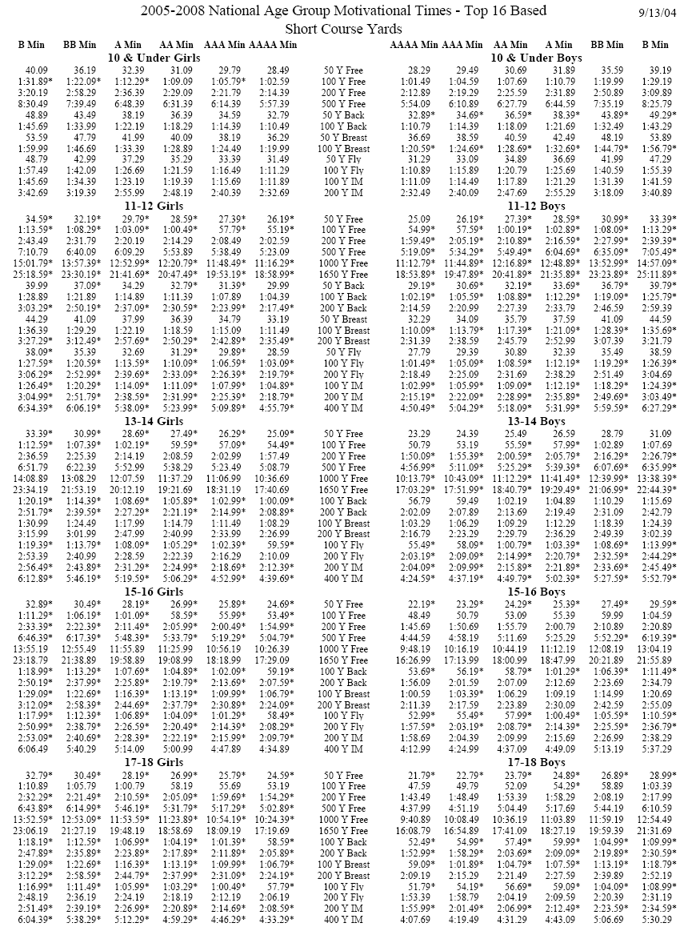
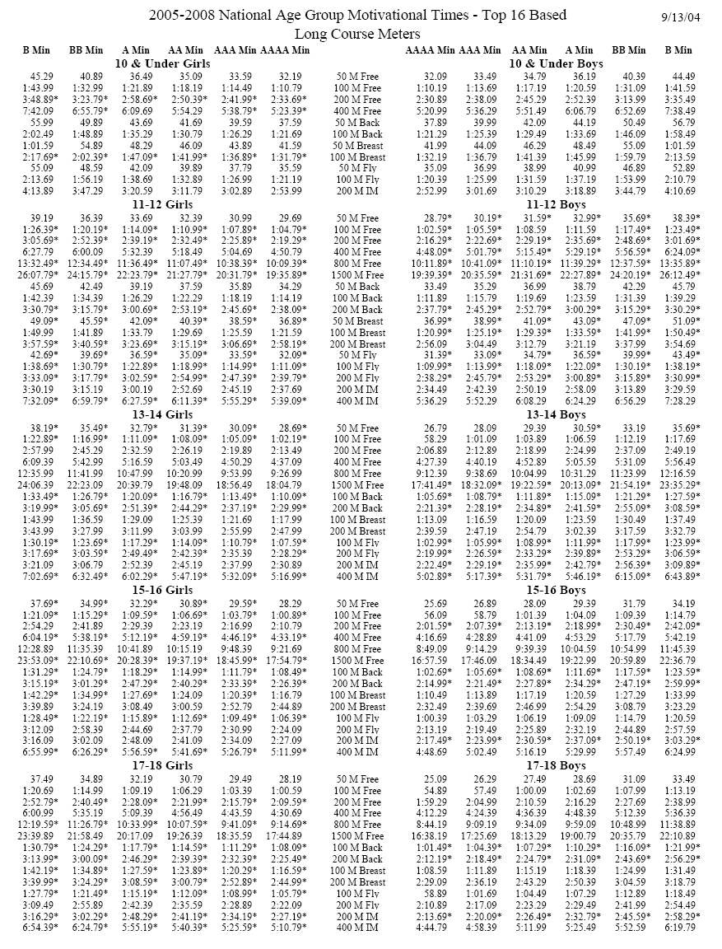
State Senior Championships Time Standards*
(* 2007-2008 Standards not available at press time)

State Age Groupr Championships Time Standards*
(* 2007-2008 Standards not available at press time)

2005-2008 Central Section 3 Speedo Championship Series
Time Standards for IN, MI, OH, and LE Participants below

Qualifying Period: January 1 of previous year
through the entry deadline

WOMEN |  |  | MEN
SCY | LCM | EVENT |  | LCM | SCY
25.29 | 28.79 | 50 FREE |  | 25.89 | 22.59
54.79 | 1:01.79 | 100 FREE |  | 56.39 | 48.99
1:57.89 | 2:13.09 | 200 FREE |  | 2:02.89 | 1:46.89
5:12.09 | 4:38.79 | 400/500 FREE |  | 4:19.39 | 4:48.89
10:44.79 | 9:37.59 | 800/1000 FREE |  | 9:06.39 | 10:03.89
18:00.79 | 18:26.29 | 1500/1650 FREE |  | 17:30.99 | 16:53.89
1:01.49 | 1:10.79 | 100 BACK |  | 1:03.69 | 55.89
2:11.89 | 2:31.09 | 200 BACK |  | 2:19.79 | 1:59.99
1:09.29 | 1:19.29 | 100 BREAST |  | 1:12.59 | 1:02.19
2:29.09 | 2:50.19 | 200 BREAST |  | 2:37.39 | 2:14.99
1:00.09 | 1:07.89 | 100 FLY |  | 1:01.09 | 53.79
2:12.49 | 2:28.79 | 200 FLY |  | 2:17.39 | 2:00.49
2:13.19 | 2:30.89 | 200 IM |  | 2:18.89 | 2:00.59
4:40.49 | 5:18.79 | 400 IM |  | 4:58.19 | 4:19.39
3:46.39 | 4:13.59 | 400 FREE RELAY |  | 3:55.19 | 3:23.19
8:05.99 | 9:07.99 | 800 FREE RELAY |  | 8:30.39 | 7:22.79
4:11.29 | 4:45.99 | 400 MEDLEY RELAY |  | 4:21.99 | 3:47.19

Short Course Team Records - Girls

8 & U
25 Free 14.62 2-Oct-98 Erin Rennebohm
50 Free 32.41 2-Oct-98 Erin Rennebohm
100 Free 1:13.42 2-Oct-98 Erin Rennebohm
200 Free 2:50.57 23-Jan-04 Annie Miller at Kelly German 2004
25 Back 16.70 2-Oct-98 Erin Rennebohm
50 Back 36.66 2-Oct-98 Erin Rennebohm
25 Breast 18.80 2-Oct-98 Katy Sturtz
50 Breast 40.46 2-Oct-98 Katy Sturtz
25 Fly 15.27 2-Oct-98 Erin Rennebohm
50 Fly 34.47 2-Oct-98 Erin Rennebohm
100 IM 1:19.42 2-Oct-98 Erin Rennebohm
200 IM 3:03.36 2-Oct-98 Kerry German
100 Free Relay 1:04.44 15-Feb-03 C. Rabold, E. Harty, M. Girardi, A. Miller
200 Free Relay 2:28.17 8-Mar-03 C. Rabold, E. Harty, M. Girardi, A. Miller
100 Medley Relay 1:15.56 15-Feb-03 C. Rabold, E. Harty, M. Girardi, A. Miller
200 Medley Relay 2:44.83 2-Oct-98 A. Campbell, E. Moore, E. Rennebohm, A. Riddle

9-10
50 Free 27.64 1-Mar-96 Mina Son
100 Free 1:02.22 1-Mar-94 Erin Rennebohm
200 Free 2:17.91 2-Oct-98 Erin Rennebohm
500 Free 6:29.72 2-Oct-98 Erin Rennebohm
50 Back 32.12 1-Jan-95 Katie Ness
100 Back 1:09.82 1-Mar-96 Mina Son
50 Breast 34.80 13-Mar-06 Maren Reeder at SC State Championships
100 Breast 1:15.87 1-Mar-96 Mina Son
50 Fly 30.46 2-Oct-98 Erin Rennebohm
100 Fly 1:09.52 2-Oct-98 Erin Rennebohm
100 IM 1:09.81 1-Mar-96 Mina Son at Ohio State AA Championships
200 IM 2:31.85 1-Mar-96 Mina Son
200 Free Relay 1:57.34 9-Mar-01 J. Wright, O. Mongeau, S. Atkinson, B. Litteral
200 Medley Relay 2:12.81 9-Mar-01 S. Atkinson, O. Mongeau, J. Wright, B. Litteral

11-12
50 Free 25.76 19-Mar-99 Madeline E Merrill at JO Championship Meet
100 Free 55.76 19-Mar-99 Madeline E Merrill at JO Championship Meet
200 Free 2:03.84 2-Oct-98 Heather Rennebohm
500 Free 5:31.23 2-Oct-98 Heather Rennebohm
50 Back 28.94 1-Mar-96 Emily Moore
100 Back 1:02.72 1-Mar-96 Emily Moore
50 Breast 31.53 2-Oct-98 Katy Sturtz
100 Breast 1:08.39 2-Oct-98 Katy Sturtz
50 Fly 27.10 2-Oct-98 Heather Rennebohm
100 Fly 1:01.20 2-Oct-98 Heather Rennebohm
100 IM 1:02.14 19-Mar-99 Madeline E Merrill at JO Championship Meet
200 IM 2:15.33 19-Mar-99 Madeline E Merrill at JO Championship Meet
200 Free Relay 1:49.14 19-Mar-99 M. Merrill, A. Rennebohm, H. Walbright, K. Callahan
400 Free Relay 4:04.55 1-Mar-97 B. Fries, T. Wright, M. Son, M. Thornburg
200 Medley Relay 2:01.75 1-Dec-96 M. Thornburg, M. Son, K. Ness, J. Alexander
400 Medley Relay 4:28.46 19-Mar-98 K. Favret, M. Son, M. Merrill, T. Wright at JO98

Short Course Team Records - Girls

13-14
50 Free 25.10 2-Oct-98 Pam Beim
100 Free 54.73 31-Dec-99 Madeline E. Merrill at 1999 Non-Team Meets
200 Free 1:57.83 1-Feb-96 Heather Rennebohm
500 Free 5:18.00 1-Dec-95 Heather Rennebohm
1650 Free 18:43.83 1-Jan-96 Heather Rennebohm
100 Back 1:00.16 6-Nov-98 Katie D Ness at UASC Golden Bear Inv
200 Back 2:11.84 1-Mar-96 Heather Rennebohm
100 Breast 1:07.50 2-Oct-98 Tracy Macaulay
200 Breast 2:26.00 2-Oct-98 Tracy Macaulay
100 Fly 58.06 6-Nov-98 Katie D Ness at UASC Golden Bear Inv
200 Fly 2:09.68 1-Mar-95 Heather Rennebohm
200 IM 2:10.01 15-Mar-01 Madeline E. Merrill at 2001 Sectional 3 Champs
400 IM 4:34.71 6-Nov-98 Katie D Ness at UASC Golden Bear Inv
200 Free Relay 1:44.87 19-Mar-99 T. Wright, M. Thornbrg, M. Son, K. Favret
400 Free Relay 3:50.46 17-Mar-00 A. Rennebohm, M. Merrill, H. Walbright, K. Favret
800 Free Relay 8:37.90 14-Mar-03 A. Rausch, E. Valencia, J. Wright, B. Litteral
200 Medley Relay 1:56.48 19-Mar-98 M. Thornburg, A. Riddle, K. Ness, J. Alexander at JO98
400 Medley Relay 4:17.52 19-Mar-98 M. Thornburg, A. Riddle, K. Ness, J. Alexander at JO98

Short Course Team Records - Boys

8 & U
25 Free 14.67 4-Mar-06 Colin J. Reardon at Barbara Kay Meet
50 Free 30.88 10-Mar-06 Colin J. Reardon at Ohio SC Championships
100 Free 1:07.78 4-Mar-06 Colin J. Reardon at Barbara Kay Meet
200 Free 2:29.18 3-Feb-06 Colin J. Reardon at Ground Hog
25 Back 17.70 4-Mar-06 Colin J. Reardon at Barbara Kay Meet
50 Back 36.31 2-Oct-98 Rory McVay
25 Breast 19.60 4-Mar-06 Colin J. Reardon at Barbara Kay Meet
50 Breast 41.00 10-Mar-06 Colin J. Reardon at Ohio SC Championships
25 Fly 16.10 4-Mar-06 Colin J. Reardon at Barbara Kay Meet
50 Fly 33.63 10-Mar-06 Colin J. Reardon at Ohio SC Championships
100 IM 1:16.53 2-Oct-98 Chris Harsh
200 IM 2:53.08 20-Jan-06 Colin J. Reardon at Kelly German Meet
100 Free Relay 1:03.75 2-Oct-98 S. Sung, M. Warnick, C. Lloyd, S. Rubsam
200 Free Relay 2:30.23 4-Mar-06 I. Banks, J. Reymann, N. Spegal, C. Reardon at Barbara Kay Meet
100 Medley Relay 1:12.86 2-Oct-98 S. Rubsam, S. Sung, C. Lloyd, M. Morris
200 Medley Relay 2:51.61 1-Mar-92 R. Daniell, K. Davis, B. Baertsche, E. Vikre

9-10
50 Free 28.57 1-Mar-95 David Walbright
100 Free 1:03.06 2-Oct-98 David Walbright
200 Free 2:13.05 1-Feb-76 C. Hymmer
500 Free 6:34.08 1-Dec-06 Colin Reardon
50 Back 32.50 2-Oct-98 Rory McVay
100 Back 1:11.42 1-Jan-97 Pavan Ananth
50 Breast 36.15 14-Mar-03 Jon L. Miller at 2003 Ohio LSC Short Course Championship Meet
100 Breast 1:20.72 14-Mar-03 Jon L. Miller at 2003 Ohio LSC Short Course Championship Meet
50 Fly 31.07 2-Oct-98 Michael Westaway
100 Fly 1:10.43 19-Mar-98 Eric C. Ness at JO98
100 IM 1:13.56 2-Oct-98 Michael Westaway
200 IM 2:30.78 2-Oct-98 Ned Skinner
200 Free Relay 1:58.04 9-Mar-01 T. Johnson, P. Bunting, H. Heisey, C. Blocher at Ohio Swimming, Inc.
200 Medley Relay 2:12.61 9-Mar-01 C. Blocker, P. Bunting, T. Johnson, H. Heisey at Ohio Swimming, Inc.

11-12
50 Free 25.11 2-Oct-98 Kyle Riddle
100 Free 54.87 1-Feb-97 Michael Joyce
200 Free 1:58.38 1-Feb-97 Michael Joyce
500 Free 5:17.43 2-Oct-98 Brian Harsh
50 Back 29.62 2-Oct-98 Rory McVay
100 Back 1:02.47 1-Mar-97 David Walbright
50 Breast 32.61 23-Oct-98 Arnab Majumder at '98 Worthington Open
100 Breast 1:10.10 1-Mar-79 Dan Ersley
50 Fly 26.85 12-Jan-01 Eric C. Ness at 2001 Quad Meet
100 Fly 59.58 12-Jan-01 Eric C. Ness at 2001 Quad Meet
100 IM 1:03.04 1-Feb-97 Michael Joyce
200 IM 2:14.62 1-Feb-97 Michael Joyce
200 Free Relay 1:44.04 1-Feb-97 R. Collins, S. Harris, M. Joyce, D. Walbright
400 Free Relay 3:56.67 8-Nov-96 D. Walbright, R. Collins, D. Kouo, M. Joyce at Golden Bear '96
200 Medley Relay 1:58.29 1-Feb-97 D. Walbright, M. Joyce, S. Harris, R. Collins
400 Medley Relay 4:22.47 1-Mar-97 D. Kouo, S. Harris, D. Walbright, R. Collins

Short Course Team Records – Boys

13-14
50 Free 23.14 1-Mar-96 Kyle Riddle
100 Free 50.55 1-Mar-96 Kyle Riddle
200 Free 1:48.11 4-Mar-99 Michael R Joyce at 1999 Senior A Meet
500 Free 4:47.10 4-Mar-99 Michael R Joyce at 1999 Senior A Meet
1650 Free 16:49.73 4-Mar-99 Michael R Joyce at 1999 Senior A Meet
100 Back 56.62 19-Mar-99 D. Walbright at JO Championship Meet
200 Back 2:02.76 19-Mar-99 D. Walbright at JO Championship Meet
100 Breast 1:05.40 1-Mar-96 Kyle Riddle
200 Breast 2:25.63 19-Mar-99 Ronnie B Collins at JO Championship Meet
100 Fly 54.01 2-Oct-98 Geoff Gear
200 Fly 2:01.42 15-Mar-02 Eric C. Ness at Ohio Short Course Championships
200 IM 2:04.88 2-Oct-98 Geoff Gear
400 IM 4:25.65 2-Oct-98 Geoff Gear
200 Free Relay 1:35.87 19-Mar-99 R. Collins, P. Walbright, B. Campbell, T. Okada
400 Free Relay 3:29.21 19-Mar-99 R. Collins, P. Walbright, B. Campbell, T. Okada
800 Free Relay 8:05.07 14-Mar-03 P. Bunting, E. Novikov, C. Blocher, K. McNeilis
200 Medley Relay 1:50.11 19-Mar-99 D. Walbright, T. Okada, R. Collins, B. Campbell
400 Medley Relay 4:03.29 15-Mar-02 E. Ness, B. Wright, R. Irons, C. Blocher

Long Course Team Records - Girls

8 & U
50 Free 34.67 1-Aug-92 Erin Rennebohm
100 Free 1:18.27 1-Aug-92 Erin Rennebohm
200 Free 2:52.88 1-Aug-92 Erin Rennebohm
50 Back 38.97 1-Aug-92 Erin Rennebohm
100 Back 1:25.09 1-Aug-92 Erin Rennebohm
50 Breast 44.61 1-Aug-88 Katy Sturtz
100 Breast 1:40.18 1-Aug-88 Katy Sturtz
50 Fly 38.08 1-Aug-92 Erin Rennebohm
100 Fly 1:29.30 1-Aug-92 Erin Rennebohm
200 IM 3:08.29 1-Aug-92 Erin Rennebohm
200 Free Relay 3:04.64 1-Aug-94 K. Favret, M. Merrill, M. Rau, A. Rennebohm
200 Medley Relay 3:27.25 1-Aug-94 K. Favret, M. Merrill, M. Ness, A. Rennebohm
9-10
50 Free 30.75 13-Jul-97 Madeline Merrill at JO LC 97
100 Free 1:09.82 13-Jul-97 Madeline Merrill at 1997 Mike Peppe Meet
200 Free 2:34.56 1-Aug-94 Erin Rennebohm
50 Back 37.40 27-Jun-97 Madeline Merrill at 1997 OU SC Invitational
100 Back 1:21.27 1-Aug-94 Erin Rennebohm
50 Breast 37.52 1-Aug-90 Katy Sturtz
100 Breast 1:22.25 1-Aug-90 Katy Sturtz
50 Fly 33.26 8-Aug-97 Madeline Merrill at 1997 Zones
100 Fly 1:16.83 1-Aug-94 Erin Rennebohm
200 IM 2:47.28 1-Aug-74 Tara Skinner
200 Free Relay 2:17.54 1-Aug-97 H. Campbell, H. Walbright, M. Merrill, A. Rennebohm
200 Medley Relay 2:35.12 1-Aug-94 K. Ness, E. Rennebohm, A. Riddle, M. Thornburg
11-12
50 Free 28.46 29-Jul-99 Madeline Merrill at 1999 JO Championship
100 Free 1:02.73 29-Jul-99 Madeline Merrill at 1999 JO Championship
200 Free 2:17.02 29-Jul-99 Madeline Merrill at 1999 JO Championship Meet
400 Free 4:56.09 9-Jul-99 Madeline Merrill at 1999 Mike Peppe Meet
50 Back 32.89 29-Jul-99 Madeline Merrill at 1999 JO Championship Meet
100 Back 1:12.10 1-Aug-88 Karen Babb
50 Breast 35.26 1-Aug-91 Katy Sturtz
100 Breast 1:17.93 1-Aug-91 Katy Sturtz
50 Fly 30.69 29-Jul-99 Madeline Merrill at 1999 JO Championship
100 Fly 1:08.15 1-Aug-94 Heather Rennebohm
200 IM 2:30.72 6-Aug-99 Madeline Merrill at 1999 Central Zones
200 Free Relay 2:02.88 1-Aug-96 J. Alexander, K. Ness, E. Rennebohm, M. Thornburg
400 Free Relay 4:57.34 7-Jul-00 K. Hall, L. Oshima, B. Hall, H. Campbell
200 Medley Relay 2:17.39 1-Aug-96 K. Ness, E. Rennebohm, M. Son, M. Thornburg
400 Medley Relay 5:14.05 30-Jul-98 K. Favret, M. Merrill, M. Ness, R. Mongeau

Long Course Team Records - Girls

13-14
50 Free 28.37 13-Jul-01 Annie Rennebohm at Ohio Senior LC Champs
100 Free 1:01.64 13-Jul-01 Annie Rennebohm at Ohio Senior LC Champs
200 Free 2:14.24 6-Jul-01 Annie Rennebohm at Mike Peppe Meet
400 Free 4:43.60 13-Jul-01 Annie Rennebohm at Ohio Senior LC Champs
800 Free 10:07.92 1-Aug-97 Jill Collins
1500 Free 19:25.77 1-Aug-97 Jill Collins
100 Back 1:09.28 10-Aug-98 Katie Ness at 1998 Central Zones
200 Back 2:34.64 10-Aug-98 Katie Ness at 1998 Central Zones
100 Breast 1:20.64 19-Jul-07 Claudia Doyle
200 Breast 2:54.96 3-Jul-98 Katie Ness at 1998 AA Champs
100 Fly 1:06.91 10-Aug-98 Katie Ness at 1998 Central Zones
200 Fly 2:29.58 1-Aug-95 Heather Rennebohm
200 IM 2:29.42 10-Aug-98 Katie Ness at 1998 Central Zones
400 IM 5:17.64 10-Aug-98 Katie Ness at 1998 Central Zones
200 Free Relay 2:02.04 27-Jul-00 A. Rennebohm, M. Ness, K. Favret, H. Walbright
400 Free Relay 4:26.44 26-Jul-02 M. Alexander, J. Wright, A. Rausch, H. Campbell
800 Free Relay 9:46.93 27-Jul-02 M. Alexander, A. Rausch, J. Wright, H. Campbell
200 Medley Relay 2:15.45 27-Jul-00 A. Rennebohm, M. Ness, J. Shufflebarger, K. Favret
400 Medley Relay 4:57.93 10-Jul-98 A. Riddle, E. Moore, M. Thornburg, K. Ness

Senior
50 Free 27.66 23-Jul-03 Annie M. Rennebohm at 2003 Speedo Champions Series
100 Free 59.70 2-Aug-05 Katie Ness at USA NationalsSummer 2005
200 Free 2:08.91 1-Aug-84 Karen Taylor
400 Free 4:29.55 8-Jan-83 Kelly Davis
800 Free 9:03.41 1-Aug-83 Kelly Davis
100 Back 1:04.01 1-Aug-89 Sheri White at 1989 Senior National Championships
200 Back 2:17.78 1-Aug-89 Sheri White at 1989 Senior National Championships
100 Breast 1:17.86 18-Jul-02 Katie Ness at Ohio Senior LC Championships
200 Breast 2:47.02 20-Jul-00 Katie Sprague at 2000 Ohio Senior LC Championsh
100 Fly 1:02.57 22-Mar-02 Katie Ness at 2002 Spring National Championships
200 Fly 2:19.72 31-Jul-02 Katie Ness at USA Sectional 3 Championships
200 IM 2:23.27 26-Jul-05 Katie Ness at 2005 Speedo Champions Series
400 IM 5:04.88 21-Mar-02 Katie Ness at 2002 Spring National Championships
200 Free Relay 1:54.71 1-Aug-86 K. Faircloth, J. Jones, K. Littig, S. Litchenburg
400 Free Relay 4:05.96 23-Jul-02 K. Ness, H. Rennebohm, M. Merrill, A. Rennebohm
800 Free Relay 9:00.23 18-Jul-02 K. Ness, H. Rennebohm, M. Merrill, A. Rennebohm
200 Medley Relay 2:07.77 20-Jul-00 L. Favret, H. Rennebohm, J. Collins, E. Moore
400 Medley Relay 4:38.23 20-Jul-00 K. Ness, H. Rennebohm, J. Collins, E. Moore

Long Course Team Records - Boys

8 & U
50 Free 35.86 1-Aug-91 Michael Westaway
100 Free 1:20.03 16-Jun-06 Colin J. Reardon at GCSTO Creekside
200 Free 2:54.35 03-Jun-06 Colin J. Reardon at BGSC Summer Meet
50 Back 41.12 12-May-06 Colin J. Reardon at Carmel Swim Club
100 Back 1:38.78 16-Jun-06 Colin J. Reardon at GCSTO Creekside
50 Breast 51.38 16-Jun-06 Colin J. Reardon at GCSTO Creekside
100 Breast 1:50.21 16-Jun-06 Colin J. Reardon at GCSTO Creekside
50 Fly 41.12 16-Jun-06 Colin J. Reardon at GCSTO Creekside
100 Fly 1:38.17 16-Jun-06 Colin J. Reardon at GCSTO Creekside
200 IM 3:15.01 16-Jun-06 Colin J. Reardon at GCSTO Creekside
200 Free Relay 3:28.39 1-Aug-93 P. Ananth, D. Forbes, B. Campbell, D. Kouo
200 Medley Relay 3:53.36 1-Aug-93 B. Campbell, D. Kouo, D. Forbes, T. Schwarz

9-10
50 Free 31.10 1-Aug-95 David Walbright
100 Free 1:08.27 1-Aug-95 David Walbright
200 Free 2:31.07 1-Aug-95 David Walbright
50 Back 36.45 1-Aug-95 David Walbright
100 Back 1:21.65 1-Aug-95 David Walbright
50 Breast 42.59 27-Jun-03 Jon L. Miller at Mike Peppe / John Bruce Memorial Invitational
100 Breast 1:33.29 31-Jul-03 Jon L. Miller at Ohio State Age Group Championships
50 Fly 34.42 1-Aug-93 Michael Westaway
100 Fly 1:19.63 1-Aug-95 David Walbright
200 IM 2:46.75 1-Aug-77 Michael Ersley
200 Free Relay 2:24.74 1-Aug-95 D. Kouo, D. Walbright, B. Campbell, M. Williams
200 Medley Relay 2:43.99 1-Aug-95 D. Kouo, D. Walbright, B. Campbell, M. Williams

11-12
50 Free 28.56 1-Aug-94 Kyle Riddle
100 Free 1:02.01 1-Aug-94 Kyle Riddle
200 Free 2:14.76 1-Aug-97 David Walbright
400 Free 4:54.23 1-Aug-88 Jeremy Spray
50 Back 32.65 1-Aug-92 Adam Minister
100 Back 1:08.87 1-Aug-79 Dan Ersley
50 Breast 36.43 1-Aug-88 Jeremy Spray
100 Breast 1:20.34 1-Aug-88 Jeremy Spray
50 Fly 31.02 1-Aug-92 Adam Minister
100 Fly 1:09.99 1-Aug-97 David Walbright
200 IM 2:19.19 1-Aug-79 Dan Ersley
200 Free Relay 2:02.16 1-Aug-96 R. Collins, S. Harris, M. Joyce, D. Walbright
400 Free Relay 4:32.04 28-Jul-02 P. Bunting, E. Novikov, M. Earley, K. McNeilis
200 Medley Relay 2:20.53 1-Aug-96 R. Collins, S. Harris, M. Joyce, D. Walbright
400 Medley Relay 5:10.42 27-Jul-02 P. Bunting, M. Earley, E. Novikov, K. McNeilis

Long Course Team Records - Boys

13-14
50 Free 26.33 1-Aug-96 Kyle Riddle
100 Free 57.61 1-Aug-94 Adam Minister
200 Free 2:07.43 30-Jul-98 Mike Joyce at 1998 AA Champs
400 Free 4:29.25 30-Jul-98 Mike Joyce at 1998 AA Champs
800 Free 9:46.60 1-Aug-95 Troy Blanton
1500 Free 18:34.80 1-Aug-95 Troy Blanton
100 Back 1:05.91 1-Aug-94 Adam Minister
200 Back 2:25.11 1-Aug-95 Troy Blanton
100 Breast 1:11.70 9-Jul-99 Takaharu Okada at 1999 MIKE PEPPE MEET
200 Breast 2:40.43 9-Jul-99 Takaharu Okada at 1999 MIKE PEPPE MEET
100 Fly 1:01.64 9-Aug-02 Eric C. Ness at 2002 Central Zone Championships
200 Fly 2:18.85 25-Jul-02 Eric C. Ness at Ohio Age Group State Championships
200 IM 2:23.43 25-Jul-02 Eric C. Ness at Ohio Age Group State Championships
400 IM 5:05.10 25-Jul-02 Eric C. Ness at Ohio Age Group State Championships
200 Free Relay 1:52.52 24-Jul-97 C. Cook, M. Joyce, T. Kouo, R. Collins
400 Free Relay 4:07.08 24-Jul-97 C. Cook, T. Kouo, T. Favret, M. Joyce
800 Free Relay 9:15.00 1-Aug-99 .
200 Medley Relay 2:08.48 27-Jul-00 A. Risher, B. Campbell, J. Rechel, P. Ananth
400 Medley Relay 4:43.65 10-Jul-98 D. Walbright, R. Collins, M. Joyce, N. Rudavsky-Brody

Senior
50 Free 24.53 1-Aug-95 Kevin Butler
100 Free 53.59 1-Aug-95 Kevin Butler
200 Free 1:56.79 1-Aug-95 Geoff Gear
400 Free 4:05.71 1-Aug-83 James Allen
800 Free 8:24.07 1-Aug-83 James Allen
1500 Free 17:30.71 1-Aug-86 Scott McVey
100 Back 1:01.81 1-Aug-86 Rick Yurick
200 Back 2:16.59 1-Aug-86 Rick Yurick
100 Breast 1:10.36 15-Jul-99 Takaharu Okada at 1999 Ohio Senior Championships
200 Breast 2:31.64 1-Aug-86 Chris Faircloth
100 Fly 57.51 1-Aug-95 Geoff Gear
200 Fly 2:08.15 1-Aug-95 Geoff Gear
200 IM 2:09.11 1-Aug-83 Craig Hummer
400 IM 4:43.11 1-Aug-83 Craig Hummer
200 Free Relay 1:43.71 1-Aug-95 C. Mayes, K. Butler, G. Gear, T. Macaulay
400 Free Relay 3:36.55 1-Aug-95 C. Mayes, K. Butler, G. Gear, T. Macaulay
800 Free Relay 8:02.51 1-Aug-83 J. Allen, D. Ersley, C. Hummer, N. Skinner
200 Medley Relay 1:53.81 1-Aug-86 R. Yurick, C. Faircloth, C. Harsh, C. Dieter
400 Medley Relay 4:12.13 1-Aug-86 R. Yurick, C. Faircloth, C. Harsh, C. Dieter

Swim Meet Terminology
Most of our team meets are held at local pools. Occasionally we will attend out-of-town meets. Championship meets are often held in other parts of the state. Maps to local and a few out of town pools are included at the back of this handbook.
All information regarding team meets is posted on the bulletin board at the Natatorium. Each person entered will also receive an abbreviated personal copy in their family’s folder at the pool. It is important for parents to check the bulletin board and your folder at least twice a week for this information.
Swim meets are usually divided into two daily sessions – morning and afternoon. Usually, the 12 and under swimmers will swim in one session and the 13 and over swimmers the other session. As each meet is different, parents should check their meet information from their folder or the Club Hotline to find out what session their child is in and what time the session is expected to begin.
There is always a warm-up period before each meet, usually an hour before the start of the meet. Sometimes warm-up sessions are divided and each team is assigned to a time and a lane. Every swimmer is expected to arrive 15 minutes before warm-ups begin and to report immediately to the coach upon arrival.
The clerk of course is an individual (or individuals) whose responsibility consists of collecting, organizing and delivering the swimmers from a “bull pen” to the start in the appropriate heat and lane.
The bullpen is a designated area where younger swimmers must report before they can swim an event. The call to the bullpen is often 20 to 30 minutes before a particular event is swum. There are three announced calls to report to the bullpen. Failure to report to the bullpen on time will result in the swimmer being scratched from the event.
At most meets, the host team prepares a heat sheet, which lists the order of events as well as all swimmers entered in each heat of each event. The heats are listed from slowest to fastest.

In Timed Finals meets for example: In a given event there may be 72 swimmers entered. If the meet were held in a six-lane pool, the swimmers would be divided into twelve heats with six swimmers in each heat. The first heat would be composed of the six swimmers with the slowest entry times. The last heat would contain the six fastest swimmers. Swimmers without established times are always entered in the first heats at NT (No Time).
In Prelims/Finals meets, championship or “circle seeding” is used. The fastest swimmer in the event is seeded in lane 3 (for 6-lane pools) or lane 4 (for 8-lane pools). The second fastest swimmer is seeded in lane 3 in the next to last heat. The next fastest swimmer is seeded in lane 3 in the third fastest heat. The fourth fastest swimmer is seeded in lane 3 in the last heat. So, the last three heats will be comprised of the fastest 18 (24 for 8-lane pools). Slower swimmers are in the earlier heats.

When swimmers are not listed in heats on the sheet, they are deck seeded. This means that the swimmers are divided into heats in the bullpen. Deck seeding allows the meet officials to fill all the lanes and expedite the running of the meet. This is often done with long distance events.
When a meet has preliminaries and finals, usually championship meets and large invitational meets, the heats are seeded differently during the preliminaries. In this case, the last three heats, consisting of swimmers with the fast times, are arranged so that the fastest swimmer is placed in the last heat, the next fastest in the next to last heat and the third fastest in the third to last heat. This is called circle seeding. The fastest six or eight swimmers (depending on the number of lanes in the pool) will qualify for the championship final heat and the next fastest six or eight swimmers will qualify for the consolation heat. Those swimmers who have qualified for these final heats will be announced and the swimmers will have thirty minutes to scratch or decline to swim the event during finals. If a swimmer scratches after this thirty-minute period or does not show up to swim the event at finals, he will not be disqualified from the rest of the meet or issued a fine as a penalty. Always check with your coach before scratching an event.
Most meets have timed finals, which means that a swimmer will swim an event (e.g. the 100 yd. butterfly) only one time. Those swimmers who achieve the fastest times will place and receive awards. The number and type of awards given varies from meet to meet, depending upon the format of the meet, number of lanes in the pool, etc. Award information for each meet is always noted in the meet entry information posted on the bulletin board.
An individual high point award is sometimes given to the swimmer in each age group who earns the most points in a meet. A team high point award may also be given to the team that scores the most points.
Most swim meets are usually held Friday evening through Sunday. Swimmers may participate in the entire meet or only one day. All swimmers are automatically entered in all meets they qualify for. Be sure to let the coach know before the posted entry deadline, so you can be removed from the entry list without charge. This is a swimmer/parent responsibility.
A swimmer may be disqualified if they are not executing the stroke according to USA Swimming rules, if they dive in early (“false start”), performs an incorrect flip turn or any number of infractions. They will receive no points or place for that event, but may go on to swim other events. Although this can be upsetting to a child, “DQ’s” are very common and should be regarded as part of the learning process.
Parents are strongly encouraged to attend swim meets. If you are not able to attend a meet, please be sure to make arrangements for another parent to be responsible for your child and to bring him home if the meet ends earlier than expected. It is not the coaches’ job to stay after a meet with the swimmer.

Meet Officials
The Worthington Swim Club attends USA Swimming sanctioned swim meets that are run by certified officials. A minimum of four officials must work at each session of a meet:
Referee: This is the head official at the meet. They make the final decisions over disqualifications, time discrepancies, etc.
Starter: This is the official who announces the event and starts it with an electronic start system.
Stroke and Turn Judge: This official walks the deck and makes sure each swimmer is performing the stroke according to USA Swimming rules.
Becoming a USA Swimming official is another way you can help the club and the sport. (See page 30 on how to become an official).

Directions to Silverlake Recreational Facility
301 Kenton Lands Road
Erlanger, KY 41018
Phone (859) 426-5253

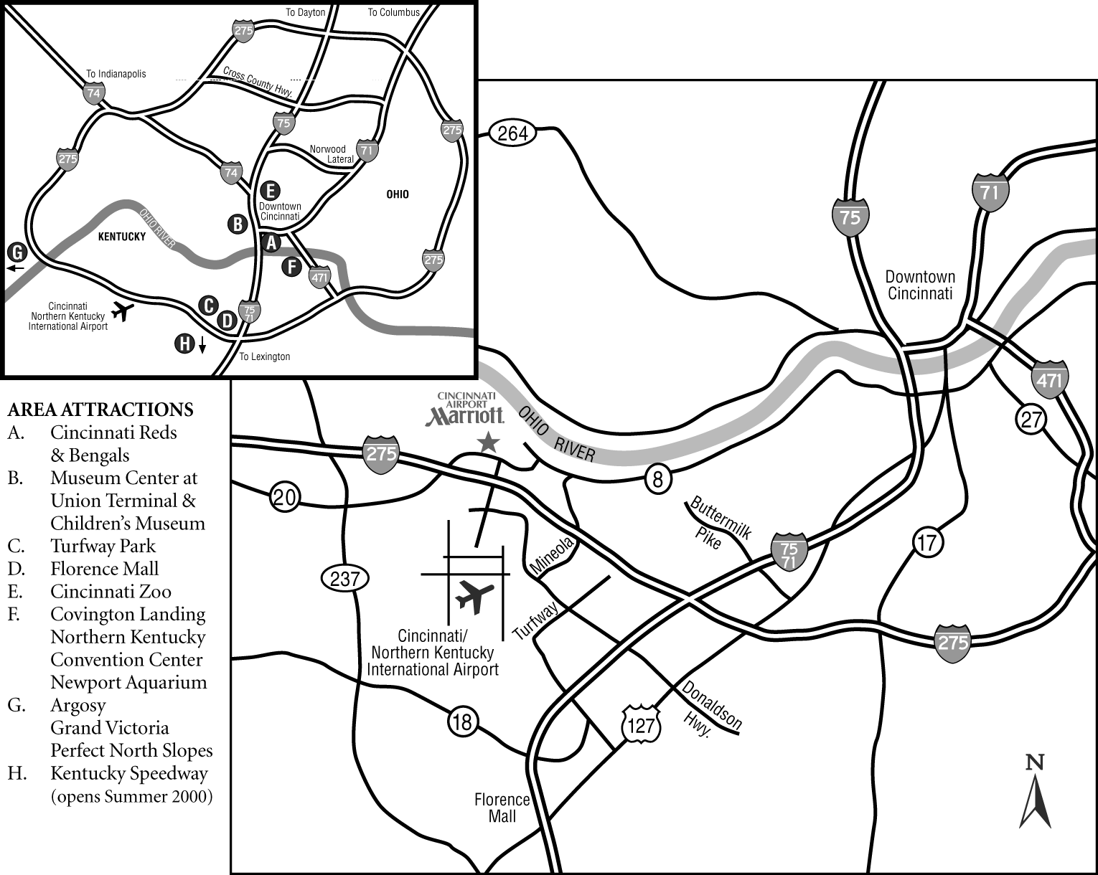
Silverlake
Recreational
Facility

Directions to Silverlake Recreational Facility.
Going Through Downtown Cincinnati
- Take I-75/71 South to I-275 East
- Exit at Dixie Highway South - Exit # 83
- Go South one mile, turn right on Kenton Lands Road (just past McDonald's and Taco Bell)
- Go .5 mile, turn left into Silverlake Recreation's driveway - sign marks the driveway.
If Taking I-275 South in Ohio (avoiding downtown Cincinnati)
- Take I-275 West once you are in Kentucky
- Exit at Dixie Highway South - Exit # 83
- Go South one mile, turn right on Kenton Lands Road (just past McDonald's and Taco Bell)
- Go .5 mile, turn left into Silverlake's driveway - sign marks the driveway
Web site is http://www.clipperswim.org/

Directions to Upper Arlington Pool

UPPER ARLINGTON HS

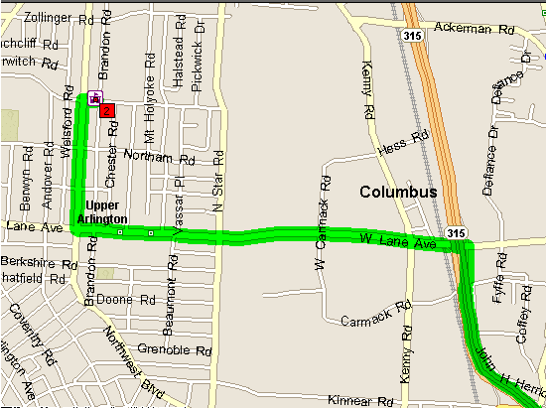

Directions from SR-315: Exit SR-315 at Lane Ave. Turn left (West) onto W Lane Ave and go approximately 1.5 mile until you come to Northwest Blvd. Turn right (North) onto Northwest Blvd and go approximately 0.5 mile until you come to Ridgeview Rd. Turn right (East) onto Ridgeview Rd. and go to the stoplight at Mt. Holyoke Rd. Turn right (South) on Mt. Holyoke Rd and go to the High School parking lot. The Natatorium is located on the East side of the High School.

Directions to Columbus Academy

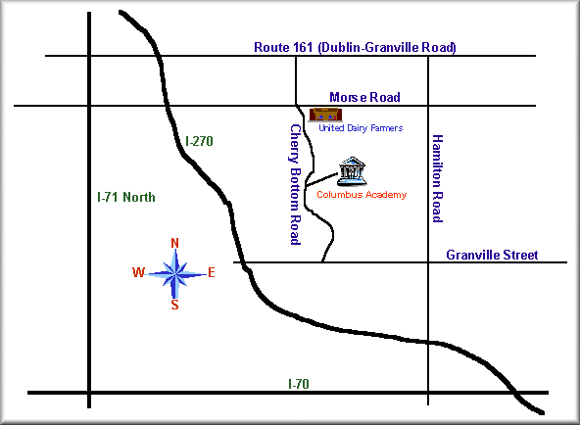

From the North: Take 1-270 on the east side of Columbus to the Morse Road exit. Turn left onto Morse and go approximately .75 mile to Cherrybottom Road. Cherrybottom is the first light after you cross the Big Walnut Creek. Turn right onto Cherrybottom and proceed approximately 1 mile. As you crest a small hill, the entrance to Academy will be on your left marked with 2 brick walls. Turn left up the drive and go to the first left. Take this and follow it to the far parking lot. You may also simply continue past this first left and go on to the east parking lot and enter the facility from there if it is one of the 3-day invitational meets.

From the South: Take 1-270 on the east side of Columbus to the Hamilton Road exit. Turn right onto Hamilton and proceed approximately .75 mile to Granville Street (Gahanna Lincoln High School is on your right at this intersection). Turn left onto Granville and proceed approximately .75 mile to Mill Street (also named Rt. 62). Just before Mill there is a Wendy's on your left. Turn right onto Mill and go to the second light. This is Cherrybottom Road. Turn left onto Cherrybottom and follow it approximately .75 miles. The entrance to Academy will be on your right marked with 2 brick walls. Turn right up the drive and go to the first left. Take this and follow it to the far parking lot. You may also simply continue past this first left and go on to the east parking lot and enter the facility from there if it is one of the 3-day invitational meets.

Directions to Keating Natatorium
Cincy Marlins

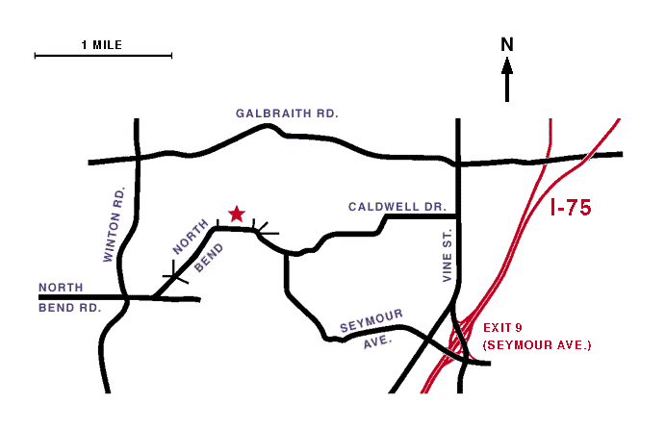

Keating Natatorium is a 50-meter pool with a movable bulkhead (sixteen 25-yard lanes or eight 50-meter lanes). The facility is located on the campus of St. Xavier High School, 616 W. North Bend Rd., in Cincinnati, Ohio. Exit I-75 at exit 9 (Paddock Rd./Seymour Ave.). Take Seymour Ave. west until it ends. Turn left onto North Bend Rd. and follow it to the top of the hill. St. Xavier High School is on the right. Go around the west (left) side of the school and the natatorium is located at the rear of the parking lot.

BEST TIMES LOG SHEET
AAA
State Qual (AA)
A
B
Distance/Stroke>
Date/Meet | FR | FR | FR | FR | FR | FR | BK | BK | BR | BR | FLY | FLY | IM | IM

- Fill in the time standards for your age and sex. (Your previous Bests, “AA”, “A”, “B”, State Qualifying time, etc.)
- Fill in the distance for each stroke. Swimmers age 8 and under should fill in Free: 25,50,100,200,400/500, Back: 25,50, Breast: 25, 50, Fly: 25,50, IM: 100,200. Swimmers age 9-12 and under should fill in Free: 50,100,200,400/500, Back: 50,100, Breast: 50,100, Fly: 50,100, IM: 100,200. Swimmers age 13 and older should fill in Free: 50,100,200,400/500, Back: 100,200, Breast: 100,200 Fly: 100,200, IM: 200,400
- Keep track of your times throughout the year!

WORTHINGTON SWIM TEAM FAMILY COMMITMENTS

The following are mandatory requirements of Worthington Swim Club families.

REQUIREMENT | PENALTY
- Work 6 home meet sessions (called  session credits). Families of new swimmers must work at least 4 sessions.  2 session credits will be given to Swim Meet Managers & Chairman positions. | Families will be assessed a fee of $50 per session not worked at the end of the Short Course season. (i.e. If you only work 2 of the 6 sessions, you will be charged $200 at the end of Short Course Season).
- Provide a predetermined food item ($20-$25 value) per family for one home meet during the Short Course season. | Families will be assessed a fee of $50 if they fail to provide their mandatory food donation.
- Sell at least one ad in the fall of 2006 to be  placed in 5 home meet programs for the  2007 calendar year. | Families will be assessed a fee of $40
- Attend a mandatory Parent Meeting in September, 2006. | You will miss a lot of great information and the chance to meet our coaches!
- You must keep a positive balance in your Meet Entry Account to cover all entry fees PRIOR to the start of a meet. | Your swimmer will not be permitted to swim in  the upcoming meet.
- Swimmers must attend all meets as  determined by their practice group unless you scratch via the website: worthingtonswimclub.org  prior to the scratch deadline for each meet. | Families will be required to pay for meet entry fees for meets they did not scratch.

Running a swim meet takes approximately 120-220 people for one weekend (depending on the length of the meet). We need your commitment to work at least 6 meet sessions & make a food donation in order to keep costs down and make everything run smoothly. If we don't get full parent participation, those that do participate either do multiple shifts, or we are short staffed, which causes a loss of credibility for the club. The penalty assessed helps us provide food and outside workers if the need arises. Our only income comes from swim meets and selling ads. This is how we provide parties, swim caps, T-shirts etc to our children.


MEET SCHEDULE
Date | Host/Meet | Ages | Group | Ability | Scratch  Deadline | Location
OCT 26-28 | WOR/John Bruce Open | All | ALL | All | Oct 8 | Worthington
NOV 4 | GCSTO/Kickoff “B” | All | BZ,SIL | All | Oct 15 | Columbus Academy
NOV 9-11 | UASC/Golden Bear | All | SIL,GLD,  AG,AAG | 9 & Up | Oct 22 | Upper Arlington HS
NOV 18 | GCSTO/November “B” | 10-Under | BZ,SIL | All | Oct 29 | Columbus Academy
NOV 30 -DEC 2 | COSA/ Katy Callard | All | ALL | All | Nov 12 | Worthington
DEC 19 | (Tentative) Dual Meet | 9-14 | t.b.a. | t.b.a. | t.b.a. | t.b.a.
JAN 5-6 | UASC/Triple Crown | All | SIL,GLD,  AG,AAG | All | Dec 10 | Upper Arlington HS
JAN 18-20 | WOR/Kelly German | All | ALL | All | Jan 7 | Worthington
Jan 30 | (Tentative) Dual Meet | 9-14 | t.b.a. | t.b.a. | t.b.a. | t.b.a.
FEB 1-3 | Cinci Marlins Winter Invite | 9-14 | t.b.a. | National BB | Jan 7 | Keating Nat., Cincinnati
FEB 10 | CLPR/Mary Lou Mini Meet | 8-Under | BZ,SIL | All | Jan 21 | Erlanger, KY
FEB 16-18 | **Ohio Regional Championships** | 9-14 | SIL,GLD,  AG,AAG | All | Jan 28 | WORTHINGTON
MAR 1-2 | **WOR/Barbara Kay** | 8-un | BZ,SIL | All | Feb 11 | Worthington
FEB 29- MARCH 2 | **State Senior Championships** | 15 & Over | AG,AAG,  HSP | Time Standards | Feb 11 | Miami University
MAR 14-16 | **State Age Group Championships** | 9-14 | All | State Q | March 3 | Keating Nat., Cincinnati
2007-2008

Notes:
- Schedule subject to changes
- Not all Swimmers go to all meets. IE Ages=8-u, Groups=BZ means only 8-unders in Bronze will be in the meet!
- Please observe Scratch Deadlines to avoid unnecessary charges.
- Worthington Home Meets SHADED.
- Championship meets are ** WE NEED ALL SWIMMERS TO CONTRIBUTE TO THE TEAM EFFORT!

