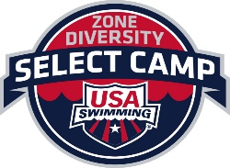
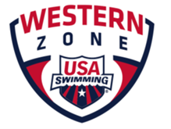 2018 WESTERN ZONE
DIVERSITY & INCLUSION SELECT CAMP
JUNE 14-17, 2018 SAN DIEGO, CALIFORNIA
Athlete’s birthday needs to be between June 15, 2001-June 14, 2004
Email applications to the PNS Diversity and Inclusion Chair and Kyle Falkner, Athlete Representative and Diversity and Inclusion Committee Member, no later than March 25, 2018
Athleterep2@pns.org
Diversity@pns.org
Athlete Information
Athlete’s Name: _________________________________________________________

Street Address: _________________________________________________________

City/State/Zip: _________________________________________________________

Athlete’s Phone: ( ) _________________________

Athlete’s Email Address: ___________________________________________

Date of Birth: ____/ ____/ ____ USA Swimming Number: ______________________

Male Female Gender non-conforming

Swim Club Name: ________________________________ Code: _____ LSC: _____

Parent #1 Name: ________________________________________________

Parent #2 Name: ________________________________________________

Parent Email Address: ___________________________________________

Parent Phone Number: ___________________________________________

T-shirt size: Small Medium Large X-Large (Adult sizes)

Western Zone Diversity Select Camp Eligibility: Any swimmer who represents an ethnically under-represented population that is less than 10% of the current USA Swimming membership is eligible for this camp.

You may check more than one:
____African American ____Native American ____Hispanic/Latino ____Asian
____Pacific Islander ____Native Alaskan _____ Native Hawaiian

____I’m diverse in another way, e.g. Outreach (low-income), LGBTQ, other. If you choose, feel free to elaborate: _____________________________________________________________

____________________________________________________________________________

MUST READ AND INITIAL ALL STATEMENTS OR APPLICATION WILL NOT BE CONSIDERED

_____ I will be physically ready for training when I arrive at camp.
_____ I understand that I must meet the diversity eligibility (Part A) to apply for this camp.
_____ I understand that I must meet the selection eligibility requirements and the qualifying time standards to apply for this camp.
_____ I understand that additional paperwork that I receive MUST be returned to the Western Zone Diversity Select Camp Committee on or before the published deadlines.
_____ I have listed my qualifying times for the camp in Part B.
_____ I understand funding for this camp will come from my local LSC for transportation, room and meals provided for me at the camp.
_____ I will follow all the USA Swimming rules, camp rules, and my LSC rules including code of conduct and safe sport.
_____ I am returning this application to my local LSC Board appointee for submission by their published deadline.
_____ I have not attended a previous Western Zone Diversity and Inclusion Select Camp or a USA Swimming National Diversity Select Camp.
_____ I will be an athlete mentor at future local camps as requested by my LSC D&I Committee.

My signature below attests to the above athlete’s eligibility:

Athlete Signature: ____________________________________________________Date_______

Parent/Guardian Signature: ____________________________________________Date________

Coach of record Signature: ____________________________________________ Date________

Top Swimming Performances
Please list your top five swims since January 1, 2017. List only one course per event. Please check the national standard for your age when the time was achieved.
Event | Time | Course | Power Points | National Standard
____________ | ____________ | _____ | ____________ | A AA AAA AAAA
____________ | ____________ | _____ | ____________ | A AA AAA AAAA
____________ | ____________ | _____ | ____________ | A AA AAA AAAA
____________ | ____________ | _____ | ____________ | A AA AAA AAAA
____________ | ____________ | _____ | ____________ | A AA AAA AAAA

Medical Authorization

Athlete Name: __________________________________________ LSC: ______________
I consent to medical care for my minor child, born on ______________, 20___, including routine diagnostic procedures and medical, dental, and/or surgical treatment by a physician, if needed during the 2018 Western Zone Diversity and Inclusion Select Camp. I give consent to the camp staff to obtain said medical care if needed.

_____________________________ _____________________________ ______________
Swimmer's Signature Printed Name Date

_____________________________ _____________________________ ______________
Parent or Legal Guardian Signature Printed Name Date
List any medical conditions:

List any allergies including medication, food, and over the counter medications:

List any medications that must be administered:

Any special food requirements:

Please include telephone numbers for a parent, relative or guardian in case of an emergency.

Contact Name______________________ Phone: _______________ Relationship_____________

Contact Name______________________ Phone: _______________ Relationship_____________

Insurance Company: _______________________________________________

Policy Number: ____________________________________________________

Phone Number: ____________________________________________________

Athlete Code of Conduct
The purpose of a code of conduct for athletes is to establish a consistent expectation for athletes’ behavior. By signing this code of conduct, I agree to the following statements:
- I will respect and show courtesy to my campmates and coaches at all times.
- I will demonstrate good sportsmanship at all practices and sessions.
- I will set a good example of behavior and work ethic for my campmates.
- I will be respectful of my campmates’ feelings and personal space. Swimmers who exhibit sexist, racist, homophobic, or otherwise inappropriate behavior will be faced with consequences.
- I will attend all camp meetings and training sessions, unless I am excused by a coach.
- I will show respect for all facilities and other property (including locker rooms) used during practices, sessions, team activities and personal time.
- I will refrain from foul language, violence, behavior deemed dishonest, offensive, or illegal.
- I will obey all of USA Swimming’s rules and codes of conduct.

I understand that if I violate this code of conduct, I will be subject to disciplinary action determined by the coach staff and coaches.

_________________________________ _____________________
Swimmer’s signature Date

_________________________________ _____________________
Parent’s signature Date

APPLICATION DEADLINE:
Your completed application is due to your LSC by March 25, 2018.

Pacific Northwest Swimming submissions shall be sent via email to the following addresses:

Athleterep2@pns.org
Diversity@pns.org
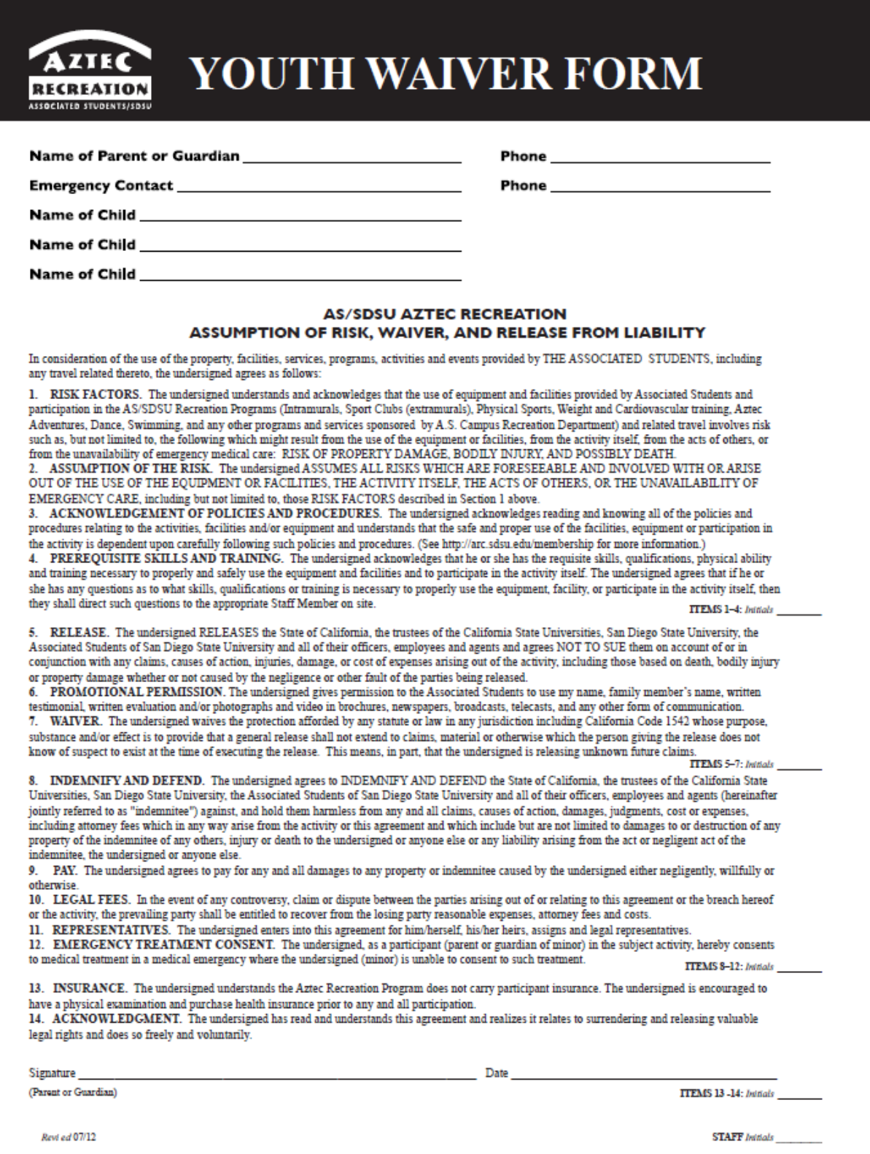
Surfrider Foundation Release of Liability

SURFRIDER FOUNDATION SAN DIEGO CHAPTER and SAN DIEGO COASTKEEPER
ASSUMPTION AND ACKNOWLEDGMENT OF RISKS AND RELEASE OF LIABILITY AGREEMENT

NOTICE: This release form is a contract with legal consequence and applies to all San Diego Coastkeeper/Surfrider events. Read carefully before signing.

Acknowledgement of Risks: I acknowledge risks associated with the cleanup include, but are not restricted to: contact with sharp, contaminated objects; exposure to insects or animals; heat or sun related injuries or illness, including sunburn, sunstroke, or dehydration.

Express Assumption of Risks and Responsibility. I assume responsibility for all the risks associated with the cleanup event. My participation in the activity is purely voluntary. I assume full responsibility for myself and of any of my minor children for whom I am responsible, for any bodily injuries, accident, illness, paralysis, death, loss of personal property and expenses thereof, as a result of any accident which may occur.

Loss of Volunteer Personal Property: I hereby release San Diego Coastkeeper/Surfrider and/or the City in which this cleanup takes place from liability for any loss or damage of personal property while participating in the cleanup event.

Group Volunteer Sign-in: groups performing trash/litter cleanup are advised that sharp objects (broken glass, needles, etc.) may be present on the beach or in the park. These items require special handling. To preclude possible exposure to blood borne pathogens or other hazardous material, volunteers should not make any effort to pick them up. Volunteers should also be aware of the possibility of over–exposure to the sun and the possibility of heat stress. Volunteers should wear hats, gloves, and sturdy shoes. It is requested that volunteers not wear sandals, thongs, or go barefoot. By signing below, volunteers agree to hold harmless San Diego Coastkeeper/Surfrider and the City of which this cleanup takes place, for any injury or loss that may occur during the cleanup.

Release. I hereby release San Diego Coastkeeper/Surfrider and the City in which this cleanup takes place, FROM ANY AND ALL LIABILITY OF ANY NATURE FOR ANY AND ALL INJURY OR DAMAGE, as a result of my participation in the cleanup.

Photos: I hereby grant San Diego Coastkeeper, Surfrider Foundation San Diego Chapter, and their legal representatives the absolute right and permission to copyright, use and publish images in which I may be included in whole or in part, or composite or distorted in character form, for use in published materials, illustration, promotion, art, advertising, trade, web sites and any other purpose in order to promote San Diego Coastkeeper and Surfrider Foundation San Diego Chapter’s programs. I hereby waive any right that I may have to inspect or approve the finished product.

I have read this Assumption and Acknowledgement of Risks and Release of Liability Agreement. I understand that by signing this document, I am waiving valuable legal rights including any and all right I may have against the San Diego Coastkeeper,/Surfrider and the City in which the cleanup takes place, or their employees and agents.

______________________________ ________________________________ ______________ __________________________
Name of Volunteer Signature Date Email (optional)

______________________________ ________________________________ ______________ __________________________
Name of minor’s Parent/Legal Guardian Signature Date Email (optional)

San Diego Coastkeeper protects the region’s bays, beaches, watersheds and ocean for the people and wildlife that depend on them.

The Surfrider Foundation is a non-profit grassroots environmental organization dedicated to the protection and enjoyment of our world’s oceans, waves and beaches.

