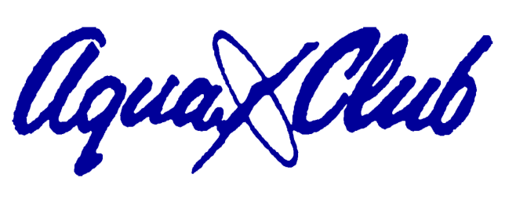
PHOTOGRAPHY/VIDEO
NON-PERMISSION/OPT-OUT FORM

Regular Club activities and events are sometimes photographed by Club Staff for purposes of media coverage, newsletters, websites and brochures. If you do NOT wish to have yourself or your child(ren) photographed for media coverage, newsletters, websites and brochures, complete and return this form to the Club manager. An updated photo must be attached to this form.

Full Name(s) (print)

Contact Telephone number

Signature

Date

This opt-out request is good for one year (May 1st through April 30th) and must be renewed each year to be valid.

