Centerville School District Athletic Booster Club VOLUNTEERHUB Instructions

EVERYONE MUST CREATE A NEW ACCOUNT!!
- Go to: http://athleticboosters.volunteerhub.com/Events/Browse.aspx
- Click the REGISTER button and follow the prompts
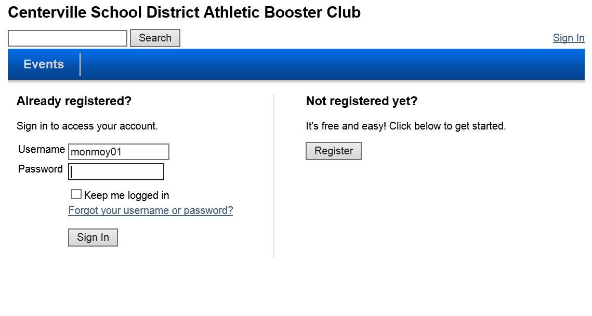

- Select a user name and password and click next
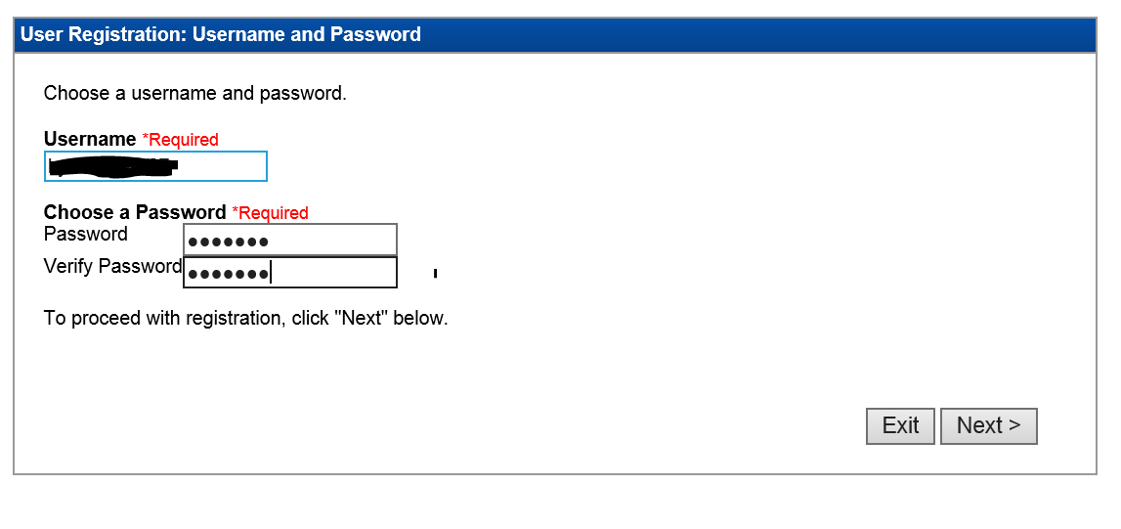

- Select the groups that apply to you, you can select more than one. Example if you want to see Boys Soccer, select Soccer, Boys. If you want to see Boys Soccer and Boys Track, select Soccer, Boys and Track, Boys. When finished click next.
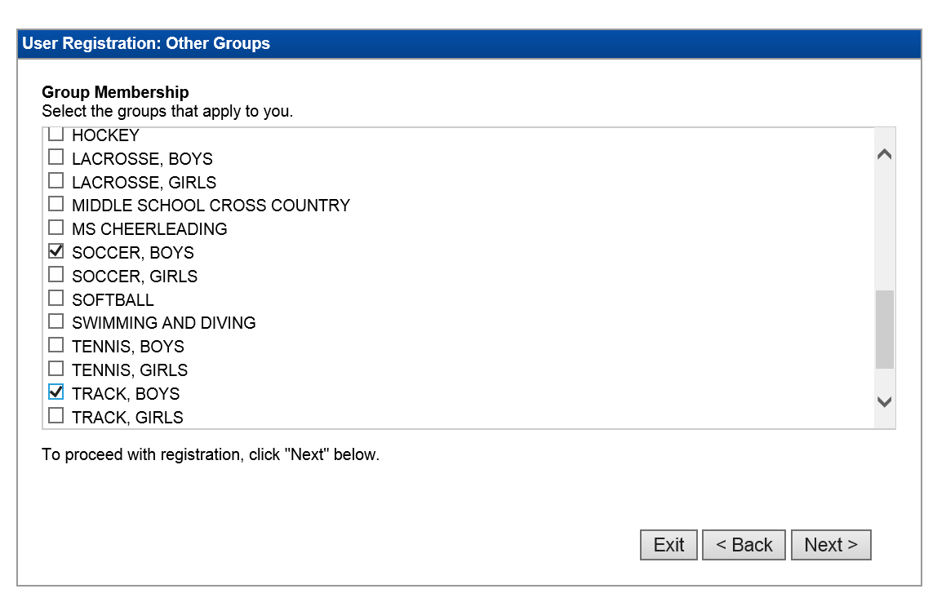
- Enter your user details and click next.
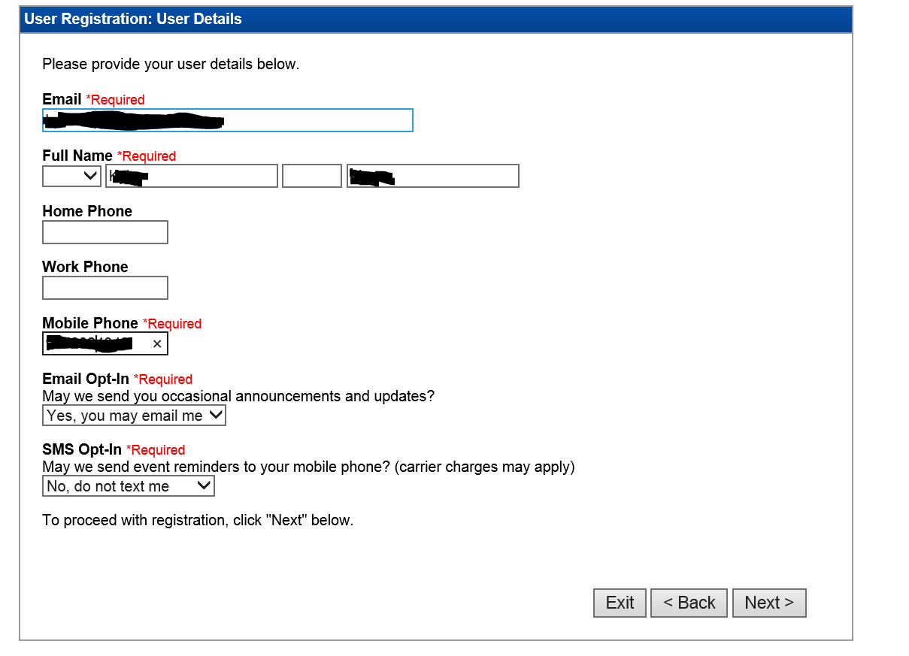

- Click next and confirm your information. Click back to make any edits.
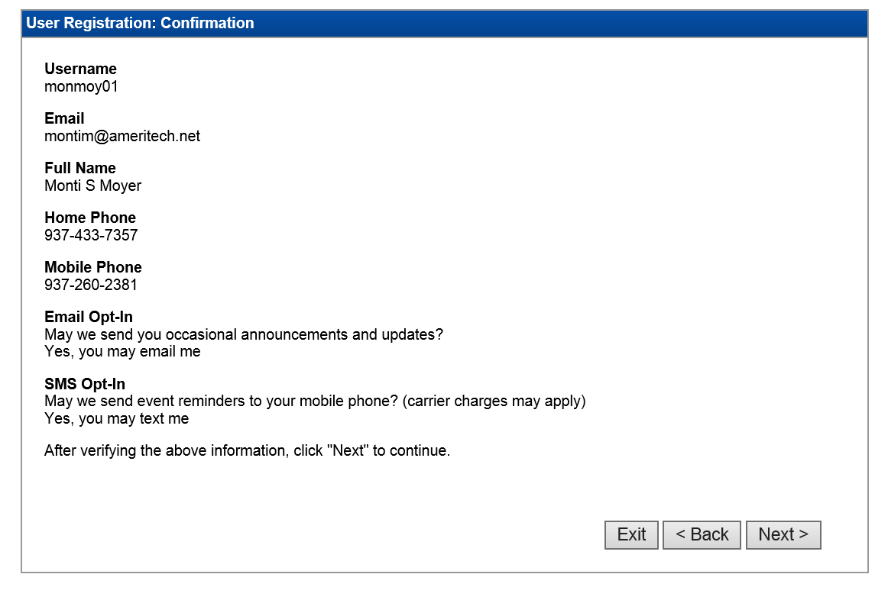

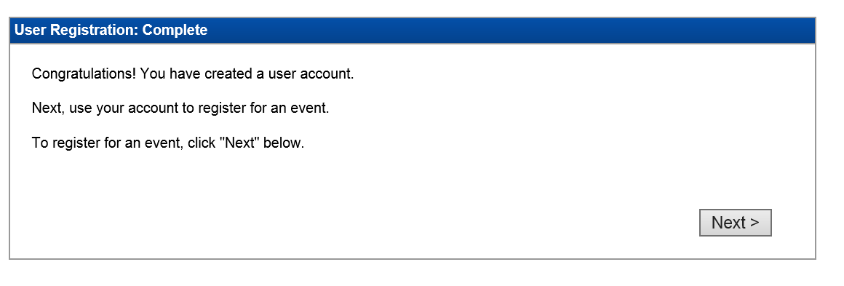
- You should now be able to see events that are available to work.
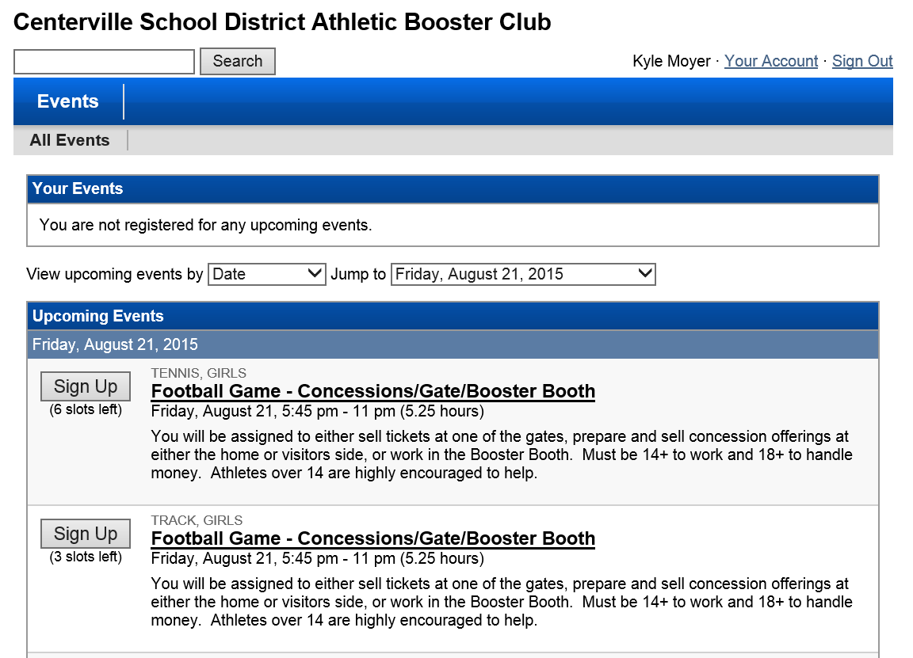

- Sign up in any “OPEN” slots and a reminder will be sent to your email a few days prior to the event
To Make Changes to your registration:
- Click “Your Account”
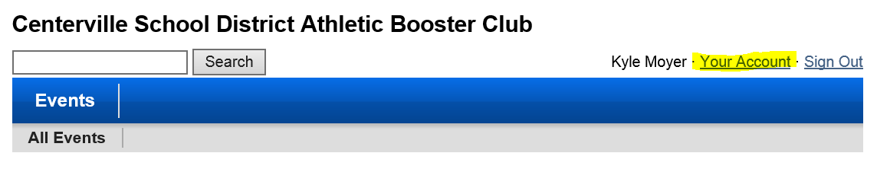

- Verify your account with your user name and password. By default it is already auto-populated you should be able to click next. (Enter your information if it isn’t auto-populated.)
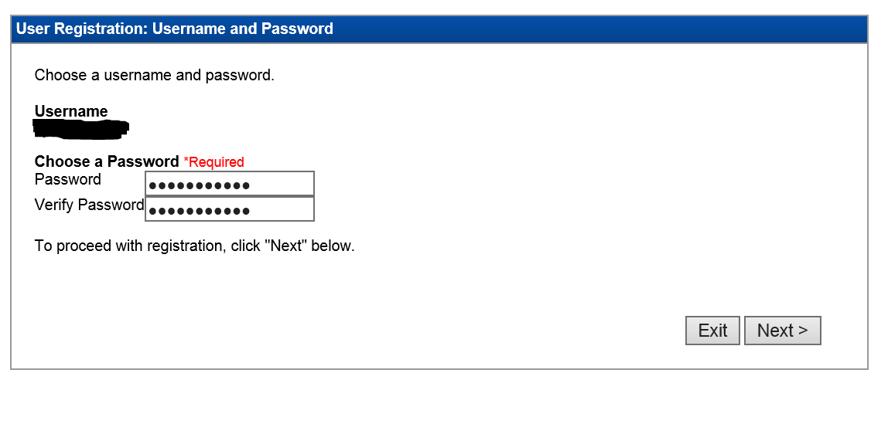

- Make any updates to your user registration groups and click next.
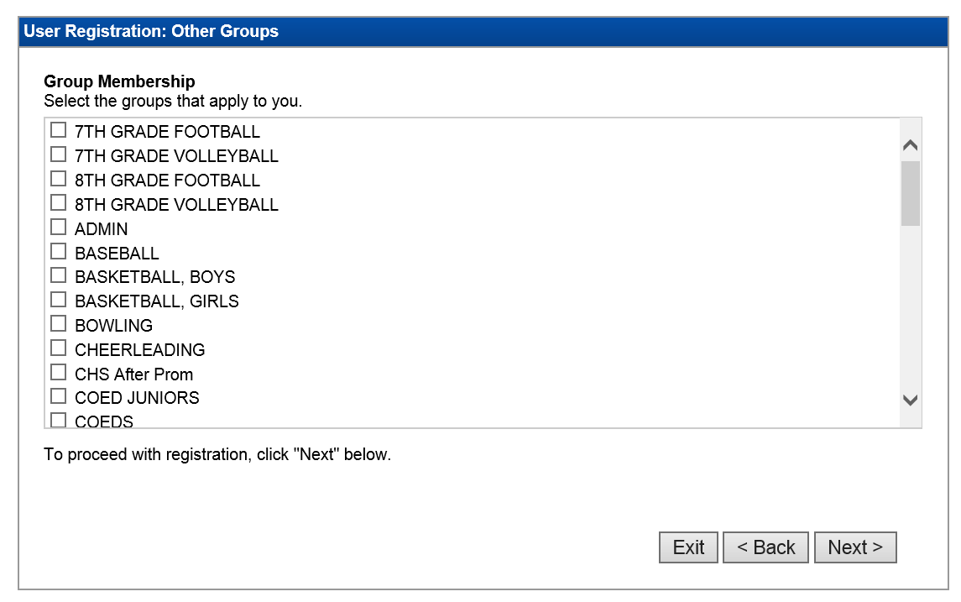
- Make any edits needed to your User Details and click next.

- All information is updated.
Questions regarding Volunteerhub, contact Chris Lamier at chris.lamier@gmail.com or Monti Moyer at monti.moyer@ameritech.net

