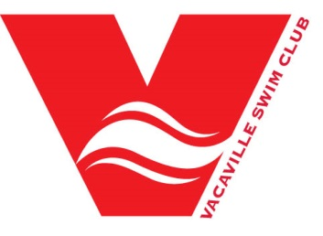
Sponsorship Levels
Gold Medal - $1000
- Home page sponsorship recognition on the VACA website, with links to your website
- Two promotional email blasts distributed to the entire swim team membership and on our Facebook and Instagram pages
- Recognition by our meet announcers at all home meet thanking your company for its support
- Your company banner displayed at the Walter Graham Aquatic Center during home meets
- Sponsorship plaque with team photo
Silver Medal - $500
- Home page sponsorship recognition on the VACA website, with links to your website
- One promotional email blast distributed to the entire swim team membership and on our Facebook and Instagram pages
- Sponsorship recognition at VACA home swim meets
- Sponsorship plaque with team photo
Bronze Medal - $250
- Home page sponsorship recognition on the VACA website, with links to your website
- One promotional email blast distributed to the entire swim team membership and on our Facebook and Instagram pages
- Sponsorship recognition at VACA home swim meets
Friends of VSC - $100
- Home page sponsorship recognition on the VACA website
- Sponsorship recognition at VACA home swim meets

