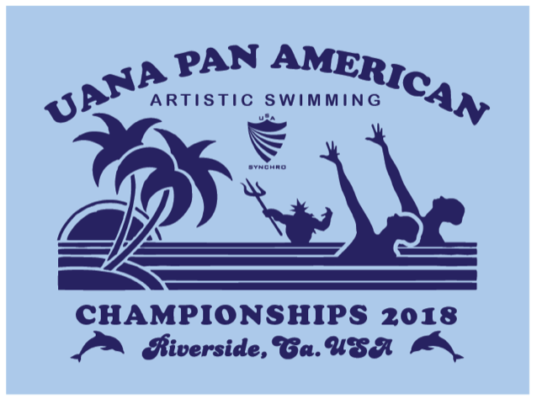
2018 UANA Pan American Artistic Swimming Championships
August 6-11, 2018 – Riverside, California USA

Preliminary Entry Form
Due: May 7, 2018

Federation: _________________________________________________________________________________

Contact Person 1: ___________________________________ Telephone with country code: _______________

Email: _______________________________________

Contact Person 2: ___________________________________ Telephone with country code: _______________

Email: _______________________________________

Please indicate the numbers of entries you plan to attend the 2018 UANA Pan American Artistic Swimming Championships, August 6 – 11, 2018.

Category | Figures | Free Solo | Free Duet | Free team | Tech Solo | Tech Duet | Tech Team | Mixed Duet Tech |  | Mixed Duet Free
12& Under
13-15
Junior
Senior
Free Combination (open event 13 and older athletes)

Total estimated athletes:
12&Under ____________
13-15 ____________
Junior ____________
Senior ____________

Total estimated coaches: ____________

Total estimated staff: ____________

Total estimated judges: ____________

Total estimated delegation: __________

Email preliminary entry to: 2018UANASynchroUSA@gmail.com and Chief Referee Erika Lindner (kelindner@rogers.com). Please note that 50% of payment is due by June 6, 2018. Refer to final entry forms and fees document for payment form and information.

