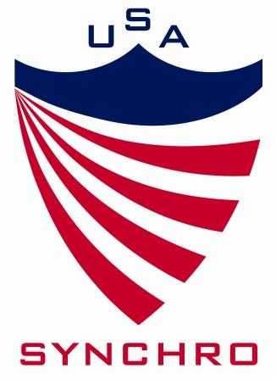
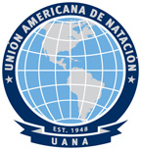
Certificate of Appreciation
Presented to:

Name of Official, Participant, Coach, etc
In Recognition for Officiating, Participating etc.
7th UANA Pan American
Synchronized Swimming Championships
On August 10-16, 2014
____________________________________________________________________
Rose Cody, UANA Technical Synchronized Swimming Chair

