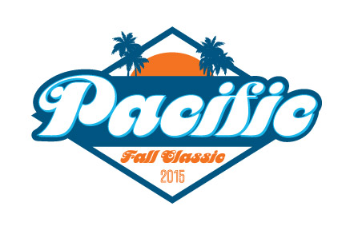
18s Girls A
A B C
Shores A Huntington Beach A TJ Tritones
La Jolla Del Mar Shores B
Tribe CHAWP Pacific Polo

Saturday 10/10 at Cathedral Catholic (Big Tank)
1. 9:00 A1 vs. A3
2. 9:50 B1 vs. B3
3. 10:40 C1 vs. C3
4. 11:30 A1 vs. A2
5. 12:20 B1 vs. B2
6. 1:10 C1 vs. C2
7. 2:00 A2 vs. A3
8. 2:50 B2 vs. B3
9. 3:40 C2 vs. C3

Sunday 10/11 at Cathedral Catholic (Big Tank)
10. 9:50 1st A vs. 1st C
11. 10:40 2nd A vs. 2nd C
13. 12:20 1st A vs. 1st B
14. 1:10 2nd A vs. 2nd B
16. 2:50 1st B vs. 1st C
17. 3:40 2nd B vs. 2nd C
18. 4:303rd B vs. 3rd C
Sunday at Mount Carmel HS
12. 11:20 3rd A vs. 3rd C
15. 1:50 3rd A vs. 3rd B

