Diet for Competitive Swimming
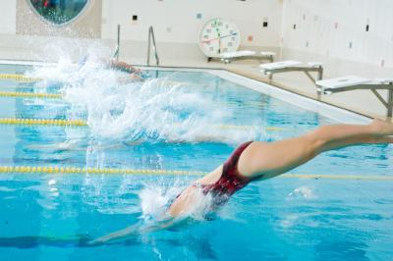
For the competitive swimmer, your diet is as important as your training program. It can be complex to determine the right amounts and types of foods for swimmers, since different phases in training and competition require different meal plans. Competitive swimming requires a high-energy exertion, however, though you may burn a good amount of calories in training and competition, what you eat is still important.

Six Small Meals
Swimmers constantly need to fuel and refuel. It can be more beneficial for you to eat six small meals per day rather than three larger meals. This allows you to eat all of the appropriate times, such as pre-workout, pre-training, post-training, breakfast, lunch and dinner, without over-doing your caloric intake. In addition, eating numerous times throughout the day can help to keep your energy levels elevated and your appetite at bay, which can help you to avoid overeating.

Workouts
It is important that competitive swimmers consume a good amount of carbohydrates to have energy for their workouts and training sessions. In addition, swimmers need protein to help with muscle repair, as well as energy. Swimmer intake should be at a ratio 60:40 of carbohydrates to protein, about two to three hours before a practice session. Foods that are beneficial to eat are pasta, beans, brown rice, eggs, whole wheat toast and corn. Incorporate the healthy poly and monounsaturated fats into your post-training meals rather than pre-training meals.
Note: Fats should be avoided, even unsaturated fats, which are healthy but will slow the body down as they are being digested.

Pre & Post Training Snacks
The snacks or meals that you eat close to training or immediately after are important for keeping your blood sugar levels balanced during training; a drop in blood sugar can cause fatigue and poor performance. These meals should be smaller in size and consist of foods that are healthy yet easily digestible, such as fresh fruit, cereal bars, yogurt, smoothies and whole grains.

Competition
It's natural to feel nervous the morning of a big race, and though you may have butterflies in your stomach, it is still important to eat and fuel appropriately. Practice your race day morning routine and meal ahead of time so that you will know exactly what to do, even if nerves take over. Suggested breakfasts are cereal with milk, yogurt, and fresh fruit with whole wheat toast or oatmeal.
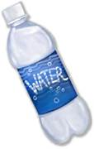

Water
Along with the proper diet, it is imperative that competitive swimmers stay hydrated throughout all of their workouts, trainings and competitions. Dehydration can impede performance and cause your muscles to fatigue very quickly. Don't wait until race day to rehydrate; it is important to start drinking adequate amounts of water the day before competition. Don’t wait until you’re thirsty to start your water intake, drink at a minimum 8oz per hour on race day. If it’s a hot day increase your water intake.

Note: Avoid drinks such as energy drinks, soft drinks (soda pop) and coffee. Although you maybe in the habit of having one or more these drinks, they are known as diuretics and they can contribute to dehydration.

This information is provided to you by the IES Safety Committee

