Third Quarter 2013 USAS Accident Summary

During the third quarter of 2103, USA Swimming experience 1436 accidents. At Inland Empire Swimming there were no reports filed, so congratulations to all. With that said; we cannot let our guard down, we need to be proactive and find the hazards, make corrections before they find the unsuspecting person who will suffer the consequences. In some cases the consequences were minor, in other cases the officials, swimmers, volunteers and the general public weren’t so fortunate resulting in fractures, broken bones and even death. The vast majority of the injuries are occurring to swimmers during in the water activities at competition meets and practice. The leading body parts affected are (Head/Neck) (Leg/Ankle/foot) and (Hand /Arm/Wrist).

What can be done to reduce the chance of an accident occurring?

Remind everyone “No Running on Deck”

Identify slick spots-clean them up, use barriers or post as necessary

Cover cords with mats, tape or suspend when possible

Proper entry into pools including warm-up pools at swim meets

Use handrails when ascending or descending stairs

Report unsafe conditions to life guard, coach or officials

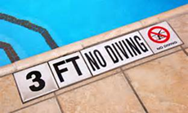
No horse play

No standing on chairs, tables etc…

Use GFI’s for all electrical needs

USA Swimming 3rd Quarter 2013 Accident Summary
WHEN ACCIDENTS HAPPEN
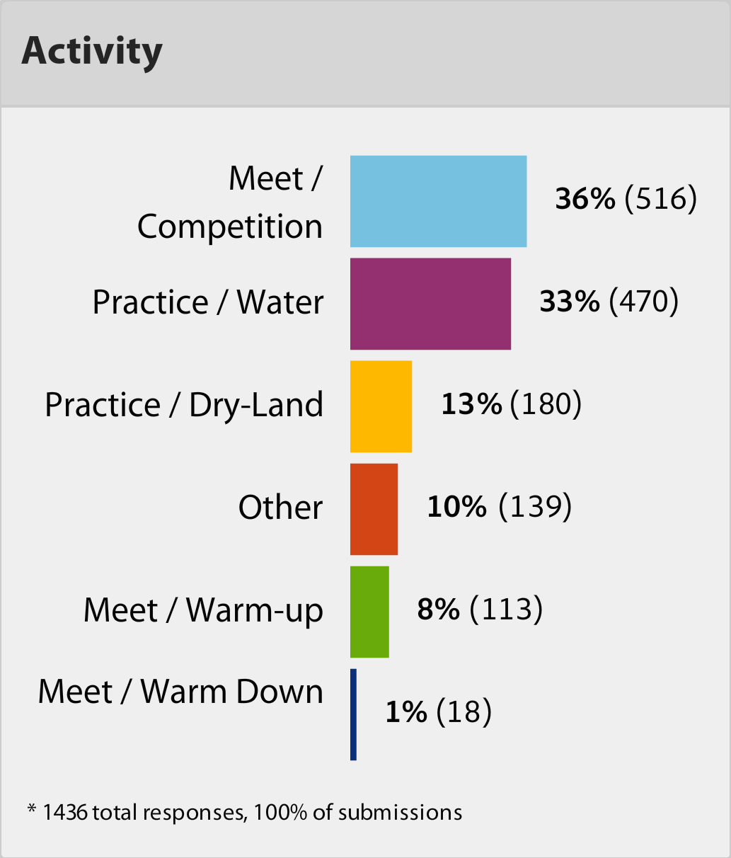
WHERE ACCIDENTS HAPPEN

AFFECTED BODY PART
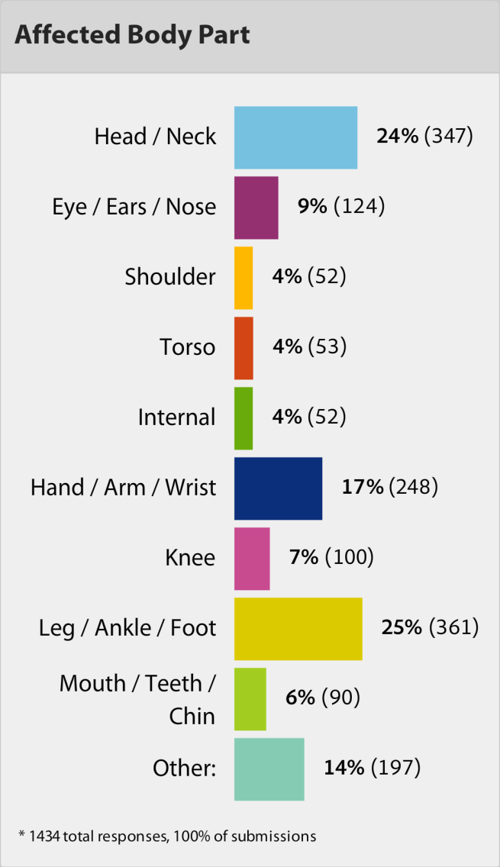

MEMBER/NON-MEMBER TYPE
