11th Annual
Diversity Swim Meet
In memory of
Deputy Chief Steven Bonano

Hosted by
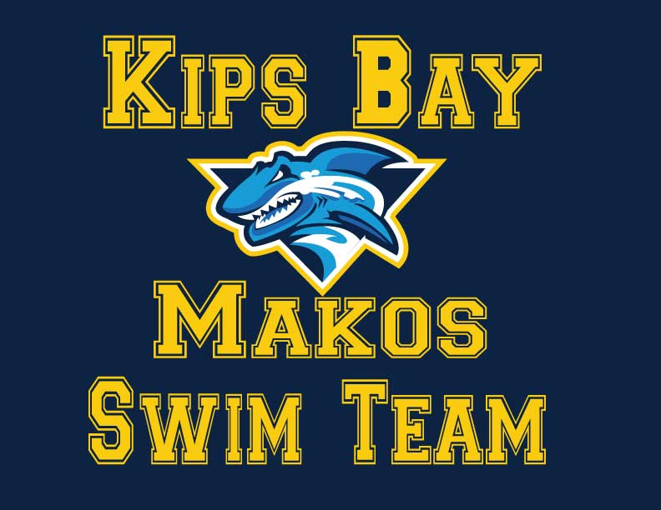
Saturday, May 14, 2016
at the
Lehman College APEX Aquatics Center
Bronx , New York

Teams: Harriman Boys Club, Milbank Stingrays, Trident Swim Club, McBurney YMCA, BronxWorks, HES Huuricaines, Nu-Finmen Swim Team, Westside YMCA, Plainfield Aquatics Club, Riverbank Redtails, Garfield YMCA, Paterson Marlins, Bed-Stuy Y Piranhas, Brooklyn Otters, 92nd Street Y, NCAC, NYAC, BGCD, Abbe Boys Club, APEX, Flathery Dolphins, DHS Stingrays and many more……

This a USA Approved Meet- Sanction # TBA
11th Annual
Diversity Swim Meet
In memory of
Deputy Chief Steven Bonano

SANCTION: | Held under the APPROVED MEET sanction of USA Swimming/Metropolitan Swimming, Inc., #
LOCATION: | Lehman College APEX Aquatic Center 250 Bedford Park Boulevard West Bronx, New York 10468
FACILITY: | 8 Lane 50 Meter Pool utilizing Daktronic Timing System and Scoreboard The pool Has been certified in accordance with Article 104.2.2C (4) The competitive course is 7-13 feet deep. NO SMOKING ALLOWED IN THE BUILDING. Teams are expected to police and maintain their areas on the pool deck. Athletes, parents and children are restricted to the pool area and stands. Spectators and are not authorized to be in any other part of the building. Offenders will be ejected from the facility
SESSIONS: | Saturday, May 14th –  Session #1 – 8:00 AM Warm Up / 9:00 AM Start (10 & Under/ 15 & Over)  Session #2 – 1:00 PM Warm Up / 2:00 PM Start (11-12s/ 13-14s)  (Session Start Subject to change based on number of entries)
FORMAT: | This meet is timed finals. Deck seeding will be used. Events will be run as Open and scored separately in the follow age groups: 10&U, 11-12, 13-14, 15&O. ELIGIBILITY: Open to all USA Swimming/Metropolitan Swimming Inc. registered swimmers. All swimmers participating in this meet must be registered by the first day of the meet. Age on May 14, 2016 will determine age for the entire meet.
ELIGIBILITY: | This is an APPROVED MEET. Open to all and NON-USA Swimming/Metropolitan Swimming Inc. registered swimmers. Non- USA Swimmers can be entered in this meet and follow all USA Swimming guidelines. Age on May 14, 2016 will determine age for the entire meet.
DISABILITY  SWIMMERS: | Swimmers with disabilities are encouraged to attend. Contact the Meet Director if you need special consideration. The athlete (or the athlete’s coach) is also responsible for notifying the meet referee of any disability prior to the competition.
ENTRIES: | Swimmers may enter up to 4 Individual events per day plus a relay. Entries will only be accepted in HyTek format. No manual entries. No NTs will be allowed. They will be booted from the entry if NT pops up for an event.  U.S. Mail Payment to: Kips Bay Boys & Girls Club c/o Eddie Oyola, Aquatics Director –  1930 Randall Avenue, Bronx, NY 10473  Email Entries/Confirm Entry Receipt: Eddie.Oyola@KipsBay.org or ezno@aol.com
DEADLINE: | Metro Swim League Teams get first preference to the meet. Metro LSC Team and other team entries must be received by May 6th, 2016. In order to be given preference over non-Metro Swim League Teams, all entries will be processed as received in a first-come/first-served fashion. Cuts will be made as necessary to maintain a meet size of 375-400 swimmers per session as required by the APEX Aquatic Center. An email confirming receipt of entries will be sent if you provide an email contact. Please contact Eddie Oyola at Eddie.Oyola@KipsBay.org or Ezno@aol.com . If you do not receive such a report within 2 days of your original email.
ENTRY FEE: | A flat entry fee of $17.00 per individual Swimmer for (4) individual swims. Relays will be $10.00 each. There will be No surcharge fee for the meet.  Make checks payable to: Kips Bay Boys & Girls Club  Payment must be received by May 14th, 2016 for email entries. Payment must be included with all mail entries. Failure to pay entry fees by this deadline could result in teams being barred from the meet.
WARM-UP: | General Warm Up will occur in two sessions consisting of (25) minutes each and with all lanes to be shared by all clubs. Assignments will be emailed to you prior to the meet and please make sure your swimmers arrive before the start of their warm up since there will be no warm up pool available for the meet. During Sprints, lanes 1 and 8 will remain open for continuous warm up swim.
SCRATCHES: | Coaches will be given scratch sheets upon check-in for each session. All scratches are due no later than 30 minutes prior to the start of the session. Coaches are asked to indicate clearly individual events scratches and which swimmers will not be participating in the session.
COACHES: | In accordance with Metropolitan Swimming Inc. Policy, only those coaches who display current, valid USA Swimming credentials will be permitted to act in a coaching capacity at this meet. Coaches who do not possess these credentials will be required to leave the deck area.
AWARDS: | Medals: 1st through 3rd place, Ribbons: 4th through 16th place, Team Awards 1st through 6th for all age groups in the meet.
Scoring: | Standard Points:  Ind. Events 20, 17, 16, 15, 14, 13, 12, 11, 10, 9, 8, 7, 6, 5, 4, 3, 2, 1  Relays Events: 40. 34. 32, 30, 28, 26, 24, 22, 20, 18, 16, 14, 12, 10, 8, 6, 4, 2
OFFICIALS: | Meet Referee: Elaine Ang, Email: eababy68@yahoo.com  Officials wishing to volunteer should contact Meet Referee by May 12th, 2016
ADMIN. OFFICIAL: | Administrative Official: Wendy Martinez, Email: Eddie.Oyola@KipsBay.org
MEETDIRECTOR: | Eddie Oyola, Email: Eddie.Oyola@KipsBay.org
RULES: | The current USA Swimming Rules and Regulations will apply.  The USA Swimming Code of Conduct is in effect for the duration of the meet.  The overhead start procedure may be used at the discretion of the meet Referee.
SAFETY: | Metropolitan Safety and Warm-up procedures will be in effect. Marshals will be present throughout warm-ups and competition, and have the authority to remove, with the concurrence of the meet Referee, any swimmer, coach, club, or spectator for failure to follow the safety rules.  “Any swimmer entered in the meet must be certified by a USA Swimming member coach as being proficient in performing a racing start or must start each race from within the water. When unaccompanied by a member-coach, it is the responsibility of the swimmer, or the swimmer’s legal guardian, to ensure compliance with this requirement”
DISCLAIMER:  AUDIO/VISUAL STATEMENT: | Upon acceptance of his/her entries, the participant waives all claims against the Kips Bay Boys & Girls Club and Makos Swim Team, Metropolitan Swimming Inc., USA Swimming Inc., their agents or representatives for any injury occurring as a result of the meet. "It is understood that USA Swimming, Inc. and Metropolitan Swimming, Inc. shall be free from liabilities or claims for damages arising by reason of injuries to anyone during the conduct of the event."  Use of Audio or visual recording devices, including a cell phone, is not permitted in changing areas, rest rooms, locker rooms or behind the starting blocks.
DECK CHANGING: |  | Deck changes are prohibited.
ADMISSION: |  | $5.00 Admission Fee per session and Programs $3.00 each as per Lehman College APEX
MERCHANTS: |  | Food Concessions will be available for the meet.
PARKING: |  | Parking is $5 in The North Lot (alongside the reservoir) There is also ample free and metered street parking however be sure to read all signs to avoid costly parking tickets. (Parking fees are set and collected by Lehman College and subject to change at the discretion of Lehman College and without prior notice or consultation with the Patriot Swim Team.
DIRECTIONS: |  | 250 Bedford Park Boulevard West (between Goulden and Paul Avenues). BY SUBWAY: Take the IRT #4 (Lexington) or IND ‘D’ to Bedford Park Boulevard and walk West on Bedford Park Blvd past Paul Ave to entrance on south side of street.  BUS: FROM WESTCHESTER: (White Plains, Hartsdale, Scarsdale, Yonkers via Central Park Ave.) #20 or #2oX or (Yonkers via Getty Square/South Broadway/McClean Ave/Central Park Ave) #4 to Bedford Park Blvd. Terminus and walk West.  BY CAR: Take Major Deegan Expressway (I-87) to the Van Cortlandt Park South Exit and turn left onto Van Cortlandt Ave. Proceed up the winding hill to Sedgwick Ave and make left onto Sedgwick and continue uphill. Turn right at Goulden Ave (keeping Reservoir on right) and go south to Bedford Park Blvd. Proceed two long blocks. Parking lots will be on your right.  Via Saw Mill River Parkway South (becomes the Henry Hudson Parkway) to Mosholu Parkway exit. Proceed on long exit ramp. At the second traffic light, before the subway underpass, turn right onto Paul Avenue. Go for two long blocks. At Bedford Park Boulevard, turn right. APEX building is on your left. Proceed to traffic light and then turn left onto Goulden. Parking lots will be on your right
11th Annual Diversity Swim Meet
Saturday May 14, 2016
Hosted by: Kips Bay Makos
@ Lehman College APEX Aquatics Center
250 Bedford Avenue, Bronx, N.Y. 10468
Event #  1  3  5  7  9  11  13  15  17  19  21  23  25  27  29  31  33  35  37  39 | Session 1 Warm up 8:00 am / 9:00 start  Events  10 & Under 50 Meter Free  15 & Over 50 Meter Free  10 & Under 50 Meter Fly  15 & Over 100 Meter Fly  10 & Under 50 Meter Back  15 & Over 100 Meter Back  10 & Under 50 Meter Breast  15 & Over Meter Breast  10 & Under 200 Meter Free Relay  15 & Over 200 Meter Free Relay  Session 2 Warm up 1:00pm/ 2:00pm Start  Events  11- 12 50 Meter Free  13- 14 50 Meter Free  11- 12 50 Meter Fly  13- 14 100 Meter Fly  11- 12 50 Meter Back  13- 14 100 Meter Back  11- 12 50 Meter Breast  13- 14 100 Meter Breast  11-12 200 Yard Meter Free Relay  13- 14 200 Yard Meter Free Relay | Event #  2  4  6  8  10  12  14  16  18  20  22  24  26  28  30  32  34  36  38  40

