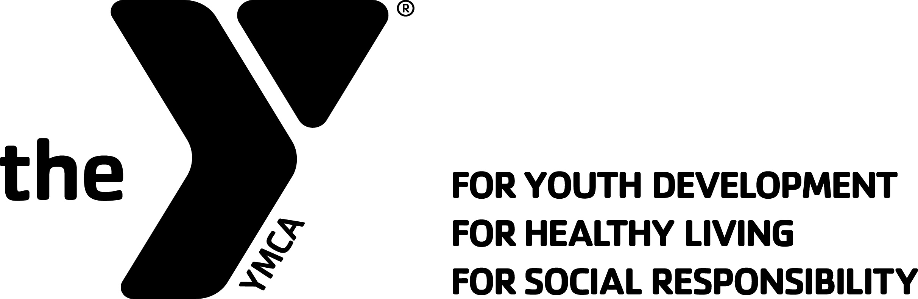
Sussex County YMCA
Swordfish Swim Team

2017 LONG COURSE SEASON INFO SHEET

The Sussex County YMCA is offering a unique opportunity for swimmers to experience Long Course training and competition for swimmers (Coaches discretion) age 11 to 18 our coaching staff is experienced, certified and dedicated to the sport. Our practices will be held at the following sites:

Sussex County YMCA (15 Wits End Road, Hardyston NJ 07419)
Lake Mohawk Pool (21 Lake Mohawk Country Club Boardwalk, Sparta Township NJ 07871)

Coaches for Long Course season will be Coach Ray & Coach Linda. Occasional substitute certified Coach when needed.

**We are pleased to be offering ( for the first time) a “Stay in Shape” practice session that will run with the same schedule as below, however, will end on June 17th. This is an opportunity to allow our swimmers who may decide to compete with their summer league teams a chance to stay in shape leading into that season. Keep in mind this session is only for practices and you won’t be allowed to compete in any invitational meets during the summer. ** We start our summer on Monday June 19th. More information to follow.

Space is limited so please register as soon as you can.

Tryout Information
We remain committed to accommodating as many swimmers on our team as we possibly can without sacrificing the quality of our program. In an effort to place any new swimmers in the LC practice groups possible we hold mandatory try-outs for all new swimmers for our upcoming season. There are separate tryout forms for each age-group, with the available dates/times for that group listed on each form.
Try-out Fees: $10 for any new swimmers that didn’t compete with us during the winter SC 2016-2017 season. No tryout needed for any returning swimmers.
YOU MUST REGISTER AHEAD OF TIME-AS SPACE IS LIMITED.
Try-out results will be posted on Monday, April 10th, 2017 at www.scymcaswordfish.org and www.sussexcountyymca.org

Team Deposit and registration fees will be due by Monday, April 17th, 2017. These must be received by this date to assure a spot on our team this year (see Fees below).

Note to Returning Swimmers: Your TeamUnify account will not be accessible until swimmers are activated after registration. All fees from the previous short course season MUST be paid in FULL before swimming for the Long Course season.

Any new swimmers should:

- Download and fill-out a Tryout Registration Form from www.scymcaswordfish.org or www.sussexcountyymca.org
- Bring in your completed form, along with your Tryout Fee to our Welcome Center at the Sussex County YMCA.
- Space is limited; first come, first served…
- Swimmers should arrive 15 minutes prior to their appointment, and be ready to swim.
- Swimmers should have a cap (for long hair), goggles, suit, and towel.

Practice Schedule (Subject to Change)

Practices begins on April 24, 2017
Practices will end on July 29, 2017

April 24, 2017 – June 3rd, 2017

Group | Mon | Tues | Wed | Thurs | Fri | Sat | Sun
ALL LC SWIMMERS | 7:00 8-45pm | 7:30-9:30 pm | 7:00-8:45 pm | 7:30-9:30 pm | LC | 7:15-9:00 am
 | @SCY- All | @SCY- all | @SCY- all | @SCY | OFF | @SCY | OFF
 |  |  |  | ** 13 & over LC swimmers only this night** | ** 11/12 LC swim here from 5:30-7pm

June 5th, 2017 – June 22, 2017

Group | Mon | Tues | Wed | Thurs | Fri | Sat | Sun
ALL LC  SWIMMERS | 6:00-7:30 pm | 6:00-7:30 pm | 6:00-7:30 pm | 6:00-7:30 pm | OFF | 7:15am- 900am@SCY | OFF
 | @Lake Mohawk | @Lake Mohawk | @Lake Mohawk | @Lake Mohawk

June 23, 2017 – July 29, 2017

Group | Mon | Tues | Wed | Thurs | Fri | Sat | Sun
ALL LC SWIMMERS | 7:00-8:30 pm @Lake Mohwak | 7:00-830 pm @Lake Mohwak | 7:00-8:30 pm @Lake Mohwak | 7:00-8:30 pm @Lake Mohwak | OFF | 7:00-9:00 am @Lake Mohwak on 6/24, 7/8 & 7/22  At SCY 715am-9am on 7/1 & 7/15 | OFF

Competition Schedule

We do not have our full LC Competition Schedule at this time; however continue to check our website for updates. Here are some general guidelines:

YMCA & NJ Swimming Invitational’s
There are also a myriad of invitational meets (with multiple teams attending) which offers swimmers the options of swimming additional events for times, which they can choose. We compete against other teams throughout New Jersey.

YMCA & NJ Swimming Championship Meets
Swimmers must make qualifying times to be eligible for a series of Championship meets, which begin in February and run through the beginning of April.

Our Competition schedule will be posted on our TeamUnify website at the beginning of the season. Team members will have the opportunity to sign up for meets directly online.
Fees

There are 3 categories of fees that need to be satisfied: YMCA Membership (including Joining Fee), Team Deposit, and Practice Group Fee. All fees must be paid at time of registration in order to reserve spot on the team.

YMCA Membership
Required for all YMCA programs, including swim team. ( This is for any new members looking to join the YMCA)

Membership Type | Monthly Draft 20/20 | Joining Fee
Youth (0-12) | $21.00 | $25.00
Teen (13-17) | $29.00 | $25.00
Young Adult (18-22) | $40.00 $32.00 | $25.00
Adult (23-64) | $51.00 $40.80 | $25.00
Senior (65 & up) | $41.00 $32.80 | $25.00
Senior Couple (65 & up) | $58.00 $46.40 | $25.00
Family* | $82.00 $65.60 | $50.00
Family Plus * | $15.00 addtl. $77.60
*(additional adult living in same household)

Team Deposit
$100.00 Non-Refundable Team Deposit for all groups. Covers USA Swimming Registration, $40 towards meet Entry Fees for season, t shirt, and more…

Practice Group Fees
Covers pool time and coaching for all practices from April thru July. (Final dates are determined by what championship meets each swimmer individually qualifies for. Season for some may extend into first week of August.)

All LC Swimmers Full season (14 weeks) $515.00 Plus $100.00 nonrefundable deposit
Deposit plus first payment due by 4/17 $200.00
2nd payment due- $103.75 5/17/17
3rd payment due $103.75 6/17/17
4th payment due $103.75 7/17/17
Final payment due $103.75 8/1/17
Weekly cost is $44.00 per swimmer

** Only LC SWIMMERS ( not Stay in shape) will be eligible to go on our training trip to Florida in late June if we have enough interest.**

All “Stay in Shape” Shorter season (8 weeks) $350.00 Plus $50.00 nonrefundable deposit
Deposit plus first payment due by 4/17 $ 150.00
2nd payment due by 5/17 $83.33
3rd payment due by 6/17 $83.33
4th payment due by 7/1 $83.33
Weekly cost per swimmer is $50.00

Additional Costs
Some are additional costs throughout the season are team suits, gear, team photos, meet entry fees (in excess of the $40.00 allotment), hotel and travel costs (for championship meets should swimmer qualify), etc.

Answers to Frequently Asked Questions

- The age of our swimmers is 11-18 years old with different practice groups for age and ability levels.

- Tryouts begin at the beginning of April (Both at the YMCA School), with multiple dates and times available. A list of all new swimmers who made the team will be posted on our website shortly after the last tryout.

- Our team participates in two different leagues: the Northern New Jersey YMCA Swim League, and NJ Swimming (USA Swimming).

- Our coaches are ASCA, USA Swimming, and YMCA certified and are accomplished and dedicated to the sport.

- Our season runs from early late April to approximately end of July (depending on age and what championship meets your child qualifies for).

- Practices are five times a week, Most competitions are on the weekends.

- We require swimmers to maintain a minimum of 70% practice attendance.
- All swimmers must be members of the Sussex County YMCA.

- Parents are required to volunteer at a few meets as timers, etc. No experience necessary for most jobs. Generally Timers needed at meets.
Additional information, including tryout information, meets. coach biographies, and more can be found at www.scymcaswordfish.org.

LC 2017 REGISTRATION FORM ( ONE FORM PER SWIMMER)
(11 & over only)

(Select one)

LC SEASON: ____ $515.00 PLUS $100.00 DEPOSIT

STAY IN SHAPE:___ $350.00 PLUS $50.00 DEPOSIT

SWIMMERS NAME:__________________________________________________

DATE OF BIRTH:___________________________________________________

CURRENT AGE:________________

PARENTS NAME:___________________________________________________

PARENTS EMAIL:___________________________________________________

PARENTS CELL NUMBER:_____________________________________________

T SHIRT SIZE:_________________ ( INDICATE YOUTH OR ADULT SIZE. EG.AS

First payment due on 4/17/17

LC SEASON: $200.00 1st payment plus $100.00 deposit

STAY IN SHAPE: $ 150.00 1st payment plus $50.00 deposit

Checks payable to : Sussex County YMCA

Signature to charge credit card on file:_______________________________________

Last four digits of card:______________________

PLEASE RETURN THIS FORM TO THE WELCOME CENTER BY APRIL 17th

Office use:

Family name:_________________________________________________________

Type of payment:______________________________________________________

Amount:_____________________________________________________________

Date receipted:_____________________________________________________

