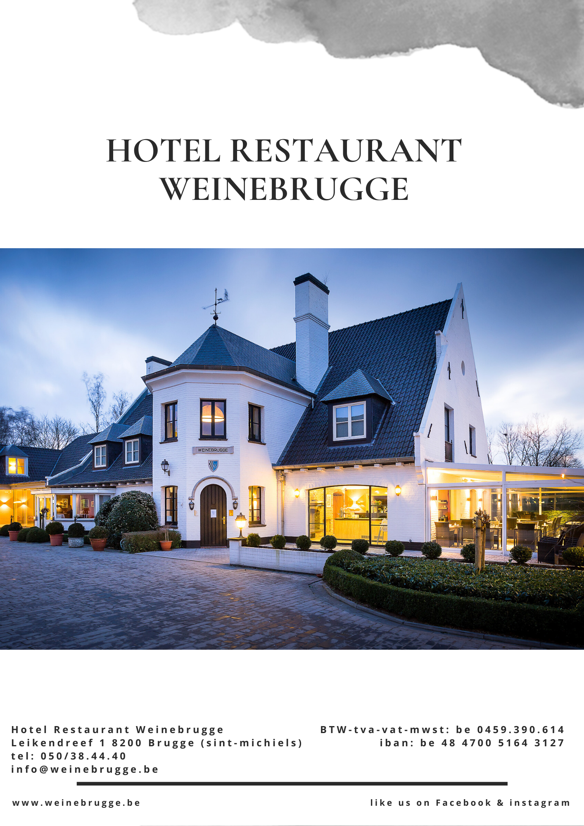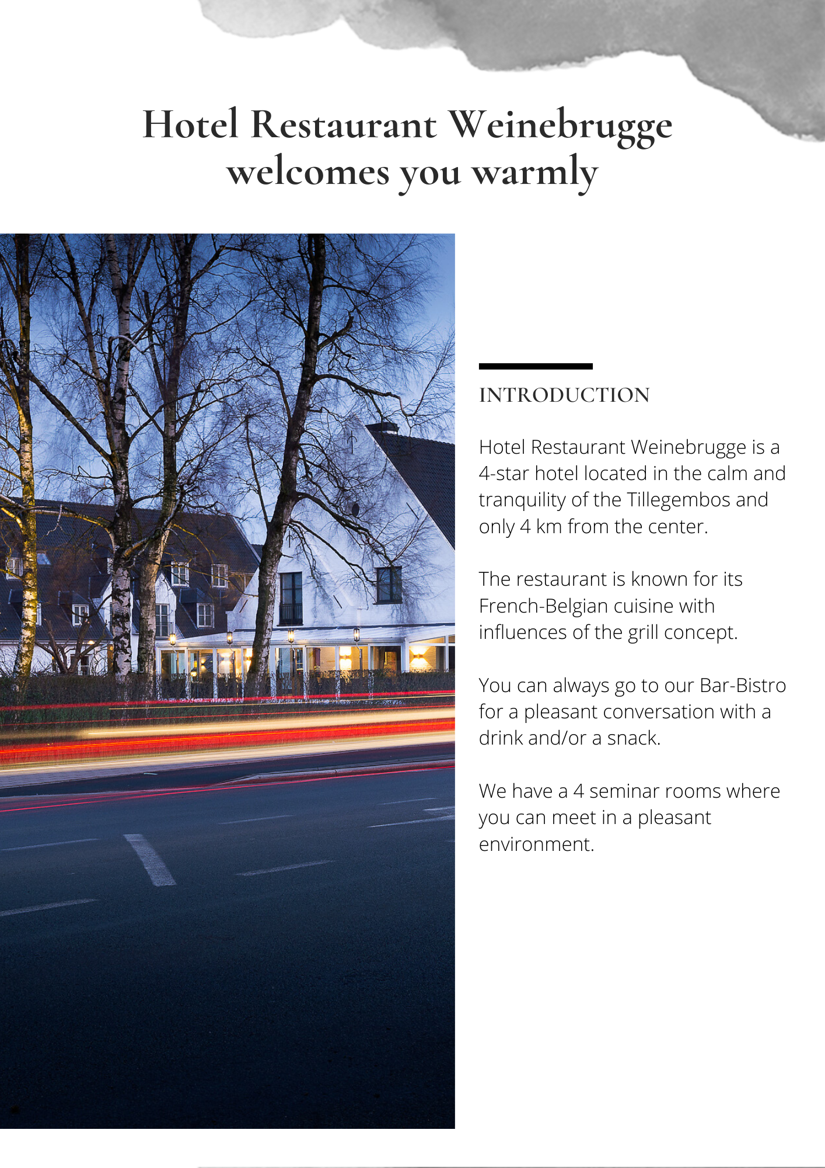
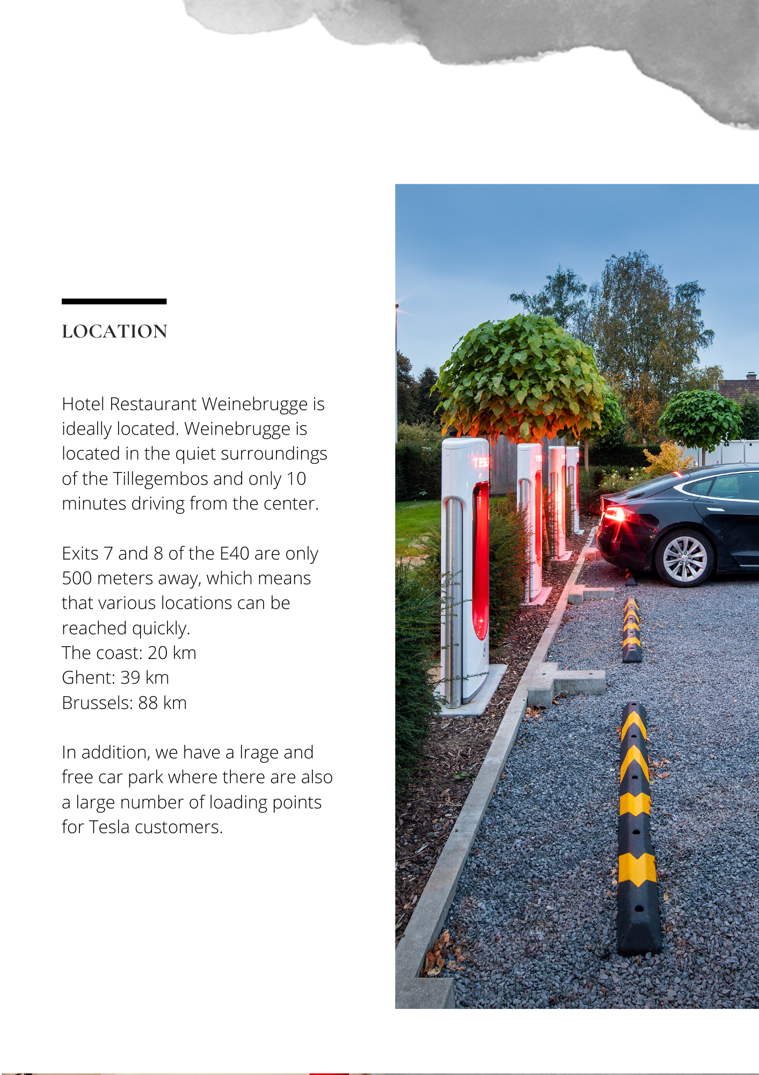
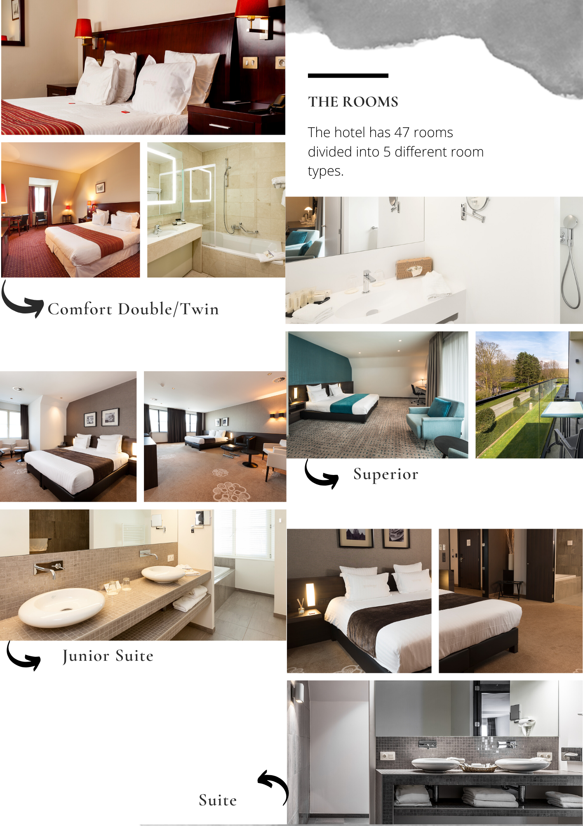
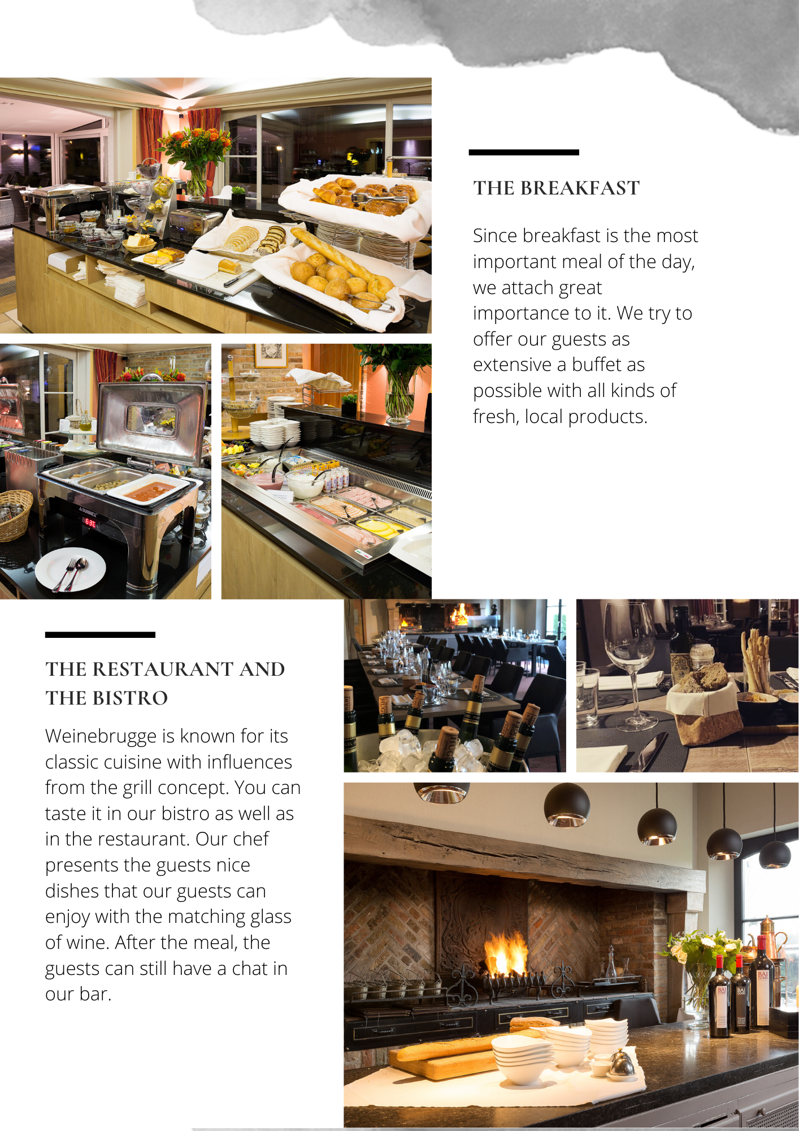

06.10.2021

Sender's contact person: Liessa Vanhoorne
Contact recipient: Liz Berdugo

For the period requested, we still have availability. We can offer you the following prices:

Check-in: 26.11.2021
Check-out: 28.11.2021
Total night : 2 night(s)
Comfort Double/Twin room(s) | € 140.00 per room per night
Comfort Single room(s) | € 115.00 per room per night
Upgrade Superior Double room(s) | € 30.00 per room per night

- City tax of € 3.00 per person per night is not included in the rate

If you would like to have Half Board, we can offer you the following:

- Fresh soup of the day with a local dish as main course at €18.00 per person
- A complete buffet with different dishes at €26.00 per person

Porterage:
We can provide porterage at the rate of 5.00 € per room one way.

For the reservation, we offer you the following:
- Room with breakfast
- Free bus parking
- Free use of Wi-Fi
- Free water during dinner, other drinks not included
- 1 Single free of charge per every 20 paying guests

Policies:
Payment Policy:
30 days before arrival: 30%
14 days before arrival: 70%

Cancelation Policy:
<45 days before arrival: 30%
>7 days before arrival: 100%

If you have any further questions, you can always contact us. For an optional reservation, you can also let us know.

For the moment there is no reservation taken in option or definitively.

Thank you very much in advance and we look forward to a positive response.

Sincerely,
Liessa Vanhoorne

Hotel - Restaurant Weinebrugge

