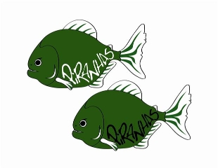Piranha Press
December 2011 Edition

Thank You!
Thank you to all parents, coaches, and swimmers for a great December Distance Meet!!! It was a fantastic event and I am very thankful to all of the parents who volunteered to make everything happen. Awesome swimming by all and a terrific day for the Piranhas, way to go!!! I hope everyone has a safe and happy holiday season, I am very grateful and appreciative for the opportunity to work with such great families, and wish everyone a terrific 2012!!!

Practice Changes
Here are the remaining practice changes for the month of December/Early January:
Saturday December 24th No Practice: Christmas Eve
Saturday December 31st No Practice: New Years Eve
Monday January 2nd No Practice: School Holiday

Holiday Practice Schedule
Here are the practice times for each group for Monday Dec. 26th – Friday Dec. 30th
Senior: M-F 11-2 (Dry land 11-12 @ Sheen; NO FITNESS ARTIST)
Junior: M-F 12-2
Age Group II: M,W,F 12-1:30
Age Group I: T,Th,F 12-1:00
Mini Piranhas: W,F 12-1:00

Upcoming Meets
The following meets are coming up in January; please make sure to check the website to sign up:
Meet | Dates | SR Boy | SR Girl | Junior | AG II | AG I | Mini
Starfish Invitational | Jan. 7-8th | Sat. | Sat. | X | X | X | X
Chris Goody IMX Meet | Jan. 14-15th | Sat. | Sat. | Sat.
Attleboro Blue Fish Meet | Jan. 28-29th |  | X | X

The Fitness Artist
For Seniors: January 3rd-February 9th
Tuesday and Thursday Nights BOTH will be @ Fitness Artist Studio from 5-6 PM

