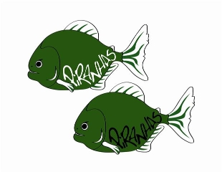Piranha Press
January 2013 Edition
Congratulations!!
Congratulations to everyone on a fantastic job at both the Starfish Invitational and Chris Goody IMX Meet!! We have already had more Gold Qualifiers than any prior season and we are not even into February yet!! Special Congratulations to Abby Lorch on winning the 8 & under High Point High Point Award Trophy @ the Starfish Invitational!
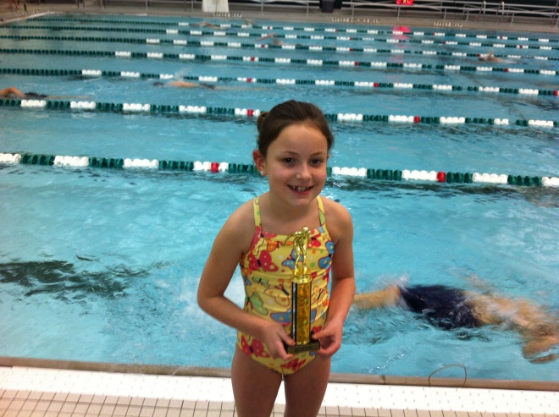
Practice Changes
Here are the remaining practice changes for the month of January:
Age Group I: Thurs. January 24th 6:30-7:30 PM
Junior: Thurs. January 24th 6:30-8:30 PM
Senior: Thurs. January 24th 6:30-8:30 PM (Dryland 5-6 @ Pool)

Attleboro Travel Meet
PLEASE NOTE THAT THE LOCATION OF THE MEET HAS BEEN CHANGED

Pool Address:
Roger Williams University
1 Old Ferry Road
Bristol Rhode Island 02809

I’d like to thank Kathy Keefe for setting up our original hotel choice @ Holiday Inn Express. That hotel is approximately 40 minutes away from the new pool location, so for those interested we were able to set up an additional hotel for the same price at the following location (approximately 10 minutes from the pool):

Marriott Residence Inn
325 West Main Road
Middletown, Rhode Island 02842

All swimmers should be dressed and on-deck no later than 12:00 for Saturday and Sunday. Everyone should wear either a Fast Skin suit (no LZR, those come later ) or their Piranhas team suit if they do not have one. Please wear Piranhas team caps, see Coach Dunham if you are in need of a new one.

GOOD LUCK TO ALL PIRANHAS SWIMMERS!!!

Piranhas Pentathlon
We will once again be hosting a meet on Sunday February 10th @ the Shen Aquatic Center. This meet is unique in that it will be a swimming pentathlon, where swimmers will compete in all 5 events and their cumulative times will be added and scored. This helps to reinforce one of the main Piranha Philosophies, which is that we want to develop all around swimmers who excel in all events and distances. Please be on the lookout for work assignments in an e-mail very soon. Thank you all in advance for your help!

End of Season Banquet
Please save the date for the end of season banquet which will be held Weds. March 27th. More details to follow next month.

Championship Meet Season
Our main focus of the season is right around the corner, championship meet season!! I wanted to take a quick second to highlight the difference in the upcoming championship meets and stress the importance of the commitment from everyone to attend those meets to help represent the Piranhas to our fullest potential.

Region I Championships (Feb. 15-18th) This is a qualifier meet for the Senior Group that is trials and finals @ Union College. All female qualifiers will be going Sat.-Mon. (Friday night for those selected to swim the 1650 or 1000 Free). All male qualifiers will swim on Monday only. Relays for most swimmers will be at night so all swimmers should plan on being at both prelims and finals

Silver Championships (March 1-3rd) The culminating meet for ALL swimmers who have not qualified in a particular event for Gold Championships. All 5 groups will be attending this meet Friday-Sunday @ RPI. For anyone who does not achieve a Gold Qualifying Time, this will mark the end of their season.

Gold Championships (March 10th, 15-17th) This is the end of season meet for all swimmers who hit a qualifying time. All 5 groups will be attending this meet and it is the primary focus for us as a team to get as many swimmers as possible qualified and 100% participation from those athletes. All 12 and unders swimming the 500 Free plus 13 and overs swimming the 1650 will swim a one-session meet on March 10th. All other qualifiers will be swimming March15-17th @ RPI.

*For Silver and Gold Championships, relays count DOUBLE for points so it is essential that everyone plan on participating the entire weekend to help our team reach its potential

**We will be ordering a championship t-shirt for all Gold Qualifiers, more info to follow next month

Speedo Sectionals (March 21-24th) This is an elite level regional traveling meet for all those who qualify. Our goal is to send multiple swimmers to gain additional exposure and represent the club at this prestigious meet in Buffalo NY.

The following swimmers have qualified for the following meets as of January 18th:
Region I Championships
Female
Autumn Boxley (50 Free, 500 Free)
Christy Brown (50 Free, 100 Free, 100 Back, 200 Back, 100 Fly)
Leah Constable (500 Free)
Angela Ferlo (50 Free, 100 Free, 200 Back)
Alyssa Gardiner (200 Breast, 400 IM)
Caitlyn Gardiner (100 Breast, 200 Breast)
Bridget Geary (50 Free, 100 Free, 200 Free, 100 Breast, 200 Breast)
Kristina Keefe (100 Back)
Tarah Killane (200 Free, 500 Free, 1000 Free, 1650 Free, 100 Back, 200 Back, 400 IM)
Colleen Luibrand (50 Free, 100 Free)
Paris Walkowiak (50 Free, 100 Free, 200 Free, 100 Fly)
Shawna Weaver (200 Free, 100 Fly, 400 IM)
Male
Peter Beidl (100 Free, 500 Free, 100 Back, 200 Back)
Eric Burdge (100 Free, 200 Free, 500 Free)
Mike Conley (50 Free, 100 Free, 200 Free, 500 Free, 100 Back, 200 Back, 100 Fly, 400 IM)
Piotr Czajkowski (50 Free, 100 Free, 200 Free, 500 Free, 1650 Free, 100 Back, 400 IM)
Alex Dreisbach (50 Free, 100 Free, 200 Free, 200 Back, 100 Fly, 200 IM, 400 IM)
Connor Killane (500 Free, 1650 Free, 200 Breast, 200 IM, 400 IM)
Tim Monaghan (100 Fly)
Dylan Yates (100 Breast, 200 IM, 400 IM)
Gold Championships
Female
8 and under
Izabella Czajkowski (50 Free, 100 Free)
Norah Eisnor (50 Free, 100 Free, 50 Back, 50 Breast, 50 Fly, 100 IM)
Abby Lorch (50 Free, 100 Free, 50 Back, 50 Breast, 50 Fly, 100 IM)
Lydia Pacinella (50 Free, 100 Free, 50 Back, 50 Fly, 100 IM)
Eva Sheffer (50 Free, 50 Back, 50 Breast)
9-10
Sarah Cooper (50 Free, 100 Free, 50 Back, 100 Back, 50 Breast, 100 Breast, 50 Fly, 100 IM)
Anne Gutelius (500 Free, 50 Breast, 100 Breast)
Natasha Sheffer (50 Free, 100 Free, 500 Free, 50 Back, 100 Back, 50 Breast, 100 Breast, 50 Fly, 200 IM)
11-12
Lizzie Buzash (50 Free, 50 Breast)
Hannah Gizara (50 Free, 100 Free, 50 Back, 100 Back, 200 Back, 50 Breast, 50 Fly, 100 IM)
Shuana Killane (100 Back, 50 Breast, 100 Breast, 50 Fly)
Lindsay Mayo (50 Fly)
Liz Roos (50 Breast)
13-14
Autumn Boxley (50 Free, 100 Free, 200 Free, 500 Free, 1650 Free, 100 Fly)
Leah Constable (100 Free, 200 Free, 500 Free, 1650 Free, 200 Back)
Helen Gutelius (200 Breast)
Aurielle Marvin (50 Free, 100 Free, 200 Free, 500 Free, 1650 Free, 100 Back, 200 Back, 100 Breast, 200 Breast, 100 Fly, 200 IM)

15 and over
Reilley Blue (200 Breast)
Christy Brown (50 Free, 100 Free, 200 Free, 100 Back, 200 Back, 100 Fly, 200 IM, 400 IM)
Julie DeGuardi (50 Free, 100 Free, 200 Free, 200 Back, 100 Fly)
Elizabeth Eisnor (50 Free, 100 Free, 200 Free, 100 Breast, 100 Fly, 200 IM)
Angela Ferlo (50 Free, 100 Free, 500 Free, 100 Back, 200 Back, 100 Breast, 100 Fly, 200 IM)
Alyssa Gardiner (50 Free, 100 Free, 200 Free, 100 Back, 200 Back 100 Breast, 200 Breast, 100 Fly, 200 Fly, 200 IM, 400 IM)
Caitlyn Gardiner (100 Free, 200 Free, 200 Back, 100 Breast, 200 Breast, 200 IM)
Bridget Geary (50 Free, 100 Free, 200 Free, 100 Back, 200 Back, 100 Breast, 200 Breast, 200 IM, 400 IM)
Tarah Killane (50 Free, 100 Free, 200 Free, 500 Free, 1650 Free, 100 Back, 200 Back, 200 Breast, 100 Fly, 200 Fly, 200 IM, 400 IM)
Kristina Keefe (50 Free, 100 Free, 100 Back, 200 Back, 100 Breast, 200 Breast, 100 Fly)
Colleen Luibrand (50 Free, 100 Free)
Gabby Marchetti (50 Free, 100 Free, 200 Free, 500 Free, 1650 Free, 100 Back, 200 Back, 100 Breast, 200 Breast,100 Fly, 200 Fly, 200 IM, 400 IM)
Karen Silaika (200 Back)
Paris Walkowiak (50 Free, 100 Free, 200 Free, 500 Free, 100 Back, 200 Back, 100 Fly, 200 Fly, 200 IM, 400 IM)
Shawna Weaver (50 Free, 100 Free, 200 Free, 500 Free, 100 Back, 200 Back, 200 Breast, 100 Fly, 200 Fly, 200 IM, 400 IM)
Male
8 and under
Zack Stoup (50 Back)
9-10
Devin Herbinger (50 Back, 50 Breast)
Ben Tandlymayer (50 Free, 100 Free, 50 Back)
11-12
Peter Kirkpatrick (50 Free, 100 Free, 500 Free, 100 Back)

13-14
Andy Ouyang (50 Free, 100 Free, 200 Back, 200 IM)
Alek Piekarski (100 Free)
Ian Tozier (50 Free, 100 Free, 200 Free, 100 Back)
15-18
Peter Beidl (50 Free, 100 Free, 100 Back, 200 Back, 200 Breast, 400 IM)
Eric Burdge (100 Free, 200 Free, 500 Free, 1650 Free, 100 Back, 200 Back, 100 Fly, 200 Fly, 200 IM, 400 IM)
Mike Conley (50 Free, 100 Free, 200 Free, 500 Free, 100 Back, 200 Back, 100 Fly, 200 Fly, 200 IM, 400 IM)
Piotr Czajowski (50 Free, 100 Free, 200 Free, 500 Free, 1650 Free, 100 Back, 200 Back, 100 Fly, 200 Fly, 200 IM, 400 IM)
Alex Dreisbach (50 Free, 100 Free, 200 Free, 200 Back, 100 Breast, 200 Breast, 100 Fly, 200 IM, 400 IM)
Christian Gizara (50 Free, 100 Free, 500 Free, 100 Back, 200 Back, 100 Breast, 200 Breast, 100 Fly, 200 IM. 400 IM)
Connor Killane (50 Free, 100 Free, 200 Free, 500 Free, 1650 Free, 100 Back, 200 Back, 100 Breast, 200 Breast, 100 Fly, 200 Fly, 200 IM, 400 IM)
Connor Melleady (500 Free, 200 Back, 200 Breast, 400 IM)
Tim Monaghan (100 Free, 100 Back, 200 Back, 200 Breast, 100 Fly, 200 Fly, 200 IM)
George Stack (50 Free, 100 Free, 200 Free, 500 Free, 100 Back, 200 Back, 100 Fly, 200 Fly, 200 IM)
Dylan Yates (50 Free, 500 Free, 200 Back, 100 Breast, 200 Breast, 100 Fly, 200 IM, 400 IM)
Speedo Sectionals
Bridget Geary(50 Free)
Alex Dreisbach (50 Free, 100 Free)

