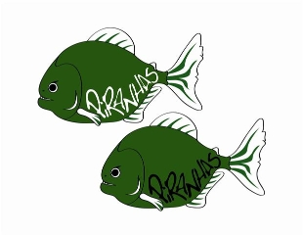Piranha Press
July 2013 Edition
As hard as it is to believe there are only 2 weeks left!! I would like to thank all of the parents, coaches, and swimmers for a great season and best of luck @ Championships! Thank you to all for helping run a very smooth and effective Summer Kick-Off meet, we could not do it without your support. We still have two meets on the horizon and want to show off all of the hard work and dedication that everyone has put in all season. Please read below for all of the details involving these meets, our end-of-season picnic and championship team dinner, as well as information about registration for the Fall-Winter Short Course Yard Season to continue on with the wonderful development from this past season!

Practice Changes
The following are the only practice changes for end of the season:
Weds. July 17th @ Shen Aquatic Center (Team Picnic; see below)
Seniors and Juniors 4-6 PM
Age Group II 4:30-6 PM
Age Group I and Mini Piranhas 5-6 PM Thurs.
**Last Day of Practice for Age Group II, Age Group I and Mini Piranhas**

New Paltz Meet
Please note that this is a positive check-in meet and all swimmers need to be on-time or they will be scratched from the meet. Please give yourself plenty of time to be there as it takes quite a while to travel. This is a fun meet and is outdoors so please dress accordingly and bring chairs to sit in! We would like to sit together as a team as well

All 12 and under swimmers need to be dressed and on-deck by 7:45 AM
All 13 and over swimmers need to be dressed and on-deck by 12:30 PM

***ALL SWIMMERS IN THE 400 FREE AND 1500 FREE TO PROVIDE THEIR OWN TIMER AND COUNTER***

Team Picnic (Wednesday July 17th)
We will be having an End-of-Season Team Picnic on Weds. July 17th @ Collins Park from 6-8 PM. The pool will be open for practice at the times listed above for all groups. This will allow them to practice and we encourage parents to help set-up @ Collins Park during this time. Parking is limited at the park; additional cars may park across the street at Clifton Park Community Church. There will be games, food, and fun!

Championship Meet Information
The following are arrival times for all swimmers attending championships @ Colgate University July 19th-21st:
All 13 and over swimmers need to be dressed and on-deck no later than 6:45AM
All 12 and under swimmers need to be dressed and on-deck no later than 12:30 PM
All 11 and older swimmers who qualify for finals need to be back no later than 5:00 PM

Please find the attached letter regarding team dinner @ Colgate Inn following Finals on Saturday night @ approximately 8:15 PM after the conclusion of the last event. Swimmers not swimming in Finals are highly encouraged to come back to the pool and cheer!!

Short Course/Fall-Winter Information
As part of our picnic, we will have a registration table for all current Piranhas to sign up for the Short Course Season. All swimmers who are being moved up will be notified by Coach Dunham beforehand. Here is some important dates/information regarding the Short Course/Fall-Winter Season:
July 17th: Registration for all current Piranhas @ Team Picnic
August 1st - 31st: Checks and Registration information can be mailed to the following address:
Lisa Gardiner
9 Timber Trace
Malta, NY 12020
***IN ORDER TO ASSURE YOUR SPOT ON THE SHORT COURSE TEAM, REGISTRATION INFORMATION MUST BE RECEIVED BY AUGUST 31st ***
We can guarantee that we will be at maximum capacity for the upcoming short course season. Failure to get your registration in prior to August 31st means that your spot will no longer be guaranteed so please plan accordingly. Important Dates for the Fall:
September 7th: 9-11 AM Registration/Tryouts for new and returning swimmers
September 12th: 6-8 PM Registration/Tryouts for new and returning swimmers
September 16th: Short Course Season Begins
GOOD LUCK IN COLLEGE
CLASS OF 2013!!!
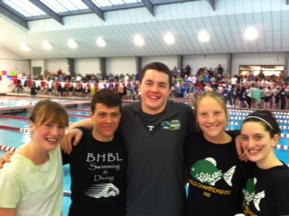
Good Afternoon Piranhas,
For those of you attending Long Course Championships in Colgate, we will be having a team dinner at the Colgate Inn on Saturday night following finals (exact time TBD). Team dinner will be a buffet style with the menu below at a cost of $25 per person including tip, tax etc. If you are attending please leave a check made out to the Piranhas by 7/11 in either Susan Celia or Michele Boxley’s folder, we will in turn put a coupon back in your folder indicating the number of dinners paid for, you will need to bring this coupon to the Colgate Inn for the team dinner, the banquet director will collect them at the door. Please email me (micheleboxley@gmail.com) or Susan (stogaspa@hotmail.com) should you have any questions. Thank you, looking forward to seeing you there.
FOOD:
Sports Team Buffet includes:
Tossed salad with two dressings on the side
Rolls and butter
Chef Starch
Chef Vegetable
Entrees: Penne Pasta with Marinara Sauce
Chicken Parmesan with Marinara Sauce
Platter of assorted cookies and brownies
BEVERAGES:
Pitchers of Ice Tea, Decaf, Coffee, Herbal teas, condiments

