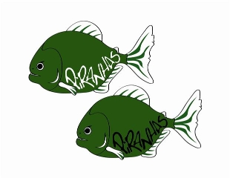Piranha Press
June 2013 Edition

Piranhas off to a great start!!
Congratulations to everyone on a great June so far!! All of the swimmers did a great job @ Meter Madness, and the Senior Group did a terrific job competing in the Triathlon!! Congratulations to the following award winners :
Meter Madness
Riley Simmons 2nd Place Girls 7 and Under!!
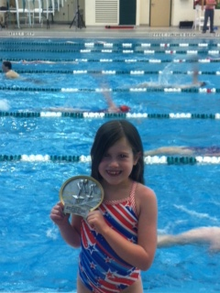
Hudson Crossing Triathlon
1st Place Alyssa Gardiner (15-19)
1st Place John Stack (Boys 10-14)
1st Place George Stack (Boys 10-14)
2nd Place Autumn Boxley (Girls 10-14)
2nd Place Clayton Bennice (Boys 10-14)
3rd Place Caitlyn Gardiner (Girls 15-19)
3rd Place Piotr Czajkowski (Boys 15-19)
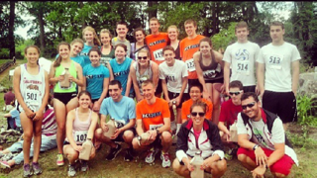
Piranhas Summer Kick Off Meet
A reminder that our team hosted Piranhas Summer Kick Off Meet is SATURDAY JUNE 15th. All Swimmers need to be dressed and on-deck by the following times:

All 9-12 year old swimmers need to be dressed and on-deck no later than 7:15 AM
All 8 and under,13+ swimmers need to be dressed and on-deck no later than 11:15 AM

Parents: Please check in at the concession stand to sign in for all job responsibilities and concession donations
Both sessions should run fairly quick and the 2nd session has been moved up by an hour. It is vital for the continued success and growth of our team to run a quality meet so I thank you in advance for your time and efforts. We moved the meet up a day to avoid Fathers Day as well so thank you to all the Dads AND Moms for all of your help This should be a great opportunity for us to once again host a fabulous meet, thank you in advance for all of your hard work in helping make everything happen!!

Congratulations Coach Caitlin Brauer!!
Congratulations to Coach Caitlin Brauer on being named the 2013 NE-10 Conference Woman of the Year!! In addition to balancing out her coaching duties with the Piranhas, Caitlin is an All-American in and out of the pool all 4 years @ The College of Saint Rose and recently completed her MBA in 4 years. She graduates having qualified for NCAA’s all 4 seasons and and was a finalist in the 400 IM along with numerous school record holder. Caitlin won the award out of over 4,000 student-athletes in over 23 sports that compete in the NE-10, the largest DII Conference in the country. The award was presented to someone who was “Leading the way in the classroom, on the field, and within the community”
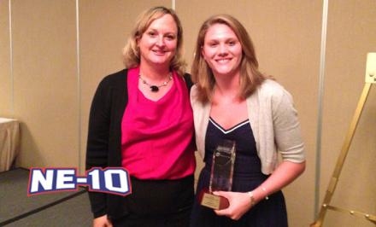

Summer Practice Schedule Changes
Below are the practice changes for all groups from June 24th-July 18th. They include the days that we will not be having practice and note the changes in both days and time.
*PLEASE CHECK THE WEBSITE FOR UP TO THE MINUTE PRACTICE CHANGES*
Summer Practice Schedule June 24th -July 12th
Group | Monday | Tuesday | Wednesday | Thursday | Friday
Senior Boys* | 6-8 PM | 7:30-9:30 | 7:30-9:30 | 7:30-9:30 | 4-6 PM
Senior Girls* | 6-8 PM | 7:30-9:30 | 7:30-9:30 | 7:30-9:30 | 4-6 PM
Junior | 6-8 PM | 7:30-9:30 | 7:30-9:30 | 7:30-9:30 | 4-6 PM
Age Group II | 6-7:30 PM |  | 6-7:30 PM |  | 4:30-6 PM
Age Group I | 6-7 PM |  | 6-7 PM |  | 4:30-6 PM
Mini Piranhas |  |  | 6-7 PM |  | 5-6 PM
- *Senior Boys and Senior Girls @ Fitness Artist Studio Tues/Th from 6-7 PM
- Senior and Juniors will practice outside @ Colonie Town Pool T-Th 7:30-9:30
- NO Practice on Saturdays, June 25th (Seniors will go to Studio), and July 4th
End of Year Picnic (Wednesday July 17th)
We will be once again be having an End-of-Season BBQ on Weds. July 17th @ Collins Park from 6-8 PM. Parking is limited at the park, additional cars may park across the street at Clifton Park Community Church. Also this will allow swimmers to register for the Fall/Winter Short Course Season as well. We 100% will have to turn swimmers away in the fall and be at full capacity, so to guarantee your spot on the team it is smart to sign-up at the Picnic. We will practice from 4-6 on this day so the swimmers can come and eat immediately after practice and get ready for summer championships.

Championships (July 19-21st)
Summer Championships will be the weekend of July 19th-21st. There are no qualifying times or prior requirements. ALL Piranhas swimmers are expected to attend a minimum of 1 day. 13 and over swimmers will swim trials/finals, while 10 and under swimmers will swim 1 session in the afternoon. 11-12 swimmers will swim trials/finals in the afternoon/evening. Families are on their own regarding hotels, if you are going for 1 day it is approximately a 2 hour drive. Thank you to Susan Celia and Michelle Boxley for arranging a team dinner @ Colgate Inn for Saturday Night following Finals, more info coming soon.
It is important that as we continue to grow as a club/team that we are well represented at all meets. Please make every effort to try to make it out to the meet for a min. of 1 day.
Remaining Summer Meet Schedule with Registration Deadlines
Meet | Date | Reg.  Deadline | Senior | Junior | Age Group II | Age Group I | Mini Piranhas
Hawks Invitational | Saturday 7/13 | Thursday 6/27 | X | X | X | X | X
Long Course Championships | Friday-Sunday 7/19-21 | Saturday 7/6 | X | X | X | X | X

