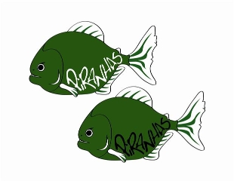Piranha Press
November 2013 Edition
Great Job!
We have had another terrific month of training and fast swimming in the pool!! I am very pleased and excited by the Attitude, Commitment, and Effort from the parents, coaches, and most importantly the swimmers. I am sure that we will ACE the rest of the season if we can continue to build off of the very strong foundation that we have laid out in the fall.

PIRANHAS COMING UP ACES!!

Practice Changes
Here are the remaining practice changes for the month of November:
Thursday November 28th: No Practice: HAPPY THANKSGIVING
Friday November 29^{th:} No Practice: Thanksgiving Break
Saturday November 30th: No Practice: Thanksgiving Break

Pilgrims Pride Meet
The Pilgrims Pride Meet is Sunday November 17th @ RPI.
All Swimmers 13&over, 8&under need to be dressed and on-deck no later than 6:45 AM
All Swimmers 9-10, 11-12 need to be dressed and on-deck no later than 12:15 PM

Harvest Invitational Meet
The Harvest Invitational Meet is Saturday November 23rd @ Ballston Spa High School.
All Swimmers 10 and under need to be dressed and on-deck no later than 6:45 AM
All Swimmers 11-12 need to be dressed and on-deck no later than 11:30 AM

Timing Assignments
Please make sure that you are diligently checking your e-mail regarding timing assignments. The club has gone to great lengths to evenly distribute the responsibilities amongst families and have put many layers to ensure that all of those people are held accountable if they are unable to attend. If you cannot fulfill your responsibilities, it is mandatory that you find a replacement and notify the timing coordinator of who is taking over your shift.
As our team continues to grow, it is important that we continue to maintain this kind of attention to detail and build systems such as this to ensure the participation of everyone. Please also understand that we cannot run meets without parent participation. Thank you all in advance for your help

December Meets
December Distance Meet: Sunday December 15th (Senior, Junior, Age Group II)
Registration Deadline: December 1st
12 and Under Mini-Meet: Saturday December 21st (Age Group I, Mini Piranhas)
Registration Deadline: December 7th

December Distance (Home Meet) Parent Work Assignments
Please remember to keep Sunday December 15th and Sunday February 9th open on your calendars. These are the dates of our home swim meets and ALL FAMILIES are expected to work both meets. Please understand there is a lot of work that goes into hosting a meet and we literally need “all hands on-deck”. Thank you to those who have already volunteered, we will be sending more information out very soon. Be on the lookout for a sign-up genie for work assignments, please be prepared to help out!

Great Job by Piranhas Swimmers at High School Sectionals!
Congratulations to all Piranhas Swimmers on an Outstanding Job @ Section 2 Girls High School Sectionals!!
Ballston Spa
Alyssa Gardiner (Junior)
200 IM: 11^{h}Place
100 Fly: 11thPlace
Caitlyn Gardiner (Junior)
200 IM: 17thPlace
100 Breast: 7thPlace
Kristina Keefe (Junior)
50 Free: 16thPlace
100 Back: 6thPlace
Paris Walkowiak (Junior)
200 Free: 4thPlace
100 Butterfly: 9th Place
Burnt Hills
Lizzie Buzash (8th Grade)
500 Free: 15th Place
Shawna Weaver (Sophomore)
200 Free: Section 2 Champion
500 Free: Section 2 Champion
***DIVISION 2 OUTSTANDING COMPETITOR OF THE MEET***
Saratoga
Autumn Boxley (Freshmen)
200 Free: 7th Place
500 Free: 3rd Place
Gabby Celia (Junior)
50 Free: 3rd Place
100 Breast: Section 2 Champion
Emily Danielson (Sophomore)
200 Free: 10th Place
100 Breast: 4th Place
Maddison Feeley (Junior)
200 Free: 11th Place
100 Free: 7th Place
Sophia Tannatta (Sophomore)
200 IM: 14th Place
100 Fly: 12th Place
Shaker
Elizabeth Morgan (Freshmen)
200 IM: 18th Place
100 Fly: 16th Place
Stephanie Morgan (Junior)
200 Free: 19th Place
500 Free: 19th Place
Shenendehowa
Leah Constable (Sophomore)
50 Free: 9thPlace
500 Free: 9th Place
Elizabeth Eisnor (Senior)
100 Breast: 9thPlace
Angela Ferlo (Senior)
50 Free: 12thPlace
100 Free: 11thPlace
Tarah Killane (Sophomore)
500 Free: 5th Place
100 Back: 7th Place
Colleen Luibrand (Senior)
50 Free: 5th Place
100 Free: 6th Place
Aurielle Marvin (Sophomore)
50 Free: 10thPlace
100 Breast: 12thPlace
Karen Silaika (Sophomore)
100 Back: 10th Place
*11 of our 20 Girls Competing Qualified for the State Meet!
**Good Luck @ States to Alyssa, Caitlyn, Kristina, Paris, Gabby, Autumn, Maddison, Emily, Shawna, Tarah, and Colleen**
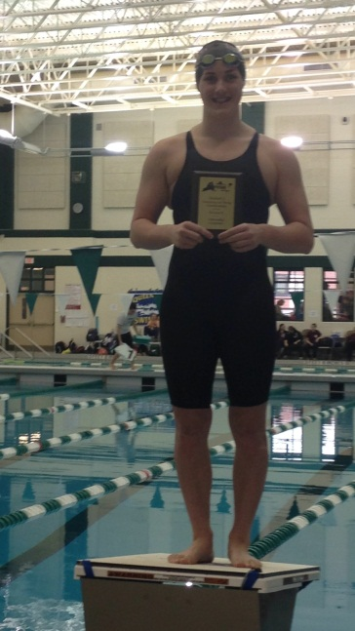

Terrific Job 12 and Under Travel Team!!
The Clifton Park Piranhas were represented by 4 members of the Travel Team at Roger Williams University in Bristol RI this weekend. The lady Piranhas performed like seasoned swimmers in this, their first out of district meet. In all, the girls competed in 35 swims and achieved: 22 Best times (63 % of the swims), 10 new "A" times, 1 new "BB" times, 6 Team records, and in the 11-12 age group, made finals in 5 events!!

Finishing in the top 6 among 9 year olds was Abby Lorch. 1st in the 50 Br, 2nd in the 200 IM/200 Fr, 3rd in the 50/100 Fr, and 4th in the 50/100 Bk/50 Fly.

Among 10 yr olds Natasha Sheffer finished: 2nd in the 50 Bk/50 Br, 3rd in the 50/100 Fr/100 Bk, 4th in the 200 IM, 5th in the 50 Fly and 6th in the 200 Free. Notable was that all 8 of her swims were "A" times and 6 were new TEAM RECORDS.
Competing in the 11 and 12 category, Shauna Killane achieved a new "A" time in prelims of the 200 IM came back in finals to lower that time once again! She also achieved an "A" time in the 100 Fly. Overall she placed: 3rd in the 200 Fly, 5th in the 200 IM, 6th in the 100 Br and 100 Fly and 7th in the 200 Free.
Norah Wilson swam to 6 new Best times to include a "BB" standard in the 100 Breast. Notable was her 18 second drop in her 1st event, the 200 IM!!!
Nice job ladies!!!!

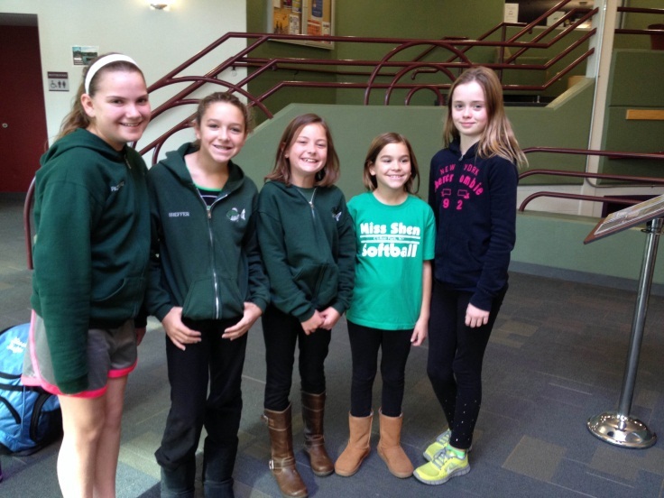

GREAT JOB PIRANHAS!!

