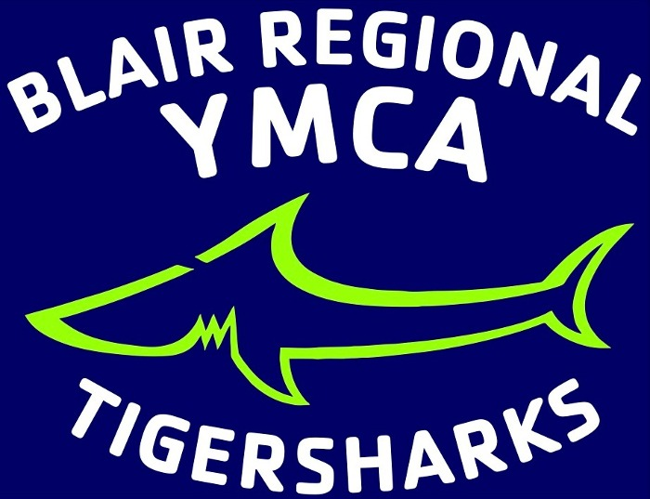

PERMISSION FOR UNRELATED APPLICABLE ADULT TO PROVIDE LOCAL TRANSPORTATION FOR MINOR ATHLETE CONSENT FORM

I,__________________________________________ , legal guardian of_________________________ ,

a minor athlete, give express written permission, and grant an exception to the Minor Athlete Abuse

Prevention Policy for_____________________________________________ to provide local vehicle
Unrelated Applicable Adult
transportation to___________________________________ to_______________________________
Minor Athlete Destination
On ____________________________at __________________________, and further acknowledge that
Date(s) of Travel Approximate Time Frame

this written permission is valid only for the transportation on the specified date and to the specified

location.

___________________________________________ _________________
Parent/Legal Guardian Signature Date

