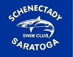 Schenectady-Saratoga Swim Club

Please fill out the following and return the form with check made payable to “SSSC” at: Laura Davis, 1380 Ruffner Road, Niskayuna NY 12309. Information must be received by October 5, 2019 to be included in the first meet. Send camera ready (preferably .JPG) logos to: dranelson1539@gmail.com
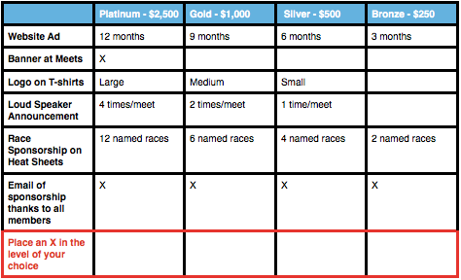
Sponsor Name _______________________________________________________________
Sponsor Contact__________________________________Phone_______________________
Email_____________________________________________Fax______________________
Address___________________________________________________________________
__________________________________________________________________________
Swim Team Rep Name __________________________________Phone__________________
Email___________________________________________________

