SST NEWS
PO Box 72301
Fairbanks, AK 99707

Phone: 970-689-1407
Email: coachjosh@outlook.com
Web: www.stingrayswim.org

April, 2016 Volume 3, Issue 4

12 Keys to a Winning Program
By Alan Stein, Performance Coach at DeMatha High School

When we say ‘winning’, we are not referring to the win/loss column exclusively. We are referring to a winning culture, developing winning habits and setting winning standards. Winning is all about commitment. Every swimmer and every coach must be committed to:

- Academic work. Aim for success in everything you do, not just the things you want to do
- Behavior. Carry yourself in a first class manner at all times. Be respectful
- Character. Doing the right thing all the time (not just when someone is watching)
- The Program. No one is bigger than the group and no group is bigger than the program
- Working Hard. There is never an excuse to let someone outwork you. Never
- Working Smart. Workout with efficiency and purpose. Learn how to train the right way
- Working Consistently. Anyone can be good for a day. Work hard/smart every day
- Unselfishness. Be a positive leader. Put other’s needs first.
- A Winning Attitude. Earn confidence through effort and demonstrated performance
- The Team. Commit to your team’s philosophy and system
- Your Role. Know it. Embrace it. Take pride in it. Fulfill it to the best of your ability
- Your Teammates and Coaches. They are your brother/sisters. You are a family. When one succeeds you all succeed

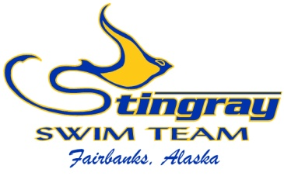
Inside This Issue:
Keys to a
‘winning’ program 1

NA Champ Recap 2

Swim-a-Thon 3

Summer CA Trip 4-5

State Ranking 6

Parent Ed Meetings 7

April at a Glance 8

2016 Meet
Schedule 9

NORTHERN AREA CHAMPIONSHIP RECAP
Congratulations to all of our swimmers on an outstanding Northern Area Conference Championship meet. We were the second largest team with 64 swimmers (behind NPAC with 67) and each athlete did a wonderful job. We were impressed with everyone’s energy, sportsmanship, and cheering. We also raced very well and made this the closest NA Champ meet in ten years. We put pressure on MSST as the team scores went back and forth all weekend. MSST ended up winning the meet with 3,313.5 points, followed by SST with 3,068, NPAC with 2,908, Nome with 275 and Unattached (Galina and Delta) with 207. SST finished 2nd in the women’s score behind MSST and 2nd in the men’s score behind NPAC. The 245.5-point difference between SST and MSST was the closest in ten years, and we improved on our 600-point deficit from last season. We continue to improve and get closer to a conference championship…maybe 2017 will be our year.
Our outstanding meet was highlighted by having the best disqualification percentage of all attached team (meaning all USA Swimming Sanctioned teams: SST, MSST, NPAC, NNST). We only had 5% of our swims disqualified and we also had the best time improvement of all teams with 54%. This shows our swimmers are learning and improving each day in technique and speed. This may be the most satisfying statistic to the coaching staff and we could not be more proud.
Our swimmers also took home some serious hardware. SST was 2nd in the medal count with 123 total medals, 45 of which were gold, 43 silver, and 35 bronze. We were on the medal podium all weekend and nearly every athlete scored points for the team. We also had a large number of high point winners (scoring the top three most points in their age division throughout the whole meet). Our individual high point winners were: Fiona Secor (2nd), Meah McCallum (1st), Lily Hsieh (3rd), Lauren White (2nd), Logan Fox (1st), Crieghton Beshears (1st), and Tristan O’Donoghue (1st). Two Stingray swimmers also broke Northern Area Records. Meah McCallum broke her own NA record in the 1,650 free, as well as Coach Felina’s record in the 1,000 free. Logan Fox broke his own NA record in the 1,000 free. Congratulations swimmers!
This meet also took a great deal of volunteers, and we would like to thank each and every volunteer for your time and effort. We understand it was a long weekend at the pool, but it would not be possible without you. Thank you and congratulations on being part of an extremely smooth, successful meet.
We saw our swimmers earn 130 Alaska Age Group Championship times, 163 Alaska Summer Championship times, 90 Alaska Junior Olympic Championship times, 37 Alaska Senior Championship times, and 32 Oregon/Region XII Championship times.

SWIM-A-THON IN FULL SWING

Our annual Stingray Swim-a-Thon is in full swing and we hope you are calling friends/family for donations. The monies raised during our Swim-a-Thon are vital to our team’s success and is a required fundraiser. Each swimmer much secure a minimum of $100 in donations, but don’t stop there! The top individual performer will receive a coveted gift card, the top roster group will get a pizza party, and the top location will get a fun-day at practice. Plus, SST will purchase new starting blocks for both pools if we reach our goal of $18,000. With less than one month left in the donation period, please don’t delay. The time is NOW to generate excitement and collect donations.

The donation process is easy and is all done through our website. Log into your team account and click any of the Swim-a-Thon banners. You can then send donor emails with full instructions, modify your personal Swim-a-Thon page, and track your progress. Please watch the ‘help video’ in your Swim-a-Thon page for more information.

On Saturday, April 30th we will meet at Hamme Pool for the actual event. Copper-Gold will swim from 2:00-4:00pm, and Platinum-Senior will swim 4:00-6:00pm. All swimmers will complete as many lengths of the pool as possible within those two hours (up to 200 lengths). Parents will help count laps, we will have music and a pancake feast, and the diving well will be open once swimmers are done with their laps. This is a great event for the whole family.

We will also hold our Board of Director elections and Bylaw Amendment voting at 3:00pm. It is critical that each family submits their vote. Board position nominations are due by April 25th to sstboardelections@outlook.com. For more information about the Swim-a-Thon and Board Elections, please visit our website and click on ‘Swim-a-Thon’ under the ‘team functions’ tab.

Current Leaders:
Top Individual | Top Roster (avg) | Top Location (avg)
Lauren White - $440 | Junior - $426.67 | Patty Pool - $85.33
Grace White - $440 | Gold - $200 | Alaska Club - $45
Logan Fox - $400 | Silver - $165
Hunter Lankford - $200 | Platinum - $110
Brooks Whitman - $165 | Bronze - $105

SUMMER CALIFORNIA TRIP
The Stingray Swim Team will be travelling to a swim meet in Santa Clara, California in June. The meet, hosted by De Anza Cupertino Aquatics, will be held June 3-5. In the evenings the swimmers will have the opportunity to watch the Arena Pro Swim Series and witness world class swimming first hand.

Planning for this travel team has begun. All SST swimmers are welcome and encouraged to attend. Swimmers over 12 years old may attend without a parent and will be chaperoned by either Coach Josh or a team chaperone. Swimmer’s under 12 must have a parents or guardian on the trip.

The meet will start Friday, June 3, so please plan to arrive in California by June 2. There are several airports that serve the Santa Clara area (San Francisco, Oakland, San Jose) but San Jose will be the closest and most convenient to fly into. Any swimmers attending the meet without a parent must fly to/from the meet with Coach Josh. His flights are listed below. Please use his confirmation number to link your swimmer’s reservation to his.

FLIGHTS
Confirmation code: NKGVEB Alaska Airlines

6/2/16 flight 2818 FAI-ANC
flight 80 ANC-SEA
flight 322 SEA-SJC

6/7/16 flight 327 SJC-SEA
flight 123 SEA-FAI

HOTEL
We will be staying at The Plaza Suites Hotel, 3100 Lakeside Drive, Santa Clara, which is close to the pool we will swim at and the pool we will watch the Arena Pro Series.
- Rates are:
  - Deluxe King Suite $169/night
  - Deluxe Double Suites $179/night
Use the link on the SST website (can be found under the EVENTS TAB) or call 1-800-345-1554 and ask for Stingray Swim Team rate. Rate is available May 30-June 9 if you plan on extending your trip on either end.

ARENA PRO SERIES
We will attend the Arena Pro Series in the evening. The team will purchase the 3 day passes which include tickets to get into the meet, food/drink at the meet, parking passes and a t shirt. More event info at: http://www.usaswimming.org/DesktopDefault.aspx?TabId=2062&Alias=Rainbow&Lang=en

ACTIVITIES
Monday, June 6 the team will attend a water park or amusement park. We will present the swimmer’s going on the trip with a few options in the San Jose area and let them vote on which one they want to attend. The team will purchase these tickets ahead of time to take advantage of group discounts.

FEES
There will be a $350 fee per swimmer, which must be paid in full by April 30, to attend this meet. This fee will cover the following costs:
$125-Arena Pro Series tickets
$100-Travel fee (to offset coach’s travel costs)
$75-water/amusement park tickets (if less than $75, we will credit your account)
$50 meet fees (if less/more, you will see credit/debit posted to your account)

Hotel, airfare & food costs will be your responsibility. The hotel costs for chaperoned swimmers travelling with the team with be determined once we know the number and gender of unaccompanied swimmers.

If you plan to attend the Summer Trip please fill out the declaration form (on team website) and return to Coach Josh with your check for $350 (made out to Stingray Swim Team) no later than April 30. If you have any questions, please contact:

Head Coach Josh Gregory
970-689-1407 or coachjosh@outlook.com

Travel Coordinator Laurie Keyes
907-378-5423 or lauriekeyes.ak@gmail.com

Travel Coordinator Ann Marie White
907-450-9173 or amwhite@acsalaska.net

STATE RANKING LEADING INTO JOs
We finished last season (after JOs) with a 7th place state ranking. This was in improvement from our 14th place ranking in 2013-2014. Before this season began, we made it a team goal to finish in the top 5. The top 5 teams in the state are generally very close and it is a big accomplishment to earn a top 5 ranking. With JOs only a few weeks away, we are within striking distance of that number 5 spot. We will be prepared, excited, and will give everything we have to secure a top 5 state ranking in 2015-2016.
Every swimmer and every meet plays a part in this ranking. USA Swimming takes each swimmer’s times across the entire season to build state rankings, regional rankings, and national rankings. If you swam in any meet this season, you played a critical role. Here is where we stand leading into JOs:

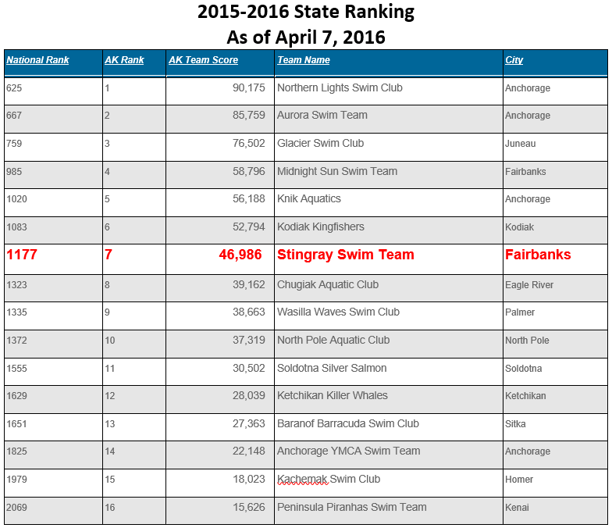

PARENT EDUCATION MEETINGS
We held our first parent education meeting in March and covered multiple topics including, Swim-a-Thon, progressing through the group structure, competitive events, and how to be a successful swim parent. We had roughly 30 parents in attendance. If you were unable to attend, you can find the presentation materials and meeting minutes on the team website.
We will hold these meetings every other month. It is important for parents to understand the sport, learn more about our program, and have an in-person opportunity to ask questions. We will also share the latest news/updates regarding technique, nutrition, motivation, and development. Our next two meetings will be held at UAF, time and date TBA. Please plan to attend these important informational meetings.

May 2016
“The Power of Proper Nutrition”

July 2016
“The College Recruiting Process”
(high school swimmers only)

APRIL AT A GLANCE
  - April 1 – Vincent Maio’s Birthday
  - April 1 – Ryan Nash’s Birthday
  - April 8 – House of Delegates Meeting (Anchorage)
    - Alaska Swimming Legislature
  - April 9 – USA Swimposium (Anchorage)
  - April 11 – Cassidy Welsh’s Birthday
  - April 14 – Baylee Gutzman’s Birthday
  - April 21-24 – Junior Olympics (Anchorage)
    - Entry deadline April 13th
  - April 25 – Sam Atchison’s Birthday
  - April 26 – Timberlyn Wendt’s Birthday
  - April 28 – Meah McCallum’s Birthday
  - April 30 – Swim-a-Thon (Hamme Pool)
    - Copper-Gold swim 2:00-4:00pm
    - Platinum-Senior swim 4:00-6:00pm
    - Elections (all parents) 3:00pm

SST 2016 Meet Schedule (remaining)

Alaska Junior Olympic Championships (deadline 4/13/16)
April 21-24
Prelim/Final Meet
*qualification standards
Bartlett Pool, Anchorage

De Anza Cupertino A/B/C Invite (deadline 4/30/16)
and Area Pro Series at Santa Clara
June 3-5
*swim in morning, watch finals of Pro Series at night
**no qualification standards, open to all
Santa Clara, CA

Alaska Summer Championships (deadline 7/13/16)
July 21-24
Prelim/Final Meet
*qualification standards
Bartlett Pool, Anchorage

