SST NEWS
PO Box 72301
Fairbanks, AK 99707

Phone: 970-689-1407
Email: coachjosh@outlook.com
Web: www.stingrayswim.org

February, 2015 Volume 2, Issue 4

TOP FOOD MISTAKES MADE BY SWIMMERS
Mistake No. 1: Thinking you can eat whatever you want because you are very active.
It is true that active young swimmers burn a lot of calories in training and have a higher need for calories because they are growing. However, that doesn’t mean you can thrive by eating double quarter pounders with cheese, fries and large soft drinks. That meal contains 1250 calories, easily a third to half of an active swimmer’s calorie needs for the entire day. Every fast food restaurant offers healthier choices these days, even on the value menu, so when faced with choices, make good ones. A better choice would be a regular cheeseburger, small fries and a fruit ‘n yogurt parfait for about half the calories with the added benefit more healthful nutrients and less fat and sodium. And, it still tastes pretty good if you like fast foods.

Mistake No. 2: Thinking more is better when it comes to protein.
Protein is very important for athletes, but more isn’t better. Research shows that you need 0.55-0.90 grams of protein per pound of body weight per day. Most swimmers should aim for somewhere in the middle of the range. The higher end of the range is needed when you are cutting calories to reduce body fat. For recovery, you need about 20 grams of high quality protein within the first hour after exercise. The double quarter pounder meal has almost 50 grams of protein, way more than needed for recovery. The single cheeseburger meals has about 20 grams of protein…just right. Extra protein isn’t stored in the muscles. It is broken down for energy which can be stored as fat. The excess nitrogen (the part that makes protein unique from carbohydrate or fat) gets eliminated in the urine.

Mistake No. 3: Overemphasizing the value of supplements and undervaluing the power of healthy foods.
I must admit that the marketing for healthy foods is not nearly as exciting as for supplements. Supplement ads promise quick weight loss, bigger muscles, and increased energy; one study of about 600 supplements identified over 800 performance enhancing claims, most of which were bogus without scientific backing. Supplements are no short-cut to improving body composition, building muscle or increasing performance. Supplements have the added risk of containing banned or illegal substances that could harm your health and your sports career. That is why USA Swimming takes a food-first approach when advising athletes.

CHRIS ROSENBLOOM//PHD, RDN, CSSD, consultant for USAS

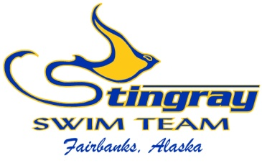
Inside This Issue:
Food Mistakes 1
5 Protein Steps 2-3

Stingray Recognition 3-4
Swimmers of the
Month 5

February at a Glance 6
SST 2014-2015
Meet Schedule 7

5 STRATIGIES TO MAKE SURE YOUR SWIMMER GETS ENOUGH PROTEIN
Protein is a nutrient everyone in the sports world talks about, from boosting it in the diet to eating the right types. Protein certainly plays an important role in the young swimmer’s diet. For one, it has a starring role in growth, supporting the building of new tissue. Protein also lends a hand in muscle repair. During intensive exercise, muscles work hard and break down. Protein, and the amino acids that make up protein, help repair muscle damage and support muscle growth.
Most nutrition experts agree that getting protein from food is the ideal strategy for growing athletes. But some athletes (and their parents) worry that their swimmer isn’t eating enough.
Rest assured, most young athletes get plenty of protein in their diet from the food they eat. In fact, studies show that most young athletes eat 2-3 times more protein than they need. However, swimmers who diet or follow a vegan diet may fall short on good protein sources.
Getting enough protein isn’t the only issue for athletes, though. The timing of when protein is eaten matters also. For example, spacing protein evenly across the day is ideal for making sure protein is available to the body when needed. And, eating a source of protein within 45 minutes of a grueling workout is linked to improved muscle repair.
Here are some fail-proof strategies to ensure swimmers get enough protein, and at the right times:
Know your Protein: Food including meats like beef, lamb, chicken and other poultry sources; fish; beans and products made with beans like hummus and other bean-based dips; eggs; milk; soymilk; cheese; yogurt; and nuts and nut butters are all good sources of protein.
Space out Protein: Make sure you eat a quality protein source at each meal and include protein with most snacks. This effort will make protein available to muscles and the rest of the body throughout the day.
Recover with a Protein-containing Snack: A source of protein eaten within 45 minutes of intensive exercise has been linked to muscle recovery and muscle mass gain. Studies have pointed to chocolate milk as a good recovery snack, as it contains protein (a casein- and whey-based type of protein) and carbohydrate, of which effectively repair muscle and supply glycogen (energy) to the muscle, respectively. Other sources of protein, like cheese or yogurt, combined

with a carbs like crackers or fruit, likely provide similar benefits as chocolate milk.
Drink Milk or Soymilk Regularly: Drinking milk or soymilk with meals is one easy way to assure protein appears at mealtime. Of course, if the swimmer is eating other protein foods at that time, milk may not be needed. Milk and soymilk are also packed with other nutrients important for the swimmer like calcium and vitamin D.
Don’t Overdo It with Extra Protein: Adding extra protein to shakes, or eating high protein bars or other supplements isn’t necessary for the young athlete and may provide too much protein. Going overboard with protein can contribute to dehydration, stress the kidneys, and promote unwanted weight gain.

STINGRAY RECOGNITION
We would like to congratulate all our Stingray swimmers on a fabulous season thus far. We have had great technique improvement on all levels, which has enabled our times to improve faster than the Alaska Swimming average (table 1). We have also improved our team ranking from last year and are currently in 8th place throughout the state (table 2). We even won the Most Points Per Swimmer Award at the 2015 Great Alaska Open in Juneau. This improvement is a testimate to each swimmers effort and drive to be the best swimmer they can. Our coaches focus on a fun, instructional environment and strive to give each swimmer the individual attention they deserve. With our championship meet season in full swing, we look forward to more time improvement and fast swims.
We would also like to thank our amazing parents and volunteers. The Stingrays would not be successful, or even exist, without the support of our parents and volunteers. Many of you have volunteered this season as officials, timers, computer operators, ribbon managers, etc. We thank you for your time and effort!
With many of our championship meets having qualification standards (times that must be achieved in order to attend the meet), we are very excited for the Northern Area Championships on March 27-29 at Hamme Pool. This meet has no qualification standards and is open to all Stingray swimmers. We have the oportunity to win this meet for the first time in many years, but it will take our entire team to make this happen. We hope to see everyone sign up for this fun meet once the entry file is available. Thank you again and GO STINGRAYS!

Table 1
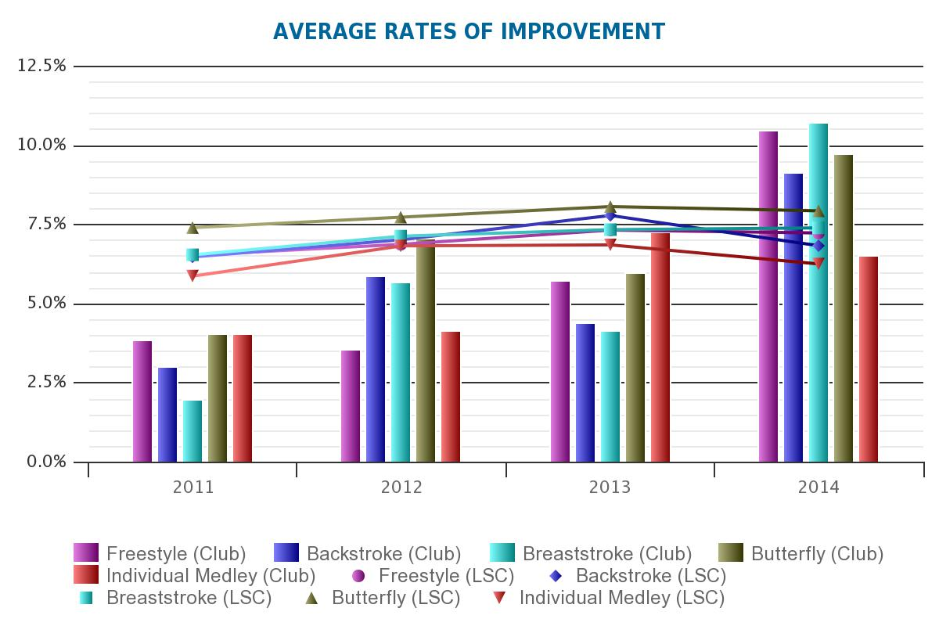
Table 2
National Rank | Alaska Rank | AK Team Score | Team Name | City
553 | 1 | 85,276 | Northern Lights Swim Club | Anchorage
615 | 2 | 77,650 | Aurora Swim Team | Anchorage
754 | 3 | 65,798 | Glacier Swim Club | Juneau
938 | 4 | 52,792 | Knik Aquatics | Anchorage
947 | 5 | 51,766 | Midnight Sun Swim Team | Fairbanks
1183 | 6 | 38,358 | Baranof Barracuda Swim Club | Sitka
1200 | 7 | 36,769 | Kodiak Kingfishers | Kodiak
1253 | 8 | 34,557 | Stingray Swim Team | Fairbanks
1381 | 9 | 29,663 | Soldotna Silver Salmon | Soldotna
1403 | 10 | 28,622 | Wasilla Waves Swim Club | Palmer
1418 | 11 | 28,233 | North Pole Aquatic Club | North Pole
1428 | 12 | 27,934 | Chugiak Aquatic Club | Eagle River
1719 | 13 | 19,336 | Ketchikan Killer Whales | Ketchikan
1733 | 14 | 18,985 | Viking Swim Club | Petersburg
1867 | 15 | 15,704 | Seward Tsunami Swim Club | Seward
1907 | 16 | 15,002 | Anchorage YMCA Swim Team | Anchorage
2089 | 17 | 11,213 | Kachemak Swim Club | Homer

SWIMMERS OF THE MONTH IN JANUARY

To be selected as the Swimmers of the Month, athletes must show their dedication to our team through their hard work, attendance, desire to improve, teamwork, and ability to listen to instruction. We are proud to look back at January’s Stingray Swimmers of the Month.

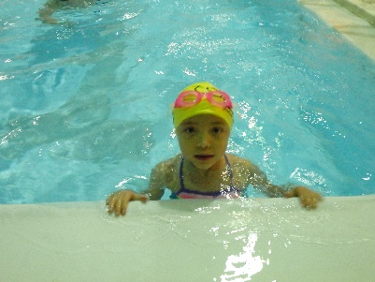
Angela Huffer
Angela joined the Stingrays in September, 2014 and has been improving ever since. She has put in a lot of work on her technique and is seeing great improvement in her speed. She listens well and puts her coach’s instruction into action. She has become a leader in the Bronze Group and is a pleasure to work with. During the Robb Coady Novice Invite, she posted two best times in the 25 free and 25 back, placing 12th in each. She then swam four events in the Valentine’s Day Meet, posting three best times in the 50 free (7th), 50 back (6th), and again in the 50 free leading off her 200 free relay (8th). She has attended 83% of her workouts this season which has allowed her great success. Congratulations Angela on being January’s Stingray Swimmer of the Month!

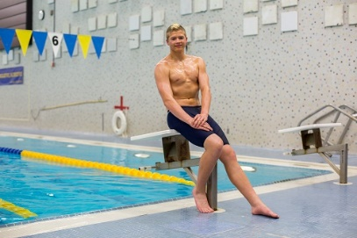
Tristan O’Donoghue
Tristan rejoined the Stingrays this season in November after a very successful high school season. He is a leader at the Patty Pool and one of our fastest 15&Over swimmers. He has improved his endurance and has very high goals for the remainder of the year. During the Great Alaska Open last month, he won the 100 and 200 back and also finaled in the rest of his events. He has multiple qualification standards for all of our championship meets, including Senior Sectionals this March in Federal Way, Washington. He owns 21 Stingray team records as a previous and current team member. He is a very hard worker and listens well, attending 78% of his workouts this season. Congratulations Tristan on being January’s Stingray Swimmer of the Month!

FEBRUARY AT A GLANCE
- February 4 – Ezra Billings’ Birthday
- February 4 – Heidi Billings’ Birthday
- February 5 – Annika Merkel’s Birthday
- February 5 – Patty Pool Closed
- February 9 – Arwen Gustafson’s Birthday
- February 10 – Board of Director Meeting
  - Location: Polar Fuel
  - Time: 6:30pm
  - All members are welcome to attend
- February 12 – Jace Zaldivar’s Birthday
- February 12 – Patty Pool Closed
- February 13-15 – Alaska Age Group Championships
  - Location: Juneau, AK
  - Qualified swimmers only
- February 21 – Talia Wentz’s Birthday
- February 22 – Anne Gregor’s Birthday
- February 24 – Sophie Henry’s Birthday
- February 26 – Patty Pool Closed
- February 27 – Abigail Dixon’s Birthday

SST 2014-2015 Meet Schedule

Fall Equinox Meet September 20 – Wescott Pool
Warm ups: 8:00 am

Halloween Meet October 18 – Patty Pool
Warm ups: 2:30 pm

Wishbone Invite November 14-16 – Hamme Pool
Prelim/Final Meet

Coach Robb Coady Novice Invite December 6 – Hamme Pool
Warm ups: 8:00 am

Candy Cane Swim Meet December 13 – Wescott Pool
Warm ups: 8:00 am

Spring Will Come Meet January 10 – Hamme Pool
Warm ups: 8:00 am

Valentine’s Day Meet January 31 (scheduled to change) – Patty Pool
Warm ups: 8:00 am

AK Age Group Championships February 13-15
Juneau, AK

Region XII Championships March 5-8
Gresham, OR

St. Patrick’s Day Meet March 14 – Wescott Pool
Warm ups: 8:00 am

Northern Area Championships March 27-29 – Hamme Pool
Prelim/Final Meet

AK Junior Olympics April 23-26 - Bartlett Pool
Anchorage, AK

