SST NEWS
PO Box 72301
Fairbanks, AK 99707

Phone: 970-689-1407
Email: coachjosh@outlook.com
Web: www.stingrayswim.org

June, 2016 Volume 3, Issue 5

9 Ways to be a Great Team Member
Jon Gordon, May 31, 2016
While watching all the great sporting events on television this weekend it was clear that no one achieves success alone. We all need a great team to accomplish great things. In this spirit I want to share 9 ways to be a great team member.

1. Set the Example - Instead of worrying about the lack of performance, productivity and commitment of others you simply decide to set the example and show your team members what hard work, passion and commitment looks like. When you do this you’ll raise the standards and performance of everyone around you.

2. Use Your Strengths to Help the Team - The most powerful way you can contribute to your team is to use your gifts and talents to contribute to the team's vision and goals. Without your effort, focus, talent and growth the team won't accomplish its mission.

3. Share Positive Contagious Energy - Research shows emotions are contagious and each day you are infecting your team with either positive energy or negative energy. When you share positive energy you infectiously enhance the mood, morale and performance of your team. Remember, negativity is toxic.

4. Know and Live the Magic Ratio - High performing teams have more positive interactions than negative interactions. 3:1 is the ratio to remember. Teams that experience interactions at a ratio equal or greater than 3:1 are more productive and higher performing than those with a ratio of less than 3:1. This means you can be a great team member by being a 3 to 1'er. Create more positive interactions.

5. Put the Team First - Great team players always put the team first. They work hard for the team. They develop themselves for the team. They serve the team. They don't take credit. They give credit to the team.

6. Build Relationships - Relationships are the foundation upon which winning teams are built and great team members take the time to connect, communicate and care to build strong bonds and relationships with all their team members

7. Trust and Be Trusted - You can't have a strong team without strong relationships. And you can't have strong relationships without trust. Great team members trust their teammates and most of all their team members trust them.

8. Hold Them Accountable - Sometimes our team members fall short of the team's expectations. Sometimes they make mistakes. Sometimes they need a little tough love. Great team members hold each other accountable. They push, challenge and stretch each other to be their best.

9. Be Humble - Great team members are humble. They are willing to learn, improve and get better. They are open to their team member's feedback and suggestions and don’t let their ego get in the way of their growth or the team’s growth.

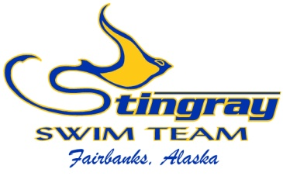
Inside This Issue:
Great Team Members 1

Upcoming Summer
Meets 2

Parent Education
Meetings 2

Swim-a-Thon Results 3

Santa Clara Recap 4

June at a Glance 15

2016 Meet
Schedule 6

UPCOMING SUMMER MEETS

With summer in full swing, we hope everyone is enjoying their time outside. The long days lead to camping trips, family vacations, and enjoying the weather. With all the summer excitement, we want to remind you that there are two swim meets coming in June and July.

The Midnight Sun Invite at Hamme Pool will be June 24-26. This is run in short course meters and is a great opportunity to experience the longer pool. It is also a very fun meet with teams outside of Fairbanks participating. It is open to all Stingray members and we hope to see great participation. It will also be the first time the new Hamme scoreboard is used, which will be very exciting. REGISTRATION DEADLINE IS JUNE 16TH.

The second meet this summer is the 2016 Alaska Summer Championships at Bartlett Pool in Anchorage. This will be run in long course meters on July 29-31. We only get a few chances to swim long course, and it is a great experience for all Alaskan swimmers. This meet does have time standards a smidge faster than Age Group Champs, but with 36 Stingrays qualified we hope to take a large group. More info can be found on the team website. REGISTRATION DEADLINE IS JULY 19TH.

PARENT EDUCATION MEETINGS

We will hold our next parent education meeting in July. Date and location TBD and will be communicated soon. Our parent education program is vital to our continued success and we highly encourage you to participate. The July meeting will be for high school age swimmers/parents only and will cover the college recruiting process. Whether you are thinking about swimming in college or not, please plan to attend this meeting. We will hold a parent education meeting in August to cover nutrition, which will be open to all Stingray parents/swimmers.

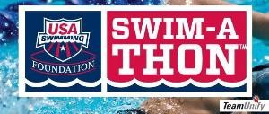

SWIM-A-THON RESULTS

Our 2016 Swim-a-Thon was a huge success. We raised more money than ever before and had great participation. Thank you to all Stingrays for your effort! We raised just under $16,500 and had some impressive individual performers. We just missed our goal amount to purchase new starting blocks but are contacting local businesses to see if they can make up the difference. If all goes as planned, we will make up the $1,500 difference this month and purchase the blocks.

The Swim-a-Thon donation races have been calculated. Congratulations to the following:

Most money raised by an individual:
1) Victoria Schachle – raised $1,200
2) Logan Fox – raised $800
3) Grace White – raised $515
3) Lauren White – raised $515
5) Lily Hsieh – raised $500
5) Taylor Keyes – raised $500

Most money raised by group (average):
1) Junior – averaged $476.55
2) Platinum – averaged $293.33
3) Senior – averaged $285
4) Bronze – averaged $249
5) Copper – averaged $231.67
6) Gold – averaged $223
7) Silver – averaged $160

Most money raised by location (average):
1) Patty Pool – averaged $89.66
2) Alaska Club Pool – averaged $61.03

SANTA CLARA TRIP RECAP

Our first annual Summer Team Trip was a success as 13 swimmers traveled to Santa Clara, California on June 2-7. We were invited to swim in the De Anza Cupertino Aquatics long course meet during the day, and we had VIP seating for the Arena Pro Swim Series finals in the evening. We swam very well for our first outdoor, long course competition and everyone adjusted to the big pool well. Our backstrokers swam straight and everyone raced hard. We had multiple top three finishes and a large number of top eight finishes. We also had eight team records broken. Crieghton Beshears broke the 50 Free record, Makenna Beshears broke the 200 Back record, Lauren White broke the 200 Free and 200 IM record, and Grace White broke the team record in all of her events (50 Free, 100 Free, 50 Back, 100 Back).

The Arena Pro Swim Series was the highlight of the trip. Our swimmers and parents were able to watch world-class swimming and meet many of the athletes. We saw some top times in the world for 2016 and many past/future Olympians. All of the Olympic athletes were friendly, signed autographs, and took pictures with our swimmers. This experience was extremely valuable and we hope to increase participation next year.

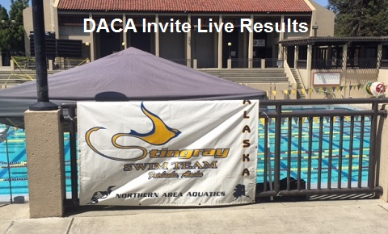

JUNE AT A GLANCE

  - June 4 – Lily Hsieh’s birthday

  - June 13 – Patty Pool reopens
    - M-F @ 8:00-10:00am AND M-TH @ 3:00-5:00pm

  - June 14 – Angela Huffer’s birthday

  - June 24-26 – Midnight Sun Invite (Hamme)
    - Entry deadline June 16th

SST 2016 Meet Schedule (remaining)

Midnight Sun Invite (deadline 6/16/16)
June 24-26
Prelim/Final Meet
*Open to all
Hamme Pool, Fairbanks

Alaska Summer Championships (deadline 7/19/16)
July 29-31
Prelim/Final Meet
*qualification standards
Bartlett Pool, Anchorage

