SST NEWS
PO Box 72301
Fairbanks, AK 99707

Phone: 970-689-1407
Email: coachjosh@outlook.com
Web: www.stingrayswim.org

March, 2015 Volume 2, Issue 5

WHAT TO EAT AND WHEN
Timing is Everything!
Knowing how much carbohydrate, protein and fat to get in a day is good. But knowing when you should be getting those nutrients is even better. In general, follow these guidelines for incorporating carbohydrate, protein and fat into your day:
1) Spread carbohydrate intake out over the course of the day (i.e. smaller meals and frequent snacks). This keeps blood sugar levels adequate and stable.
2) Eat carbohydrate in the form of a carb-electrolyte drink, such as Gatorade or PowerAde, during workout IF workout is 90 minutes or longer. Gels are also acceptable.
3) Eat carbohydrate and protein within the first 30 minutes after practice. This enables the body to replenish glycogen stores and repair muscle tissue. This is perhaps the most important time to eat!!!!
4) Eat again (something substantial, like a real meal) before two hours post-practice has elapsed. This is critical to maximizing recovery!!!!
5) Incorporate fat into the day at times that are not close to workout. Fat is necessary, but contributes little to the workout or immediate post-workout recovery period.
Part of the reason good nutrition is critical during recovery has to do with the fact that the body is extremely good at making the most of what it is given. Following exercise, the body is very sensitive to the hormone insulin. Insulin is that hormone that rises every time blood sugar rises. In other words, every time a swimmer eats carbohydrate, which causes blood sugar to rise, insulin goes up. Well, its insulin’s job to remove sugar from the bloodstream, and it does so by facilitating its storage as glycogen. Glycogen, the storage form for carbohydrate, is what the body taps into for fuel when exercise is very intense. This can happen quite a bit during a tough workout, which is why it’s important to see that glycogen is replenished before the next practice.

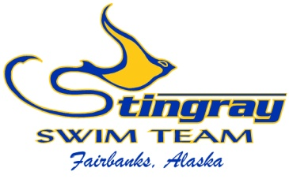
Inside This Issue:
What to Eat and When 1
Northern Area Champs 2

Swim-a-Thon 3
Swimmers of the
Month 4

February at a Glance 5
SST 2014-2015
Meet Schedule 6

NORTHERN AREA CHAMPIONSHIPS
Most of our championship meets throughout the year have qualification standards; times that swimmers much achieve in order to participate in the meet. This is not the case with the Northern Area Championships, which allows all of our swimmers to participate! This is the season culminating meet for most of our swimmers and it is important to have everyone involved. Not only is it a fun meet with the entire team cheering and swimming fast, but it also allows the coaches to evaluate how our training worked for this season. Without seeing how each swimmer competes at the end of the season, it is difficult for the coaches to know if training adjustments need to be made.

We also have an opportunity this season that has not been possible for many years. If we have maximum participation, we will be set to make a push for a conference championship title. Midnight Sun has won this award the past few seasons, and it is time for SST to fight for a title. In order to make a conference title a reality, we will need all of our swimmers to participate. Whether you are ranked 1st in the state or have just joined the Bronze Group, this is the meet for you! Let’s make our presence felt and push for a Northern Area Conference Championship.

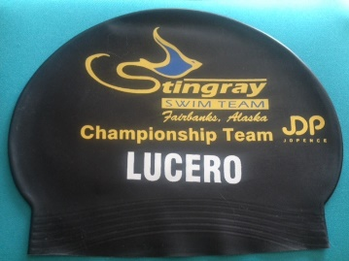
We have ordered special championship caps for everyone who participates in the Northern Area Championships. These stylish, tough looking caps have our team logo, championship team recognition, and your last name. In order to receive your special cap, you must participate in the Northern Area Championships.

The 2015 Northern Area Championships are on March 27 – 29 at Hamme Pool. The entry deadline is March 19. Please visit our website to see all meet details. We are proud of each swimmer and are very excited for this fun, fast meet.

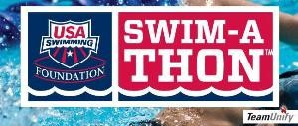

2015 SWIM-A-THON

It is that time again; time for our annual USA Swimming Foundation Swim-a-Thon! Our Swim-a-Thon is one of our largest fundraisers of the year and allows us to offer the greatest swimming experience possible. We did a great job last season by reaching our goal of $12,000 raised, and this year we’re shooting for more. Our goal this season is $15,000! In order to reach our goal, we need to average $175 raised per swimmer.

During the Swim-a-Thon fundraiser, swimmers will contact friends, family, neighbors, businesses, etc. to secure donations toward their swimming. Each swimmer will then complete as many lenghts of the pool as possible, up to 200 lenghts. Donations can be a flat donation or based on the number of lenghts swum. The Swim-a-Thon event will be a fun evening full of play time, pancakes, and a little swimming.

We have made things as simple as possible to contact donors, raise money, and earn cool prizes for your efforts. We handed out many prizes for last year’s Swim-a-Thon, including a swim parka to Gwendolyn Bunch. To see this year’s prizes and what it takes to get there, please view the Swim-a-Thon tab on our website.

We are again using the on-line donation platform for this year’s Swim-a-Thon. Everything is done through our team website, from the first step of contacting donors to the final record of laps swum. By using the on-line platform, it can’t be easier to see your progress and watch the donations roll in.

This year’s Swim-a-Thon will be held on Saturday, May 2nd at Hamme Pool from 5:00 – 9:00. We will have a pancake feed and will also hold our Board of Directors election. More information will come soon as we get ramped up for our most successful Swim-a-Thon in team history!

SWIMMERS OF THE MONTH IN JANUARY

To be selected as the Swimmers of the Month, athletes must show their dedication to our team through their hard work, attendance, desire to improve, teamwork, and ability to listen to instruction. We are proud to look back at February’s Stingray Swimmers of the Month.

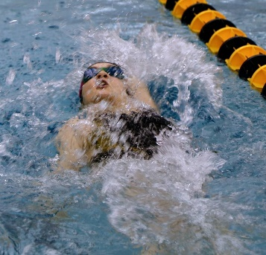
Greta Johnson
Greta joined the Stingrays in September, 2011 and has been improving ever since. She has put in a lot of work on her technique and is seeing great improvement in her speed. She is one of the best listeners on the team and puts her coach’s instruction into action. She has become a leader in the Platinum Group and is well on her way to making the move to the Junior Group. During her 2015 Alaska Age Group Championships in Juneau on February 13-15, Greta posted all best times and helped her relays race hard. She dropped 7.06 seconds (18.7%) in the 50 free, 16.55 seconds (18.8%) in the 100 free, and 9.8 seconds (21.3%) in the 50 back leading off her 200 medley relay. She has one Junior Olympic Championship cut and will add more before April. She attended 100% of her workouts through February which has allowed her great success. Congratulations Greta on being February’s Stingray Swimmer of the Month!

Trevor Chiu
Trevor joined the Stingrays in September 2012. He is a leader at the Patty Pool and works hard each day. As a member of the Junior Group, he leads by example and is looked up to by his teammates. He listens well and has improved his technique. During the 2015 Alaska Age Group Championships in February, Trevor posted all best times. He dropped 1.76 seconds (6.3%) in the 50 free, 7.46 seconds (11.6%) in the 100 free, 17.7 seconds (12.4%) in the 200 free, 5.21 seconds (7.1%) in the 100 back, 12.49 seconds (7.8%) in the 200 back, 26.01 seconds (15.3%) in the 200 IM, and 17.04 seconds (5.2%) in the 400 IM. He placed in the top 4 in all of his events, including a silver medal in the 100 back, 200 back, & 200 IM, and a bronze medal in the 100 free, 200 free, and 400 IM. He was the 3rd highest point scorer of all 13-14 year old boys. He will compete in the maximum 7 events at the Alaska Junior Olympic Championships in April. His success is largely based on his work ethic, and he attended 100% of his workouts through February. Congratulations Trevor on being February’s Stingray Swimmer of the Month!

MARCH AT A GLANCE
- March 3 – Cooper Wentz’s birthday
- March 5 – 2015 Swim-a-Thon kicks off!
- March 8 – Gwendolyn Bunch’s birthday
- March 9 – Michael Lucero’s birthday
- March 10 – Ellie Lovely’s birthday
- March 10 – SST Board Meeting
  - Located at Madden Real Estate from 6:30-8:00
  - All members are welcome to attend
- March 11 – Sydney Teslow’s birthday
- March 11-13 – Patty Pool Closed
  - Dryland will be held at The Alaska Club South in group fitness room
  - 3/11 & 3/13 – 4:40-5:20, 3/12 – 4:45-5:45
- March 11-15 – Speedo Senior Sectional Championships
  - Two Stingray swimmers participating
- March 14 – St. Patrick’s Day Meet
  - At Wescott Pool
  - Warm up at 8:00, meet starts at 9:00
- March 19-22 – Northwest Age Group Regional Championships
  - One Stingray swimmer participating
- March 21 – Blaque Secor’s birthday
- March 25 – Sadie Johnson’s birthday
- March 27-29 – Northern Area Championships
  - Open to ALL swimmers from Bronze to Senior
  - Registration deadline is March 19th

SST 2014-2015 Remaining Meet Schedule

Speedo Senior Sectional Championships – King County Aquatic Center
March 11-15
Prelim/Final Meet
*Qualification standards required
Federal Way, WA

St. Patrick’s Day – Wescott Pool
March 14
Half Day Meet
Open Bronze to Senior
Registration Deadline: March 7
Warm ups: 8:00 am

Northwest Age Group Regional Championships - King County Aquatic Center
March 19-22
Prelim/Final Meet
*Qualification standards required
Federal Way, WA

Northern Area Championships – Hamme Pool
March 27-29
Prelim/Final Meet
Open Bronze to Senior
Registration Deadline: March 19

AK Junior Olympics - Bartlett Pool
April 23-26
Prelim/Final Meet
*Qualification standards required
Anchorage, AK

