2017-2018 State Ranking
As of April 11
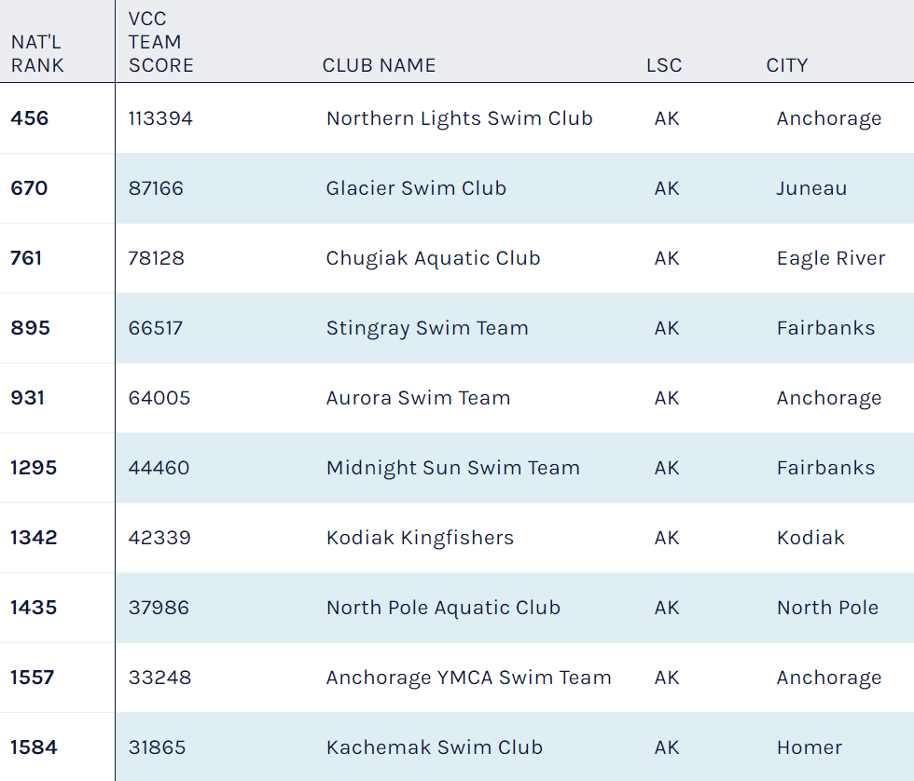

2016-2017 Season Final Ranking
Short Course Yards

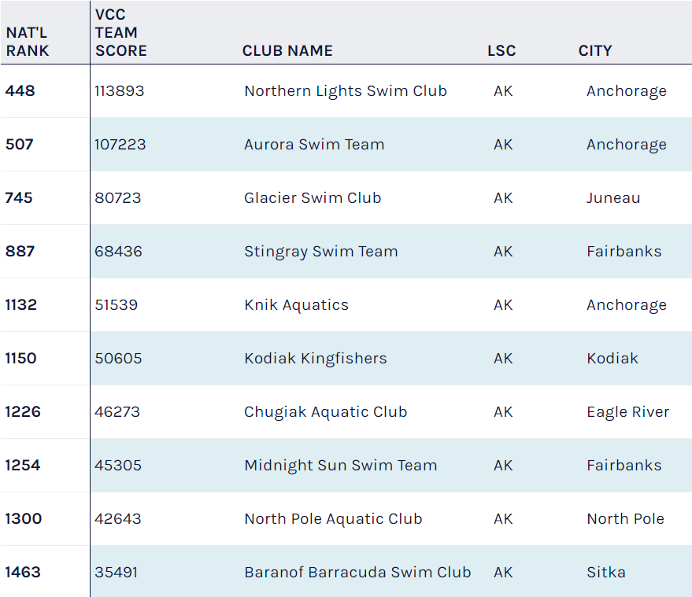

2015-2016 Season Final Ranking
Short Course Yards

National Rank | AK Rank | AK Team Score | Team Name | City
462 | 1 | 110,310 | Aurora Swim Team | Anchorage
495 | 2 | 105,474 | Northern Lights Swim Club | Anchorage
701 | 3 | 82,248 | Glacier Swim Club | Juneau
950 | 4 | 61,569 | Knik Aquatics | Anchorage
956 | 5 | 61,004 | Midnight Sun Swim Team | Fairbanks
1044 | 6 | 55,475 | Kodiak Kingfishers | Kodiak
1134 | 7 | 49,843 | Stingray Swim Team | Fairbanks
1282 | 8 | 41,094 | Chugiak Aquatic Club | Eagle River
1324 | 9 | 39,265 | Wasilla Waves Swim Club | Palmer
1353 | 10 | 38,038 | North Pole Aquatic Club | North Pole
1546 | 11 | 31,132 | Soldotna Silver Salmon | Soldotna
1606 | 12 | 29,061 | Ketchikan Killer Whales | Ketchikan
1635 | 13 | 27,940 | Baranof Barracuda Swim Club | Sitka
1810 | 14 | 22,773 | Anchorage YMCA Swim Team | Anchorage
1934 | 15 | 19,314 | Kachemak Swim Club | Homer
1982 | 16 | 18,134 | Peninsula Piranhas Swim Team | Kenai
2074 | 17 | 15,535 | Viking Swim Club | Petersburg
2124 | 18 | 14,412 | Seward Tsunami Swim Club | Seward
2360 | 19 | 8,286 | Valdez Torpedoes Swim Club | Valdez
2416 | 20 | 7,043 | Sockeye Swim League | Naknek
2540 | 21 | 4,319 | Cordova Iceworms | Cordova
2558 | 22 | 3,885 | Nome Northstar Swim Team | Nome
2637 | 23 | 2,311 | Craig Waverunners Swim Club | Craig
2706 | 24 | 810 | Haines Dolphins Swim Team | Haines
2721 | 25 | 438 | Bore Tide Swim Club | Anchorage

2015-2016 Season Final Ranking
Long Course Meters
National Rank | AK Rank | AK Team Score | Team Name | City
600 | 1 | 77,267 | Northern Lights Swim Club | Anchorage
724 | 2 | 65,052 | Aurora Swim Team | Anchorage
1114 | 3 | 37,683 | Knik Aquatics | Anchorage
1178 | 4 | 34,709 | Stingray Swim Team | Fairbanks
1382 | 5 | 26,527 | Midnight Sun Swim Team | Fairbanks
1449 | 6 | 23,883 | Wasilla Waves Swim Club | Palmer
1521 | 7 | 21,670 | Chugiak Aquatic Club | Eagle River
1563 | 8 | 20,392 | Soldotna Silver Salmon | Soldotna
1688 | 9 | 16,322 | Ketchikan Killer Whales | Ketchikan
1703 | 10 | 15,893 | Glacier Swim Club | Juneau
1748 | 11 | 14,966 | Kodiak Kingfishers | Kodiak
2012 | 12 | 9,361 | Anchorage YMCA Swim Team | Anchorage
2116 | 13 | 7,402 | North Pole Aquatic Club | North Pole
2191 | 14 | 5,955 | Peninsula Piranhas Swim Team | Kenai
2435 | 15 | 2,469 | Baranof Barracuda Swim Club | Sitka
2522 | 16 | 1,408 | Kachemak Swim Club | Homer
2531 | 17 | 1,330 | Seward Tsunami Swim Club | Seward

2014-2015 Season Final Ranking
Short Course Yards

National Rank | Alaska Rank | AK Team Score | Team Name | City
478 | 1 | 109,035 | Aurora Swim Team | Anchorage
494 | 2 | 106,117 | Northern Lights Swim Club | Anchorage
701 | 3 | 83,398 | Glacier Swim Club | Juneau
971 | 4 | 61,708 | Midnight Sun Swim Team | Fairbanks
981 | 5 | 61,011 | Knik Aquatics | Anchorage
1079 | 6 | 53,760 | Kodiak Kingfishers | Kodiak
1209 | 7 | 45,953 | Stingray Swim Team | Fairbanks
1232 | 8 | 44,594 | Baranof Barracuda Swim Club | Sitka
1313 | 9 | 40,001 | Soldotna Silver Salmon | Soldotna
1354 | 10 | 38,320 | Chugiak Aquatic Club | Eagle River
1396 | 11 | 36,693 | Wasilla Waves Swim Club | Palmer
1443 | 12 | 34,803 | North Pole Aquatic Club | North Pole
1680 | 13 | 26,967 | Ketchikan Killer Whales | Ketchikan
1799 | 14 | 23,023 | Viking Swim Club | Petersburg
1876 | 15 | 21,002 | Seward Tsunami Swim Club | Seward
1937 | 16 | 19,297 | Anchorage YMCA Swim Team | Anchorage
1956 | 17 | 18,749 | Kachemak Swim Club | Homer
2135 | 18 | 14,002 | Peninsula Piranhas Swim Team | Kenai
2207 | 19 | 12,450 | Valdez Torpedoes Swim Club | Valdez
2516 | 20 | 4,893 | Haines Dolphins Swim Team | Haines
2518 | 21 | 4,863 | Sockeye Swim League | Naknek
2555 | 22 | 4,132 | Cordova Iceworms | Cordova
2668 | 23 | 1,948 | Nome Northstar Swim Team | Nome
2691 | 24 | 1,490 | Craig Waverunners Swim Club | Craig

