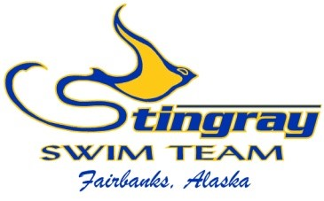

I, __________________________________, am applying for the Stingray Swim Team Scholarship Program for my child(ren), _____________________________________________. I understand that my application will be reviewed by the Head Coach and Board of Directors. I agree to fulfil my team fundraising and volunteer agreement, and my potential Scholarship Program approval may be revoked if I do not fulfil such agreements. I will remain in good standing with the Stingray Swim Team and USA Swimming. I understand my Scholarship Program participation may be revoked if the Stingray Swim Team experienced unforeseen financial hardship, with thirty (30) days notice. I understand the Scholarship Program would reduce my monthly dues by 50% per swimmer, and that the program does not cover my annual fundraising requirement, USA Swimming registration, meet fees, or equipment.

I acknowledge my family qualifies for Free or Reduced Price Lunches thru the National School Lunch Program (NSLP). I have obtained and attached a letter from the appropriate school district verifying participation in the NSLP for the current or upcoming school year.

I have fully read and understand the Stingray Swim Team Scholarship Program Financial Assistance Outline and agree to all items.

___________________________________________
Swimmer’s Name (print)

___________________________________________
Parent’s Name (print)

___________________________________________ ___________________
Parent’s Name (signature) Date

