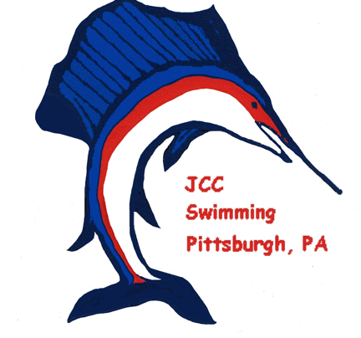
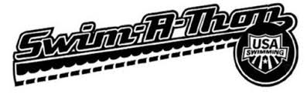
THANK YOU FOR SPONSORING A JCC SAILFISH SWIMMER!

SWIMMER: _________________________________________

AGE: _________

JCC SAILFISH SWIM A THON
CASH OR CHECKS (Payable to JCC Sailfish)
Pledges returned by FEBRUARY 3RD 2020

SPONSOR NAME | ADDRESS | SIGNATURE | Pledge Per  Length | Lengths  Completed | Total  Amount | Paid  Date
TOTAL: $___________

