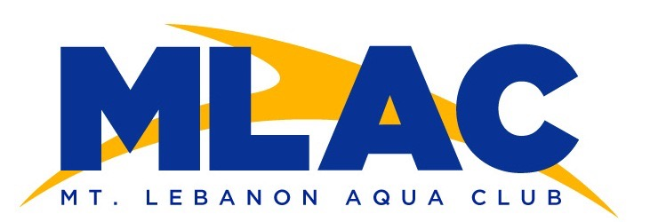
_____________________________________________________________________________________

The MLAC COVID-19 Protocols are an implementation of best practices from other aquatics facilities, guidelines from governing bodies, and requirements from local, state, and federal authorities. The requirements and guidelines were adapted for our community facilities.

COVID-19 is an illness with potentially serious consequences that is transmitted by body fluids. While proper pool sanitization likely prevents the spread of viruses in water, the coronavirus can be spread in air, making mitigating protocols necessary to achieve a reasonable risk. Parents and swimmers must decide if this risk is acceptable and sign a waiver to indicate their agreement to participate.

Assumptions:
- Protecting the health and safety of all members of the MLAC community will be sustained as the highest MLAC priority.
- Members of the MLAC community who choose to participate in swimming will sign a participation waiver and cooperate with the protocols in the best interest of the community.
- This plan supports MLAC use of the indoor pool.
- Practices will be conducted within required attendance guidelines.
- Pool operators have enhanced protocols in place (e.g., cleaning, staff use of masks).
- Coaches will wear appropriate personal protective equipment as directed by the head coach and as required by the facility.
- Swimmers will answer a required MLSD five-question survey and have their temperature checked prior to practice. Any swimmer with a temperature higher than 100.4 will not be admitted into the facility.
- The plan was written and adapted from MLAC experience with outdoor swimming at multiple locations. Consistency in protocols will help achieve the best compliance.

Protocols:
      - Swimmers must be asymptomatic for COVID-19 (e.g., no fever within 48 hours, cough, or shortness of breath) and have not been exposed to anyone diagnosed with COVID-19 within 14 days prior to attending each practice.
      - Coaches will observe swimmers for symptoms of COVID-19 upon entry and during practice. Any sick or symptomatic swimmers (regardless of the reason) will be excluded from practice and sent home immediately.
      - Attendance will be limited by pre-arranged scheduling directed and managed by MLAC coaching staff. Swimmers arrive only at their designated practice times.
      - Swimmers should prepare for practice by washing their hands with a disinfectant soap or hand sanitizer before coming to the pool, dressing for swimming, using the bathroom immediately prior to attendance, and bringing only the necessary equipment (e.g., goggles, cap, towel, an already filled personal water bottle, and equipment bag) to practice. If a bathroom is used, the coaching staff will inform the pool operator so cleaning can be performed as appropriate.
      - Locker room entry or use will not be permitted. The center hall restroom will be available for emergency use by coaches and swimmers with required cleaning immediately after each use. The athletics building’s entry way, common areas, weight rooms, and athletic trainers’ office will not be used at this time by MLAC.
      - Swimmers will not store personal equipment bags at the facility at this time.
      - Swimmers should arrive at the pool no more than ten (10) minutes before their designated practice time and should be ready to follow coaches’ instructions for lane assignments.
      - Swimmers shall follow social distancing guidance, wear masks, and be admitted to the pool through the Stadium Drive (glass) doors of the pool area. Swimmers shall place any necessary personal items (e.g., towel, bag, clothes) in designated spaces as directed by a coach, six feet apart, before getting in their assigned lane. Masks should be removed immediately prior to entering the pool and stored inside the swimmers’ personal bags. Swimmers will not make physical contact with others (e.g., giving a hug, shaking hands, or putting on each other’s caps).
      - Parents shall not enter the pool or spectator areas. Parents shall observe social distancing guidelines during drop off and pick up. Start and stop times will be staggered to minimize the number of cars in the area. No parking in the oval drop off/pick up area on Horsman Drive.
      - A USA Swimming Safe Sport observer (who may be a parent) may observe practice as arranged by the head coach in a location directed by the coach and approved by the facility.
      - Swimmers will be spaced approximately no more than four per lane by the coaches, starting at marked locations along the lane. The goal is to circle swim at an equivalent pace to maintain social distancing. There will be no passing. (Please see the supplemental USA Swimming Facility Re-Opening diagram of pools for further spacing explanation.)
      - At the conclusion of practice, swimmers will exit the pool, collect personal items, and exit the pool area while maintaining social distancing through the Horsman Drive (glass) doors of the pool area.
      - No gatherings or social activities shall take place after practice on school grounds prior to or following practice sessions.
      - Swimmers shall shower and change at home after practice and wash thoroughly.
      - Any swimmer who contracts COVID-19 or has been exposed to someone who is positive for COVID-19, shall inform the coaching staff immediately. The coaches will be keeping a daily log of which swimmers swam together in each lane to aid health department and district authorities with contact tracing. MLAC must follow Mt. Lebanon School District requirements on quarantine decisions with a confirmed-positive COVID case.

Reference Documents:
      - USA Swimming Guidance
      - CDC FAQs
      - CDC Considerations for Public Pools, Hot Tubs, and Water Playgrounds during COVID-19
      - Interim Guidance for Businesses and Employers Responding to Coronavirus Disease (COVID-19), May 2020
      - Pennsylvania COVID-19 Guidelines
      - Pennsylvania Department of Health Summer Recreation, Camps and Pools FAQ
      - OSHA Guidance on Preparing Workplaces for COVID-19
      - Allegheny County COVID-19 Guidance
      - Pennsylvania Department of Education Preliminary Guidance for Phased Reopening of Schools
      - CDC Considerations for Youth Sports

Please contact Jesse McBurney-Rebol if you have any questions about the protocols: jesse@mlacswimming.com
Please contact Mike Kristufek for questions about scheduling and signups: coachmikek@mlacswimming.com

