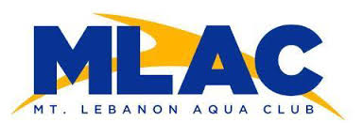
Mt. Lebanon Aqua Club
Scholarship Application

This application is for MLAC’s year-round competitive program only. Scholarships are awarded for the duration of the current season only. All Scholarships are awarded based solely on NEED. Proof of need is required for a scholarship to be approved. A “Free or Reduced Lunch” approval from the swimmer’s school district will suffice as proof. Please include this document with your application. If applying for more than one child in same family, please include all children’s names on one application.

Swimmer/s Name: ________________________________________________________
Swimmer/s Fish Group: ___________________________________________________
Grade/s in School: ________________________________________________________
Name/s of School: ________________________________________________________

Parent/Guardian Name(s): ________________________________________________
Billing Address: __________________________________________________________
Phone: ____________________ Email: ____________________________

Please describe the amount of financial assistance you are seeking. (MLAC currently offers up to a 70% waiver of dues excluding the $250 registration fee or meet entry fees.)

Please describe why you think your swimmer is a good candidate for a MLAC scholarship. (e.g. why does the swimmer want to swim, swimmer’s dedication, character, work ethic and commitment to the sport and team)

All information you provide will be held in the strictest confidence. Any information provided will only be used by the Board of Directors to determine eligibility for MLAC scholarship funds. We hope to help as many families as possible each year and funds are limited.

