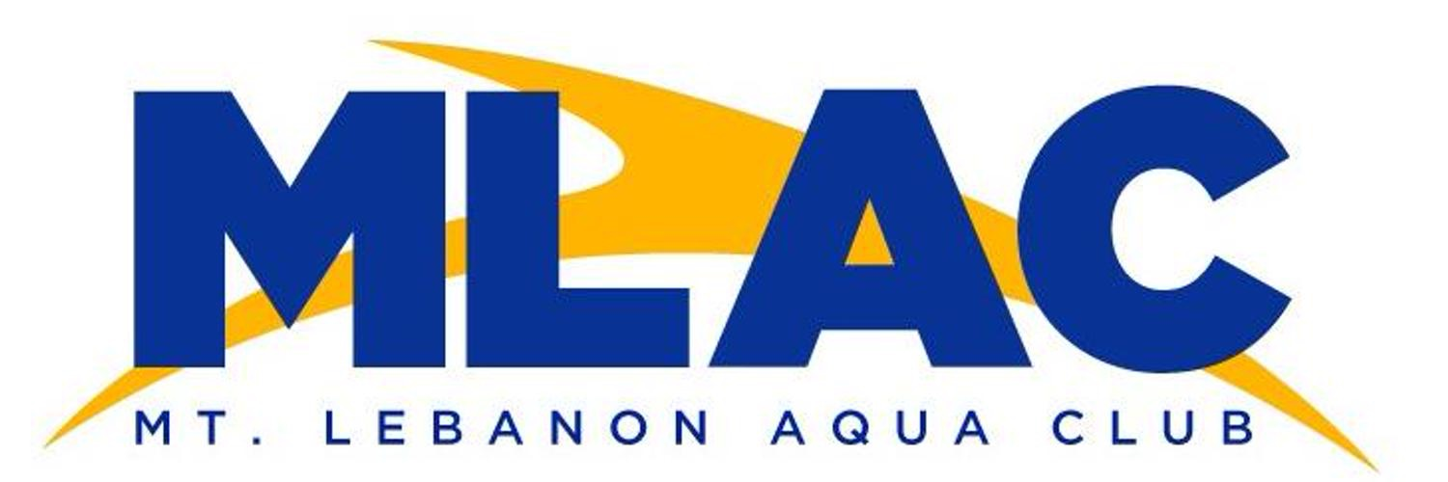
Annual Sponsorship Packages
Corporate: $1000+
- Sponsorship of T-Shirts worn by over 500 swimmers (Name on the back)
- Name and Logo Shown 4 times on Digital Scoreboard during swim meet
- Full page ad in Heat Sheets
- Spot on Website with link to company site
- More things negotiable
Gold Medal Plus: $500
- Sponsorship of T-Shirts worn by over 500 swimmers (Name on the back)
- Name and Logo Shown 4 times on Digital Scoreboard during swim meet
- Full page ad in Heat Sheets
- Spot on Website with link to company site
Gold Medal: $300
- Full page ad in Heat Sheet at Fall
- Name and Logo Shown 2 times on Digital Scoreboard
- Spot on Website with link to company site
Silver Medal: $200
- Name and Logo Shown on Digital Scoreboard
- 1⁄2 page ad in Heat Sheets
- Spot on Website with link to company site
Bronze Medal: $100
- 1⁄4 page ad in Heat Sheets at
- Spot on Website with link to company site
OVER 2000 SPECTATORS AND SWIMMERS ATTEND MEETS!!!!!

