2020 PSC Masters Dryside Training

https://youtu.be/q4nPUq9_gfU
https://youtu.be/-ADJP4sIAlE
Water Bottle Twist
From a seated position with your legs on or off the floor (your choice), twist your upper body from left to right while holding a 1 gallon water bottle.

https://youtu.be/ryvX6Ps-ybk

Prone Butterfly
While standing in a bent over position and holding 500ml water bottles. Perform a butterfly arm stroke by raising your parallel to the floor. Go lower and repeat.

https://youtu.be/gFY-WI6C88U

Water Bottle Hammer Curl
Standing upright while holding a 500ml water bottle in each hand, perform a hammer movement. Alternate arms.

https://youtu.be/irufCUnqZwI

Lunge in Place with 500ml Water Bottle
Standing upright with your feet together, step forward and create a 90-degree angle at the knee joint, lowering the back knee to about 2 inches above the floor. Using the forward leg, push yourself back up. Alternate legs.

https://youtu.be/YmeFFtBADxY

Freestyle Stroke with 500ml Water Bottle
Bend forward, perform a freestyle stroke with 500ml water bottles in each hand.

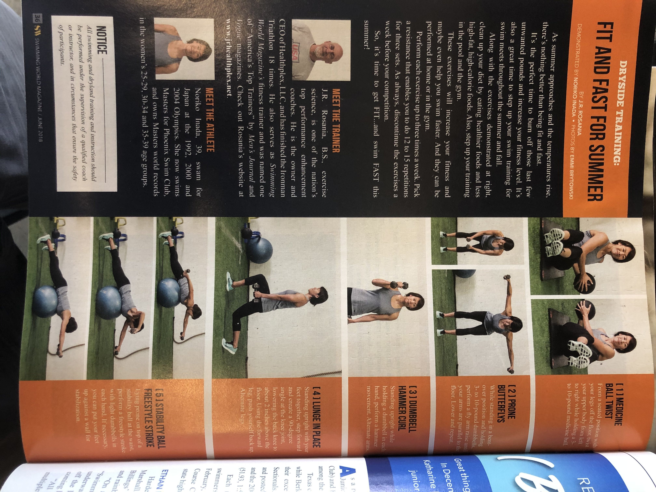

Reference: Swimming World Magazine / June 2018 / Emmi Brytowski, J.R. Rosania, Noriko Inada / Sports Publications International / Pp.36

