**Here is a simple guide to get started with our new recreation software. See next page for details pertaining specifically to the “Storm” swim team billing.**

**SurpriseREC**

**Online Registration Information**

## Getting Started...

SurpriseREC offers easy on-line access to browse or register for the City of Surprise’s recreational activities 24 hours a day, 7 days a week. To register, you will need your email, password and valid VISA or MasterCard. If you are a new customer to the Community and Recreation Services Department, to create your online account, you will need the following:

* Name and birth date of all family members you wish to have on your account.
* Home Address - Surprise residents will need to bring proof of residency.
* Best Phone Number
* Best E-mail Address

*Now you are ready to go to **surpriseaz.gov/recreation** and click on the SurpriseREC logo to begin browsing for activities.

## Browsing for Activities...

Click on the Catalog Tab. Click on one of the tabbed sections for a list of activities associated with that tab. NOTE: Click on a class to view specific details regarding that activity. Click the icon next to the class price for registration dates, age requirements, etc.

## Registering for an Activity...

Find the activity you wish to register for and, after clicking on the sessions associated with that activity, check the boxes of the account members you wish to register and then click the “add to cart.” button. NOTE: If the “Add to Cart” button is not available, then this activity is not available online. When finished, click on “Cart” in the upper right hand corner of the screen. NOTE: You must agree to the waiver to proceed to pay for classes. Enter your credit card information and click Review Transaction. A receipt will be displayed if the registration is successful. Press print to print the page or if you click email it will email you the receipt.

## Account Information...

#### Changing your password

You may change your password as often as you wish. Click on Account after you have logged in. Click on the “Edit User” pencil icon next to the account member whose password you would like to change. Enter your new password. Re-enter the new password. Click on the “Save User” button.

#### Making a payment

If you are in a program where you have a weekly or monthly fee, you may make your payments online. Click on the My Account icon and then click the “Pay Balance” button located in red on the right side of the screen. Check the box next to the Item you select to pay for and then click the “Pay Selected Balances” button. Confirm the waiver agreement by clicking the button and proceed to the payment screen to enter your payment information.

#### Forgot my password

Click on the forgot my password link on home page. Enter your e-mail address as it has been saved in the database. Click on the Submit button. An e-mail will be sent to your e-mail address with the information. NOTE: This function will only work for the e-mail address that is entered for the account in the database.

**Frequently Asked Questions...**

#### Are SurpriseREC registrations secure?

Yes. The standard SSL encryption is used and all credit card transactions are encrypted and secure.

#### I would like to change my mailing or e-mail address or add a family member. How can I do this?

It is very important that we have current information in our database. You can change your email and add family members by accessing your account.

#### Can I register a child/person from another family?

We do not allow you to register someone from another family. All registrations must be made by family members only.

#### I am a Non-Resident, will I be able to register for programs and classes online?

Yes. The registration process is the same for both residents and non-residents.

# For More Information:

### Community & Recreation Services

15960 N. Bullard Ave. Surprise, AZ 85374

# 623.222.2000

### www.surpriseaz.gov/recreation

Storm Families,

As you all should be aware by now the City of Surprise has launched a new registration and billing system not only for swim team, but all of the recreational sports, special events and programs.  As of now all swim team related fee’s, including past balances and credits have been transfered to each account.

Once again when you login to your [SurpriseRec](https://secure.rec1.com/AZ/surprise-community-rec/catalog) Account you may see a balance such as the following;

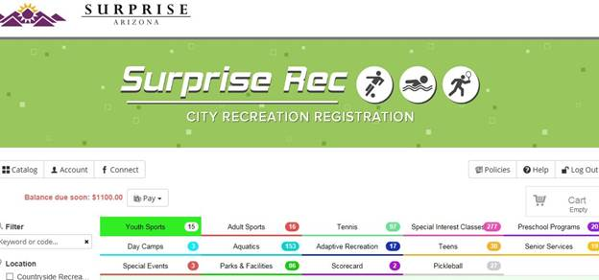

You will see a Balance Due Soon: Please do not be alarmed at the total.  This is a total of all the Storm payment installments from now through the end of the season.  Monthly Storm Team fee’s are billed to accounts on the 1st of each month.  If you click on the Pay icon next to this balance you will see these payments broken down and can select the month you would like to add to your cart for payment.

If you previously had a credit card on file and had auto-payments made on your behalf by the City of Surprise you have been already “Opted-In” to auto payments, although we are **not** able to enter your credit card information which creates a much safer experience for you!  You must login and save your credit card info to complete the payment.  To save a card on file you will click on the **Account** button located in the top left of your screen, which will take you to your dashboard.  On the right side of the screen there is an option to Manage Payment Accounts and this is where you will be able to enter and securely save your card information.  Once your payment information has been saved you must notify Tim Manley or Joann Estfan to opt you in to auto payments. Auto-payments will only charge your monthly “Storm” fees to your card, this will not include swim meet entry fees or any other recreation program fees.  To pay for additional fee’s you will need to login or visit the Recreation Services or Aquatics Office to pay for these fees.

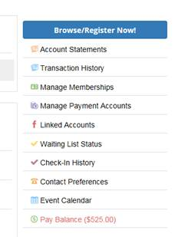

If you have any questions or concerns regarding your account please feel free to call or email.

Tim Manley 623.222.2264 or [tim.manley@surpriseaz.gov](mailto:tim.manley@surpriseaz.gov)