Southwest Aquatic Team
SWAT 3000 - Fundraising Packet

2019 Swim-A-Thon
February 16, 2019
Westside Natatorium
El Paso, Texas
TEAM GOALS:
Minimum Raised: $10,000
Team Participation: 100%

What is the SWAT 3000 Swim-A-Thon?

- SWAT 3000 Swim-A-Thon is one of SWAT’s largest fundraiser of the year. All proceeds go to support the Southwest Aquatic Team. We use the funds to pay for coaches, rent pool time, purchase equipment and many other activities that provide a quality experience for our swimmers and families.
- Swimmers earn money for SWAT by swimming as many lengths of the pool as possible. Swimmers have a 2-hour period to swim the minimum of 3,000 yards (Thus, SWAT 3000!), which is equal to about 125 laps. Green Group swims as much as they can! SWATStarters are not required, but encouraged, to participate.
- Swimmers get pledges per lap or flat donations from family, friends, neighbors, businesses, etc., prior to swimming. Each swimmer is encouraged to raise a minimum of $100 for SWAT 3000! There is a minimum fundraising requirement of $50/swimmer! Any Swimmer that does not meet the minimum requirement will have the difference billed during March dues.

When and where is the SWAT 3000 Swim-A-Thon?

- Saturday, February 16, 2019
- Westside Natatorium located at: 650 Wallenburg, El Paso, TX 79912
- SWAT 3000 SCHEDULE:
- Check-in: 7:30 am
- 2018 – 2019 Short Course – SWAT Team Photo: 7:45am (*)
- 3000 Swim-A-thon: 8:00am - 10:00am
- Smoothies & Food - Galatzan Rec Center: 10:00 – 11:00am
- Prizes Awarded - Galatzan Rec Center: 11:00am
(*) Individual Photos available for additional cost; bring your medals!

What will we do at SWAT 3000 Swim-A-Thon?

- Athletes will swim as many laps as they can during a 2 hour (or less) period.
- Parents play a vital role! They count laps, cheer on the swimmers and help raise pledges.

- Upon completion, Swimmers receive Smoothies, enjoy fun food and have prizes awarded!

How do we raise money for the SWAT 3000 Swim-A-Thon?

- Online Giving – SWAT uses our Team Unify website to coordinate individual giving. You just set up your own personal website and send the link to family and friends via Email, Facebook, and Twitter. See page 6 for more instructions or contact us for help if needed.
- Traditional Pledge Forms – Sample pledge letters, and a pledge form is included on the last page of this package, if you would like to solicit donations personally.
- Corporate Matching – Don’t forget to see if your employer has a Corporate Matching Gift Program. Many Corporations will match their employee’s contributions to non-profit organizations. This is a great way to help your swimmer increase the money they raise!

How do I win prizes?

- Each swimmer will have the opportunity to seek donations individually to earn prizes. Individual prizes will be awarded as follows:

Prizes Awarded by SWAT:

INDIVIDUAL -
- For all swimmers who raise a minimum of $100 (multiple entries for each $100 pledged) have a chance at a raffle drawing for a fabulous SECRET PRIZE! Do not need to be present to win raffle prizes!

GRAND PRIZE -
- Special Grand Prize for the swimmer that raises the most funds!

What is the deadline for turning in pledge forms and donations?

- The deadline for turning in pledge forms is at check-in the morning of the SWAT 3000 Swim-A-Thon! Because donations may be based on pledged amounts per lap completed, all tallies will be totaled at the end of SWAT 3000.
- Parents are responsible for turning in all pledged donation monies no later than the last day of Border Champs, Sunday February 24, 2019.

How to Set Up Your Personal Website

- Each athlete will need to create an online webpage for SWAT 3000 - Swim-A-Thon.
- Go to https://www.teamunify.com/Home.jsp?_tabid_=0&team=bdsat and sign into your account
- Click on the Swim-A-Thon logo at the top of our web page. Once there, you should see the following page: 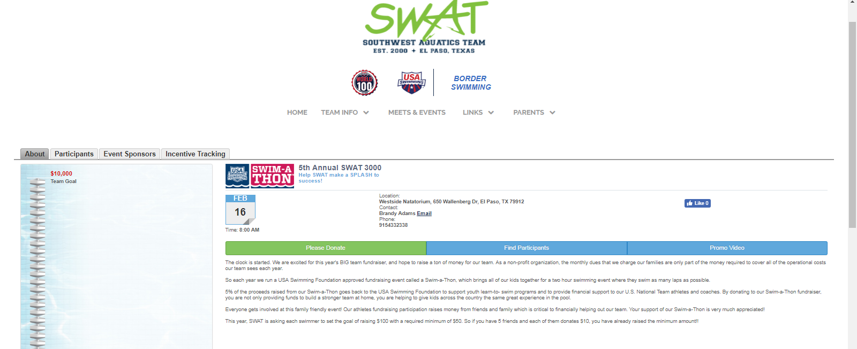
- Click on the red tab labeled “Setup”. Here you personalize your messages to be sent via email. The default goal amount is $200, but you can change it to whatever you want, minimum of $50. You also enter the number of laps you would like to complete.
- Click on the red “Promote” tab. This is where you enter the email address of your potential donors. Click on the “Invite list” to add new emails.
- When you are ready to send out your solicitations, just click the “Name” box and it will select all your potential donors. Then select the green “Email Selected” button. Then click on “Pick Template” button and select the email to be sent. Modify the recipient name, press “Email Now” and the system will email your solicitation letter to everyone on your list.
- You will then receive an “Operation Processed Successfully” note and press “ok”. It’s as simple as that!

What if I have questions?

- Please email all questions to Brandy Adams at brandyadams.915@gmail.com, or Stephanie Otero efsxotero@gmail.com or Jessie Hernandez jrmanzan@episd.org.

Sample Correspondence

Dear Aunt Sally:

Did you know that I’m a USA Swimming registered swimmer and I swim competitively for the Southwest Aquatic Team (SWAT)? I swim a lot, almost every day and I’m getting pretty good. My swim team is raising money by having a SWAT 3000 Swim-a-Thon and I’d like you to help me by pledging $.10 for each lap I swim. I will be swimming 3000 yards (I hope).

Thank you very much for helping SWAT and me.

Love,
(Name)

Dear Mr. Jones:

Well, it is annual lean on your friend’s time again, and Dad says if you don’t have friends to lean on, you’ll fall down. I swim competitively for Southwest Aquatic Team (SWAT). Every year our club raises money for our youth swimming activities by participating in a Swim-a-Thon. The money we raise goes to our club and to USA Swimming to help our programs.

I’d like to tell you a little about our Club. Our swimmers have represented our community and state. There are many reasons to be proud of our team, and many reasons to raise money for team events for the coming season.

Here’s how a Swim-a-Thon works: You pledge a certain amount of money for each length of a pool that I can swim within three hours, up to a maximum of 200 lengths. After I swim, I will let you know how many lengths I completed and the total amount due for your donation. You may pledge any amount you like, and it may be tax deductible. If you prefer, you can make a flat pledge instead.

If I can count on you for support, please call or write Dad or me. By the way, my goal is to complete 125 lengths.

Thank you,
(Name)

Southwest Aquatics Team

SWAT 3000 - Swim-A-Thon Pledge Form

Swimmer’s Name: ________________________________________________

Sponsors Name  (please print) | Flat Pledge | Pledge Per Length | Lengths Completed | Total Amount Pledged

