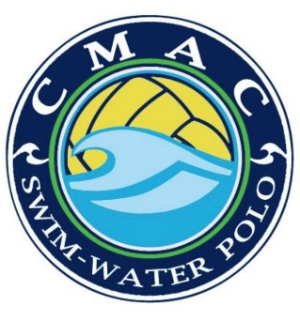
CMAC Parka Order
Cost $120.00

Name: ___________________________________
Phone Number ____________________________
SIZE Youth YS YM YL YXL
Adult XS S M L XL XXL

Embroidery Name: ______________________________

Special Request: ________________________________
IS THIS A GIFT OR SURPRISE YES NO
Checks made out to JD Distribution
Via Venmo Cmac-aquatics
Paid w CC Paid W Check Paid v VENMO

