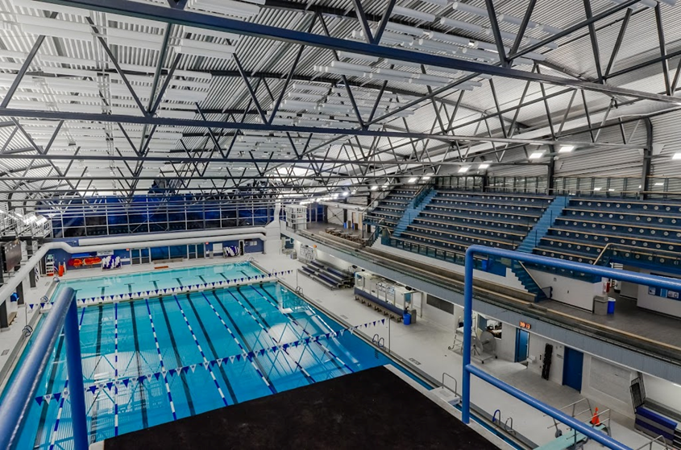

**2018 WESTERN REGION SC CHAMPS**

**February 2 – 4, 2018**

**Meet Information Package**

Hosted By:



**CANADA GAMES AQUATIC CENTRE – LONDON, ONTARIO**

**WESTERN REGION SC CHAMPS**

DATE(S): February 2 – 4, 2018 Region: Western

HOSTED BY: London Aquatic Club

LOCATION: Canada Games Aquatic Centre

1045 Wonderland Road North, London, Ontario, N6G 2Y9

FACILITY: Eight lane, 50 meter indoor tank, with bulkheads, creating two 25m pools, with “Keifer” type lane markers, Daktronics 64101-H8 8 lane swimming scoreboard at both ends of the pool with Swiss Timing Quantum Timing System.

PURPOSE: Short Course Regional Championship

MEET PACKAGE: The only meet package which will be considered as valid must be the most current version found on [www.swimming.ca](http://www.swimming.ca)

COMPETITION

COORDINATOR: Mark Lukings, Level V, **Email:** [mark.lukings@gmail.com](mailto:mark.lukings@gmail.com)

MEET MANAGER: Trevor Pool, **Email:** [**2018WOSA@gmail.com**](mailto:2018WOSA@gmail.com)

Martin Troughton (*Entries Coordinator*) **Email:** [**2018WOSA@gmail.com**](mailto:2018WOSA@gmail.com)

MINOR OFFICIALS: Rebecca Shearer, **Email:** [rebeccashearer@rogers.com](mailto:rebeccashearer@rogers.com)

DESCRIPTION: 12&Under – events will be timed finals and will swim in the afternoon.

13&Over – Preliminary events swim in the morning – top 8 in **each age group** going to finals.

* Friday – 1500 and 800 are timed finals – all other events are preliminary events with finals Saturday and Sunday evening.
* All Saturday & Sunday events are preliminary and finals except 400 events which are timed finals.
* All Relay events are timed finals.

POOL ASSIGNMENT: Meet Management will determine the distribution of swimmers into session ends

All Evening Finals will be held in the Deep End.

COMPETITION RULES: Sanctioned by Swim Ontario.  
All current Swimming/Natation Canada (SNC) rules will be followed.

Please note that Swimming Canada Competition Warm-Up Safety Procedures will be in effect. The full document can be viewed [HERE.](https://www.swimming.ca/en/resources/officiating/event-resources/competition-warm-up-safety-procedures/%20)

**Coaches are responsible for their swimmers’ conduct and knowledge of the Safety Procedure Rules.** Before arrival, coaches are responsible to inform their swimmers of the Safety Rules as contained in this package, to ensure the athletes’ adherence of these rules and to discipline the athletes’ behavior if necessary.

For club and provincial meets, a swimsuit that covers more of the body such as modesty swimwear or religious cover-ups is permitted providing that the fabric is permeable open mesh textile material and does not give the swimmer an advantage. The full interpretation can be viewed [HERE](http://swimontario.com/uploads/Officials/Resources/SNC_Swimwear_Interpretation_2017.pdf). For advanced notification or for clarification of the interpretation, please see the Competition Coordinator.

Meet Officials will provide a safe environment and an organized competition. We are not responsible for the supervision of the athletes during the competition and especially during session breaks.

**GLASS CONTAINERS** are strictly prohibited in and around the deck area.

Sprint Lanes (lanes 1 and 8) will be available for the last 20 minutes of warm-ups. Lanes 1 and 8 will be used for Sprinting and are designated as diving lanes. After the dive the swimmer must leave the lane and return to the starting end. PARA and Backstroke start lanes may also be designated, will be announced, and then will be controlled by the Safety Marshalls.

13&Over preliminaries will swim combined age groups and will be separated into designated age groups for finals.

There will be an “A” final only for male and female 13, 14, 15, 16 and 17&Over age categories.

All 12&Under events will be timed finals.

The 1500 and 800 Free will swim fastest to slowest. The 1500/800/400 Free and 400 IM will swim as timed finals. **Meet Management reserves the right to combine age groups if time requires.**

Meet Management reserves the right to senior seed 1500/800/400 events if demand warrants.

Meet Management reserves the right to swim the distance freestyle events 2 per lane.

Meet Management reserves the right to split preliminary session age categories to ensure proper session lengths.

Meet Management reserves the right to advance the Sunday finals start time.

Preliminary events with less than 9 swimmers will still be swum – will not go straight to finals.

All relay events will be timed finals.

NO deck entries or exhibition swims will be permitted.

Coaches must have relay cards filled in and returned to the Clerk of Course or Meet Office **30 minutes** prior to the start of the relay events.

**“I Made It!" t-shirts** will be given out to all swimmers achieving a Festival/Provincial standard, regardless if the swimmer qualified previously.

This meet will be scored. (see SCORING)

**ALL PARTICIPATING CLUBS ARE ENCOURAGED TO PROVIDE 2 OFFICIALS PER SESSION.**

ELIGIBILITY: All athletes must be registered as Competitive swimmers with SNC, or any other amateur swimming organization recognized by FINA. A valid SNC registration number is required for all Canadian swimmers, and entries without a SNC registration number will be declined entry.

* All swimmers must be registered with a **Western Region** club and in good standing.
* All athletes must be registered as Competitive swimmers with SNC, or any other amateur swimming organization recognized by FINA. A valid SNC registration number is required for all Canadian swimmers, and entries without a SNC registration number will be declined.

QUALIFYING

INFORMATION:

* Valid SC times along with LC entry times will be accepted and not converted.
  + - * Any 12&Under swimmers qualifying for Ontario Festivals are de-qualified from that event.
      * Any swimmer qualifying for Ontario Spring Provincial Champs in 13, 14, 15, 16, 17&Over and/or Open category, using the Ontario Provincial Standards, is not eligible to participate in that event.
      * A coach, who has a swimmer qualify for a Festival/Provincial event after the entry deadline has passed, must email Meet Management to withdraw the swimmer(s) from that event. The swimmer may be placed in an alternate event of which the swimmer is not de-qualified in with NO PENALTY, provided there is an open lane. If no open lane exists, the swimmer will be refunded for the event. A new heat will not be created. It is incumbent on the coaches to make sure over-qualified swimmers are not entered in events, whether the qualification was in LC or SC.
      * Stroke 50’s (50 fly, 50 back & 50 breast) have no de-qualifying standards.
      * Entry priority order for seeding will be SCM, then LCM, then bonus swims.
      * For all PARA events, PARA Provincial "B" standards (10% slower than PARA Provincial times).

ENTRY FEE: Individual Events - $9.00 per swim

Relay Events - $10.00 per team

Swimmer Surcharge - $5.00 per swimmer, including relay only swimmers.

* Entry fees are to accompany the Club Information sheet and a hardcopy of the Team’s entry report.
* Cheques and Club Information sheets must be completed and handed in before warm-up on Friday, February 2, 2018.

PAYMENT: Please submit one cheque for all club swimmers with your Club Information sheets:

Payable to: **London Aquatic Club**

(includes HST – London Aquatic Club GST # R103378279)

ENTRIES: Entries will be at the discretion of the Meet Manager. Only appropriate and complete event files with appropriate times will be accepted.

* All entries must be in a Hy-tek accepted format and must be submitted through the SNC online entries system at: [www.swimming.ca](http://www.swimming.ca)
* Coaches will be sent an entry list after receipt of club entries; please contact Meet Management immediately if there is a discrepancy or issue of any kind.
* "Relay-Only" swimmers are permitted. The remaining three members of the relay team must be properly qualified for the meet in an individual event. The relay only swimmer’s name must appear in the team entry file (roster) with no individual entries.
* No limitation on number of events entered, providing qualifying criteria have been met.
* Except for relays, each swimmer must swim in the proper age group, no swimming up is permitted. Swimming “up” is only permitted on relays as per SNC rules. A maximum of 2 swimmers may swim up for a relay team. An exception to this can be located under, **“Age Up Date.”**

BONUS SWIMS: Any swimmer qualifying with only one (1) qualifying standard may have three (3) additional bonus swims. If they qualify in two (2), they receive two (2) additional bonus swims and if they qualify in three (3), they receive one (1) bonus swim.

* The 1500/800/400 free and 400 IM may **not** be used as bonus swims.
* All bonus swims must be entered with a '**B'** indicator following the seedtime. To facilitate the most efficient swim sessions, coaches are requested to enter **actual** times for bonus swims and **NOT** enter them at **NT**.

PARA: PARA swimmers will be officiated under WPS Swimming Rules.

PARA ENTRIES: **PARA** events as follows:

**50 Free** S1-S14, **100 Free** S1-S14, **200 Free** S1-S14, **400 Free** S6-S13

**100 Back** S1-S14

**100 Breast** S1-S14

**50 Fly** S1-S7, **100 Fly** S8-S14

**150 IM** SM1-SM4, **200 IM** SM5-SM14

* PARA swimmers may enter other events in which they meet the Regional time standard, but there will not be separate PARA awards for these events. There will be no bonus swims for PARA for distances greater than 100.
* In PARA swimming events with five or more entries, Para-swimmers will compete in able-bodied heats during preliminaries, seeded by time, then compete in a PARA swimming final during the finals session.
* In PARA swimming events with fewer than five entries, the event(s) will be Para-swimmer only timed finals during the preliminary session.
* PARA that have the Able Bodied standard in any event may enter that event as Able Bodied. A PARA athlete may swim as either Able Bodied or PARA in any event they qualify for, but not both.
* PARA only events will be in the series 400+, see event file.
* **Coaches must indicate each PARA classification with their entries: Able Bodied swims entered into the Able Bodied events; PARA swims entered into the 400+ series events.**
* **Para Swimmers 12&Under** – **PARA qualified events only**: PARA will swim in the 12&Under session with their peers in the “able bodied” events.  These results will be moved to the 400+ series PARA events for scoring.

ENTRY DEADLINE: Entry Deadline: **January 26, 2018**.

**You will be sent confirmation of receipt of your entries.**

**Please ensure that you check these entries and immediately contact the Meet Manager with any problems.**

SCRATCH RULES: Swimmers will not be penalized for scratching from preliminary/timed finals heats.

**Finals “No Show” Fee** - A $10 penalty will be charged per “no show,” per event. The swimmer will NOT be permitted to swim in any further events until the penalty is paid.  The penalty will be payable to the host club.  Coaches are to ensure all of their swimmers know they are in finals.  The scratch deadline will be one **(1) hour after** the preliminary session.  Coaches should check scratch sheets and/or posted results to ensure that their swimmer is crossed out.  Once heat sheets are printed for finals, the fee will only apply to the top 8 swimmers in each final, and 2 alternates.  There will be **NO POSITIVE CHECK IN** prior to finals beginning.

AGE

CLASSIFICATIONS: Male and female:

* + - * **Individual**: 10&Under; 11; 12; 13; 14; 15; 16; 17&Over
      * **Relays**: 10&Under; 11 - 12; 13 - 14; 15&Over

AGE UP DATE: The swimmer’s age shall be calculated as of the first day of the meet, **Friday, February 2, 2018.**

**Birthdays which fall between WOSA Champs & Festival/Provincial** - if a coach wants to have a swimmer compete in a de-qualified event for the purpose of achieving a Festival/Provincial time in the next age group, they must email Meet Management to find out if there is room available to have the swimmer placed as exhibition for this swim in their current age group.

CANCELLATIONS: In the event of unforeseen circumstances beyond the control of the City of London or London Aquatic Club, (for example but not limited to; weather interruptions or facility malfunctions) that force the cancellation of all or part of the meet, a partial refund may be granted at the discretion of the Meet Manager.

VENDORS: It is anticipated that Team Aquatic Supply and Marble Slab Creamery will be attending. Other food venders are still to be determined. A canteen will also be provided.

SCHEDULE OF SESSIONS:

| Session # | Date | Prelim/Finals | Warm Up | Start | Finish | Estimated Duration |
| --- | --- | --- | --- | --- | --- | --- |
| 1 | Feb 2 | Timed Finals | 1:00-1:50 | 2:00 | 5:00 | 3hrs |
| 2 | Feb 2 | Prelims | 5:00-5:50 | 6:00 | 8:00 | 3hrs |
| 3 | Feb 3 | Prelims | 7:30-8:20 | 8:30 | 11:30 | 3hrs |
| 4 | Feb 3 | Timed Finals | 12:00-12:50 | 1:00 | 5:00 | 4hrs |
| 5 | Feb 3 | Finals | 5:00-5:50 | 6:00 | 8:00 | 2hrs |
| 6 | Feb 4 | Prelims | 7:30-8:20 | 8:30 | 11:30 | 3hrs |
| 7 | Feb 4 | Timed Finals | 12:00-12:50 | 1:00 | 5:00 | 4hrs |
| 8 | Feb 4 | Finals | 5:00-5:50 | 6:00 | 8:00 | 2hrs |

SCHEDULE OF

EVENTS: See event list – **Appendix A**

COACH’S

REGISTRATION: Meet Management will cross reference the list of coaches in attendance at this competition with the [Swim Ontario Compliancy lists](http://www.swimontario.com/page.php?id=2748).  If a coach is not on this list, meet management is obligated to enforce the SNC policy and not permit that coach to attend meet.  Meet management will forward Swim Ontario a list of coaches who they have found to be in non-compliance.

TIME SPLITS: The procedure for obtaining an “Official Split” requires that coaches make the request to the session Referee or Meet Management on the “Official Split Request” form prior to the race. The split for the lead-off leg in relays will still be regarded as an official split and therefore no request by coaches is needed for relays. However, in the new 'mixed gender' relays, lead-off times/splits are not considered “official splits' as per international practice.

Meet Management requires that any coach wishing to rely on a time achieved by the swimmer for an interval shorter than the total distance of the event shall so advise the Referee prior to the commencement of the session (or event) in question.

Finals sessions (session 5 and 8) are not eligible for officials splits.

SCORING: The meet will be scored as follows:

* Individual and Relay events will be scored from 1st - 8th place, on a scale of 9-7-6-5-4-3-2-1.
* PARA scoring will be based on number of entrants. If there are 8 or more entrants in an event, it will be scored the same as Able Bodied swimmers. If there are fewer than 8 entrants, the event will be "reverse-scored". (For example, if there are three entrants, the event will be scored 3-2-1.

AWARDS: The following will be awarded:

* **Able Bodied Medals:** 1st to 3rd for individual events **by age group** and 1st only for relay events.

* **Able Bodied Ribbons:** 4th to 8th for individual events **by age group** and 2nd and 3rd for relay events.

* **PARA:** Medals will be awarded in IPC eligible events only using the PARA British Points System, and shall be awarded on a "mixed gender" basis to the top 3 swimmers in each event.  In order to award gold there must be at least 2 competitors, to award silver there must be at least 3 competitors and to award bronze there must be at least 4 competitors in the event.

MEET RESULTS: The meet will run on Hy-Tek Meet Manager.

* + - * Results will be posted on the LAC website [www.londonaquaticclub.ca](http://www.londonaquaticclub.ca) as quickly as possible.
      * Final results will be uploaded to [www.swimming.ca](http://www.swimmeet.ca) within 48 hours of the completion of the meet.
      * Unofficial results will also be posted to Meet Mobile following each event.

RECORDING

OF EVENT: Only individuals that have made application and received authorization to record the event in any manner, in any medium or context now known or hereafter developed shall be granted access and permission to do so. Please contact Meet Management for application and authorization.

Photographers must obtain authorization from Meet Management before the start of the meet to obtain access to the deck.

SAFETY &

LIABILITY: Only participating swimmers, officials, certified registered coaches and authorized people are allowed on deck.

**Appendix A**

**Event List**

|  |  |  |  |  |  |  |
| --- | --- | --- | --- | --- | --- | --- |
| **Session 1** | | | | | | |
| Friday, February 2, 2018 | | | | | | |
| Warm-Ups **1:00-1:50** Start: **2:00** | | | | | | |
|  |  | **EVENT** | | |  |  |
| **#** | **WOMEN** | **DISTANCE** | **STROKE** |  | **MEN** | **#** |
|  |  |  |  |  |  |  |
| 1 | 15&Over | 800 | *Freestyle* | Timed Final | 15&Over | 2 |
| 3 | 13 -14 | 800 | *Freestyle* | Timed Final | 13 -14 | 4 |
| 5 | 11-12 | 800 | *Freestyle* | Timed Final | 11-12 | 6 |
| 7 | 15&Over | 1500 | *Freestyle* | Timed Final | 15&Over | 8 |
| 9 | 13 -14 | 1500 | *Freestyle* | Timed Final | 13 -14 | 10 |

|  |  |  |  |  |  |  |
| --- | --- | --- | --- | --- | --- | --- |
| **Session 2** | | | | | | |
| Friday, February 2, 2018 | | | | | | |
| Warm-Ups 5**:00-5:50** Start: **6:00** | | | | | | |
|  |  | **EVENT** | | |  |  |
| **#** | **WOMEN** | **DISTANCE** | **STROKE** |  | **MEN** | **#** |
| 13 | 13&Over | 50 | *Backstroke* | Prelims | 13&Over | 14 |
| 15 | 13&Over | 50 | *Breaststroke* | Prelims | 13&Over | 16 |
| 17 | 13&Over | 50 | *Butterfly* | Prelims | 13&Over | 18 |
| 19 | 13&Over | 200 | *Individual Medley* | Prelims | 13&Over | 20 |

|  |  |  |  |  |  |  |
| --- | --- | --- | --- | --- | --- | --- |
| **Session 3** | | | | | | |
| Saturday, February 3, 2018 | | | | | | |
| Warm-Ups 7**:30-8:20** Start: **8:30** | | | | | | |
|  |  | **EVENT** | | |  |  |
| **#** | **WOMEN** | **DISTANCE** | **STROKE** |  | **MEN** | **#** |
| 21 | 13&Over | 200 | *Freestyle* | Prelims | 13&Over | 22 |
| 23 | 13&Over | 100 | *Breaststroke* | Prelims | 13&Over | 24 |
| 25 | 13&Over | 50 | *Freestyle* | Prelims | 13&Over | 26 |
| 27 | 13&Over | 200 | *Backstroke* | Prelims | 13&Over | 28 |
| 29 | 13&Over | 100 | *Butterfly* | Prelims | 13&Over | 30 |
| 31 | 13&Over | 400 | *Individual Medley* | Timed Final | 13&Over | 32 |
| 301 | 15&Over | 200 | *4 x 50 Medley Relay* | Timed Final | 15&Over | 302 |
| 303 | 13 - 14 | 200 | *4 x 50 Medley Relay* | Timed Final | 13 - 14 | 304 |

|  |  |  |  |  |  |  |
| --- | --- | --- | --- | --- | --- | --- |
| **Session 4** | | | | | | |
| Saturday, February 3, 2018 | | | | | | |
| Warm-Ups **12:00-12:50** Start: **1:00** | | | | | | |
|  |  | **EVENT** | | |  |  |
| **#** | **WOMEN** | **DISTANCE** | **STROKE** |  | **MEN** | **#** |
| 33 | 10&Under | 100 | *Individual Medley* | Timed Final | 10&Under | 34 |
| 35 | 12 | 200 | *Free* | Timed Final | 12 | 36 |
| 37 | 11 | 200 | *Free* | Timed Final | 11 | 38 |
| 39 | 10&Under | 200 | *Free* | Timed Final | 10&Under | 40 |
| 41 | 12 | 100 | *Breaststroke* | Timed Final | 12 | 42 |
| 43 | 11 | 100 | *Breaststroke* | Timed Final | 11 | 44 |
| 45 | 10&Under | 100 | *Breaststroke* | Timed Final | 10&Under | 46 |
| 47 | 12 | 50 | *Butterfly* | Timed Final | 12 | 48 |
| 49 | 11 | 50 | *Butterfly* | Timed Final | 11 | 50 |
| 51 | 10&Under | 50 | *Butterfly* | Timed Final | 10&Under | 52 |
| 53 | 12 | 200 | *Backstroke* | Timed Final | 12 | 54 |
| 55 | 11 | 200 | *Backstroke* | Timed Final | 11 | 56 |
| 57 | 10&Under | 200 | *Backstroke* | Timed Final | 10&Under | 58 |
| 59 | 12 | 100 | *Butterfly* | Timed Final | 12 | 60 |
| 61 | 11 | 100 | *Butterfly* | Timed Final | 11 | 62 |
| 63 | 10&Under | 100 | *Butterfly* | Timed Final | 10&Under | 64 |
| 65 | 12 | 50 | *Breaststroke* | Timed Final | 12 | 66 |
| 67 | 11 | 50 | *Breaststroke* | Timed Final | 11 | 68 |
| 69 | 10&Under | 50 | *Breaststroke* | Timed Final | 10&Under | 70 |
| 71 | 11-12 | 400 | *Individual Medley* | Timed Final | 11-12 | 72 |
| 305 | 11-12 | 200 | *4 x 50 Medley Relay* | Timed Final | 11-12 | 306 |
| 307 | 10&Under | 200 | *4 x 50 Medley Relay* | Timed Final | 10&Under | 308 |

|  |  |  |  |  |  |  |
| --- | --- | --- | --- | --- | --- | --- |
| **Session 5** | | | | | | |
| Saturday, February 3, 2018 | | | | | | |
| ***FINALS*** | | | | | | |
| Warm-Ups 5**:00-5:50** Start: **6:00** | | | | | | |
|  |  | **EVENT** | | |  |  |
| **#** | **WOMEN** | **DISTANCE** | **STROKE** |  | **MEN** | **#** |
|  | 17&Over | 200 | Freestyle | Final | 17&Over |  |
| 21 | 16 | 200 | *Freestyle* | Final | 16 | 22 |
| 21 | 15 | 200 | *Freestyle* | Final | 15 | 22 |
| 21 | 14 | 200 | *Freestyle* | Final | 14 | 22 |
| 21 | 13 | 200 | *Freestyle* | Final | 13 | 22 |
| 23 | 17&Over | 100 | *Breaststroke* | Final | 17&Over | 24 |
| 23 | 16 | 100 | *Breaststroke* | Final | 16 | 24 |
| 23 | 15 | 100 | *Breaststroke* | Final | 15 | 24 |
| 23 | 14 | 100 | *Breaststroke* | Final | 14 | 24 |
| 23 | 13 | 100 | *Breaststroke* | Final | 13 | 24 |
| 25 | 17&Over | 50 | *Freestyle* | Final | 17&Over | 26 |
| 25 | 16 | 50 | *Freestyle* | Final | 16 | 26 |
| 25 | 15 | 50 | *Freestyle* | Final | 15 | 26 |
| 25 | 14 | 50 | *Freestyle* | Final | 14 | 26 |
| 25 | 13 | 50 | *Freestyle* | Final | 13 | 26 |
| 27 | 17&Over | 200 | *Backstroke* | Final | 17&Over | 28 |
| 27 | 16 | 200 | *Backstroke* | Final | 16 | 28 |
| 27 | 15 | 200 | *Backstroke* | Final | 15 | 28 |
| 27 | 14 | 200 | *Backstroke* | Final | 14 | 28 |
| 27 | 13 | 200 | *Backstroke* | Final | 13 | 28 |
| 29 | 17&Over | 100 | *Butterfly* | Final | 17&Over | 30 |
| 29 | 16 | 100 | *Butterfly* | Final | 16 | 30 |
| 29 | 15 | 100 | *Butterfly* | Final | 15 | 30 |
| 29 | 14 | 100 | *Butterfly* | Final | 14 | 30 |
| 29 | 13 | 100 | *Butterfly* | Final | 13 | 30 |
| 19 | 17&Over | 200 | *Individual Medley* | Final | 17&Over | 20 |
| 19 | 16 | 200 | *Individual Medley* | Final | 16 | 20 |
| 19 | 15 | 200 | *Individual Medley* | Final | 15 | 20 |
| 19 | 14 | 200 | *Individual Medley* | Final | 14 | 20 |
| 19 | 13 | 200 | *Individual Medley* | Final | 13 | 20 |
| **13** | 17&Over | 50 | *Backstroke* | Final | 17&Over | 14 |
| **13** | 16 | 50 | *Backstroke* | Final | 16 | 14 |
| **13** | 15 | 50 | *Backstroke* | Final | 15 | 14 |
| **13** | 14 | 50 | *Backstroke* | Final | 14 | 14 |
| **13** | 13 | 50 | *Backstroke* | Final | 13 | 14 |

|  |  |  |  |  |  |  |
| --- | --- | --- | --- | --- | --- | --- |
| **Session 6** | | | | | | |
| Sunday, February 4, 2018 | | | | | | |
| Warm-Ups 7**:30-8:20** Start: **8:30** | | | | | | |
|  |  | **EVENT** | | |  |  |
| **#** | **WOMEN** | **DISTANCE** | **STROKE** |  | **MEN** | **#** |
| 73 | 13&Over | 100 | *Freestyle* | Prelims | 13&Over | 74 |
| 75 | 13&Over | 200 | *Butterfly* | Prelims | 13&Over | 76 |
| 77 | 13&Over | 100 | *Backstroke* | Prelims | 13&Over | 78 |
| 79 | 13&Over | 200 | *Breaststroke* | Prelims | 13&Over | 80 |
| 81 | 13&Over | 400 | *Freestyle* | Timed Final | 13&Over | 82 |
| 309 | 15&Over | 200 | *4 x 50 Free Relay* | Timed Final | 15&Over | 310 |
| 311 | 13 - 14 | 200 | *4 x 50 Free Relay* | Timed Final | 13 - 14 | 312 |

|  |  |  |  |  |  |  |
| --- | --- | --- | --- | --- | --- | --- |
| **Session 7** | | | | | | |
| Sunday, February 4, 2018 | | | | | | |
| Warm-Ups **12:00-12:50** Start: **1:00** | | | | | | |
|  |  | **EVENT** | | |  |  |
| **#** | **WOMEN** | **DISTANCE** | **STROKE** |  | **MEN** | **#** |
| 83 | 12 | 200 | *Individual Medley* | Timed Final | 12 | 84 |
| 85 | 11 | 200 | *Individual Medley* | Timed Final | 11 | 86 |
| 87 | 10&Under | 200 | *Individual Medley* | Timed Final | 10&Under | 88 |
| 89 | 12 | 100 | *Freestyle* | Timed Final | 12 | 90 |
| 91 | 11 | 100 | *Freestyle* | Timed Final | 11 | 92 |
| 93 | 10&Under | 100 | *Freestyle* | Timed Final | 10&Under | 94 |
| 95 | 12 | 200 | *Butterfly* | Timed Final | 12 | 96 |
| 97 | 11 | 200 | *Butterfly* | Timed Final | 11 | 98 |
| 99 | 12 | 50 | *Freestyle* | Timed Final | 12 | 100 |
| 101 | 11 | 50 | *Freestyle* | Timed Final | 11 | 102 |
| 103 | 10&Under | 50 | *Freestyle* | Timed Final | 10&Under | 104 |
| 105 | 12 | 100 | *Backstroke* | Timed Final | 12 | 106 |
| 107 | 11 | 100 | *Backstroke* | Timed Final | 11 | 108 |
| 109 | 10&Under | 100 | *Backstroke* | Timed Final | 10&Under | 110 |
| 111 | 12 | 200 | *Breaststroke* | Timed Final | 12 | 112 |
| 113 | 11 | 200 | *Breaststroke* | Timed Final | 11 | 114 |
| 115 | 12 | 50 | *Backstroke* | Timed Final | 12 | 116 |
| 117 | 11 | 50 | *Backstroke* | Timed Final | 11 | 118 |
| 119 | 10&Under | 50 | *Backstroke* | Timed Final | 10&Under | 120 |
| 121 | 12 | 400 | *Freestyle* | Timed Final | 12 | 122 |
| 123 | 11 | 400 | *Freestyle* | Timed Final | 11 | 124 |
| 125 | 10&Under | 400 | *Freestyle* | Timed Final | 10&Under | 126 |
| 313 | 11-12 | 200 | *4 x 50 Free Relay* | Timed Final | 11-12 | 314 |
| 315 | 10&Under | 200 | *4 x 50 Free Relay* | Timed Final | 10&Under | 316 |

|  |  |  |  |  |  |  |
| --- | --- | --- | --- | --- | --- | --- |
| **Session 8** | | | | | | |
| Sunday, February 4, 2018 | | | | | | |
| ***FINALS*** | | | | | | |
| Warm-Ups 5**:00-5:50** Start: **6:00** | | | | | | |
|  |  | **EVENT** | | |  |  |
| **#** | **WOMEN** | **DISTANCE** | **STROKE** |  | **MEN** | **#** |
| 73 | 17&Over | 100 | *Freestyle* | Final | 17&Over | 74 |
| 73 | 16 | 100 | *Freestyle* | Final | 16 | 74 |
|  | 15 | 100 | *Freestyle* | Final | 15 | 74 |
| 73 | 14 | 100 | *Freestyle* | Final | 14 | 74 |
| 73 | 13 | 100 | *Freestyle* | Final | 13 | 74 |
| 15 | 17&Over | 50 | *Breaststroke* | Final | 17&Over | 16 |
| 15 | 16 | 50 | *Breaststroke* | Final | 16 | 16 |
| 15 | 15 | 50 | *Breaststroke* | Final | 15 | 16 |
| 15 | 14 | 50 | *Breaststroke* | Final | 14 | 16 |
| 15 | 13 | 50 | *Breaststroke* | Final | 13 | 16 |
| 75 | 17&Over | 200 | *Butterfly* | Final | 16 | 76 |
| 75 | 16 | 200 | *Butterfly* | Final | 16 | 76 |
| 75 | 15 | 200 | *Butterfly* | Final | 15 | 76 |
| 75 | 14 | 200 | *Butterfly* | Final | 14 | 76 |
| 75 | 13 | 200 | *Butterfly* | Final | 13 | 76 |
| 77 | 17&Over | 100 | *Backstroke* | Final | 17&Over | 78 |
| 77 | 16 | 100 | *Backstroke* | Final | 16 | 78 |
| 77 | 15 | 100 | *Backstroke* | Final | 15 | 78 |
| 77 | 14 | 100 | *Backstroke* | Final | 14 | 78 |
| 77 | 13 | 100 | *Backstroke* | Final | 13 | 78 |
| 79 | 17&Over | 200 | *Breaststroke* | Final | 17&Over | 80 |
| 79 | 16 | 200 | *Breaststroke* | Final | 16 | 80 |
| 79 | 15 | 200 | *Breaststroke* | Final | 15 | 80 |
| 79 | 14 | 200 | *Breaststroke* | Final | 14 | 80 |
| 79 | 13 | 200 | *Breaststroke* | Final | 13 | 80 |
| 17 | 17&Over | 50 | *Butterfly* | Final | 17&Over | 18 |
| 17 | 16 | 50 | *Butterfly* | Final | 16 | 18 |
| 17 | 15 | 50 | *Butterfly* | Final | 15 | 18 |
| 17 | 14 | 50 | *Butterfly* | Final | 14 | 18 |
| 17 | 13 | 50 | *Butterfly* | Final | 13 | 18 |

**Appendix B**





**Appendix C**

**OFFICIALS LIST**

**CLUB:**

Please list people who will be at the meet and would be willing to offer their services in officiating. Each session requires two officials to be available, if required.

Please submit with meet entries or if possible e-mail to Meet Officials:

(Minor Officials) Rebecca Shearer, **Email:** rebeccashearer@rogers.com

(Senior Officials) Mark Lukings, **Email**: [mark.lukings@gmail.com](mailto:mark.lukings@gmail.com)

|  |  |  |
| --- | --- | --- |
| **NAME and Level** | **SESSION** | **POSITION** |
|  |  |  |
|  |  |  |
|  |  |  |
|  |  |  |
|  |  |  |
|  |  |  |
|  |  |  |
|  |  |  |
|  |  |  |
|  |  |  |
|  |  |  |

**APPENDIX D**

**CLUB INFORMATION SHEET**

**COACHES: Please fill out this form and return with entries or payment.**

**Club: _______________________________________________**

**Club Mailing Address: _______________________________________________**

**_______________________________________________**

**_______________________________________________**

**Club Phone #: _______________________________________________**

**Club Contact Person: _______________________________________________**

**Phone #: _______________________________________________**

**Assistant Coach: _______________________________________________**

**Phone #: _______________________________________________**

**Chaperone(s): _______________________________________________**

**_______________________________________________**

**_______________________________________________**

**_______________________________________________**

**Hotel: _______________________________________________**

**_______________________________________________**

**Phone #: _______________________________________________**

**Appendix E**

**Canada Games Aquatic Centre**

**Event Procedure Policy For:**

**Meet Managers, Officials, Coaches, Athletes & Spectators**

1. The City Of London Aquatic Staff (and specifically the CGAC Deck Supervisor) will remain in control of the facility at all times during the event. Their decisions and instructions are to be complied with without argument by all participants, coaches and officials. In the event of an emergency, City staff will only transfer care of an individual to EMS personnel.
2. No coach or official may permit a swimmer to enter the pool prior to the lifeguards being in place. No swimmer is to enter the pool without lifeguards in place.
3. All participants must obey all pool rules as posted.
4. No outside footwear may be worn on the pool deck by any participant, coach, official or any other person.
5. No food of any kind is permitted on the pool deck, except for refreshments provided directly to officials.
6. Coaches are responsible for the conduct of their team at all times in all areas of the facility.
7. Participants / coaches are responsible for picking up their garbage and depositing it in waste containers; excessive garbage left on the pool deck will be billed as an additional staffing charge.
8. Participants must be dry and wearing footwear on the upper level.
9. Participants / coaches / officials must not leave belongings in front of access points, including but not limited to emergency exits, staff offices, first aid rooms, change rooms, etc.
10. Parking is permitted in designated areas only; parking is not permitted on curbs or on grass areas surrounding the building. Signs will be posted indicating parking locations.

**RZONE**

Rzone is a program requiring all persons wishing to visit or use any City of London recreation facility, park, or program, to respect others and take responsibility in helping the City maintain a positive environment. The "R" in Rzone stands for Respect and Responsibility. Respect for yourself, Respect for others, and Responsibility for your actions. The Rzone program applies to all community organizations and individuals using City of London recreational facilities, parks, and programs.

**Please review the information online at** [**http://london.ca/rzone**](http://london.ca/rzone) **before attending this event.**

**Appendix F**

**City Of London By-Law**

**Single Use Disposable Water Bottles**

**According to the City of London by-laws, single use disposable standard water bottles can no longer be sold at events hosted at city-owned facilities.**

**We will continue with our Maximize Waste Diversion. Water coolers / city water taps will be available for water needs for our Athletes, Coaches, Officials, and Volunteers.**

**Please make sure that you bring a refillable water bottle with you to our meet.**

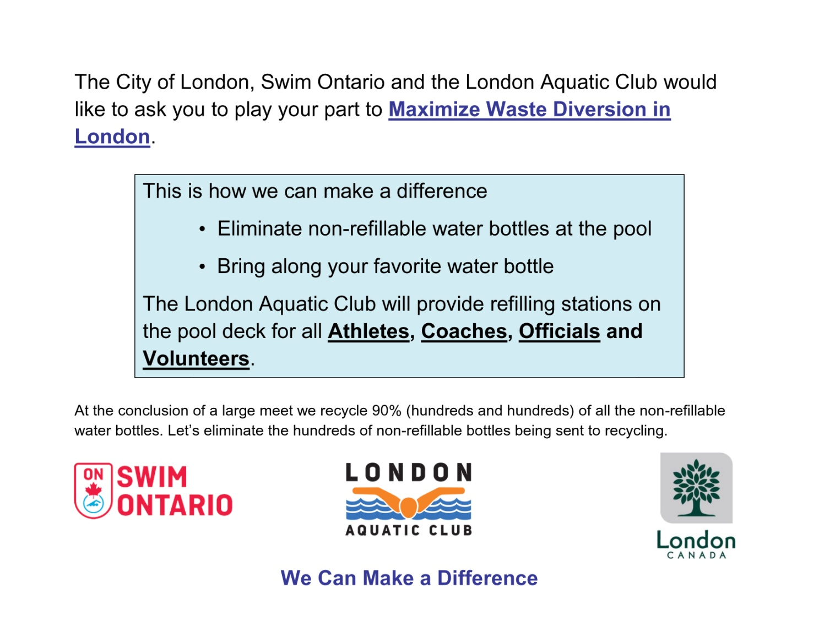

**Appendix G**

**Parking Options**

Parking is available at:

1. Canada Games Aquatic Centre (CGAC)
2. Banting Lots 1, 2 and 3
3. On neighbourhood streets: EAST and WEST off Lawson Rd.   
   (City of London parking bylaws in effect)

**NO PARKING in neighbouring business lots (which includes Mall, Bank, Arena and others). Vehicles may be towed.**

