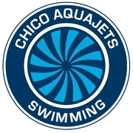
CAJ SPONSORSHIP AT A GLANCE

WHAT IS A CAJ SPONSORSHIP?

- A great way to support an exciting organization that has been producing great student-athletes in the Chico area for over 70 years!

WHAT DO I GET?

- Regular exposure to a membership base of over 150 swimmers through digital and print media distributed by CAJ. Our swimmers range from beginners to elite, and adults continuing their love for the sport! Swimmers of all ages and abilities are welcome at CAJ, and they will see you support them!

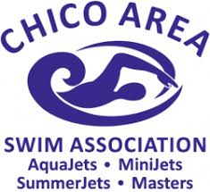
- Visibility at some of the largest sporting events in the Chico area, featuring swim meets hosting up to 400 swimmers and their families stay, eat and play in Chico!

- CAJ hosts 2 large swim meets per year, with the participants ranging from Vacaville to Redding and everything in between!

- High visibility translates to high traffic for you! Our CAJ Families are excited to be patrons of organizations that support our program.

HOW ARE YOU HELPING?

- All money donated goes to the team to help keep dues affordable, while having the ability to get the most up to date training equipment.

- Your donation will assist in North Valley residents joining the Aquajets, while allowing us to rent the necessary facilities to grow, and aid in supporting travel competitions.

Thank you!!! Go Chico!

