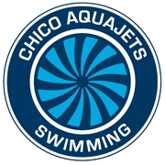

Please Support the fundraising goals of the Chico Aquajets by becoming an Aquajet Sponsor! Sponsor at one of the following levels:

GOLD SPONSOR $1000
- Advertises your business on our team shirt (150 Swimmers + Families)
- Advertises your business on our website www.chicoaquajets.org
- Advertises your business at all of our hosted meets
  - Our meets include guests from Vacaville through Redding

SILVER SPONSOR $500
- Advertises your business on our team shirt (150 Swimmers + Families)
- Advertises your business on our website www.chicoaquajets.org

BRONZE SPONSOR $100
- Advertises your business on our team shirt (150 Swimmers + Families)

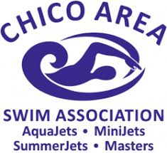

SPONSOR/ UNDERWRITER INFORMATION
Yes, I/we would like to support the Chico Aquajets with a
tax deductible donation at the following level:

SPONSORSHIP DONATION LEVEL: GOLD/SILVER/BRONZE

DONOR INFO: Name or Business name exactly as you would like it to appear in all promotional materials along with your logo in pdf form.

Donor’s Name ________________________________________________________
Address __________________________________City ________________________
State______________ Zip Code ________________ Phone ____________________
E-Mail ______________________________________________________________

For more information, please contact Chris Daly at coachcdaly@gmail.com
Please submit completed form and payment to:
PO Box 1131 Chico, CA 95927
Chico Aquajets are a non-profit 501(c)(3) organization whereby all donations are tax deductible as allowable by tax laws
TAX ID# 94-2194440

