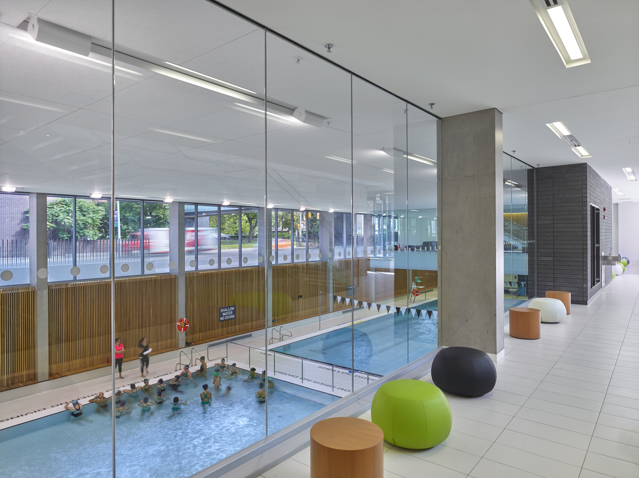
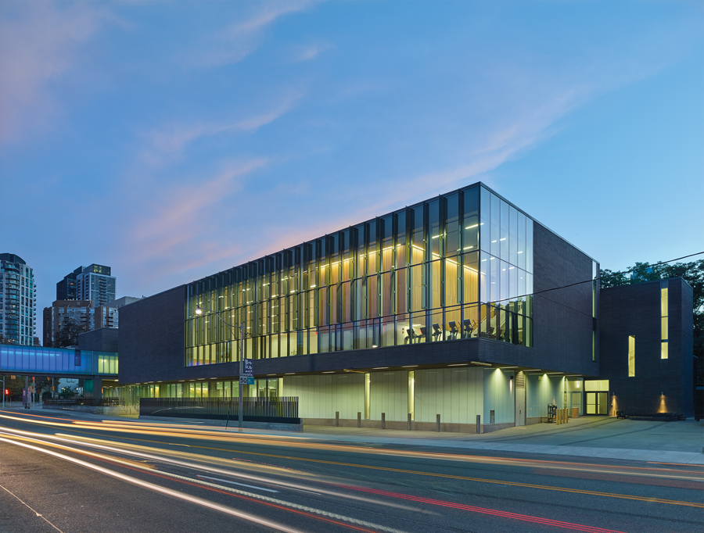
POOL POINTERS – Branksome Hall Pool

ADDRESS: Clare Weisser, Branksome Hall Athletics and Wellness, 6 Elm Avenue, Toronto, ON, M4W 1N4
MAJOR INTERSECTION: Mt Pleasant / Bloor (if you are coming north on Mt Pleasant there is no left turn into Branksome Hall Athletic Center – you must turn right on Elm)
CLOSEST TTC STATION: Sherbourne
PARKING:
- There is limited parking on west side of Mt Pleasant in the Branksome Hall parking lot along roundabout and in small parking lot on south side of Athletic Centre. Please note all signage as some is staff parking.
- Parking is also available on east side of Mt Pleasant on streets as marked or in Branksome Hall lot on East side (cross street or take over-street walkway after buzzing in)
- Parking can get very congested at pickup / drop-off times and there are often other events being held at school so parking is often limited. Please do not block the pathway of other cars and watch for kids crossing through roundabout
FACILITY ENTRANCE:
- Entrance requires buzzing security and then sign in as TSC swimmer / parent
DECK/CHANGE ROOM ENTRANCE:
- The changerooms are downstairs – walk straight towards cafeteria and take stairs down
- This is an all-girls schools so note signage for boys changerooms. Girls changeroom is on left and boys is on the right (nearest pool)
VIEWING GALLERY CONDITIONS:
- Lots of room to sit and watch. Free wifi (security deck has code). There are benches, ottomans, and couches to comfortably sit and watch your swimmer up top or down below at pool level.
- Cafeteria on site also has chairs and if you get there early has food available for purchase (Cash only)

