POOL POINTERS – Central Technical School

ADDRESS: 725 Bathurst St., Toronto, ON, M5S 2R5

MAJOR INTERSECTION: Bathurst St. & Harbord St.

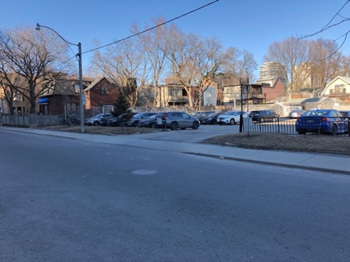
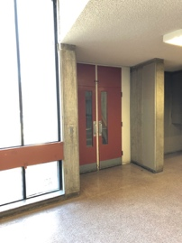
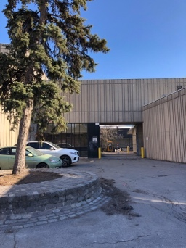
CLOSEST TTC STATION: Bathurst station
Larger school parking lot across the street from the school (Lippincott St., south of Harbord St.)

PARKING:
- There are only 3 or 4 free parking spots directly in front of the entrance on Lennox; arrive early to get a spot.
- To reach a large school lot with free parking (although it is a walk to the pool entrance and not recommended for those who can’t walk long distances, or for those really cold winter evenings with wet hair!), turn north onto Lippincott St. off of Harbord St. – parking lot is about halfway down the street, across from the school’s mechanical shop section.
- 1 hour limited free parking along Lennox St. and Lippincott St.
- A Green P lot is located just south of Bloor off of Lippincott St.
- Metered parking on Bathurst St.

FACILITY ENTRANCE:
- Central Tech is a large school with many buildings. The pool is accessed from Lennox St., just east off of Bathurst. It is a 1967 brutalist style concrete building with glass door entrance. You will see #13 above the glass doors to enter the building.

DECK/CHANGE ROOM ENTRANCE:
- The change rooms are only accessed by traversing the viewing gallery and crossing the pool deck.
- Upon entering the building go through the red/orange coloured doors on the left in the main foyer; travel up steep set of stairs to find viewing gallery.
- To access change rooms, walk down through the viewing gallery, remove outdoor shoes and walk across the deck.

VIEWING GALLERY CONDITIONS:
- Fairly humid and hot; wear light clothing.
- The upper hall along the top of the viewing gallery is often wet, so take precautions when walking.
- Lots of seating and good view of practice.

COFFEE & FOOD:
- On Harbord St. just west of Lippincott you will find Subway, Krispy Kreme Donuts and pizza options.
- On Harbord St. going eastward you will find more many dining options: Harbord Fish and Chips; Harbord House; Akai Sushi; Harvest Kitchen and so much more!
- Immediately around Bloor St. W. and Lippincott St. there are many options for coffee and food: Sushi on Bloor; Starbucks; A&W;
  - Moving eastward on Bloor you will find Future Bistro; Victory Café; Thai Basil
  - Moving westward on Bloor you will find Paupers Pub; Insomnia; Pizza Pizza Arisu Korean BBQ

GROCERY STORES:
- A local grocer/produce market at Markham St. & Bloor.
- Metro across from Walmer Rd. on Bloor W. (425 Bloor St. W).
- Bulk Barn (503 Bloor St. W).

MISC.:
- This pool water can sometimes be foggy and/or quality of water is not optimal.
- Don’t be misled by other TSC signs on Central Tech campus – the Toronto Soccer Club (TSC) uses nearby facilities.

